Directorate of MERSIN TARSUS AGRICULTURAL PRODUCT PROCESSING SPECIALIZED ORGANIZED INDUSTRIAL ZONE

MERSIN TARSUS AGRICULTURAL PRODUCT PROCESSING SPECIALIZED ORGANIZED INDUSTRIAL ZONE
BASIC INFRASTRUCTURE PROJECT

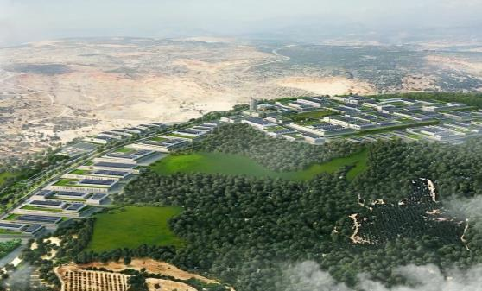
ENVIRONMENTAL AND SOCIAL
MANAGEMENT PLAN
(ESMP)


JULY 2023
ANKARA

MERSIN TARSUS AGRICULTURAL PRODUCT PROCESSING SPECIALIZED
ORGANIZED INDUSTRIAL ZONE
BASIC INFRASTRUCTURE PROJECT

ENVIRONMENTAL AND SOCIAL
MANAGEMENT PLAN (ESMP)
Version | Revision | Date | Prepared by | Prepared by | Prepared by | Quality Management by | Controlled by | Approved by
Draft | A.0 | February 2023 | Eray Özen | Onur Ali Taşkın | Celal Denizli | Esra Okumuşoğlu | D. Emre Kaya | Turgay Eser
 |  |  | Environmental Engineer | Sociologist | Biologist | Geological Engineer | Environmental Engineer, B.Sc. | Environmental Engineer
 | A.1 | February 2023 | Eray Özen | Onur Ali Taşkın | Celal Denizli | Esra Okumuşoğlu | D. Emre Kaya | Turgay Eser
 |  |  | Environmental Engineer | Sociologist | Biologist | Geological Engineer | Environmental Engineer, B.Sc. | Environmental Engineer
 | A.2 | March 2023 | Eray Özen | Onur Ali Taşkın | Celal Denizli | Esra Okumuşoğlu | D. Emre Kaya | Turgay Eser
 |  |  | Environmental Engineer | Sociologist | Biologist | Geological Engineer | Environmental Engineer, B.Sc. | Environmental Engineer
 | A.3 | April 2023 | Eray Özen | Onur Ali Taşkın | Celal Denizli | Esra Okumuşoğlu | D. Emre Kaya | Turgay Eser
 |  |  | Environmental Engineer | Sociologist | Biologist | Geological Engineer | Environmental Engineer, B.Sc. | Environmental Engineer
Final Draft | B.0 | July 2023 | Eray Özen | Onur Ali Taşkın | Celal Denizli | Esra Okumuşoğlu | D. Emre Kaya | Turgay Eser
 |  |  | Environmental Engineer | Sociologist | Biologist | Geological Engineer | Environmental Engineer, B.Sc. | Environmental Engineer
REVISION CODES: A: DRAFT, B: FINAL DRAFT, C: FINAL
PROJECT NO: 22/016
JULY 2023
CLIENT: | CONSULTANT:
 | 
Mersin Tarsus Tarımsal Ürün İşleme  İhtisas Organize Sanayi Bölgesi  Müdürlüğü  Yeni Mah. 5302 Sokak Port Plus Large  No: 3/12  Akdeniz- Mersin / Türkiye  : +90 0 (324) 342 10 33  : +90 0 (324) 342 10 33 | Tepe Prime İş ve Yaşam Merkezi  Mustafa Kemal Mahallesi Dumlupınar  Bulvarı No: 266 B Blok Kat: 2 Daire: 38  Çankaya - Ankara / Türkiye  : +90 (312) 295 62 48  : +90 (312) 295 62 00
.

TABLE OF CONTENTS
Page
Table of Contents i
List of Tables iv
List of Figures vi
List of Abbreviations v
Glossary ix
Executive Summary 1
1 INTRODUCTION 7
1.1 Purpose of Environmental and Social Management Plan 8
1.2 Review of ESMP 10
1.3 Training 11
2 PROJECT DESCRIPTION 14
2.1 Project Location 14
2.2 Purpose of the Project 20
2.3 Project Components 20
2.4 Permits and Management System of the Project Owner 28
2.4.1 Management Systems of the Project Owner 28
2.4.2 Permits 28
3 LEGAL FRAMEWORK 29
3.1 National Legal Framework 29
3.2 International Standards 36
3.3 Major Gaps between the Turkish EIA Regulation and World Bank’s ESF 42
4 ENVIRONMENTAL BASELINE OF THE PROJECT 48
4.1 Project Location and Topography 48
4.2 Land Use 49
4.3 Geology 53
4.3.1 General Geology 53
4.3.2 Tectonics 55
4.4 Soil and Soil Quality 56
4.5 Hydrogeology 58
4.6 Noise 58
4.7 Air Quality 59
4.8 Waste Management 60
4.9 Water Resources 61
4.10 Climate and Vegetation 63
4.11 Natural Disaster Potential 65
4.12 Biodiversity and Protected Areas 66
5 SOCIAL BASELINE OF THE PROJECT 89
5.1 Cultural Heritage 89
5.2 Traffic and Transportation 90
5.3 Demography and Population 90
5.4 Means of Livelihood and Employment 91
5.4.1 Major Economic Activities in Settlements Located in the Project AoI 91
5.5 Education and Health Services 92
5.6 Vulnerable Groups 93
5.7 Seasonal Workers and Unemployed Person 94
5.8 Infrastructure Services 94
5.9 Level of Information about the Project 95
5.9.1 Results of the Key Informant Interviews with Headmen 95
6 ENVIRONMENTAL AND SOCIAL IMPACTS OF THE PROJECT 96
6.1 Air Quality 98
6.1.1 Construction Phase 98
6.1.2 Operation Phase 107
6.2 Water Use 108
6.2.1 Construction Phase 108
6.2.2 Operation Phase 109
6.3 Wastewater 110
6.3.1 Construction Phase 110
6.3.2 Operation Phase 110
6.4 Waste 113
6.4.1 Construction Phase 113
6.4.2 Operation Phase 115
6.5 Noise 118
6.5.1 Construction Phase 118
6.5.2 Operation Phase 124
6.6 Land Use and Soil Quality 124
6.6.1 Construction Phase 124
6.6.2 Operation Phase 125
6.7 Landscape 126
6.7.1 Construction and Operation Phases 126
6.8 Biodiversity and Protected Areas 126
6.8.1 Construction and Operation Phases 126
6.9 Population / Demography 128
6.9.1 Construction and Operational Phases 128
6.10 Cultural Heritage 129
6.11 Vulnerable/Disadvantaged Groups 129
6.12 Economy / Employment 129
6.12.1 Construction and Operation Phase 129
6.13 Land Acquisition 130
6.14 Labour Conditions 133
6.14.1 Construction and Operation Phases 133
6.14.2 Training 134
6.15 Community Health and Safety 135
6.16 Occupational Health and Safety 137
6.16.1 Construction and Operation Phases 137
6.17 Traffic and Transportation 146
6.17.1 Construction and Operation Phases 146
7 ENVIRONMENTAL AND SOCIAL ASPECTS, AND BEST PRACTICE MITIGATION MEASURES 147
7.1 Mitigation Plan for the Construction Phase of the Project 148
7.2 Mitigation Plan for the Operation Phase of the Project 170
8 ENVIRONMENTAL AND SOCIAL MONITORING PLAN 183
8.1 Monitoring Plan for the Construction Phase 186
8.2 Monitoring Plan for the Operation Phase 190
9 STRUCTURE AND ORGANIZATIONAL CHART OF THE PROJECT OWNER 193
9.1 Roles and Responsibilities 194
10 STAKEHOLDER MANAGEMENT UNDER ESMP 197
10.1 Previous Stakeholder Engagement Activities 198
10.2 Grievance Mechanism 199
10.2.1 Existing GMs 202
10.2.1.1 GM at National Level 202
10.2.1.2 GM at Ministry Level 202
10.2.1.3 Project Level Grievance Mechanism 203
11 REPORTING 204
12 CONCLUSION 206
13 REFERENCES 207
Appendix-A Land Title Deed Records 208
Appendix-B EIA Positive Certificates 231
Appendix-C Permits and Opinion Letters 234
Appendix-D Chance Find Procedure 249

LIST OF TABLES
Page
Table 0-1. Summary Table of Loan Usage in the OIZ 2
Table 0-2. E&S Documents Recommended for the Subproject 3
Table 1-1. Training Program 12
Table 3-1. National Environmental and Social Legal and Policy Framework 30
Table 3-2. International Legislation (Chronological) 37
Table 3-3. Comparison between the World Bank ESSs and the National Legislation 44
Table 4-1. Monthly Average Air Quality Parameters in Mersin 59
Table 4-2. According to the Months and Annual Average Precipitation and Temperature Values of Mersin 64
Table 4-3. Flora Species Identified in the AoI as a Result of Studies 69
Table 4-4. Amphibian Species Identified in the AoI as a Result of Studies 76
Table 4-5. Reptilian Species Identified in the AoI as a Result of Studies 76
Table 4-6. Bird Species Identified in the AoI as a Result of Studies 78
Table 4-7. Mammal Species Identified in the AoI as a Result of Studies 81
Table 4-8. Identified threatened fauna species according to the IUCN red list in the AoI 83
Table 4-9. Identified endemic species in the AoI 85
Table 5-1. Common Economic Activities in the Project Area 91
Table 5-2. Vulnerable/Disadvantaged Individuals/Groups in the Project Area 93
Table 5-3. Unemployment in the Settlements 94
Table 5-4. Seasonal Workers 94
Table 5-5. Infrastructure Services of the Neighbourhoods 94
Table 6-1. Emission Factors to be used in Dust Emission Mass Flowrate Calculations in the RoCIAP 99
Table 6-2. Calculation of Dust Emission Flowrate that may Occur Regarding Topsoil 99
Table 6-3. Calculation of Dust Emission Flowrate that may Occur Regarding Excavation Material 100
Table 6-4. Total Dust Emission Flowrate from the Project’s Two Phases 100
Table 6-5. Dust Emission Flowrate Calculation Generated During Silica Sand Mining 101
Table 6-6. Total Dust Emission Flowrate from Silica Sand Mining 101
Table 6-7. Heating-Related Dust Emission Mass Flowrates 102
Table 6-8. Emission Factors and Dust Emission Mass Flowrates of Vehicles on Ankara-Aksaray Road 103
Table 6-9. Emission Factors and Dust Emission Mass Flowrates of Vehicles on the Tarsus-Ankara Highway 103
Table 6-10. Total Dust Emission Mass Flowrates 103
Table 6-11. National and International Air Quality Limit Values and Calculated Emission Values 104
Table 6-12. Specification of Diesel 105
Table 6-13. Emission Factors Originating from Diesel Vehicles (kg/tonne) 106
Table 6-14. Lower Limit Values of Modelling Study with Calculated Exhaust Emissions Mass Flowrates 106
Table 6-15. Emission Factors for Natural Gaseous 107
Table 6-16. Emission Mass Flowrate and Limit Values to be Formed from a Facility 107
Table 6-17. Combustion Thermal Power Limit Values in the RoCIAP 108
Table 6-18. Planned Domestic and Process Water Demand Amounts of Facilities in OIZ 109
Table 6-19. The Estimated Quantities of Wastewater in OIZ 111
Table 6-20. Discharge Standards for the Treated Process Water to Receiving Environment in the RoCWP for planned WWTP 112
Table 6-21. The List of Vehicles and Equipment to be used in the Ground levelling and Excavation Works 118
Table 6-22. Sound Power Levels of Vehicles and Equipment During the Construction 119
Table 6-23. Distribution of Sound Power Levels to Octave Bands 119
Table 6-24. Sound Pressure Levels in 4 Octave Bands by Distance 120
Table 6-25. Correction Factors 120
Table 6-26. Atmospheric Absorption 121
Table 6-27. The Final Sound Pressure Levels in the 4-Octave Band 121
Table 6-28. The Final Sound Pressure Levels 122
Table 6-29. Estimated Lday Sound Level Values and the National and International Noise Limit Values 123
Table 6-30. Coordinates of the Points for Soil Sampling 124
Table 6-31. Characteristics of the affected parcels before acquisition in Phase 1 area of the Sub-project 131
Table 7-1. Activities to be performed in the Scope of the Project 147
Table 8-1. Key Performance Indicators for both construction and operation phases of the Project 183
Table 9-1. Project’s Organizational Management 195
Table 10-1. Stakeholder Groups 197
Table 11-1. Reporting Process Requirements and Distribution of Roles 204

LIST OF FIGURES
Page
Figure 2-1. The Project Location 14
Figure 2-2. The Layout showing the Two Phases of the Project 15
Figure 2-3. The Quarries Adjacent to Project Area 16
Figure 2-4. The Closest Sensitive Receptor to the Project Area 16
Figure 2-5. The Closest Settlement and Sensitive Receptor to the Project Area 17
Figure 2-6. 1/100,000 scale territorial plan of Mersin-Adana planning zone showing 5 km around of the Project 19
Figure 2-7. The Project Time Schedule 20
Figure 2-8. The Project Electric Network Layout Plan 21
Figure 2-9. The Project Lighting Network Layout Plan 22
Figure 2-10. The Project Clean Water Network Layout Plan 23
Figure 2-11. The Project Process Water (Treated Wastewater) Network Layout Plan 24
Figure 2-12. The Project Stormwater Network Layout Plan 25
Figure 2-13. The Project Wastewater Network Layout Plan 26
Figure 2-14. The Project Road Layout Plan 27
Figure 4-1. Before and After Expropriation (1) 49
Figure 4-2. Before and After Expropriation (2) 50
Figure 4-3. Before and After Expropriation (2) 51
Figure 4-4. The Map of the Tectonic Assemblies and Seal Rocks Found in Mersin 55
Figure 4-5. Structures of the Previously Operating Gas Station in Lot 105: Parcel no. 1 and 2 of the Project Area 57
Figure 4-6. Stripped Topsoil in the Project Area 58
Figure 4-7. Air Quality Monitoring Stations in Mersin 59
Figure 4-8. The Wells and Water Table Contour in the AoI of the Project 62
Figure 4-9. The View of the Well-2 in Lot 105: Parcel no. 2 of the Project Area 63
Figure 4-10. Mersin Province Earthquake Zones Map (Earthquake Research Department Ankara) 65
Figure 4-11. Habitats within the Project Area and Close Vicinity 66
Figure 4-12 General View from the Project Area 67
Figure 4-13 General View from the Project Area 67
Figure 4-14. Internationally Recognized Areas 87
Figure 5-1. Ancient Roman Road and Project Area 90
Figure 5-2. Education and Health Services Near the Project Area 92
Figure 6-1. Project’s Area of Influence for the Assessment of the Social and Environmental Impacts 97
Figure 6-2. Soil Sampling Locations 125
Figure 6-3. Social Facilities Near the Project Area 136
Figure -. Organizational Chart (for both construction and operation phases) of TUIOSB Basic Infrastructure Project 193
Figure 9-2. Organizational Chart of Project Management Unit 194

LIST OF ABBREVIATIONS
AoI | Area of influence
CHS | Community, Health and Safety
CİMER | Presidency’s Communication Center
CoC | Code of Conduct
DC | Distribution Center
DSI | General Directorate of State Hydraulic Works
EBRD | European Bank for Reconstruction and Development
EEA | European Environment Agency
EHS | Environmental, Health and Safety
EIA | Environmental Impact Assessment
EMEP | European Monitoring and Evaluation Programme
EPSA | Ex-Post Social Assessment
ES | Environmental and Social
ESF | Environmental and Social Framework
ESIA | Environmental and Social Impact Assessment
ESMF | Environmental and Social Management Framework
ESMMP | Environmental and Social Management and Monitoring Plan
ESMP | Environmental and Social Management Plan
ESMR | Environmental and Social Monitoring Report
ESMS | Environmental and Social Management System
ESPR | Environmental and Social Progress Report
ESR | Environmental and Social Report
ESS | Environmental and Social Standard
FI | Financial Intermediary
GHG | Greenhouse Gas
GM  HSE | Grievance Mechanism  Health and Safety Executive
HV/LV | High Voltage and Low Voltage
IFC | International Finance Corporation
ILO | International Labour Organization
IUCN | International Union for Conservation of Nature and Natural Resources
KBA | Key Biodiversity Area
KPI | Key Performance Indicators
LMP | Labor Management Plan
MoEUCC | Ministry of Environment, Urbanization and Climate Change
MoIT | Ministry of Industry and Technology
MTA | General Directorate of Mineral Research and Exploration
NCR | Non-Conformance Report
NGO | Non-Governmental Organizations
OG | Official Gazette
OHS | Occupational Health and Safety
OIZ | Organized Industrial Zone
OP | Operational Policy
PIU | Project Implementation Unit
PM | Particulate Matter
PMU | Project Management Unit
PPE | Personal Protective Equipment
RP | Resettlement Plan
RoCAN | Regulation on Control of Ambient Noise
RoCIAP | Regulation on Control of Industrial Air Pollution
RoCWP | Regulation on Control of Water Pollution
SCADA | Supervisory Control and Data Acquisition
SEA/SH | Sexual Exploitation and Abuse/Sexual Harassment
SEP | Stakeholder Engagement Plan
TKN | Total Kjeldahl Nitrogen
TOC | Total Organic Compounds
TUIOSB | Directorate of Mersin Tarsus Agricultural Product Processing Specialized Organized Industrial Zone
TSE | Turkish Standards Institution
TSS | Total Suspended Solids
TurkStat | Turkish Statistical Institute
TÜRKAK | Turkish Accreditation Agency
WB | World Bank
WBG | World Bank Group
WHO | World Health Organization
WWTP | Wastewater Treatment Plant
YİMER | Foreigners Communication Center

GLOSSARY
Associated Facility | Facilities or activities that are not funded as part of the project and, in the judgment of the Bank, are: (a) directly and significantly related to the project; and (b) carried out, or planned to be carried out, contemporaneously with the project; and (c) necessary for the project to be viable and would not have been constructed, expanded or conducted if the project did not exist. For facilities or activities to be Associated Facilities, they must meet all three criteria.
Implementing Agency | T.C. Sanayi ve Teknoloji Bakanlığı (in Turkish) or Republic of Türkiye Ministry of Industry and Technology
Project Owner / TUIOSB | Mersin Tarsus Tarımsal Ürün İşleme İhtisas Organize Sanayi Bölgesi Müdürlüğü (in Turkish) or Directorate of Mersin Tarsus Agricultural Product Processing Specialized Organized Industrial Zone
Consultant | 2U1K as Environmental and Social Consultant
Construction Supervision Consultant | Consultant for Construction Supervision
Project | Mersin Tarsus Agricultural Product Processing Specialized Organized Industrial Zone Basic Infrastructure
Project Area | The area where the first phase of the Project will be implemented

EXECUTIVE SUMMARY
The Directorate of Mersin Tarsus Agricultural Product Processing Specialized Organized Industrial Zone (TUIOSB or Project Owner) plans to implement Mersin Tarsus Agricultural Product Processing Specialized Organized Industrial Zone Basic Infrastructure Project (Project). The Project will be implemented in two phases as Phase 1 and Phase 2. TUIOSB will use loan only for Project’s Phase 1. The Project’s Phase 2 will be financed with the use of Mersin Tarsus Agricultural Product Processing Specialized Organized Industrial Zone (OIZ)’s own equity. In addition, investments will not be made in the Project’s Phase 2 area until the expropriation process for the Project’s Phase 2 area is completed. The Project construction works are planned to last for 12 months. Its operation will have a service lifetime of 50 years. In this context, the Project includes as follows.
- 977.633 m diversion canal,
- 8.85 km road,
- 8.135 km clean water line,
- 9.435 km process water (treated wastewater) line,
- 5.05 km stormwater line,
- 3.998 km wastewater line,
- 15.370 km electricity distribution line,
- 3.581 km environmental lighting line,
- 4 electricity distribution centers,
- 110 lighting poles,
- 143 LED armatures,
- One (1) set of SCADA and
- One (1) set Telecom infrastructure.
As a part of OIZ, a wastewater treatment plant (WWTP) is planned to be implemented. It will be built in parallel with the construction of the infrastructure lines and is planned to be completed at the same time. As it is planned for Phase 2 of the Project, the WWTP is not part of the present Project and not within the scope of loan usage. Hence, WWTP and the Phase 2 of the Project have been assessed as associated facility. In this context, activities to be carried out within the OIZ Area that are not covered by the Project loan usage but assessed as associated facility are summarized in Table 0-1.

Table 0-1. Summary Table of Loan Usage in the OIZ
Activities to be carried out within the OIZ Area | Phase 1 |  | Phase 2
 | Construction Phase | Operation Phase | Construction Phase | Operation Phase
Basic Infrastructure | +* | + | - | -
WWTP | - | - | - | -
Natural Gaseous Line | - | - | - | -
Facilities to be in the OIZ | - ** | - | - ** | -
Buildings of the OIZ Management | - | - | - | -
* (ground levelling works already carried out are not included for loan usage.)
** (including excavation works in their areas)
The planning studies of TUIOSB were prepared in accordance with the provisions of the Organized Industrial Zones Law No. 4562, the Zoning Law No. 3194, the Regulation on the Production of Spatial Plans, the 1/100,000 scaled Territorial Plan and Plan Provisions of the Mersin-Adana Planning Zone and the OIZ Implementation Regulation. Land acquisition was implemented as the project area had multiple owners. The project required additional land, of which 13 parcels were public lands and three parcels were private land with multiple owners. The agreements were reached with all the shareholders of the private lands, and the shares were acquired with willing buyer-willing seller. Detailed information on the related expropriation and procurement processes is given in Table 6-31.
The production process issues of the facilities to be established within the scope of the OIZ are determined by the investors who filled in the Investor Preliminary Request Form of the Organized Industrial Zones Site Selection Regulation, published in the Official Gazette on 18.11.2015 and numbered 29536, and submitted it to Mersin Specialized Organized Industrialists Association.
"Türkiye Organized Industrial Zones Project" which is financed by World Bank (WB) was formulated to increase the efficiency, environmental sustainability and competitiveness of the OIZs. Within this main Project, some OIZs are planned to be developed within the defined criteria and it is aimed that these OIZs will set an example for other OIZs. In this context, the implementing agency for the main Project is Republic of Türkiye Ministry of Industry and Technology (MoIT), whose Directorate General for Organized Industrial Zones is responsible for designing the policies to plan and develop OIZs including providing credits for OIZ Managements. For the main Project, an Environmental and Social Management Framework (ESMF) that is the key document committed by MoIT to comply with national legislation and WB’s Environmental and Social Framework (ESF) has been prepared. ESMF is the framework document for the overall Project and forms the basis and guidance throughout the Project lifetime for the site-specific Environmental and Social Management Plan (ESMP) of the Project. The ESMF covers environmental and social management approach that will be implemented during the main Project. According to the ESMF, before preparation of the Environmental and Social (E&S) documents, MoIT will prepare E&S Screening Reports or assign a Company to prepare these reports for all sub-projects and submitted them to World Bank Team for review and approval. As a result of the information obtained in the screening studies, a risk analysis will be made as well as the E&S Screening Report.
The activities under this Project are included in Annex-1 List of the Regulation on the Environmental Impact Assessment according to the Turkish EIA legislation, and therefore the Environmental Impact Assessment (EIA) Report was prepared, then EIA positive required certificate has been secured. According to E&S Screening report, Environmental and social risks are determined according to the WB ESSs and ESMF of the Project. The overall environmental and social risk of the subproject were rated in “Moderate” risk group. Hence, the site-specific ESMP has been prepared for the Project. E&S documents that are recommended for the subproject are given in Table 0-2.
Table 0-2. E&S Documents Recommended for the Subproject
E&S Document | Explanation | Recommended
EIA | National EIA is completed. | X
ESMP | A site-specific ESMP will be required since the overall risk of the subproject is “Moderate”. | ✓
ESIA | A detailed Environmental and Social Impact Assessment (ESIA) will not be required since the overall risk of the subproject is “Moderate”. | X
SEP | A site-specific Stakeholder Engagement Plan (SEP) will be required. | ✓
LMP | Labor Management Plan (LMP) for the Project will be developed based on Labor Management Plan (LMP) for the overall project and national legislation and OHS. The LMP for contractors will also comply with the labour legislation (Labour Law no. 4857), occupational health and safety plan and procedures (Occupational Health and Safety Law no. 6331) and Social Insurance Law no. 5510 in addition to the Labour Management Procedures of the Project. | ✓
RP/EPSA | A site-specific Ex-Post Social Assessment (EPSA) will be required as there has been an expropriation within the last 5 years. | ✓
The Project would be built on an existing technical assistance relationship between the MoIT and the World Bank Group (WBG) that helped develop a national framework for Green OIZs in Türkiye and carried out preliminary assessments of the potential impact of OIZ investments.
In this context, as the implementing agency for the project, MoIT will provide loans to borrowing OIZs, as a sub-borrower and the Project as a selected Project will use the loan.
There are currently 30 people working for ground levelling at the Project Area and it is planned to employ a total of 250 people at peak time in the construction phase of the Project. During the operation phase, approximately 3,500 people are planned to be employed by the facilities within the OIZ.
Currently, employees use the contracted restaurants for dining and the Project administrative building for sanitary facilities. It is foreseen that no accommodation facilities will be constructed during the construction activities of the Project. However, containers can be placed on the Project Area for those who will work on the Project to rest, eat and for sanitary facilities. These containers will meet standards for worker accommodation prepared by International Finance Corporation (IFC) and European Bank for Reconstruction and Development (EBRD) and approved by the WB. The Project will be awarded to the TUIOSB by a tender, which will be directly announced and led by the MoIT.
The Construction Supervision Consultant, who will be responsible for detecting nonconformities, notifying the TUIOSB and monitoring corrective actions within the scope of the Project, will be selected through tender to be opened by the TUIOSB. In this respect, the consultant criteria will be in accordance with established criteria for internationally funded projects. The competence of the Construction Supervision Consultant will be also evaluated by the MoIT.
On the other hand, the tender for the Construction Contractor will be conducted in accordance with the WB Procurement Regulations and companies that have been banned from public tenders will not be included in the tender process. The result of the tender will be determined by a committee to be consisting of members from the MoIT and TUIOSB.
Environmental and Social Management Plan (ESMP) describes the measures and controls developed for the management of the potential project impacts, determines the implementation schedule of these mitigation measures, defines the roles and responsibilities for implementation of ESMP as well as reporting and monitoring requirements in line with WB requirement. Accordingly, ESMP will be part of tender package.
According to Environmental and Social Management Framework (ESMF), Project Implementation Unit (PIU) of MoIT environmental and social experts shall monitor the sites on quarterly basis during construction, and biannually during the operation phase. More frequent monitoring may be conducted if needed to ensure compliance with the mitigation measures and resolution of any issues that are noted. Monthly monitoring activities carried out by TUIOSB as Project Management Unit (PMU) for E&S compliance will be reported regularly to PIU. PIU will carry out its supervision monitoring as required and report to World Bank quarterly/biannually on the progress and updates.
ESMP is considered as a living document that requires regular review and update with respect to the potential changes in environmental and social conditions as the project progresses. The TUIOSB together with its sub-contractors are responsible for the implementation of the ESMP. The TUIOSB is committed to follow WB ESSs, IFC PS, as well as the Guidelines of the World Bank Group (IFC Environmental, Health and Safety Guidelines (EHSs)).
This ESMP identifies the potential adverse impacts that may arise during construction and operation phases of the Project and proposed appropriate mitigation measures to effectively address these impacts. In conclusion, the Project can be carried out in an environmentally and socially sustainable manner on full implementation of this ESMP as there are no likely major or irreversible negative impacts.
As spot fuel and oil spills were observed visually in Lot 105 of the Project Area, the TUIOSB will take soil samples in the concerned area (see Table 6-30 and Figure 6-2) to be able to assess possible soil contamination in accordance with Regulation on Control of Soil Pollution and Point Source Contaminated Lands. If soil contamination is detected at the area, Soil Management Plan including studies to be carried out in this area will be prepared and ground levelling works within the area will only be started by the contractor after the rehabilitation of the area in line with the relevant regulation.
As part of the mitigation measures, management plans and procedures on different subjects should be developed. A list of recommended management plans for both construction and operation phases of the Project are presented below;
Construction Phase;
- Waste Management Plan,
- Soil Management Plan,
- Dust Management Plan,
- Noise Management Plan,
- Transport and Traffic Management Plan,
- Chemical Spill Emergency Management Plan,
- Pollution Prevention Plan,
- Occupational Health and Safety Management Plan,
- Emergency Preparedness and Response Plan,
- Community Health, Safety, and Security Management Plan,
- Labour Management Plan,
- Stakeholder Engagement Plan,
- Contractor Management Plan,
- Invasive Species Management Plan.
Operation Phase;
- Waste Management Plan,
- Effluent Management Plan,
- Odour Management Plan,
- Sludge Management Plan,
- Sustainable Water Management Plan,
- Transport and Traffic Management Plan,
- Occupational Health and Safety Management Plan,
- Emergency Preparedness and Response Plan,
- Community Health, Safety, and Security Management Plan,
- Labour Management Plan,
- Stakeholder Engagement Plan,
- Invasive Species Management Plan.
During the construction period before mitigation measures are implemented:
Land use and soil quality, waste and chemical management, noise, OHS impacts are rated as high. Labour conditions, air quality, Community, Health, and Safety (CHS) and traffic and pedestrian safety impacts are rated as medium.
During the operation period:
Water use, wastewater, waste, and chemical management impacts are assessed as high. Labour conditions, OHS, odour and CHS impacts are assessed as medium.
The monitoring process will cover construction and operation phases to monitor the implementation of environmental and social commitments of ESMP requirements. Methods for monitoring will include activities such as on-site inspection, grievance mechanism records, training records, interviews with employees, review of documents prepared/implemented by OIZ and contractors.
During the construction period:
Disclosure, labour conditions, OHS, CHS, documentation, land use, land acquisition, grievance mechanism, sustainable development, air quality, noise, waste management, domestic waste, waste oils, waste batteries and accumulators, excavation soil, construction and debris demolition waste, wastewater and water management, hazardous waste management, cultural heritage, direct and indirect threats posed by construction activities against traffic and pedestrians, access to the construction site security fence protection tape, biodiversity will be monitored.
During the operation period:
Disclosure, labour conditions, OHS, CHS, documentation, grievance mechanism, water use waste and wastewater will be monitored.
Monthly monitoring activities carried out by TUIOSB for E&S compliance will be reported regularly to MoIT for the monitoring. MoIT will carry out its supervision monitoring as required and report to World Bank semi-annually on the progress and updates. Monitoring reports will aim to identify environmental, social, OHS related risks and impacts. Grievances will also be included in the monitoring reports.
As part of the requirements stipulated by WB, ESMP is to be publicly disclosed by the TUIOSB’s and on the WB’s website. ESMP will be reviewed, updated, and approved as necessary. For each approved updated version of this ESMP, the TUIOSB will be responsible for the disclosure of the updated documents.

INTRODUCTION
This plan presents the Environmental and Social Management Plan (ESMP) for “Mersin Tarsus Agricultural Product Processing Specialized Organized Industrial Zone Basic Infrastructure” (hereinafter referred to as 'Project') and is prepared by 2U1K Engineering and Consultancy Inc. for “Directorate of Mersin Tarsus Agricultural Product Processing Specialized Organized Industrial Zone” (hereinafter referred to as 'Project Owner / TUIOSB'). The Project is located in Mersin Province, Tarsus District, Kurbanlı and Eskişehir Neighbourhoods. The concerned land title deed records of the Project are presented in Appendix-A.
The Project will be implemented in two phases as Phase 1 and Phase 2. TUIOSB will use loan only for Project’s Phase 1. The Project’s Phase 2 will be financed with the use of Mersin Tarsus Agricultural Product Processing Specialized Organized Industrial Zone (OIZ)’s own equity. In addition, investments will not be made in the Project’s Phase 2 area until the expropriation process of the Project’s Phase 2 area is completed. In the project zoning plan, the total area is 116.29 hectares, and Phase 1 corresponds to 92.64 hectares where the first phase of the Project will be implemented (Project Area), Phase 2 to 23.65 hectares. The layout plan for two phases of the Project is presented in Figure 2-2.
The Project construction works are planned to last for 12 months. Its operation will have a service lifetime of 50 years. In this context, the following construction works of the Project will be carried out.
- Clean water system,
- Process water (treated wastewater) system,
- Stormwater collection and distribution system,
- Wastewater collection system,
- Diversion canal,
- HV/LV electricity lines (including ring system to ensure energy continuity in the design of power lines),
- Electricity Distribution centers,
- Territorial lighting,
  - Grounding and lightning protection system
  - Lighting system of vehicles and pedestrian roads,
- Telecommunication lines (fibre optic cables and data infrastructure),
- SCADA system, and
- Construction of pedestrian, bicycle, and road networks
The basic infrastructure of the Mersin Tarsus Agricultural Product Processing Specialized Organized Industrial Zone is planned to be realized with green and technological solutions in order to ensure resource efficiency, create infrastructure integrity, prevent unplanned industrialization and environmental problems, direct urbanization, and use resources rationally.
Within the scope of the Project, 977.633 m diversion canal, 8.85 km road, 8.135 km clean water line, 9.435 km process water (treated wastewater) line, 3.998 km wastewater line, 5.05 km stormwater line, 15.370 km electricity distribution line, 3.581 km environmental lighting line, four (4) electricity distribution centers (DC)’s, 110 lighting poles, 143 LED armatures, one (1) set of SCADA and Telecom infrastructure systems are planned.
The Project would be based on an existing technical assistance relationship between the MoIT and the World Bank Group (WBG) that helped develop a national framework for Green OIZs in Türkiye and carried out preliminary assessments of the potential impact of OIZ investments.
In this context, as the implementing agency for the Project, MoIT will provide loans to borrowing OIZs, as a sub-borrower and the Project as a selected Project will use a loan.
Accordingly, the processes envisaged to take place in the Agricultural Product Processing Specialized Organized Industrial Zone include;
- Nuts, Coffee Processing,
- Tahini, Halva Production and Packaging,
- Spices Processing and Packaging,
- Pulses Drying, Screening and Packaging Plant,
- Tobacco Processing Plant,
- Pasteurized Liquid Egg Production, Fruit Juice Production,
- Fruit Extracts (Vinegar, Molasses, Pomegranate Syrup, Lemon Sauce)
- Processing, Fisheries Processing, Packaging and Storage,
- Processing of Medicinal and Aromatic Plants,
- Herbal Cosmetics Production,
- Canned Food Production,
- Seed Sieving, Processing and Packaging,
- Agricultural Product Processing Machinery Production.

Purpose of Environmental and Social Management Plan
The ESMP document aims to determine the risks and adverse social and environmental impacts that are likely to occur during the construction and operation phases of the Project, to evaluate these impacts, and to prescribe actions to mitigate and/or prevent negative impacts. The ESMP also establishes the E&S baseline for the project site, the organization structure, training, monitoring and reporting requirements of ESMP implementation. In addition to this, the ESMP describes the mitigations/actions to be taken by the contractor and other relevant parties, responsibilities of the contractor with respect to environmental and social issues. In this context, the ESMP will be part of the tender package and will contain the responsibilities of all relevant parties including the contract.
Within the scope of the ESMP, information is provided regarding the work items planned to be fulfilled in the contract packages, the methodologies to be applied and the working areas, determining the social and environmental impacts that are likely to occur during both construction and operation phases. Potential impacts occurring during all phases of contract packages are described, and measures to be taken to prevent impacts and/or minimize negative impacts are detailed. In order to prevent and minimize the adverse impacts described in this ESMP, it is intended to monitor and control the impacts identified in ESMP during the implementation of the Project. In this context, the ESMP is monitored to assess on a continuous basis the implementation of the ESMP and the effectiveness of the prescribed mitigation measures. Direct and indirect stakeholders of the project are identified and consulted throughout the project about its environmental and social impact and risks. A Stakeholder Engagement Plan (SEP) is worked out accordingly.
In addition, the final version of this ESMP approved by the MoIT and the WB will be made available to all stakeholders during the life of the Project. The ESMP and Stakeholder Engagement Plan (SEP) should be updated, when necessary, in case there is any change in the Project and should be disclosed and consulted upon and updated if consultations result in changes/updates to any documents.
Since land acquisition was conducted ahead of the project, an Ex-Post Social Audit is prepared to assess whether the process and outcome is compatible with the requirements of the ESS5 and the RPF of the project, and outline necessary gap filling measures if required. As part of the mitigation measures, management plans and procedures on different subjects should be developed. A list of recommended management plans for both phases of the Project are presented below;
Construction Phase;
- Waste Management Plan,
- Soil Management Plan,
- Dust Management Plan,
- Noise Management Plan,
- Transport and Traffic Management Plan,
- Chemical Spill Emergency Management Plan,
- Pollution Prevention Plan,
- Occupational Health and Safety Management Plan,
- Emergency Preparedness and Response Plan,
- Community Health, Safety, and Security Management Plan,
- Labour Management Plan,
- Stakeholder Engagement Plan,
- Contractor Management Plan,
- Invasive Species Management Plan.

Operation Phase;
- Waste Management Plan,
- Effluent Management Plan,
- Odour Management Plan,
- Sludge Management Plan,
- Sustainable Water Management Plan,
- Transport and Traffic Management Plan,
- Occupational Health and Safety Management Plan,
- Emergency Preparedness and Response Plan,
- Community Health, Safety, and Security Management Plan,
- Labour Management Plan,
- Stakeholder Engagement Plan,
- Invasive Species Management Plan.
The Contractor prepares the required management plans for both the construction phase of the Project and the commissioning before the operation phase of the Project and presents them to the Construction Supervision Consultant.
The Contractor starts construction once the Construction Supervision Consultant approves the required management plans for the construction phase of the Project. The Construction Supervision Consultant forwards the approved management plans to the TUIOSB. The TUIOSB reviews the concerned management plans and submits them to the MoIT.
The Contractor presents the required management plans for the commissioning of the Project to the Construction Supervision Consultant three (3) months before commissioning of the Project). Once the Construction Supervision Consultant approves these plans, the Project begins to operate all sub-project components. The Construction Supervision Consultant forwards the approved management plans to the TUIOSB. The TUIOSB reviews the concerned management plans and submits them to the MoIT.

Review of ESMP
ESMP will be periodically reviewed to address changes in the responsible parties’ organization, process, or regulatory requirements.
The Project Management Unit (PMU), which will be formed by the TUIOSB, and detailed in Figure 9-2 will be responsible for the implementation of this ESMP and SEP. The MoIT Directorate General for Industrial Zones, World Bank Türkiye Organized Industrial Zones Project Implementation Unit (PIU) will continue to have existing environmental experts, OHS expert/specialist and social experts to be responsible for coordinating the implementation of the Environmental and Social Framework. Environmental specialists, OHS specialist and social specialists will supervise the TUIOSB on WB safeguard requirements, provide consultancy for the implementation of the Environmental and Social Management Plan (ESMP), and monitor the implementation of ESMP and SEP together with the opinion and grievance mechanism for affected groups. In this context, the Construction Supervision Consultant will be appointed to execute these functions.
Following any reviews, the TUIOSB will provide coordination through the PIU to make any necessary amendments to the ESMP, with the updates communicated to all responsible parties and employees involved in the Project.

Training
The TUIOSB will implement a training and awareness program covering ESMP commitments, which covers project related environmental and social impacts and risks, and corresponding measures applied to avoid, reduce, and mitigate the risks and potential adverse impacts. 2U1K will organize and conduct, together with the TUIOSB, a workshop for this training in accordance with the scope of work in its current contract. As a minimum requirement, this program will be implemented as training for employees and contractor responsible for the implementation of ESMP. The trainings will be given to the employees and the Construction Supervision Consultant by the Consultant before the construction process starts. After the contract with the construction contractor is signed, the Construction Supervision Consultant will give these trainings specified in Table 1-1 to the construction contractor before commencement of construction activities. The trainings will last at most two days and will be organized twice a year. Depending on Environmental and Social Monitoring Reports (ESMRs) in which are reported the effectiveness of the ESMP mitigation measures determined through the monitoring process, further training programs may need to be performed in order to achieve required target, if the ESMP implementation will not be at desired level or failed. The necessary training will be provided to the personnel soon after recruitment, and grading and evaluation should be carried out at the end of the training provided. Construction Supervision Consultant will check the relevance of the training program and the training evaluation. According to the results of the evaluation, the training program can be modified, or trainers can be replaced, or training can be repeated, if needed, upon determining whether the training is effective. This is intended to enhance the personnel's competency.
The training program/modules will address a range of issues, including but not limited to:
- Purpose of ESMP regarding the project activities,
- Requirements in management plans, mitigation measures to be applied and monitoring activities to be performed within the scope of this plan,
- Understanding of the sensitive environmental and social receptors within the project area and its vicinity,
- Awareness raising about the potential risk and impacts from the project activities,
- Grievance mechanism developed within the scope of the project, process, procedures and service standards, grievance mechanism contact channels and employee rights,
- Occupational health and safety, first aid, emergency preparedness,
- COVID-19 related precautions and protection measures,
- Code of conduct and dress code,
- Communication with the local community,
- Code of conduct training, including gender-based violence, sexual harassment, sexual exploitation, and abuse,
- Traffic and road safety principles, and
- Training aiming at the sorting, storage, and environmental planning of waste.
The TUIOSB will ensure that all personnel responsible for the implementation of this ESMP are competent in terms of education, training, and experience. All personnel will be provided with environmental and social training appropriate to their scope of activity and level of responsibility.
The institutional capacity of TUIOSB will be strengthened through the trainings to be delivered by the environmental, social, stakeholder engagement and OHS specialists of the MoIT PIU In case needed, MoIT PIU can hire external consultants, who have knowledge and experience about ESSs, to support the trainings for TUIOSB officials/staff in order to increase their awareness of risks and mitigate the impacts of the Project. Information regarding proposed training program is provided in Table 1-1.
Table 1-1. Training Program
Item No | Heading of the Training | Target Group | Timing and Duration | Cost***
1 | Environmental and Social Framework:  - Training on ESF, and the ESSs relevant for the Project including preparation of ESMP  - Implementation of the project specific ESMP, LMP, SEP and GM | Personnel of TUIOSB  Personnel of the Construction Supervision Consultant** | Immediately after award of the contract.  (5 days) | 3,500 Euro*
2 | Occupational Health and Safety:  - Workplace risk management  - Prevention of accidents at work sites  - Use of Personal Protection Equipment’s (PPEs)  - Health and safety standards  - Hazardous waste management  - Solid and liquid waste management  - Preparedness and response to emergency situation  - Awareness on communicable diseases (i.e. Covid-19, HIV/AIDS etc.) | Personnel of the Construction Supervision Consultant**  Personnel of TUIOSB | Immediately after award of the contract.  (2 days) | 1,800 Euro*
3 | Labour and Working Conditions:  - Implementation of LMP  - Terms and conditions of employment according to national working laws and regulations  - Contractor and sub-contractor codes of conduct  - Worker’s organizations  - Child labour and forced labour issues  - Workers Grievance Mechanism | Personnel of the Construction Supervision Consultant**  Personnel of TUIOSB | Immediately after award of the contract.  (1 day) | 800 Euro*
4 | Public Grievance Mechanisms:  - Implementation of GM  - Registration and processing procedure  - Grievance procedure  - Documenting and processing grievances | Personnel of the Construction Supervision Consultant** | Immediately after award of the contract.  (1 day) | 300 Euro*
5 | Worker Grievance Mechanism  - Implementation of GM  - Registration and processing procedure  - Grievance procedure  - Documenting and processing grievances | Personnel of the Construction Supervision Consultant** | Immediately after award of the contract.  (1 day) | 300 Euro*
Total: |  |  |  | 6,700 Euro*
*Including transportation and accommodation costs.
**After the Contract with the construction contractor is signed, the construction supervision consultant will give this training to the construction contractor before commencement of construction activities.
***Costs are indicative and may change during the tendering process.

PROJECT DESCRIPTION

Project Location
The Project is planned to be established by the TUIOSB at Mersin Province, Tarsus District, Kurbanlı and Eskişehir Neighbourhoods, Evci Creek, Kum Gedigi local at 37°02'45.9" North Latitude and 34°55'18.3" East Longitude. The Project will be implemented in two phases as Phase 1 and Phase 2. The Project Area is the area where the first phase of the Project will be implemented (see Figure 2-1). The title deed information of the Project’s land area is as follows; lot 102: parcel no. 5, lot 104: parcel no. 1 and 2, lot 107: parcel no. 3, lot 189: parcel no. 3 and 4, lot 198: parcel no.8, lot 204: parcel no. 1, lot 205: parcel no. 1,2 and 3, lot 105: parcel no. 1 and 2 (see Appendix-A). Land acquisition was implemented as the project area had multiple owners. The project required additional land, of which 13 parcels were public lands and 3 parcels were private land and one of them with multiple owners. The agreements were reached with all the shareholders of the private lands, and the shares were acquired with willing buyer-willing seller. Detailed information on the related expropriation and procurement processes is given in Table 6-31.
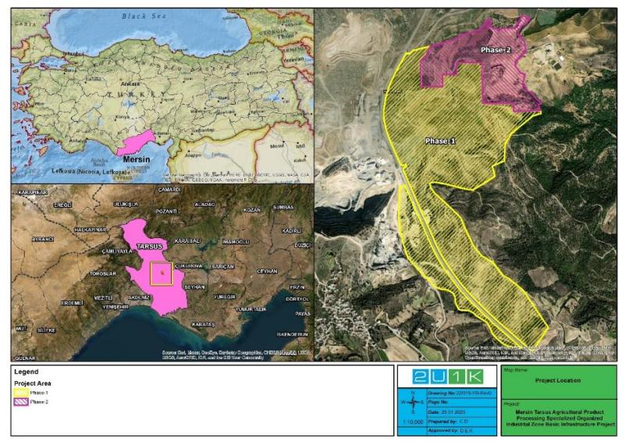
Figure 2-1. The Project Location
In the project zoning plan, the total area is 116.29 hectares, and Phase 1 corresponds to 92.64 hectares, Phase 2 to 23.65 hectares. The layout showing the two phases of the Project is presented in Figure 2-2.
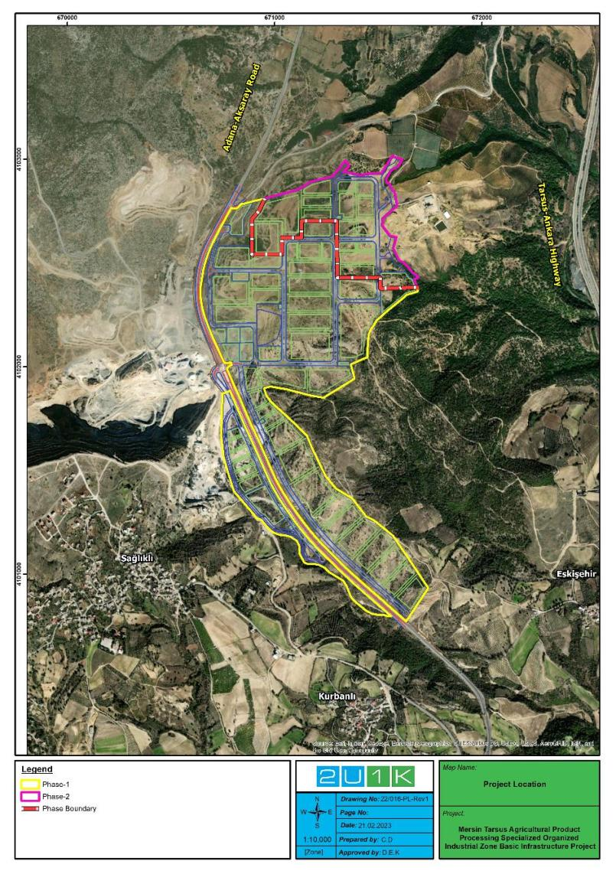
Figure 2-2. The Layout showing the Two Phases of the Project
The Kurbanlı Neighbourhood is located approximately 375 meters south of the Project Area, Sağlıklı Neighbourhood approximately 465 meters west and Eskişehir Neighbourhood 702 meters east of the Project Area (see Figure 2-5). Also, the quarries operate at nearest 30 meters west of the Project Area (see Figure 2-3 and Figure 2-5).
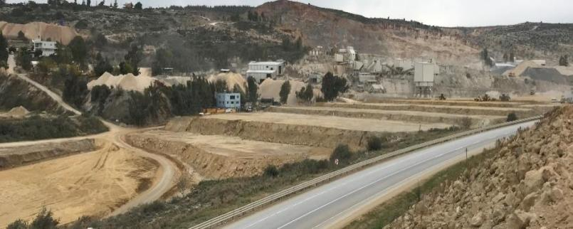
Figure 2-3. The Quarries Adjacent to Project Area
The house identified as closest sensitive receptor the 23 meters southwest of the Project Area can been seen in Figure 2-4.
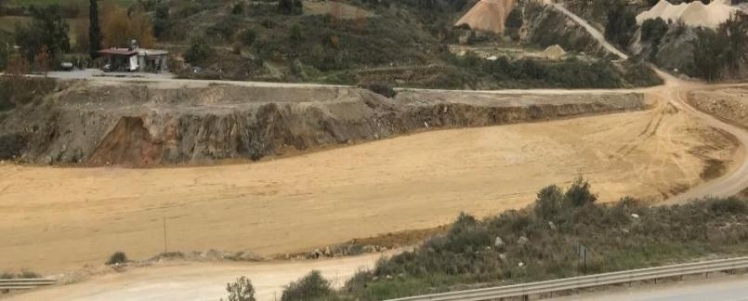
Figure 2-4. The Closest Sensitive Receptor to the Project Area
The map showing the concerned closest settlements and sensitive receptor to the Project Area is in Figure 2-5.
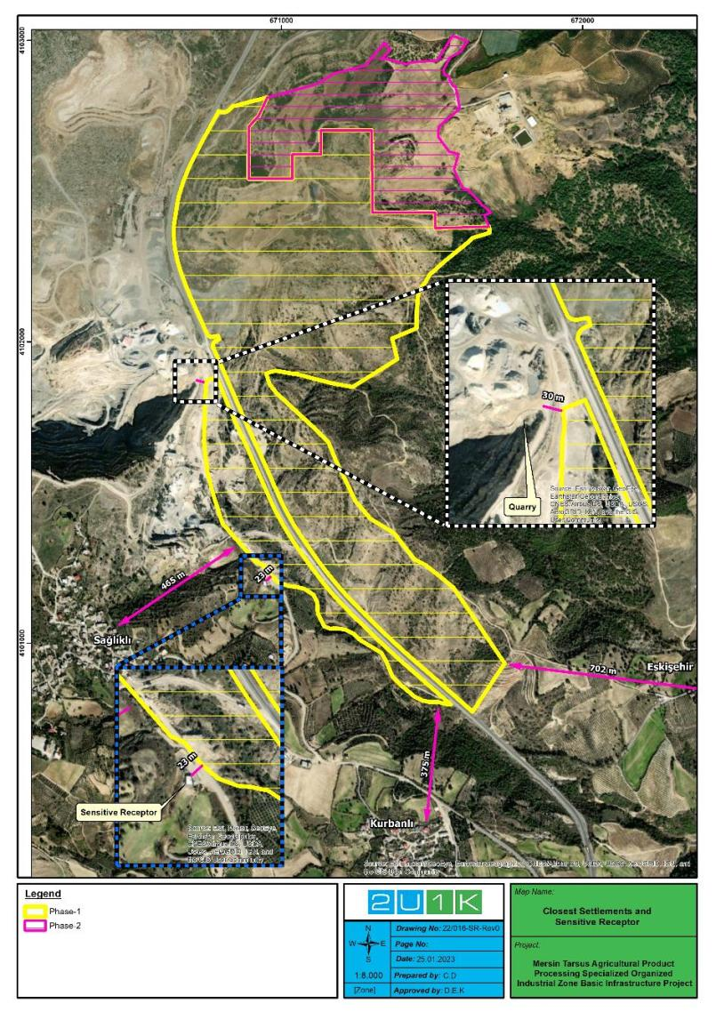
Figure 2-5. The Closest Settlement and Sensitive Receptor to the Project Area
The Project Area is 250 m away from Adana-Aksaray Road (D750) (Old Ankara Road) and connection is provided to Tarsus-Ankara Highway (E90) via the connection located 4.5 km south of the Project Area. There is a connection to Adana-Mersin and Adana-Erdemli Highway from 4.5 km south of the Project Area. In addition to this, the Project Area is 43.4 km from Adana Airport and the related transportation is provided via the Adana-Mersin Highway located in the south of the Project Area by road. The Project Area is 54.5 km from Mersin Port and the related transportation is provided via the Adana-Erdemli Highway located in the south of the Project Area by road. The Project Area is 17.8 km from Tarsus Train Station and the related transportation is provided via the Adana-Aksaray Road, which passes by the Project Area by road.
Firstly, TUIOSB was planned to be establish on an area of 58 hectares in 2018, and then the total area was increased to 116 hectares with the additional area approved by the Ministry of Industry and Technology General Directorate of Industrial Zones with the letter dated March 4, 2022 and numbered 3424023 However, not all of the owners of the private lands could be reached and land acquisition undertaken.. Hence, the project was divided into two phases with Phase 1 expanded to approximately 92 hectares. The remaining area of approximately 24 hectares was defined as Phase 2 of the project. Phase 2 will be realised with the Project Owner's own resources as mentioned before. The area referred to as Phase 1 in the following sections of this report is the final expanded version. The list of 16 parcels comprising 92 hectares is given in Section 6.13 below.
The planning studies of TUIOSB was prepared in accordance with the provisions of the Organized Industrial Zones Law No. 4562, the Zoning Law No. 3194, the Regulation on the Production of Spatial Plans, the 1/100,000 scaled Territorial Plan and Plan Provisions of the Mersin-Adana Planning Zone and the OIZ Implementation Regulation. The Project’s location on the territorial plan is shown in Figure 26.
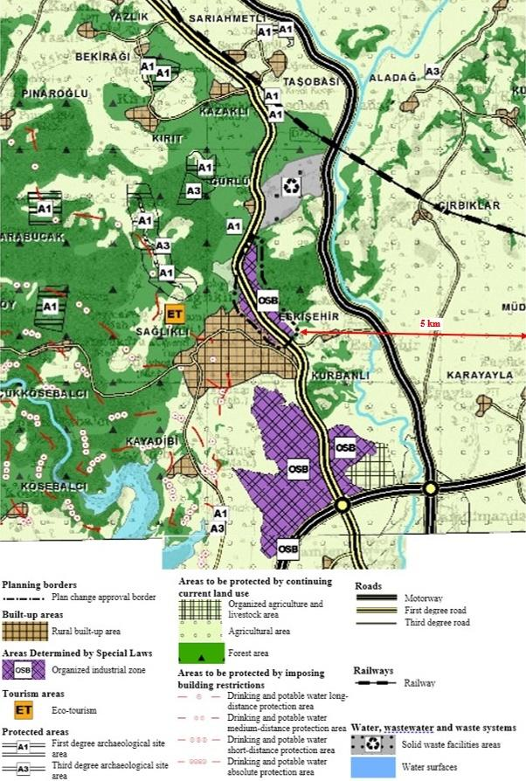
Figure 2-6. 1/100,000 scale territorial plan of Mersin-Adana planning zone showing 5 km around of the Project

Purpose of the Project
Pursuant to the Organized Industrial Zones Law No. 4562 and the Organized Industrial Zones Implementation Regulation, it is obliged to establish infrastructure as an institution within the legal framework in the approved borders of the Project.
The Project covers the infrastructure manufacturing of the newly established Mersin Tarsus Agricultural Product Processing Specialized Organized Industrial Zone. In summary, the Project aims to increase the competitiveness of companies by improving the investment environment, as well as making a positive contribution to the environment in order to create the technical/physical infrastructure of the OIZ and increase its attractiveness for investors.
In this context, the wastewater of the facilities that will operate in the OIZ will be treated at the WWTP to be constructed and given to the receiving environment. The WWTP is not the part of the Project and not within the scope of loan usage. The WWTP will be built in parallel with the construction of the infrastructure lines and is planned to be completed at the same time. The planned Project time schedule is presented in Figure 2-7.
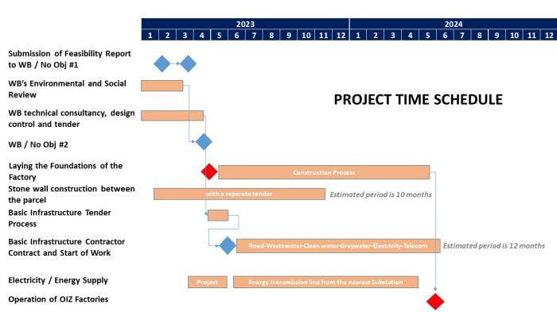
Figure 2-7. The Project Time Schedule

Project Components
Components of infrastructure investments within the scope of the Project are clean (potable) water network, process water (treated wastewater) network, stormwater network, wastewater network, road, telecommunication lines, electric network, diversion canal, ring system to ensure energy continuity in the design of power lines, territorial lighting (including grounding and lighting protection, lighting system on roads) and SCADA systems.
Since the infrastructure will be built from scratch, there will be no decommissioning. All excavations/constructions will be carried out in designated roads which are specified in the zoning plan. The details of the activities are:
Construction of electricity distribution centers
Four (4) of five (5) electricity distribution centers (the remained one (1) planned to be constructed in Phase 2) will be constructed at the Project’s Phase 1, and one ready-made prefabricated structure will be established (see Figure 2-8).
Construction of HV/LV electricity lines
A total of 15.370 km of electricity distribution lines are planned within the scope of the Project. Medium voltage main supply lines will be laid between the four (4) electricity distribution centers, parcels, and territorial lighting. For the laying of the cables, an excavation will be made along the route with a depth of 70 cm and a width of 50 cm, cables will be placed in these trenches and the top will be covered. Ring system will be built to ensure energy continuity in the design of power lines. The Electric Network Layout Plan of the Project is presented in Figure 2-8.
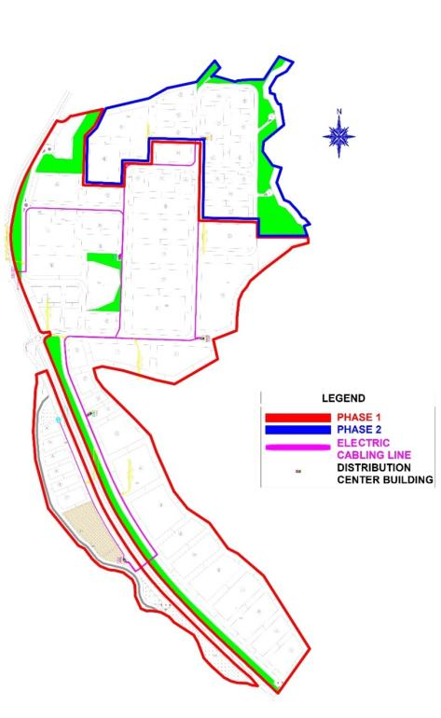
Figure 2-8. The Project Electric Network Layout Plan
Construction of telecommunication lines
One (1) set of Telecom infrastructure will be implemented in Project. Fibre optic lines will be laid through excavations with a depth of 50 cm and a width of 15 cm.
Establishment of territorial lighting
Within the scope of the Project, 110 lighting poles and 143 LED armatures are planned. The pits where the foundation concrete will be poured will be excavated and then anchor rods will be placed in this pit to prepare the foundation for the pole and then the lighting poles will be established. Grounding and lighting protection will be also constructed. The Lighting Network Layout Plan of the Project is as follows.
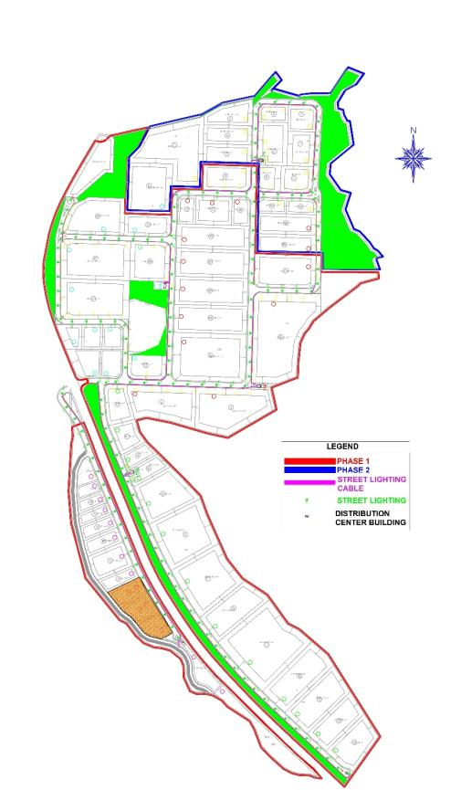
Figure 2-9. The Project Lighting Network Layout Plan
Construction of clean water pipelines/networks
Within the scope of the Project, it is planned to have total of 8.135 km clean water pipeline. Excavations with a depth of approximately 2 m and a width of approximately 1 m will be made along the routes to lay the water pipes. The Clean Water Network Layout Plan of the Project is seen in Figure 2-10.
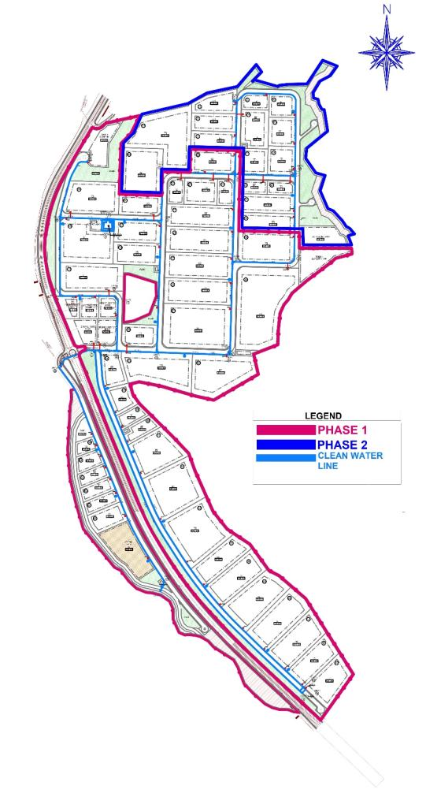
Figure 2-10. The Project Clean Water Network Layout Plan
Construction of process water (treated wastewater) pipelines/networks
It is planned to have total of 9.435 km process water (treated wastewater) pipelines. Excavations with a depth of approximately 2 m and a width of approximately 1 m will be made along the routes to lay the concerned pipes. Collected wastewater from sink and bath that along the concerned line of the OIZ will be directed to the relevant section of the WWTP, which will treat all the wastewater originating from the OIZ. After being treated, treated wastewater will be directed to the reservoir with capacity of 1,500 m³ and is planned to be reused within the OIZ for purposes other than production or potable water. The Process Water (Treated Wastewater) Network Layout Plan is in Figure 2-11.
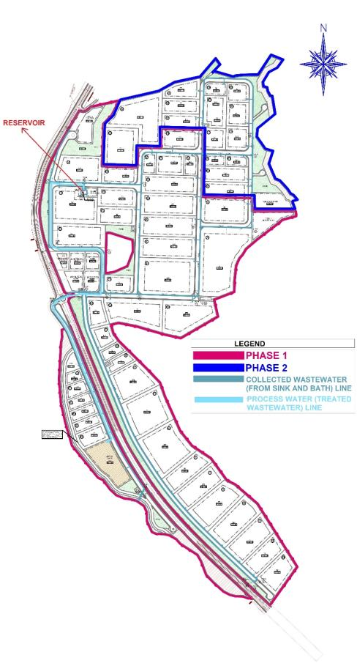
Figure 2-11. The Project Process Water (Treated Wastewater) Network Layout Plan
Construction of stormwater pipelines/networks
There is a total of 5.05 km of stormwater line within the Project’s construction activities. Excavations with a depth of approximately 2.5 m and a width of approximately 2 m will be made along the routes to lay the stormwater pipes. Also, 977.633 m of diversion canal will be built on the Evcisuyu Stream within the Project Area. Stormwater will be collected with the constructed stormwater network and will be diverted to a storage tank with a capacity of 1,800 m³. The collected stormwater will be used for irrigation activities. When the collection tank is full, stormwater will be transferred to the receiving body as Evcisuyu Stream to discharge. It is aimed to drain excessive surface run-off from extreme precipitation or flooding by diverting the collected stormwater along the concerned line to diversion canal and three (3) discharge locations in the Project Area. The Stormwater Network Layout Plan is provided in Figure 2-12.
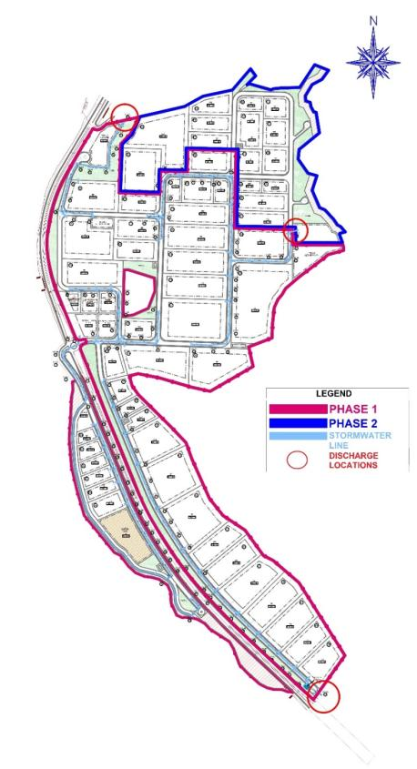
Figure 2-12. The Project Stormwater Network Layout Plan
Construction of wastewater pipelines/networks
According to the Project’s construction planning, 3.998 km wastewater pipeline are planned. Excavations with a depth of approximately 3.5 m and a width of approximately 1.5 m will be made along the routes to lay the sewer pipes. The Wastewater Network Layout Plan of the Project is seen in Figure 2-13.
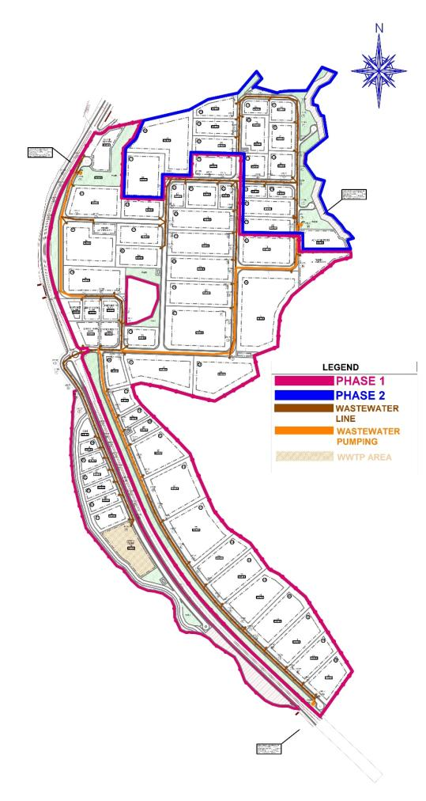
Figure 2-13. The Project Wastewater Network Layout Plan
Construction of road networks
A total of 8.85 km of road is planned to be built within the scope of the Project. The road separating the Project Area will be constructed as an intersection with traffic lights. All road is planned to be covered with bituminous asphalt. The Road Layout Plan of the Project is presented in Figure 2-14.
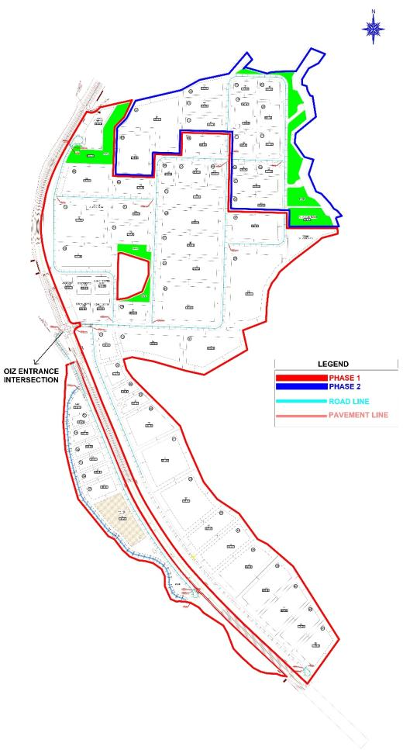
Figure 2-14. The Project Road Layout Plan
In addition to this, SCADA system will be implemented within the scope of the Project.

Permits and Management System of the Project Owner

Management Systems of the Project Owner
The Project Owner (TUIOSB) plans to secure ISO 14001:2015 (Environmental Management System) certificate, ISO 9001:2015 (Quality Management System) certificate, and ISO 45001:2018 (Occupational Health and Safety Management System) certificate.
In addition to these quality systems, a project-specific Environmental and Social Management and Monitoring Plan (ESMMP) is being developed for the construction and operation phases of the Project as a part of this Study. The ESMMP presents the mitigation measures for the expected environmental and social impacts of the Project. Accordingly, the ESMMP identifies the need for the development and implementation of several management plans as part of the Management Systems of the TUIOSB. In this respect, TUIOSB will revise its own Environmental and Operational Management System in line with the requirements stipulated in the ESMMP.

Permits
The Environmental Impact Assessment (EIA) Positive Certificates of the Project were secured by the Ministry of Environment, Urbanization and Climate Change (MoEUCC) (see Appendix-B).
In the scope of national requirements, further permits via the opinions of the relevant official authorities were secured specifically for the Project.
In this context, 2U1K has determined that the following permissions have been secured.
- Non-Agricultural Usage Permits,
- Official letter of Evcisuyu Stream Improvement Project Approval Letter from DSI 6th Regional Directorate,
- Water Allocation Letter from DSI
- Groundwater Exploration Document from DSI and,
- One Year Extension of Groundwater Exploration Document from DSI (valid until 24.11.2023).
All permits, opinion letters above mentioned and obtained within the scope of the Project presented in Appendix-C.

LEGAL FRAMEWORK
This section outlines the regulatory framework for construction and operation phases the Project in line with national and international requirements which are given below.

National Legal Framework
The Environmental Law, which was published in the OG. No. 18132 and dated 11 August 1983 and amended in the OG. dated 29 Mays 2013 (by Law No. 6486), establishes the underlying legal framework of the environmental legislation in Türkiye and is supported by a large number of regulations. Article 10 of the Environmental Law constitutes the main framework of the Environmental Impact Assessment Regulation (EIA Regulation) published in the OG. No. 31907 and dated 29 July 2022.
Environmental Impact Assessment (EIA) encompasses the identification of potential positive and negative effects of the planned projects on the environment, the measures to be taken to avoid adverse effects or minimize them to a degree not harmful to the environment, the determination and assessment of the selected location and technology alternatives, and the efforts to be maintained for the monitoring and control of the implementation of projects.
The purpose of EIA Regulation is to regulate the administrative and technical procedures and principles to be followed throughout the EIA process. This Regulation covers the aspects for which type of projects the EIA Application File, EIA Report and Project Identification Document (PID) will be required and the issues addressed by these files, the administrative and technical procedures and principles to be followed during the EIA process, the monitoring and supervision of the projects covered by EIA during the application, pre-construction, construction, operational and post-operational phases, and the necessary training activities for the effective and widespread implementation of the EIA system in environmental management and for the strengthening of its organizational structure. Annex-1 to the Regulation includes the List of Projects Which EIA Applies to, while Annex-2 includes the List of Projects Which Selection Criteria Apply to. The Ministry of Environment, Urbanization and Climate Change (MoEUCC) has the authority to make “EIA Positive”, “EIA Negative”, “EIA Required” or “EIA Not Required” decisions about the projects subject to this Regulation. However, the Ministry may delegate, when deemed necessary, its authority to render an “EIA Required” or “EIA Not Required” decision to a Governor’s Office in line with the principle of the breadth of authority, with the limits of authority determined.
Pursuant to the Regulation, an EIA Report must be prepared for the projects included in Annex-1, for the projects included in Annex-2 and for which the “EIA Required” decision is rendered, and for the projects that are considered excluded from EIA, but whose new capacity is equal to or above the threshold value given in the list of Annex-1 but in case of any planned capacity increase.

Within the scope of EIA, for the projects included in the Annex-1 list, a public consultation meeting is held to inform the public about the investment and to receive their opinions and suggestions regarding the project with the participation of the project and the institutions and organizations authorized by the MoEUCC on the date determined by the MoEUCC and at the place and time determined by the Governorship. Public consultation meetings are not held for the projects included in the Annex-2 list.
In this context, TUIOSB is considered within the scope of EIA Regulation OG. No. 29186 and dated 25.11.2014 Annex-1 List Article 33-Specialized Organized Industrial Zones, and therefore, the Environmental Impact Assessment (EIA) was prepared, then EIA positive decision has been secured. TUIOSB has EIA Positive Certificate dated 10.05.2018 and decision numbered 5072 (see Appendix-B). After the land acquisition of the existing area was finalized, an additional area was determined due to high demand in the TUIOSB area, and an EIA Positive decision was secured for the additional area dated 11.02.2022 and numbered 6564 (see Appendix-B).
101 hectares included agricultural land, stony, brushy, and raw land were acquired, of which on 92 hectares will be used in Phase 1 of the Project, and the remaining 9 hectares will be included in Phase 2. The acquisition methods (expropriation, purchase or agreement) of the land sold is given in the Table 6 31.
In the current situation, the activities under this Project are included in Annex-1 List Article 31-Specialized Organized Industrial Zones of the Regulation on the Environmental Impact Assessment published in the OG. No. 31907 and dated 29 July 2022 according to the Turkish EIA legislation. As a result, since EIA positive decision has already been secured for the activities under the Project, there is no need for an additional EIA opinion from the concerned authority. However, according to E&S Screening report, Environmental and social risks are determined within the scope of the WB ESSs and ESMF of the Project. The overall environmental and social risk of the subproject were rated in “Moderate” risk group., A public consultation meeting will be held with stakeholders, affected and interested groups and local NGOs after the draft ESMP report is prepared.
Table 3-1 presents the summary of national laws and regulations aiming to minimize the potential environmental and social impacts that may arise during the construction and operation activities of the Project.
Table 3-1. National Environmental and Social Legal and Policy Framework
National Environmental, Legal and Political Framework
General |  | Relevancy/Implications for the Project
Law on Organized Industrial Zones | Law No. 4562; OG. No. 24021 dated 15.04.2000 | As the Project is basic infrastructure Project of OIZ, which includes facilities operating in the same sector group and sub-sectors within this sector group, the provisions of this general law for the OIZ should be followed.
Environmental Impact Assessment |  | Relevancy/Implications for the Project
Environmental Law | Law No: 2872; Date of Ratification: 1983 | It is the general law that regulates the main environmental rules for all activities to be carried out during the lifetime of the Project.
Regulation on Environmental Impact Assessment | OG. No. 31907 dated 29 July, 2022 | It is the regulation that regulates the national environmental impact assessment processes of the Project including the basic infrastructure works of the OIZ. In this context, EIA studies of the OIZ were carried out, EIA Positive Certificates of the OIZ were secured. (see Appendix-B)
Regulation on Environmental Permit and License | OG. No. 29115 dated 10 September 2014 | It is the regulation that regulates the national environmental permit and license processes of the OIZ’s operation phase. As an associated facility WWTP of the OIZ and facilities within the OIZ should follow the provision of the regulation.
Water |  | Relevancy/Implications for the Project
Groundwater Law | Law No: 167; Date of Ratification: 1960 | It is the general law on the use of groundwater. Thus, compliance with this law should be ensured due to the wells used (or planned to be used) within the Project’s AoI.
Regulation on Control of Water Pollution | OG. No. 25687 dated 31 December 2004  (Last amendment on 12 May 2023 with OG. No. 32188) | The Project is subject to the regulation due to activities that may cause water pollution within the Project’s AoI during the lifetime of the Project.
Regulation on the Monitoring of Surface Waters and Groundwater | OG. No. 28910 dated 11 February 2014 | Compliance with this regulation should be ensured due to the wells used (or planned to be used) within the scope of the Project.
Regulation on Water Intended for Human Consumption | OG. No. 25730 dated 17 February 2005 | Compliance with this regulation should be ensured due to the monitoring of the suitability for human consumption of the wells used (or planned to be used) and packaging water within the scope of the Project.
Regulation on Surface Water Quality | OG. No. 28483 dated 30 November 2012  (Last amendment on 1 February 2023 with OG. No. 32091) | Due to the effluent sourced from WWTP of the OIZ (associated facility) within the Project’s AoI, it should comply the provision of the regulation.
Regulation on the Quality and Treatment of Water intended for Potable Water Supply | OG. No. 30823 dated 06 July 2019 | Compliance with this regulation should be ensured due to the controlling of the suitability as potable water supply from the wells used (or planned to be used) and packaging water within the scope of the Project.
Regulation on Protection of Drinking-Potable Water Basins | OG. No. 30224 dated 28 October 2017 | Due to the existence of the wells used (or planned to be used) and the potential impacts of WWTP effluent as an associated facility within the Project’s AoI, the provisions of the regulation should be complied with.
Regulation on Control of Water Losses in Water Supply and Distribution Systems | OG. No. 28994 dated 08 May 2014 | Due to the potential impacts of the wells used (or planned to be used) on groundwater within the Project’s AoI, the provisions of the regulation should be complied with.
Regulation on the Protection of Water Against Agricultural Nitrate Pollution | OG. No. 29779 dated 23 July 2016 | Due to the potential impacts of WWTP effluent as an associated facility within the Project’s AoI, the provisions of the regulation should be complied with.
Regulation on the Control of Pollution caused by Hazardous Materials in and around Water Sources | OG. No. 26005 dated 26 November 2005 | The Project is subject to the regulation due to the impacts on the water and its surroundings that may occur during the Project lifetime activities within the Project’s AoI.
Regulation on Protection of Groundwater Against Pollution and Deterioration | OG. No. 28257 dated 07 April 2012  (Last amendment on 12 May 2023 with OG. No. 32188) | Due to the potential impacts of WWTP’s (associated facility) effluent to the groundwater within the Project’s AoI, the provisions of the regulation should be complied with.
Regulation on the Procedures and Principles to be Followed in Setting the Tariffs for Wastewater Infrastructure and Municipal Solid Waste Disposal Facilities | OG. No. 27742 dated 27 October 2010 | Due to the existence of WWTP’s (associated facility), within the Project’s AoI, the provisions of the regulation should be complied with.
Regulation on Wastewater Collection and Disposal Systems | OG. No. 29940 dated 06 January 2017 | Due to the existence of WWTP’s (associated facility), within the Project’s AoI, the provisions of the regulation should be complied with.
Regulation on Preparation, Implementation and Following up Flood Management Plans | OG. No. 29710 dated 12 May 2016 | The Project as a basic infrastructure project with stormwater management should comply with the provisions of the regulation in order to reduce the flood risk within the Project’s AoI.
Regulation on the Control of Flood and Sedimentation | OG. No. 30763 dated 03 May 2019 | The Project as a basic infrastructure project with stormwater management within the Project’s AoI should comply with the provisions of the regulation.
Air |  | Relevancy/Implications for the Project
Regulation on Air Quality Assessment and Management | OG. No. 26898 dated 06 June 2008 | The Project is subject to this regulation due to activities that may cause the deterioration of the air quality during the lifetime of the Project, especially the construction phase of the Project within the Project’s AoI.
Regulation on Control of Exhaust Gas Emission | OG. No. 30004 dated 11 March 2017 | The Project is subject to the regulation due to activities sourced from vehicles that may cause gas emissions during the lifetime of the Project within the Project’s AoI.
Regulation on Control of Industrial Air Pollution | OG. No. 27277 dated 03 July 2009 | The Project is subject to the regulation due to activities that may cause air pollution during the lifetime of the Project, especially the construction phase of the Project within the Project’s AoI.
Odour |  | Relevancy/Implications for the Project
Regulation on the Control of Odour-Creating Emissions | OG. No. 28712 dated 19 July 2013 | The Project is subject to the regulation due to activities especially to be sourced from WWTP that may cause odour nuisance within the Project’s AoI during the lifetime of the Project.
Soil |  | Relevancy/Implications for the Project
Soil Conservation and Land Use Law and Applicable Regulation | Law No: 5403; OG. No. 25880 dated 03 July 2005  (Last amendment on 5 April 2023 with Amended Law No. 7442) | Due to land use within the scope of the Project, the law and applicable regulation should be complied with.
Regulation on Control of Soil Pollution and Point Source Contaminated Lands | OG. No. 27605 dated 08 June 2010 | The Project is subject to the regulation due to the suspicion of soil pollution, especially the area for which land preparation has not yet been made in the Project Area.
Noise |  | Relevancy/Implications for the Project
Regulation on the Ambient Noise Emission Caused by Equipment Used Outdoors | OG. No. 26392 dated 30 December 2006 | The Project is subject to the regulation due to the noise that may occur during the use of equipment, especially throughout the construction phase within the Project’s AoI.
Regulation on Control of Ambient Noise | OG. No. 32029 dated 30 November 2022 | The Project is subject to the regulation due to the noise that may occur during especially throughout the construction phase within the Project’s AoI.
Energy Efficiency |  | Relevancy/Implications for the Project
Energy Efficiency Law | Law No: 5627, OG. No. 26510 dated 2 May 2007 | It is the regulation that is subject to all activities that will directly or indirectly require energy throughout the lifetime of the Project.
Waste |  | Relevancy/Implications for the Project
Waste Management Regulation | OG. No. 29314 dated 02 April 2015 | It is the main regulation regarding the wastes that will occur as a result of all activities to be carried out throughout the lifetime of the Project.
Regulation on Management of Waste Electrical and Electronic Equipment | OG. No. 32055 dated 26 December 2022 | It is the regulation on electrical and electronic equipment waste as a result of activities to be carried out throughout the lifetime of the Project.
Regulation on the Control of Excavation Soil, Construction and Demolition Wastes | OG. No. 25406 dated 18 March 2004 | It is the regulation that is subject to activities that will cause generation of excavation soil, construction and demolition wastes during especially the construction phase of the Project.
Regulation on Control of Packaging Waste | OG. No. 31523 dated 26 June 2021 | It is the regulation on packaging waste that will occur as a result of activities that can be carried out throughout the lifetime of the Project.
Medical Waste Control Regulation | OG. No. 29959 dated 25 January 2017 | It is the regulation on the generation of medical waste as a result of first aid treatment throughout the lifetime of the Project.
Regulation on the Control of Waste Batteries and Accumulators | OG. No. 25569 dated 31 August 2004 | It is the regulation on battery and accumulator wastes that may occur as a result of office or vehicle use throughout the lifetime of the Project.
Regulation on the Management of Waste Oils | OG. No. 30985 dated 21 December 2019  (Last amendment on 12 January 2023 with OG. No. 32071) | It is the regulation on waste oils that may occur as a result of vehicle/equipment maintenance throughout the lifetime of the Project.
Regulation on Control of Waste Vegetable Oil | OG. No. 29378 dated 06 June 2015 | It is the regulation on waste vegetable oils that may occur as a result of cooking in the cafeteria during especially the operation phase of the Project.
Regulation on the Control of End-of-life Tires | OG. No. 26357 dated 25 November 2006 | It is the regulation on waste oils that may occur as a result of vehicle/equipment maintenance during especially the construction phase of the Project.
Communiqué on the Transport of Wastes by Road | OG. No. 29301 dated 20 March 2015 | It is a communiqué including the provisions regarding the transportation of wastes that will be generated as a result of all activities to be carried out throughout the lifetime of the Project.
Zero Waste Regulation | OG. No. 30829 dated 12 July 2019 | It is the regulation on the zero-waste management system that aims to protect the environment and human health and all resources regarding the wastes that will be generated as a result of all activities to be carried out throughout the lifetime of the Project.
Nature Conservation |  | Relevancy/Implications for the Project
Forestry Law | Law No: 6831; OG. No:9402 dated 08 September 1956  (Last amendment on 5 October 2023 with Amended Law No. 7442) | It is the general law that regulates the main forestry rules for all activities in the Project’s AoI to be carried out during the lifetime of the Project.
National Social Legal and Policy Framework
Community Health and Safety |  | Relevancy/Implications for the Project
Public Health Law | Law No: 1593; OG. No:1489 dated 6 May 1930 | It is the law that expresses the whole of the measures required for a healthy life. It is related to the protection of public health in the project cycle process.
Law on Disabled People | Law No: 5378; OG. No:25868 dated 7 July 2005 | It is the law that will ensure that the necessary arrangements are made to promote and ensure the enjoyment of fundamental rights and freedoms by persons with disabilities, to ensure their full and effective participation in equal conditions and to take measures to prevent disability.
Regulation on Special Educational Services | OG. No: 30471 dated 7 July 2018 | It is a regulation to ensure that individuals with special educational needs benefit from their educational rights.
Regulation on Health and Safety Signs | OG. No. 28762 dated 11 September 2013 | Regulation specifying the minimum requirements for the application of health and safety signs to be used at workplaces.
Highway Traffic Regulations | OG. No 23053 dated 18 July 1997 | It is the regulation that ensures traffic order and safety on motorways.
Labour and Working Conditions |  | Relevancy/Implications for the Project
Occupational Health and Safety Law | Law No: 6331; OG. No:28339 dated 30 June 2012 | It is the main law that regulates the duties, authorities, responsibilities, rights and obligations of employers and employees to ensure occupational health and safety at workplaces and to improve existing health and safety conditions throughout the lifetime of the Project.
Occupational Health and Safety Regulation in Construction Works | OG. No. 28786 dated 5 October 2013 | It is the regulation that regulates the minimum occupational health and safety conditions to be taken in construction works during the construction phase of the Project.
Regulation on Emergency Responses at Workplaces | OG. No. 28681 dated 18 June 2013 | For the lifetime of the Project, it is the regulation that regulates the procedures and principles regarding the preparation of emergency responses plans, prevention, protection, evacuation, firefighting, first aid and similar, as well as the safe management of these situations and the determination of the employees to be assigned in these subjects.
Regulation on Fire Protection of Buildings | OG. No. 26735 dated 19 December 2007 | Throughout the lifetime of the Project, it is the regulation that regulates the procedures and principles of organization, training and supervision, the measures to be taken before and during the fire in order to minimize the fires that may occur during the design, construction, operation, maintenance and use phases of all kinds of structures, buildings, facilities and businesses used, and to extinguish any fire that may occur in any way by minimizing the loss of life and property.
Regulation on Health and Safety Signs | OG. No. 28762 dated 11 September 2013 | It is the regulation that regulates the minimum requirements for the application of health and safety signs to be used at the Project Area throughout the lifetime of the Project.
Regulation on Occupational Health and Safety Risk Assessment | OG. No. 28512 dated 29 December 2012 | It is the regulation that regulates the procedures and principles of the risk assessment to be made in terms of occupational health and safety at the Project Area throughout the lifetime of the Project.
Regulation on Occupational Hygiene Measurement, Test, and Analysis Laboratories | OG. No. 32086 dated 27 January 2023 | Throughout the lifetime of the Project at the Project Area, it is the regulation that regulates the obligations regarding occupational hygiene measurements, tests and analyses related to physical, chemical, and biological factors for personal exposure and working environment, and the procedures and principles regarding authorization, certification and inspection of laboratories that will carry out these operations.
Regulation on the Health and Safety Measures to be Taken in the Workplace Buildings and built on | OG. No. 28710 dated 17 July 2013 | It is the regulation that regulates the minimum health and safety conditions that should be present in the workplace buildings and built on during the operation phase of the Project.
Regulation on Contractors and Sub-contractors | OG. No. 27010 dated 27 September 2008 | It is the regulation that regulates the conditions for the establishment of the main contractor-subcontractor relationship, the notification and registration of the workplace belonging to the subcontractor, and the issues that should be included in the subcontractor agreement during the lifetime of the Project.
Labour Law | Law No. 4857; OG. No. 25134 dated 10 June 2003  (Last amendment on 28 December 2022 with Amended Law No. 7429) | It is the main law that regulates the rights and responsibilities of the workers employed based on the labour contract with the employers, regarding the working conditions and working environment during the lifetime of the Project.
Law on Trade Unions and Collective Bargaining Agreements | Law No. 6356; OG. No. 28460 dated 7 November 2012 | For the lifetime of the Project, it is the law that regulates the procedures and principles related to the establishment, management, functioning, supervision, working and organization of workers’ and employers’ unions and confederations, making collective bargaining agreements to determine mutual economic and social situations and working conditions of workers and employers, to settle disputes by peaceful means, to resort to strikes and lockouts.
Law on Right to Information | Law No. 4982; OG. No. 25269 dated 24 October 2003 | For the lifetime of the Project, it is the law that regulates the principles and procedures for individuals to exercise their right to information in accordance with the principles of equality, impartiality, and openness, which are a requirement of democratic and transparent administration.
Regulation on First Aid | OG. No. 29429 dated 29 July 2015 | For the lifetime of the Project; it is the regulation that regulates the procedures and principles regarding increasing the basic health information of individuals and the society, teaching first aid knowledge and skills to the public, having first aiders according to the number of personnel in all public and private institutions/organizations and reducing the risk of death and disability due to accidents, in this respect, the training of first aid trainers, first aid trainers and first aiders, and the opening, operation and inspection of the centres that will organize these trainings.
Regulation on Health and Safety Requirements for the Use of Work Equipment | OG. No. 28628 dated 25 April 2013 | It is the regulation that regulates the minimum conditions to be complied with in terms of health and safety regarding the use of work equipment in the Project Area throughout the lifetime of the Project.
Regulation on Procedures and Principles of Occupational Health and Safety Training of Employees | OG. No. 28648 dated 15 May 2013 | It is the regulation that regulates the procedures and principles of occupational health and safety training to be given to employees throughout the lifetime of the Project.
Regulation on Protection of Employees from Noise-Related Risks | OG. No. 28721 dated 28 July 2013 | During the lifetime of the Project, it is the regulation that regulates the minimum requirements for the protection of the employees from the health and safety risks that may occur as a result of exposure to noise, especially the risks related to hearing.
Stakeholder Engagement |  | Relevancy/Implications for the Project
Laws on Right to Information | Law No. 4982; OG. No. 25269 dated 24 October 2003 | It is the law the exercise of the right to information by individuals as a requirement of democratic and transparent governance.
Social and Economic Rights and Responsibilities |  | Relevancy/Implications for the Project
Expropriation Law | Law No. 2942; OG. No. 18215 dated 8 November 1983  (Last amendment on 26 November 2022 with Amended Law No.7421) | The purpose of laws on land acquisition/expropriation is to provide the framework for the State's right to exercise eminent domain and acquire property for public use.
Municipal Law | Law No. 5393; OG. No. 25874 dated 13 July 2005  (Last amendment on 5 April 2023 with Amended Law No.7446)
Zoning Law | Law No. 3194; OG. No. 18749 dated 9 May 1985  (Last amendment on 26 November 2022 with Amended Law No.7421)

International Standards
WB’s Environmental and Social Framework (ESF)
In order to increase the efficiency, environmental sustainability and competitiveness of the OIZs, “Türkiye Organized Industrial Zones Project” which is financed by World Bank (WB) has got into operation. Within this main Project, some OIZs are planned to be developed within the defined criteria and it is aimed that these OIZs will set an example for other OIZs. In this context, the implementing agency for the main Project is MoIT, of whose Directorate General for Organized Industrial Zones is responsible for designing the policies to plan and develop OIZs including providing credits for OIZ Managements. For the main Project, an ESMF that is the key document committed by MoIT to comply with national legislation and WB’s ESF has been prepared. The ESMF covers environmental and social management approach that will be implemented during the main Project. According to the ESMF, before preparation of E&S documents, MoIT will prepare Environmental and Social (E&S) Screening Reports or assign a Company to prepare these reports for all sub-projects and submitted them to World Bank Team for review and approval. As a result of the information obtained in the screening studies, a risk analysis will be made as well as the E&S Screening Report.
For the Project, as a result of the risk analysis determined according to the WB ESSs and ESMF of the Project, the overall environmental and social risk of the sub-project were rated in the “Moderate” risk group. Hence, the site-specific ESMP has been prepared for the Project.
The ESF of WB is developed after the review of the Safeguard Policies with the objective of creating better long-term development outcomes. ESSs given in ESF have a more comprehensive approach to environmental and social risk, particularly on social issues. The list of the WB’s ESSs and the safeguard policies they are built on are given in Table 3-2. ESF became effective on October 1, 2018.
Table 3-2. International Legislation (Chronological)
Standard | Building on
ESS1: Assessment and Management of Environmental and Social Risks and Impacts | OP/BP4.01(Environmental Assessment)
ESS2: Labour and Working Conditions | OP/BP4.01 (Environmental Assessment) and EHS Guidelines
ESS3: Resource Efficiency and Pollution Prevention and Management | OP4.09 (Pest Management) and EHS Guidelines
ESS4: Community Health and Safety | OP/BP4.37 (Safety of Dams) and EHS Guidelines
ESS5: Land Acquisition, Restrictions on Land Use and Involuntary Resettlement | OP/BP4.12 (Involuntary Resettlement)
ESS6: Biodiversity Conservation and Sustainable Management of Living Natural Resources | OP/BP4.04 (Natural Habitats) and OP/BP4.36 (Forests)
ESS7: Indigenous Peoples/Sub-Saharan African Historically Underserved Traditional Local Communities | OP/BP4.10 (Indigenous Peoples)
ESS8: Cultural Heritage | OP/BP4.11 (Physical Cultural Resources)
ESS9: Financial Intermediaries | OP/BP 4.01 (Environmental Assessment)
ESS10: Stakeholder Engagement and Information Disclosure | Consolidates WB engagement provisions
The Project and the social and environmental elements in the Area of influence (AoI) of the Project include elements or activities that are related to the scope of ESS1, ESS2, ESS3, ESS4, ESS5, ESS6 and ESS10. The main objectives of these standards within the scope of the Project are presented below.
ESS 1: Assessment and Management of Environmental and Social Risks and Impacts
The main objective of this standard is to identify, evaluate and manage the environment and social risks and impacts of the project in a manner consistent with the ESSs and to adopt a mitigation hierarchy approach to avoid, minimize, mitigate, and compensate the environmental and social risks.
In this context, according to E&S Screening report, Environmental and social risks are determined within the scope of the WB ESSs and ESMF of the Project. The overall environmental and social risk of the subproject were rated in “Moderate” risk group. Sub-project specific Environmental and social assessment studies regarding ESMP will be prepared in line with ESS1. An Ex-Post Social Assessment (EPSA) report will be prepared to examine land acquisition process and impacts retrospectively. As part of the mitigation measures, management plans and procedures on different subjects should be developed. A list of recommended management plans for both phases of the Project are presented below;

Construction Phase;
- Waste Management Plan,
- Soil Management Plan,
- Dust Management Plan,
- Noise Management Plan,
- Transport and Traffic Management Plan,
- Chemical Spill Emergency Management Plan,
- Pollution Prevention Plan,
- Occupational Health and Safety Management Plan,
- Emergency Preparedness and Response Plan,
- Community Health, Safety, and Security Management Plan,
- Labour Management Plan,
- Stakeholder Engagement Plan,
- Contractor Management Plan.
Operation Phase;
- Waste Management Plan,
- Effluent Management Plan,
- Odour Management Plan,
- Sludge Management Plan,
- Sustainable Water Management Plan,
- Transport and Traffic Management Plan,
- Occupational Health and Safety Management Plan,
- Emergency Preparedness and Response Plan,
- Community Health, Safety, and Security Management Plan,
- Labour Management Plan,
- Stakeholder Engagement Plan.
ESS 2: Labour and Working Conditions
The main objective of this standard is to promote safety and health at work, to promote the fair treatment, non-discrimination and equal opportunity of project workers and to protect project workers, including vulnerable workers such as women, persons with disabilities, children (of working age, in accordance with this ESS) and migrant workers, contracted workers and primary supply workers, as appropriate and to prevent the use of all forms of forced labour and child labour.
In this context, during the construction and operation phases, Labour Management Plans (LMP)s will be developed including GM, Code of Conduct (CoC) etc. stipulated by ESS2 for providing guidance on the required mitigations or management implementations such as workers and employees.
ESS 3: Resource Efficiency and Pollution Prevention and Management
The main objective of this standard is to avoid or minimize adverse impacts on human health and the environment by avoiding or minimizing pollution from project activities, to avoid or minimize project-related emissions of short and long-lived climate pollutants to avoid or minimize generation of hazardous and non-hazardous waste to minimize and manage the risks and impacts associated with pesticide use.
In this context, during the construction phase, sub-management plans of the Project including Waste Management Plan, Soil Management Plan, Dust Management Plan, Noise Management Plan, Chemical Spill Emergency Management Plan, Pollution Prevention Plan will be developed as a part of ESMP.
On the other hand, Waste Management Plan, Effluent Management Plan, Odour Management Plan, Sludge Management Plan, and Sustainable Water Management Plan will be developed throughout the operation phase of the Project within the scope of ESMP.
ESS 4: Community Health and Safety
The main objectives of this standard is to anticipate and avoid adverse impacts on the health and safety of project-affected communities during the project life cycle from both routine and non-routine circumstance, to promote quality and safety, and considerations relating to climate change, in the design and construction of infrastructure ,including dams, to avoid or minimize community exposure to project-related traffic and road safety risks, diseases and hazardous materials, to have in place effective measures to address emergency events, to ensure that the safeguarding of personnel and property is carried out in a manner that avoids or minimizes risks to the project-affected communities.
In this context, Community Health, Safety, and Security Management Plan and Transport and Traffic Management Plan will be prepared as a part of ESMP in line with ESS4.
ESS5: Land Acquisition, Restrictions on Land Use, and Involuntary Resettlement
The main objective of this standard is to avoid involuntary resettlement or, when unavoidable, minimize involuntary resettlement by exploring project design alternatives, to avoid forced eviction, to mitigate unavoidable adverse social and economic impacts from land acquisition or restrictions on land use by providing timely compensation for loss of assets at replacement.
A site-specific Ex-Post Social Assessment (EPSA) will be prepared to ensure that land acquisition was completed in accordance with the objectives and principles of ESS5. The scope of this Ex-Post Social Assessment (EPSA) report is the Phase 1 area whose land acquisition process was completed between 2018-2022. Therefore, the land acquisition process and outcomes are examined retrospectively. Details of the land acquisition are provided in the EPSA and information such as parcel, ownership and purchase price are provided in Table 6-31.
ESS6: Biodiversity Conservation and Sustainable Management of Living Natural Resources
The main objective of this standard is to protect and conserve biodiversity and habitats, to apply the mitigation hierarchy and the precautionary approach in the design and implementation of projects that could have an impact on biodiversity, to promote the sustainable management of living natural resources, to support livelihoods of local communities, including, if applicable, Indigenous Peoples, and inclusive economic development, through the adoption of practices that integrate conservation needs and development priorities.
Within the scope of Biodiversity assessments of the Project, management and monitoring of potential impacts, mitigation measures and residual impacts for will be assessed in ESMP.
ESS10: Stakeholder Engagement and Information Disclosure
The main objective of this standard is to establish a systematic approach to stakeholder engagement that will help Borrowers identify stakeholders and build and maintain a constructive relationship with them, in particular project-affected parties, to assess the level of stakeholder interest and support for the project and to enable stakeholders views to be taken into account in project design and environmental and social performance, to promote and provide means for effective and inclusive engagement with project-affected parties throughout the project life cycle on issues that could potentially affect them and to ensure that appropriate project information on environmental and social risks and impacts is disclosed to stakeholders in a timely, understandable, accessible and appropriate manner and forma.
In this context, project specific SEP will be prepared for effective and transparent stakeholder engagement in line with ESS10.
On the other hand, the Project and the social and environmental elements in the AoI of the Project do not include elements or activities that are related to the scope of ESS7 (Indigenous Peoples/Sub-Saharan African Historically Underserved Traditional Local Communities) and ESS8 (Cultural Heritage) The Project is not considered to have an impact on cultural heritage. However, any project involving excavation work may have a cultural heritage element. A Chance Find Procedure (see also in Appendix D) has been prepared and annexed to this ESMP, and construction workers will be trained on this. Furthermore, ESS9 (Financial Intermediaries) is not relevant to this Project as the project does not involve a Financial Intermediary. Furthermore, within the scope of the main Project, the Project needs to be screened through the Exclusion List given in the ESMF of the main Project. According to the exclusion list, the Project should not trigger WB’s Safeguard Policy OP/BP 7.50 – Projects on International Waterways and WB’s Safeguard Policy OP/BP 7.60 – Projects in Disputed Areas. MoIT is responsible for ensuring that the projects financed are located/depending on national waterways only. The OIZ is located in the Eastern Mediterranean Basin, which is not an international waterway. So, the Project does not trigger the WB’s Safeguard Policies OP/BP 7.50 – Projects on International Waterways. Also, the Project does not trigger the WB’s Safeguard Policies OP/BP 7.50 – Projects on International Waterways and OP/BP 7.60 – Projects in Disputed Areas.
WB and IFC’s Guidelines
The World Bank Group’s (WBG) General Environmental, Health and Safety (EHS) Guidelines should be adopted for this Project. ESMP will also consider the IFC Environmental, Health and Safety (EHS) General Guidelines, including WB EHS Guidelines for Water and Sanitation, and where applicable Sectoral Guidelines, particularly, WB EHS Guidelines for Telecommunications, WB EHS Guidelines for Electric Power Transmission and Distribution. For the impact assessment and development of mitigation measures the performance levels and measures that are given in the EHS Guidelines will be taken into consideration in addition to the national legislative requirements. Furthermore, as required by WB’s ESF and ESS1 when the national regulations differ from the levels and measures presented in the EHS Guidelines, the more stringent threshold or standard will be applied to the Project. WB’s Pollution Prevention and Abatement Handbook will also be taken into consideration for the development of mitigation measures.
Türkiye is a signatory to many international agreements, including the:
- Stockholm Convention on Organic Pollutants,
- Convention on Long-range Trans-Boundary Air Pollution (CRLTAP),
- Rotterdam Convention on the Prior Informed Consent Procedure for Certain Hazardous Chemicals and Pesticides in International Trade,
- Basel Convention on the Control of Transboundary Movements of Hazardous Wastes and their Disposal,
- Kyoto Protocol regarding to the United Nations Framework Convention on Climate Change,
- Montreal Protocol on Substances that Deplete the Ozone Layer,
- Barcelona Convention for the Protection of Marine Environment and the Coastal Region of the Mediterranean,
- Vienna Convention for the Protection of the Ozone Layer,
- Protocol on Environmental Protection to the Antarctic Treaty,
- ILO Conventions;
  - ILO Convention on Forced Labour,
  - ILO Convention on Freedom of Association and Protection of the Right to Organize,
  - ILO Convention on Right to Organize and Collective Bargaining,
  - ILO Convention on Equal Remuneration,
  - ILO Convention on Abolition of Forced Labour,
  - ILO Convention on Discrimination (Employment and Occupation),
  - ILO Convention on Minimum Age,
  - ILO Convention on Worst Forms of Child Labour,
- Paris Agreement.

Major Gaps between the Turkish EIA Regulation and World Bank’s ESF
The Turkish EIA procedures are, with some exceptions, in line with the WB’s ESSs. The primary exceptions are in project categorization, scope of environmental and social assessment, and public consultation. In cases where the Turkish legislation differ from the ESSs, the more stringent one will be applied to the project implementation.
Project categorization
According to the World Bank’s Environmental and Social Framework (ESF), projects (including projects involving Fis) are classified into one of four classifications as High Risk, Substantial Risk, Moderate Risk or Low Risk taking into account relevant potential risks and impacts, such as the type, location, sensitivity and scale of the project; the nature and magnitude of the potential E&S risks and impacts; the capacity and commitment of the Borrower; and other areas of risks that may be relevant to the delivery of E&S mitigation measures and outcomes.
There are no clear-cut border values distinguishing the classification of the projects or, unlike the Turkish EIA Regulation (where projects are classified into two categories as Annex I and Annex II projects), any ready lists of project types for classification; rather projects are screened on a case-by-case basis in the environmental and social risk classification of the WB.
Scope of Environmental and Social Assessment
The scope and type of E&S assessment required as per ESS1 varies proportionate to the potential risks and impacts of the project and, in an integrated way, all relevant direct, indirect and cumulative environmental and social risks and impacts throughout the project life cycle, as per the ESSs 2-10, are assessed. Comparison of the indicative outline required by the WB for Environmental and Social Impact Assessment (ESIA) with the general format of a Turkish EIA indicates a number of key differences as follows:
- the absence of an executive summary and information on the legal and institutional framework in the Turkish EIA (Technical level of information in the non-technical summary required in the Turkish EIA may not meet WB requirements);
- possible discrepancies with regard to the level at which the project’s environmental and social impacts, its alternatives, and mitigation measures for the impacts are discussed (such as lack of discussions on residual impacts, limited discussion on indirect and induced impacts, limited assessment regarding use of resources and Greenhouse Gas (GHG) emissions under Turkish EIA);
- social impact assessment is not completely integrated to the Turkish EIA and this results in the absence of proper social baseline, identification and assessment of the project induced social impacts including impacts on disadvantaged or vulnerable and gender related issues,
- there are limited requirements to cover risks and impacts related to (i) community health and safety; (ii) occupational health and safety; and (iii) labour and working conditions;
- limited or no requirement to cover cumulative impacts with other projects in the Turkish EIA; and
- limited emphasis on the associated facility in the Turkish EIA.
Nevertheless, the project specific format for Turkish EIA may require more details under some of these headings than indicated in the general format. Consequently, a case-by-case review of the Turkish EIAs is necessary to identify gaps with WB requirements.
The gaps between the WB Environmental Policy and the National Legislation are presented in Table 3-3.
Table 3-3. Comparison between the World Bank ESSs and the National Legislation
WB Environmental and Social Standards (ESS) | Gaps | ESF Documents/study to fill the Gaps
ESS1: Assessment and Management of Environmental and Social Risks and Impacts | The major gaps between national EIA and ESS1 are as follows:  - Social impact assessment is not completely integrated to the Turkish EIA and this results in the absence of proper social baseline, identification and assessment of the project induced social impacts including impacts on disadvantaged or vulnerable and gender related issues,  - The absence of an executive summary and information on the legal and institutional framework in the Turkish EIA (Technical level of information in the non-technical summary required in the Turkish EIA may not meet WB requirements);  - Limited or no requirement to cover cumulative impacts with other projects in the Turkish EIA; and  - Limited emphasis on the associated facilities.  - Limited information regarding sub-management plans such as Water Quality Management Plan, Air Quality Management Plan, Noise Management Plan, Hazardous Waste Management Plan, Community Health and Safety Management Plan etc. | Sub-project specific Environmental and social assessment studies regarding ESIA or ESMP will be prepared in line with ESS1. In this respect, as it is defined in ToC provided in Annex 2 of Environmental and Social Management Framework (ESMF) that was approved by WB for Türkiye OIZs Project, potential social impacts of the sub-projects will be the part of the assessment.  The environmental and social assessment will include impacts of the associated facilities and potential cumulative impacts.  Depending on the level of the impacts and proposed mitigation measures together with residual impact analysis, sub-management plans will be annexed to the ESIA/ESMP.
ESS2: Labour and Working Conditions | In general, Turkish national laws and regulations regarding labour and working conditions satisfies ESS2 requirements. Worker grievance mechanism is the main gap between national legislative requirement and ESS2. Per the Turkish national legislation on labour and working conditions, there is no specific requirement related to grievance mechanism that allow workers to communicate their complaints to the employer. | Labour Management Plan (LMP) and Labour Management Plans are developed as a part of ESF documents. LMP will also provide guidance on the required mitigations or management implementations such as workers.  GM, code of conduct etc. stipulated by ESS2 and relevant WB EHS guidelines.
ESS3: Resource Efficiency and Pollution Prevention and Management | Most of the relevant national legislations regarding laws and regulations are in line with EU directives. There is no major gap between ESS3 and legislative requirements. Local EIA does not provide detailed management perspective on potential impacts, mitigation measures and residual impacts and monitoring. In other words, sub-management plans are not specifically defined in local EIA process.  Additionally, the specific studies regarding resource use and pollution prevention such as Water Source Vulnerability Analysis (WSVA), Greenhouse Gas (GHG) estimations etc. are not specifically included in local EIA Process. | Sub-management plans will be developed as a part of ESIA/ESMP. These management plans also provide requirement stipulated in relevant WB EHS Guidelines.  In case a requirement, additional studies (i.e. WSVA, GHG etc.) will be performed in the scope of ESIA/ESMP.
ESS4: Community Health and Safety | In general, there is no gap in terms of policy level. On the other hand, project level management of specific risks such as labour influx, sexual exploitation and abuse and sexual harassment are the key gaps in terms of ESS4. | The plans such as Traffic Management Plan and Community Health and Safety Plan etc. will be prepared as a part of ESIA/ESMP.
ESS5: Land Acquisition, Restrictions on Land Use and Involuntary Resettlement | Turkish legislation on land acquisition mainly corresponds to requirements stipulated by ESS5. However, some differences include; preparation of a Resettlement Plan (RP), compensation at replacement costs, continuous consultation during RP implementation, impact assessment on informal land users, vulnerable groups and land based livelihood restoration are the major gaps in terms of ESS5 requirement. | The specific Resettlement Framework (RF) for the overall project is prepared to provide a guidance to assess any risk of resettlement and to prepare sub-project specific RP in case a requirement. In case land acquisition required for the project took place within five years before the project, an Ex-POst Social Audit will be conducted to assess whether the process, compensation and outcomes are compliant with ESS5.
ESS6: Biodiversity Conservation and Sustainable Management of Living Natural Resources | In general, there is no gap in terms of policy level. On the other hand, in some cases, level of the considerations of not legally protected sensitive ecological areas such as Key Biodiversity Areas in local EIA Process do not sustain the requirements stipulated by ESS6. In general, there is a lack of details on the requirements for the management and monitoring of potential impacts, the implementation of mitigation measures, and the assessment of residual impacts. | Depending on the location of the sub-project and sub-project level of the impact, Biodiversity Management Plans can be annexed to the ESIA/ESMP.
ESS10: Stakeholder Engagement and Information Disclosure | Effective and transparent stakeholder engagement is the main gap in terms of ESS10 requirement. Within this scope, a Stakeholder Engagement Plan required to identify the different stakeholders (project-affected parties and other interested parties including disadvantaged or vulnerable). Stakeholder engagement should be a continuous process. An improved grievance mechanism would help bridge the gap between EIA legislation and ESS10. | Project specific SEP is prepared and included in ESF documents. The SEP will be implemented sub-project level. A GM for the public will be developed as part of the SEP-

Public Consultation and Disclosure
Pursuant to ESS 1, stakeholder engagement is an integral part of E&S assessment and should be conducted in accordance with ESS 10. Within this scope, the Borrowers should identify the different stakeholders (project-affected parties and other interested parties including disadvantaged or vulnerable) and develop and implement a Stakeholder Engagement Plan (SEP), in consultation with the Bank, proportionate to the nature and scale of the project and its potential risks and impacts. SEP should describe the timing and methods of engagement with stakeholders throughout the life cycle of the project, and also describe the range and timing of information to be communicated to the parties as well as type of information to be sought from them. The Borrower should disclose project information to allow stakeholders to understand the risks and impacts of the project, and potential opportunities, in a timeframe that enables meaningful consultations with the stakeholders on project design.
The Turkish EIA Regulation requires “pre-scoping” public consultation only for projects requiring an EIA, and only requires announcement of the environmental assessment together with the justification. However, ESS 10 does not specify an exact number and method of public consultation and information disclosure but instead the standard requires a continuous stakeholder engagement approach through the life cycle of the project that will be decided proportionate to the nature, scale, and impact magnitude of the Project
Under ESS10, the Borrower is expected to respond to concerns and grievances raised by project-affected parties regarding the environmental and social performance of the project. To fulfil this requirement, the Borrower should propose and implement a grievance mechanism that receives and facilitates the resolution of such concerns and grievances. The mechanism should be accessible, inclusive, and proportionate to the potential risks and impacts of the project.
To ensure an effective grievance mechanism, it should adhere to the following principles:
- Accessibility and inclusiveness: The grievance mechanism should be accessible to all project-affected parties, irrespective of their backgrounds or circumstances. It should be designed in a manner that considers cultural appropriateness and provides no-cost access to all stakeholders. It should also not prevent access to judicial or administrative remedies.
- Transparency and timeliness: The grievance mechanism should address concerns promptly and effectively. It should operate in a transparent manner and provide culturally appropriate and readily accessible information to all project-affected parties. The Borrower should inform the community about the grievance process during its engagement activities and make a record of the responses to all grievances publicly available.

- Discretion, objectivity, and sensitivity: The handling of grievances should be done in a culturally appropriate manner, ensuring discretion, objectivity, and sensitivity towards the needs and concerns of the project-affected parties. The mechanism should also allow for anonymous complaints to be raised and addressed.
- Design and scale: The design and scale of the grievance mechanism should be project-specific, taking into account factors such as the project context, scale, and scope, the number of project beneficiaries, capacity, cultural attitudes toward lodging grievances, available resources, and technological constraints. Existing formal or informal mechanisms identified during the environmental and social assessment may be utilized, supplemented as needed with project-specific arrangements.
- Establishing the mechanism: The grievance mechanism should be established as early as possible in project development and supported by appropriate human and financial resources. It should specify the means by which grievances can be submitted and received, assign responsibility for processing grievances, establish timelines for processing complaints, and include a process for registering and monitoring grievances. Larger or more complex projects may require multiple locations, means, and methods for receiving, processing, and monitoring grievances.
- Accessibility and advertising: The grievance procedures should be simple and easy to understand, publicly advertised through accessible and appropriate channels such as newspapers, radio broadcasts, or other mediums. The expected timelines for acknowledgment, response, and resolution should be indicated. It is essential to ensure accessibility for disadvantaged or vulnerable individuals or groups, and all grievances received and responses provided should be documented.
- Balanced actions and resolution: Actions taken on grievances or suggestions should be informed and balanced. The time frame for grievance resolution depends on factors such as urgency, research, investigation, consultation, funding, and capacity. The grievance mechanism should provide indicative time frames for acknowledgment, interim responses, and, where possible, final resolution. Grievances that require coordination among multiple departments/agencies or detailed investigation may take longer, and this should be communicated to the concerned parties when acknowledging receipt of the grievances.
- Confidentiality and non-retaliation: Grievance mechanisms should ensure confidentiality, impartiality, objectivity, and timely handling of grievances. In countries where anonymous grievances are not permitted, the Borrower may consider engaging third-party entities to facilitate their submission. Users of the grievance mechanism should not be subject to retaliation, abuse, or any kind of discrimination.

ENVIRONMENTAL BASELINE OF THE PROJECT
Within the scope of ESMP studies, 2U1K made a site visit the Project Area on the dates of 20 and 21 December 2022. In this context, the baseline findings are detailed in the following subsections.

Project Location and Topography
The Project Area is in Mersin Province, Tarsus District, Kurbanlı and Eskişehir Neighbourhoods, Evci Creek, Kum Gediği Local. Mersin province, in which the Project Area is located, is surrounded by Adana in the east, Antalya in the west, Konya, Karaman and Niğde in the north and the Mediterranean Sea in the south. The area of the province is 15,853 km² and 49.5 % of its land is forested. The province has a 321 km coastline on the Mediterranean coast.
The north of the province is surrounded by the middle Taurus Mountains, Bolkar Mountain. Medetsiz Hill constitutes the highest hill of the province. Tarsus and Mersin which are in Çukurova region have the widest plains of the province. To the west, the plains get narrower except for Silifke and Anamur.
A significant part of Mersin Province’s surface area consists of steep, very steep, and steeply inclined lands. Forest and heather cover are 59.5% (960,163 hectares) of the provincial area.
Meadows and pastures have an area of 137,631 hectares and the proportion of the area covered in the province is 8.5%. Since forest, heath and agricultural lands can also be used for grazing, animal husbandry is quite advanced.
The land type of the parcels in the area where the OIZ will be established has been determined as “Dry Marginal Agricultural Land“ by the Mersin Soil Conservation Board.
With the approval of Mersin Province Governor’s Office dated 08.08.2017 and numbered 50458482/99/01-570, the non-agricultural use of the parcels was considered as Dry Marginal Agricultural Land. In addition to this, within the scope of Article 13 of the Soil Conservation and Land Use Law, it has been accepted by the commission that a part of the area added later to the Project Area will be used for non-agricultural purposes, provided that the soil conservation project is complied with. Non-Agricultural Use has been approved with the letter dated 29.03.2021 and numbered 988835 (see Appendix-C).
The characteristics of the lands to be used as the project area are mainly formed of “Stones and Bushes”. In the Observational Geological Investigation Report prepared for the project area, the topographic slope in the project area is between 10-25 %, the observation area was evaluated in a category in terms of suitability for settlement as a result of the observations made and the information obtained from the research pits. (Burced Engineering Service Co.Ltd.,The EIA Report of the OIZ, 2022)

Land Use
According to the list in EPSA, it is stated as 57 shareholders. The majority of the Project Area consists of stony bushes and the agricultural lands are marginal dry farming. “Non-Agricultural Use Permit”s for the agricultural areas in the Project Area that was secured by the concerned authorities are given in Appendix-C.
The location of the OIZ Area was approved by the Site Selection Commission formed by the General Directorate of Industrial Zones of the MoIT. In this context, ground levelling works of the Project has been almost completed in the Project Area. It has been determined that the lands purchased from private individuals or the treasury or expropriated were previously uninhabited and not used for agriculture. The conditions of the lands before and after expropriation are presented in Figure 4-1, Figure 4-2 and Figure 4-3.
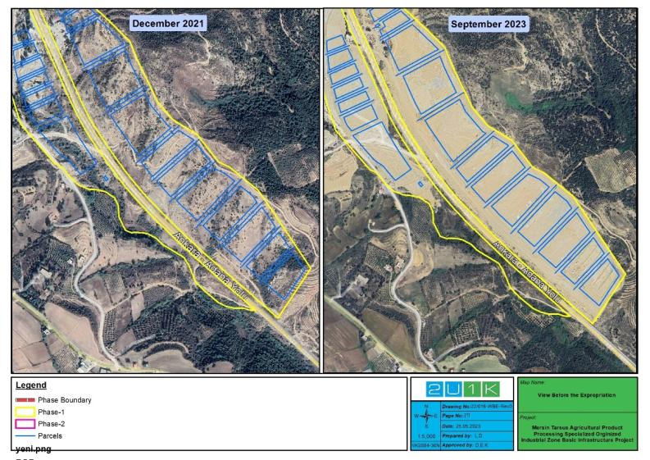
Figure 4-1. Before and After Expropriation (1)

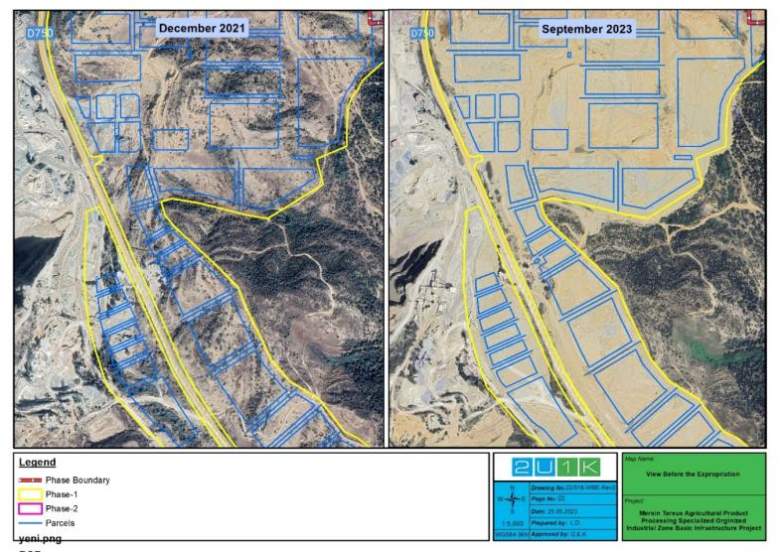
Figure 4-2. Before and After Expropriation (2)

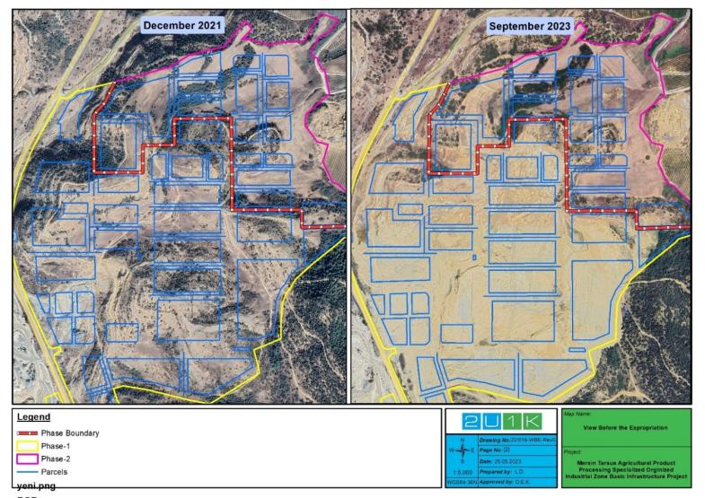
Figure 4-3. Before and After Expropriation (2)
The 101 hectares acquired land included agricultural land, stony, brushy, and raw land. The acquisition methods (expropriation, purchase or agreement) of the land sold is given in the Table 6 31. In the land acquisition process of the project, purchasing, expropriation and urgent expropriation methods were used together.
Urgent expropriation is the process through which a government or authorized public authority seizes private property rights during extraordinary circumstances for public benefit.
Urgent expropriation is primarily employed in response to critical situations requiring rapid and effective interventions. These circumstances include, but are not limited to, natural disasters (e.g., earthquakes, floods), public health crises (e.g., pandemics), terrorist attacks, war, or threats to national security.
The following conditions provide the basis for implementing urgent expropriation:
- Extraordinary Situations: Urgent expropriation is justified when faced with extraordinary situations, such as natural disasters, calamities, pandemics, terrorist attacks, or any other emergencies that necessitate urgent action.

- Public Safety: In the interest of safeguarding national security or public order, the government may exercise urgent expropriation of specific strategic areas, facilities, or assets.
- Public Health: To control disease outbreaks or prevent their spread, urgent expropriation might be employed concerning healthcare institutions, materials, or equipment.
- Reconstruction and Development: In the context of urban revitalization projects, infrastructure development initiatives, or similar cases, expropriation may be necessary to convert lands and properties into public use.
- War and National Security: During wartime or when facing serious threats to national security, urgent expropriation of assets with strategic importance may be executed.
Urgent expropriation, despite its urgency, requires careful consideration of the social implications on affected individuals and communities. By adhering to legal frameworks, conducting comprehensive social impact assessments, and implementing appropriate social management strategies, urgent expropriation can be carried out with respect for human rights, social justice, and community well-being.
There were a total of 57 shareholders of the lands. While land acquisition was completed for 35 shareholders through agreement, 22 shareholders could not be reached, and expropriation was resorted to. The other two parcels (105/1, 105/2) belonged to a single person and both parcels were acquired by agreement. Before the acquisition, 3 parcels belonged to individuals and 18 parcels belonged to the treasury.
Public land is mentioned. There was one old building on the Project area. The building belongs to the National Real Estate Agency and a payment for the building was made to the National Real Estate. A family (an elderly mother and an adult son) lived in the old building. The building was built between 1981-1984 by the deceased husband of the elderly woman. However, this is not documented. In the past years, the family was making an adequate pay to the state called adequate pay because they were the occupiers of the public land. Documents regarding these payments are from 2014 and earlier. However, the family representative (son of the old woman) declared that they made this payment in the following years also. They have another house on the neighboring plot which they own formally. This house was neglected. The governor's office helped the elderly woman to move to her own house by repairing this neglected house on their own plot and giving some household items to the old woman (for payments documents see Appendix G and for the photos of the family's renovated house see Appendix H). The informal house owner has also declared in writing that she gave up her rights in the affected house affected by the Project in exchange for the renovation of her own house.
No complaints were received from the informal users after the renovation.
Administrative Courts in the place where the immovable is located are authorized to evaluate objections to expropriation. There was no application to the Administrative Court among the owners of private lands and users of public lands. Two of the 3 affected private lands were purchased by agreement. A large number of shares of the third land were also purchased by agreement. The GM structures established under the project was not in place when the land acquisition took place. The channels through which objections could be made during the land acquisition process were the Governor's Office and the OIZ. There are no complaints recorded in these units.
An Ex-Post study on land acquisition specific to the Project was conducted. See that document for details on land acquisition.
According to studies conducted before EPSA, there were two (2) nomad families using the Project Area and they were staying there in winter, as it was empty and unused land. When the land was transferred to the OIZ, the village headman showed the two (2) nomad families another place and currently they are staying there. Within the scope of EPSA studies, no physical or economic displacement was detected for the families in question.

Geology

General Geology
When the general geological structure of Mersin province is examined, 1/100,000 – 1/1,250,000 scaled maps published by the MTA and regional geological studies that have been done before were used. In addition, the geology of the study area and its surroundings were tried to be clarified by drilling and making detailed observational and surveys on site (Şen Engineering, The Geological-Geotechnical Survey Report of the Project Area, 2018).
Assemblies classified by Özgül (1971) in Mersin region are classified as Basement Rocks and assemblies after Tertiary are classified as Seal Rocks.
Basement Rocks are as follows.
Alanya Assembly: Upper Permian and aged Bağlıca formation, Upper Permian aged Pınarkır formation and Lower Triassic Sivastıyayla formation are found in this association, which is composed of metamorphic rocks.
Antalya Assembly: Cambro-ordovician aged Çakmak formation, Lower Devonian aged Narlıca formation, Upper Permian Bıçkıcı formation, Lower Triassic aged Yöreme formation, Middle-Upper Triassic aged Çamlıca formation and Maestrichtian aged Karaçukur formation exist in a complex assembly containing Early Paleozoic and Mesozoic sediments.
Geyikdağı Assembly: There are the Lower Cambrian aged Hacıishaklı formation, the Cambrian aged Ovacıkışıklı formation, the Cambro-Ordovician aged Ovacık formation, the Lower Silurian aged Eğripınar formation and Hırmanlıanlı formation, Upper Silurian-Lower Devonian aged Karayar formation, Lower Devonian aged Sığırcık formation, Middle Devonian aged Büyükeceli formation, Upper Devonian aged Akdere formation, Lower Carboniferous aged Korucuk formation, Middle-Upper Carboniferous aged İmamuşagı formation, Upper Permian aged Kırtıldağı formation, Lower Triassic Kargıcak formation, Middle-Upper Triassic aged Kusyuvasıtepe formation, Lower-Middle Cambrian aged Sipahili formation, Lower Palaeozoic aged Badabıl group, Upper Triassic aged Murtçukuru formation, Lower Jura aged Yanışlı formation, Jura-Lower Cretaceous aged Tokmar formation and Upper Cretaceous aged Hayvandağı formation within the assembly which is considered to be relatively autochthonous or paraautochthonous, consisting of non-metamorphic sedimentary assemblies.
Aladağ Assembly: There are Middle-Upper Devonian aged Tozlucayayla formation, Carboniferous aged Harzadındağı formation, Upper Carboniferous-Permian aged Dumlugöze formation, Lower-Middle Triassic aged Dişdöken formation, Upper Triassic aged Gevne formation, Lower-Middle Jura aged Boğuntu formation, Jura-Cretaceous aged Çakozdağı formation and Upper Cretaceous aged Akçaldağı formation within an association containing shelf type carbonate and siliceous clastic sedimentary rocks in the assembly containing shelf type carbonate and siliceous clastic sedimentary rocks.
Bozkır Assembly: The assembly, which is an olistostromal complex composed of various rock assemblies, includes Güneydağı ophiolite, Campanian aged Çiftehan formation and Maestrichtian aged Blocky Flysch.
Seal Rocks: It is divided into two as Paleo-autochthonous Rocks and Neo-autochthonous Rocks. Belbağ and Sarıtaş formations belonging to the Early Tertiary are classified as Paleo-autochthonous, Oligocene-Pliocene aged rocks as Neo-autochthonous rocks (Ulu, 1998).
The 1/1,250,000 scale geotectonic map of the assemblies and rocks described above is given below.
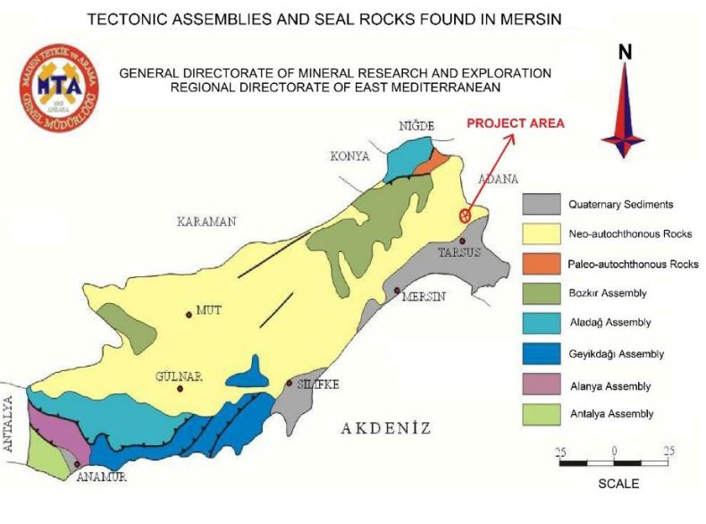
Figure 4-4. The Map of the Tectonic Assemblies and Seal Rocks Found in Mersin
According to the Geological-Geotechnical Survey Report of the Project Area, 22 (twenty-two) foundation drillings of 330 m in total, each of which is 15 m were opened. In the observational and drilling studies carried out in the study area; sand, sandstone and occasionally marl assemblies were observed as the main assembly. The observed assemblies are of Upper Miocene-Pliocene age, is defined within the Handere Formation in the Neo-autochthonous Rocks assembly and shows a creamy yellow and white coloured form.

Tectonics
The Mersin region is geographically located in the Middle Taurus Mountains, which is between two main strike-slip faults such as the right-handed Kırkkavak Fault in the west and the left-handed Ecemiş Fault in the east. Since the Central Taurus is between these two faults, it moves more south than the West-East Taurus (Şen Engineering, The Geological-Geotechnical Survey Report of the Project Area, 2018).
More research has been done on the Middle Taurus because it shows the characteristics of the Taurus belt better. As a result of these studies, it was found that the Central Taurus Mountains have many tectono-stratigraphic rock assemblies due to their stratigraphic, structural, and metamorphic features (Blumenthal, 1947; Özgül, 1971).
These rock assemblies faulted on top of each other during the Senonian and Lutetian with horizontal movements giving the complex nappe structure of the Middle Taurus Mountains. These tectono-stratigraphic assemblies; Geyikdağı, Aladağ, Bolkar Mountain, Bozkır, Antalya and Alanya assemblies.
As a result of the closure of Tethys during the Upper Cretaceous, ophiolite thrusts overtook these assemblies throughout the Taurus Mountains. The Güneydağı Ophiolite in the study area was come with overlay the aged assemblies from the Upper Cretaceous.
The other assemblies, with the Geyikdağı Assembly at the bottom, overlapped each other.
According to the Landsat TM 432 [RGB] Band Composite and Lineament map of Mersin and its surroundings, the general strike of the fractures and faults is NE-SW, but the NNE-SSW, NNW-SSE directional faults are common in the study area. The general strike of the faults is parallel to the thrust directions developed in all Taurus Mountains.
Depending on the compressional tectonics of the Taurus Mountains, NE-SW direction anticlines and synclines have developed in the formations. These folding were mapped in the Bolkardağ Mountains, around Büyükeceli. No folding is observed in the Tertiary units in the study area.
The Ecemiş Fault Corridor, which is also observed around Gülek in the study area, has a width of 5 km in some regions. It is filled with Tertiary sediments. Most of the researchers stated that the Ecemiş Fault Zone is a left-sided strike-slip fault.
The distance of the study area, located within the borders of Mersin Province, Tarsus District, Kurbanlı Neighbourhood, to the probable fault is approximately 15 km.

Soil and Soil Quality
Currently, it was observed that ground levelling activities of the Project have been completed except for lot 105: parcel no. 1 and 2 of the Project Area. But, during the site visit of 2U1K on the dates of 20 and 21 December 2022, as the title deed processes of the concerned area belonging to the Project have not been completed yet, structures belonging to the gas station that was previously operating in this area were observed (see Figure 45). It has been learned that the repair and maintenance shop operated by the previous owner of this area was being used as a fuel filling location. As spot fuel and oil spills were observed visually at relevant area, the TUIOSB will take soil samples in the concerned area to be able to assess possible soil contamination in accordance with Regulation on Control of Soil Pollution and Point Source Contaminated Lands. If soil contamination is detected at the area, ground levelling works within the area will only be started by the contactor after the rehabilitation of the area in line with the relevant regulation.

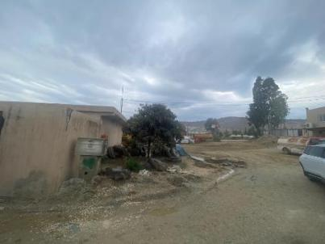 | 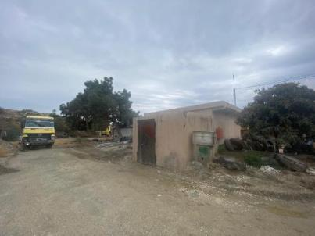
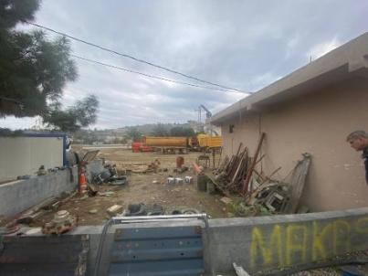 | 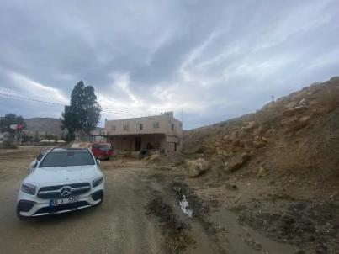
Figure 4-5. Structures of the Previously Operating Gas Station in Lot 105: Parcel no. 1 and 2 of the Project Area
In terms of soil quality, in addition to the presence of inert wastes from the buildings to be demolished in this relevant area, there are other non-hazardous and hazardous wastes left in the area that should be disposed in accordance with the national legislation.
On the other hand, project representatives stated that the stripped topsoil was carried to the section of the Project Area allocated for afforestation (see Figure 4-6).
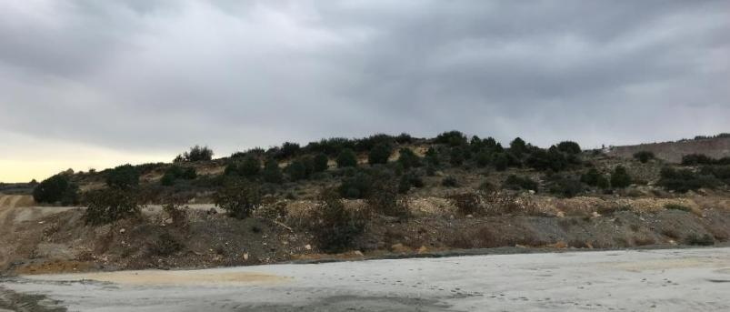
Figure 4-6. Stripped Topsoil in the Project Area

Hydrogeology
The coastline of Mersin region is hot and dry in summers and warm and rainy in winters. As it is moved from the coastline to the northern parts, there are temperature differences up to 10-15 °C. Especially in winter, as it is moved away from the seacoast, this temperature change reaches to high values (Şen Engineering, The Geological-Geotechnical Survey Report of the Project Area, 2018).
Meteorologically, the fog event, which will reduce the horizontal visibility in all directions to 1,000 meters or less, is a rare event in the province. Snowfall and frost formation are the least common event in the coastal areas of Mersin province.
Microclimatic zones, which are defined as meteorological differences, are seen in many parts of the city due to the topographic structure of the province. In summer and winter months, the temperature and humidity difference between the coastal part and the interior and highland part is palpable. Temperature and humidity are lower in the highland areas.
The most important sources feeding underground and surface water resources in Mersin are rain and snow waters.
Within the baseline hydrogeology, information on 10 wells surrounding in the AoI of the Project was obtained from DSI 6th Regional Directorate. The water table contour of the concerned wells in the AoI of the Project is visualised in Figure 4-8.

Noise
Currently, ground levelling activities of the Project have been almost completed except for lot 105: parcel no. 1 and 2 of the Project Area. Considering that the remaining works include minor excavation and piping works and due to the presence of quarries adjacent to the Project Area, which are mainly noise sources, no noise baseline measurements are not required.

Air Quality
As mentioned in the chapter on noise, since the ground levelling works of the Project have been almost completed, considering that the remaining works include minor excavation and piping works and due to the presence of quarries adjacent to the Project Area, which are mainly dust sources, no air quality baseline measurements are not required.
On the other hand, in Mersin, there are seven (7) national air quality monitoring stations under the supervision of MoEUCC. The closest air quality monitoring station with coordinates Latitude 34,8875 and Longitude 36,9116 to the Project Area is approximately 14 km to the southwest of it. (see Figure 4-7).
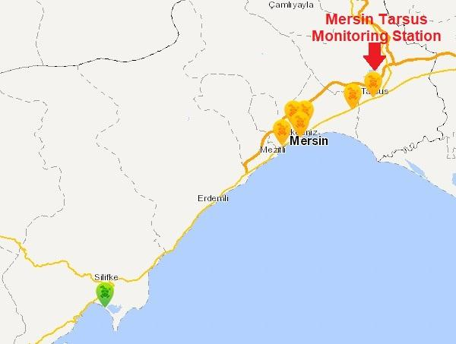
Figure 4-7. Air Quality Monitoring Stations in Mersin

Table 4-1 represents the mean monthly pollutant concentrations based on the national air quality monitoring system for the last 12 months within 2022 at the concerned monitoring in Tarsus, Mersin (see Figure 4-7).
Table 4-1. Monthly Average Air Quality Parameters in Mersin
Month / 2022 | SO₂ (µg/m³) | PM₁₀  (µg/m³) | CO  (µg/m³) | NO  (µg/m³) | NO₂  (µg/m³) | NO_{x}  (µg/m³)
January 2022 | 11.37 | 49.72 | 751.35 | 16.87 | 41.17 | 58.11
February 2022 | 9.82 | 61.69 | 698.82 | 21.15 | 53.96 | 75.15
March 2022 | 7.96 | 47.63 | 580.78 | 10.43 | 38.37 | 48.83
April 2022 | 6.39 | 76.64 | 317.60 | 8.47 | 30.49 | 39.02
May 2022 | 5.39 | 52.71 | 268.16 | - | - | -
June 2022 | 3.83 | 50.66 | 230.99 | 4.66 | 24.86 | 29.52
July 2022 | 3.62 | 70.22 | 311.42 | 7.79 | 22.99 | 30.81
August 2022 | 3.47 | 70.87 | 300.24 | 5.54 | 23.44 | 29.00
September 2022 | 4.80 | 67.94 | 265.04 | 4.80 | 28.60 | 33.44
October 2022 | 4.36 | 60.80 | 287.99 | 5.71 | 27.95 | 33.66
November 2022 | 4.95 | 51.49 | 442.62 | - | - | -
December 2022 | 9.87 | 75.41 | 948.64 | - | - | -
Source: Website of the MoEUCC: www.havaizleme.gov.tr
In this context, on the website of the MoEUCC, the current air quality index of Tarsus region is described as “medium” in terms of PM₁₀ parameter due to slightly above national and international limit value as 50 µg/m³.
Currently, the air quality of the Project Area cannot be characterized as good due to the presence of the quarries operating 30 meters west of the Project Area (see Figure 2-3 and Figure 2-5).

Waste Management
101 hectares included agricultural land, stony, brushy and raw land. The acquisition methods (expropriation, purchase or agreement) of the land sold is given in the Table 6-31. During the site visit, since the title deed processes of lot 105: parcel no. 1 and 2 belonging to the Project have not been completed yet, it has been observed that ground levelling processes have not started in this area. 2U1K also observed the structures of the gas station that was previously operating in this area (see Figure 4-5) and the repair and maintenance shop operated by the previous owner of this area was being used as a fuel filling location. In addition, small spot fuel and oil spills were observed visually at relevant area.
According to the preliminary observations, together with the presence of inert wastes from the buildings to be demolished in this relevant area, there are other non-hazardous and hazardous wastes left in the area that should be disposed in accordance with the national legislation (see Figure 4-5).
In addition, as spot fuel and oil spills were observed visually at the relevant area, the TUIOSB will take soil samples in the concerned area to be able to assess possible soil contamination in accordance with Regulation on Control of Soil Pollution and Point Source Contaminated Lands. If soil contamination is detected at the area, ground levelling works within the area will only be started by the contractor after the rehabilitation of the area in line with the relevant regulation. Thus, there is an obligation to manage wastes within the scope of national regulations in the entire project area, primarily in this area.

Water Resources
Firstly, water need of the facilities to be established in the Project Area was planned to be met by the water released from the Berdan Dam bottom spillway, which is at a distance of 5 km by bird flight from the Project Area. According to the Department of Survey, Planning and Allocation of DSI’s Water Allocation Letter, dated 04.11.2021 and numbered 1706642 regarding the Project (see Appendix-C), it was stated that 50 l/s water can be met from the left bank of the dam’s spillway except for September, October, and November months. As a result, TUIOSB has prioritized the groundwater option for the Project’s water supply.
In this context, TUIOSB obtained a Groundwater Exploration Document valid until 24.11.2022 from DSI with water allocation requirement as 4,310 tonnes/day (50 l/s) and, then its one-year extension valid until 24.11.2023 has been secured. The concerned well whose drilling studies are continued can be seen as Well-1 in Figure 4-8.
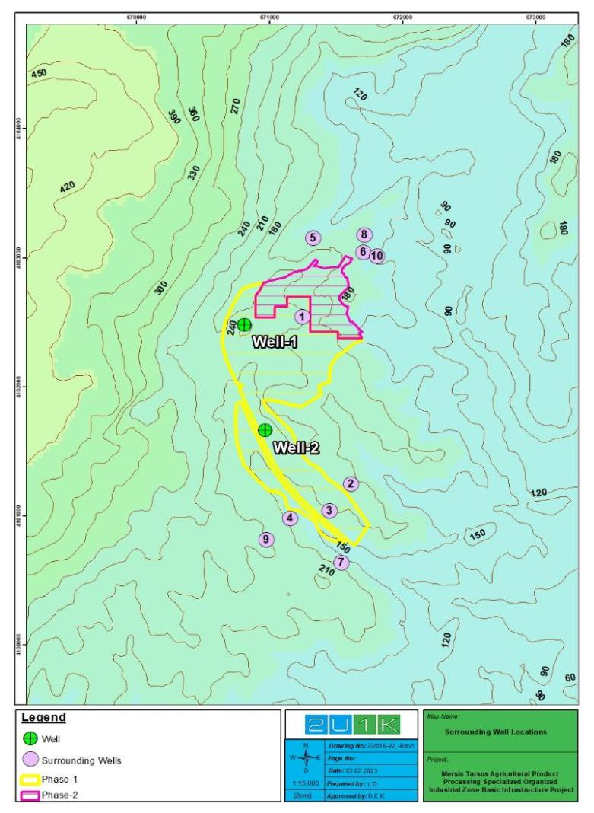
Figure 4-8. The Wells and Water Table Contour in the AoI of the Project
Moreover, in the light of the geology of the region and the study area, to determine the lateral and vertical changes of the units, their engineering properties, groundwater status and geotechnical parameters, 22 (twenty-two) foundation drilling with each 15 meters were conducted in the study area between 10.09.2018 and 27.09.2018. No groundwater was encountered (Şen Engineering, The Geological-Geotechnical Survey Report of the Project Area, 2018).
In addition, licensing studies for another well which can be seen in the map as Well-2 in Figure 4-8 within lot 105: parcel no. 2 of the Project Area are being continued by the TUIOSB (see Figure 4-9). The application letter dated 27.01.2023 for this well from the TUIOSB to the 6th Regional Directorate of DSI is presented in Appendix-C. The concerned well is the only active well in the Project Area and is used as a domestic water source for the construction phase of the Project.
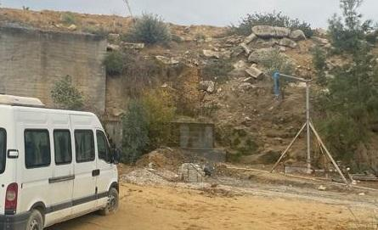
Figure 4-9. The View of the Well-2 in Lot 105: Parcel no. 2 of the Project Area

Climate and Vegetation
The Mediterranean climate prevails in Mersin. As it is moved inward from the coast, the continental climate characteristic is observed. On the coasts, summers are hot and dry, and winters are warm and rainy. At higher elevations, summers are cool and dry, and winters are cold and snowy. Annual precipitation amount varies between 419-1,032 mm in each district. It is usually below zero degrees 6 days in a year. The temperature stays generally between +6°C and +43°C throughout the year.

Table 4-2. According to the Months and Annual Average Precipitation and Temperature Values of Mersin
Mersin |  | January |  |  | February |  | March |  |  | April |  | May |  |  | June |  | July |  |  | August |  |  | September |  | October |  | November |  |  | December
Average Values Over Many Years (1960 – 2015)
Average Temperature (°C) |  |  | 10.1 |  |  | 10.9 |  | 13.7 |  |  | 17.5 |  | 21.4 |  |  | 25.2 |  |  | 27.9 |  | 28.4 |  |  | 25.6 |  | 21.1 |  | 15.7 |  |  | 11.7
Average Highest Temperature (°C) |  |  | 14.7 |  |  | 15.5 |  | 18.2 |  |  | 21.6 |  | 24.8 |  |  | 28.1 |  |  | 30.7 |  | 31.5 |  |  | 30.0 |  | 26.7 |  | 21.4 |  |  | 16.6
Average Lowest Temperature (°C) |  |  | 6.3 |  |  | 6.8 |  | 9.3 |  |  | 13.0 |  | 16.8 |  |  | 20.8 |  |  | 24.0 |  | 24.2 |  |  | 21.0 |  | 16.4 |  | 11.4 |  |  | 7.9
Average Sunshine Duration (hours) |  |  | 4.5 |  |  | 5.4 |  | 6.5 |  |  | 7.4 |  | 8.5 |  |  | 10.1 |  |  | 10.1 |  | 10.0 |  |  | 9.2 |  | 7.5 |  | 5.6 |  |  | 4.5
Average Number of Rainy Days |  |  | 10.1 |  |  | 9.3 |  | 7.7 |  |  | 6.8 |  | 5.2 |  |  | 2.3 |  |  | 1.0 |  | 0.8 |  |  | 1.7 |  | 5.0 |  | 6.8 |  |  | 10.1
Average Monthly Total Rainfall (kg/m²) |  |  | 113.7 |  |  | 80.7 |  | 56.3 |  |  | 34.8 |  | 23.4 |  |  | 8.9 |  |  | 7.5 |  | 4.6 |  |  | 8.4 |  | 38.3 |  | 77.9 |  |  | 133.9
Highest and Lowest Values in Many Years (1960 – 2015)
Highest Temperature (°C) |  |  | 25.2 |  |  | 26.5 |  | 29.8 |  |  | 34.7 |  | 35.8 |  |  | 38.2 |  |  | 37.3 |  | 39.8 |  |  | 38.5 |  | 36.4 |  | 31.0 |  |  | 27.0
Lowest Temperature (°C) |  |  | -6.3 |  |  | -6.6 |  | -2.2 |  |  | 0.6 |  | 7.0 |  |  | 5.3 |  |  | 16.1 |  | 15.0 |  |  | 11.0 |  | 2.7 |  | -3.3 |  |  | -3.0
Yearly Average |  |  | Average Temperature (°C) |  |  |  |  | Average Highest Temperature (°C) |  |  |  |  | Average Lowest Temperature (°C) |  |  |  |  |  | Average Sunshine Duration (hours) |  |  |  |  | Average Number of Rainy Days |  |  |  | Average Monthly Total Rainfall (kg/m²)
 |  |  | 19.1 |  |  |  |  | 23.3 |  |  |  |  | 14.8 |  |  |  |  |  | 89.3 |  |  |  |  | 66.8 |  |  |  | 588.4
Daily Total Highest Rainfall | 26.12.1968 |  |  | 199.5 kg/m² |  |  |  |  | Daily Fastest Wind |  |  |  |  | 22.08.2014 |  |  |  | 135.7 km/h |  |  |  | Maximum Snow Thickness |  |  |  |  |  |  | 13.01.1950  2.0 cm
Source: Meteorology General Directorate of MoEUCC: https://www.mgm.gov.tr
As for the vegetation characteristics of the region, the Anatolian peninsula is under the influence of three floristic regions due to the differences in topographic structure and climatic characteristics. These are Mediterranean, Irano-Turanian and Euro-Siberian regions. The Project Area is located within the borders of the Mediterranean Floristic Region in the district of Tarsus in Mersin.
There are no endemic species in the Project Area. Flora and fauna studies were carried out in the current area during the EIA process of the OIZ, and it has been determined that there is not a protected or endemic species. In general, there are oak species in the form of small bushes. This type of field is very sparse due to the unsuitable soil structure.
Most of the Project Area consists of forest qualified area and a small part of it consists of marginal agricultural area. When viewed from the soil quality side, it presents a sandy-loamy structure. The entire Project Area contains almost no vegetative soil.
The Project Area has stand type OT-T and OT-T1. It shows that the stand of this area is stony treeless forest soil. It is also Çfa0 stand type in small area. In this stand type, it means an empty forest land that has been determined as the area where pine nuts will be planted but has not been planted. (Şen Engineering, The Geological-Geotechnical Survey Report of the Project Area, 2018)

Natural Disaster Potential
The Project Area is in the 3rd Degree Earthquake Zone according to the Türkiye Earthquake Zones Map, which entered into force with the decision of the Council of Ministers dated 18.04.1996 and numbered 96/8109 (see Figure 4-10).
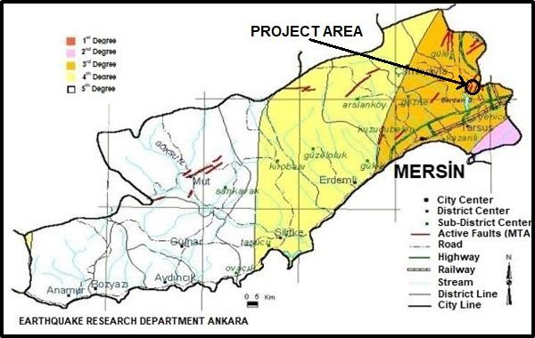
Figure 4-10. Mersin Province Earthquake Zones Map (Earthquake Research Department Ankara)
The topographic slope of the Project Area is between 0 – 50%. Observed assemblies are Upper Miocene – Pliocene in age, and the Handere Formation. It forms the geology of caliche bedded clay and clayey marl. As of the current situation, stability problems such as landslides and rockfalls are not expected in the Project Area (Şen Engineering, The Geological-Geotechnical Survey Report of the Project Area, 2018).
There is no flood risk for the Project Area considering its location and the distance of the surface waters. The seasonal Evcisuyu Stream passing through the land will be arranged as a diversion canal by considering the flood risks within the scope of this Project. In this context, with the official letter of the 6th Regional Directorate of DSI dated 26.03.2021 and numbered 1099955 (see Appendix-C), the improvement sections prepared for Evcisuyu Stream were found to be hydraulically appropriate, and it was determined that they met the criteria specified in Regulation on the Control of Flood and Sedimentation.

Biodiversity and Protected Areas
The Project Area is under the influence of the Mediterranean climate. According to the Corine 2018 Land Cover data, the Project Area is in Sparsely vegetated areas, Mineral extraction sites and Fruit trees and berry plantations. The surroundings of the Project area are also composed of Transitional woodland-shrub and various agricultural fields (Figure 4-11).
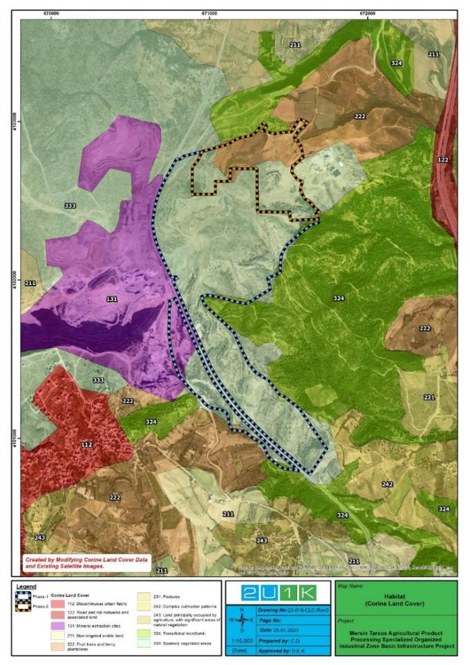
Figure 4-11. Habitats within the Project Area and Close Vicinity
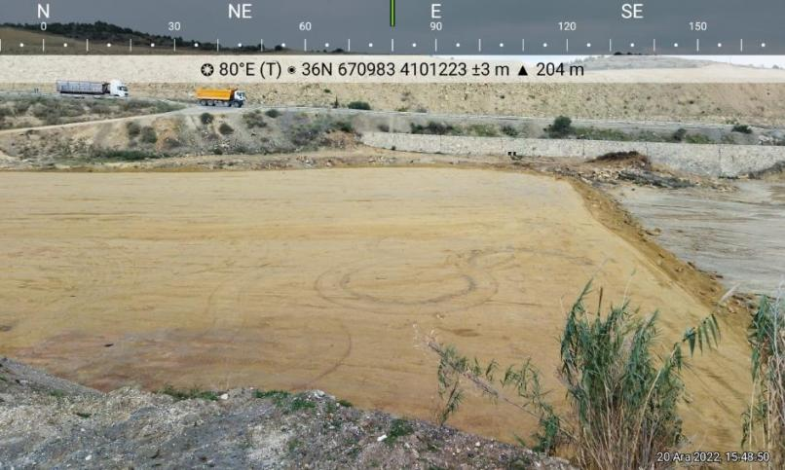
Figure 4-12 General View from the Project Area
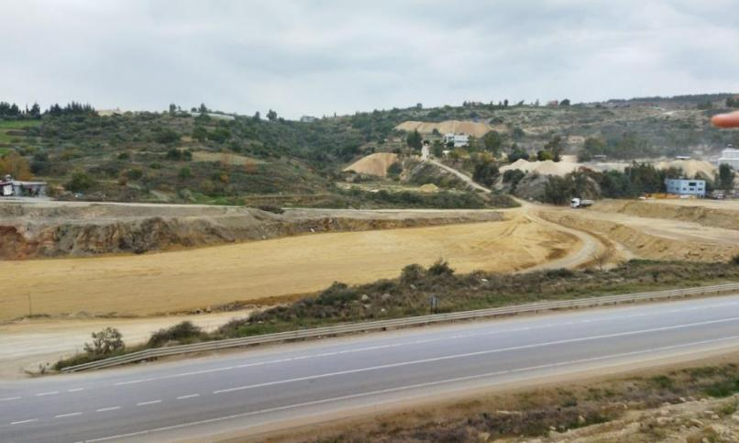
Figure 4-13 General View from the Project Area

Due to the intense anthropogenic impact observed in the project area, the distribution of flora and fauna is highly suppressed. The flora and fauna species that can be observed in the area comprise cosmopolitan species. The herbaceous vegetation on the Project Area was not in good form, being quite degenerated.
In evaluating the threat/protection status of species, Bern Convention (Convention on the Conservation of European Wildlife and Natural Habitats); and IUCN (International Union for Conservation of Nature) Red List Database were used.
Bern Convention
The Convention was put into force in 1982 for the conservation of European wildlife and natural habitats. Fauna species protected by Bern Convention are listed in four categories:
- Appendix I: Strictly protected flora species
- Appendix II: Strictly protected fauna species
- Appendix III: Protected fauna species
- Appendix IV: Prohibited means and methods of killing, capture and other forms of exploitation
IUCN Red List of Threatened Species
The International Union for Conservation of Nature (IUCN) Red List is published to draw attention to the species whose population is under risk or threatened. IUCN includes the species to the Red List after researching the reasons causing decrease in its population. IUCN Red List categories are given below:
- EX: Extinct
- EW: Extinct in the Wild
- CR: Critically Endangered
- EN: Endangered
- VU: Vulnerable
- NT: Near Threatened
- LC: Least Concern
- DD: Data Deficient
- NE: Not Evaluated
Red Book of Flora in Türkiye (Ekim et al., 2000), which is prepared as per the 1994 IUCN Red List Categories and Criteria, is used during the determination of risk status of the flora species in the study area.
The flora and fauna data were generated using EIAs dated May 2018 and February 2022, and they were verified through a field study conducted on 20th December 2022 in the scope of this ESMP preparation process and literature research.
The primary objective of the ESMP studies was to validate the findings outlined in the EIA and identify potential additional species. However, it should be noted that significant land preparations had already been executed, resulting in the removal of vegetation within the project area. Despite the fieldwork taking place before the flowering period, which posed challenges in identifying herbaceous species, the habitat assessment effectively facilitated the determination or confirmation of potential species within the area.
In conclusion, while direct observation of the species mentioned in the EIA was precluded due to the clearance of vegetation within the project area, the vast majority of these species were subsequently observed in the immediate vicinity of the project site.
Flora
According to the field studies carried out during the EIA studies, 164 species belonging to 47 families were identified through site observations and literature research. Furthermore, during the ESMP study, habitat suitability was assessed for these species. 4 endemic plant species (Astragalus condensatus (Milkvetch), Marrubium globosum subsp. Globosum (Horehound), Aubrieta canescens (Obrisia), Arabian aubrietioides (Rose caster)) were detected in the activity area and its surroundings. These species are widely distributed species and do not require protection measures. The conservation status of flora identified in the project area is given in Table 4-3.
Table 4-3. Flora Species Identified in the AoI as a Result of Studies
Species Name | Common Name | Endemism | IUCN | BERN
Anacardiaceae
Pistacia terebinthus L. subsp. palaeTtina (Boiss.) Engler | Eastern Turpentine Tree | - | LC | -
Apiaceae
Anthriscus nemorosa (M.Bieb) Spreng | - | - | - | -
Astradaucus orientalis (L.) Drude. | - | - | - | -
Caucalis platycarpos L. | Carrot Bur Parsley | - | - | -
Eryngium campestre L. | Watling Street Thistle | - | - | -
Eryngium creticum Lam. | Sea Holly | - | - | -
Ferulago cassia Boiss. | - | - | - | -
Johrenia dichotoma DC. Subsp.dichotoma | - | - | - | -
Laser triobium (L.) Borkh | - | - | - | -
Torilis arvensis (Huds.) Link | Common Hedge Parsley | - | - | -
Apocynaceae
Nerium oleander L. | Oleander | - | LC | -
Aspidiaceae
Dryopteris pallida (Bory) Fomin | - | - | LC | -
Aspleniaceae
Ceterach officinarum DC. | Common Rustyback Fern | - | LC | -
Asteraceae
Centaurea solstitialis susbs solstitialis | Golden Starthistle | - | - | -
Centaurea triumfettii | Squarrose Knapweed | - | - | -
Cichorium intybus L. | Common Chicory | - | - | -
Cirsium vulgare | Bull Thistle | - | - | -
Filago pyramidata L. | Broad Leaved Cutweed | - | - | -
Onopordum auricat L. | Illyrian Thistle. | - | - | -
Picris strigose | - | - | - | -
Scolymus hispanicus L. | Common Golden Thistle | - | - | -
Senecio vernalis | Eastern Groundsel | - | - | -
Tripleurospermum oreades (Boiss.) Rech.f. | - | - | - | -
Xanthium spinosum L. | Spiny Cocklebur | - | - | -
Xanthium strumarium subsp. Strumarium | Clotbur | - | - | -
Berberidaceae
Berberis crataegina | - | - | - | -
Boraginaceae
Anchusa undulata L.subsp.hybrida (Ten.) Coutinho | - | - | - | -
Asperugo procumbens L. | German Madwort | - | - | -
Brunnera orientalis (Schenk) Johnston | - | - | - | -
Echium italicum L. | Italian Viper’s Bugloss | - | - | -
Heliotropium europaeum L. | Common Heliotrope | - | - | -
Myosotis arvensis (L) Hill | Field Forget-Me-Not | - | - | -
Brassicaceae
Aethionema arabicum (L.) DC. | - | - | - | -
Alyssum minutum (L) Schlecht. Ex Dc. | - | - | - | -
Arabis aubrietioides | - | Endemic
Aubrieta canescens | - | Endemic | - | -
Capsella bursa- pastoris. | Shepherd’s Purse | - | LC | -
Erysimum crassipes Fisch.& C.C.Mey | - | - | - | -
Erysimum goniocolon Boiss. | - | - | - | -
Silene behen L. | Hairless Catchfly | - | - | -
Silene italica (L.) Pers. | Italian Catchfly | - | - | -
Silene vulgaris (Moench) Garcke subsp. Vulgaris | Bladder Campion | - | - | -
Caprifoliaceae
Valeriana tuberosa | Tuberous Valerian | - | LC | -
Chenopodiaceae
Chenopodium urbicum L. | City Goosefoot | - | - | -
Cistaceae
Helianthemum ledifolium (L.) Miller var. microcarpum Wilk | - | - | - | -
Compositae
Achillea biebersteinii Afan | - | - | - | -
Anthemis tinctoria L. var. tinctoria | Golden Chamomile | - | - | -
Bellis perennis L. | English Daisy | - | - | -
Carduus nutans L. | Musk Thistle | - | - | -
Carlina corymbose L. | Clustered Carline Thistle | - | - | -
Centaurea iberica Trev. Ex Sprengel | Iberian Star-Thistle | - | - | -
Centaurea virgata Lam. | Squarrose Knapweed | - | - | -
Chondrilla juncea L.var.juncea | Rush Skeletonweed | - | - | -
Cichorium intybus L. | Chicory |  | LC
Crepis foetida L. subsp. Rhoeadifolia (M.Bieb) Celak | Stinking Hawksbeard | - | - | -
Crupina crupinastrum (Moris) Vis. | False Saw-Wort | - | - | -
Ecinops orientalis Trautv. | - | - | - | -
Filago eriocephala Guss. | - | - | - | -
Lapsana communis L. subsp. Adenphoa (Boiss.) Rech. Fil. | Common Nipplewort | - | - | -
Picnomon acarna (L.) Cass. | Soldier Thistle | - | - | -
Ptilostemon diacantha (Lab.) Greuter subsp. Turcicus Greuter | - | - | - | -
Tussilago farfara L. | Coltsfoot | - | LC | -
Xeranthemum annuum L. | Common Immortelle | - | - | -
Convolvulaceae
Convolvulus arvensis L. | Field Bindweed | - | - | -
Cupressaceae
Juniperus sabina L. | Savin Juniper | - | LC | -
Crassulaceae
Sedum album L. | White Stonecrop
Sedum pallidum Bieb. Var. Pallidum | - | - | - | -
Cyperaceae
Carex elata all. Subsp. Omskiana (Meinsh) Jalas | Tufted Sedge | - | LC | -
Schoenoplectus lacustris (L.) Palla subsp. Tabernaemontani (C.C Gmelin) A.&D. Löve | - | - | - | -
Dipsacaceae
Dipsacus laciniatus L. | Cutleaf Teasel | - | - | -
Scabiosa argentea L. | Silver Scabious | - | - | -
Euphorbiaceae
Euphorbia apios L. | - | - | - | -
Euphorbia kotschyana Fenzl | - | - | - | -
Euphorbia macroclada Boiss. | - | - | - | -
Euphorbia rigida Bieb. | Rigid Spurge | - | - | -
Equisetaceae
Equisetum ramosissimum Desf. | Branched Horsetail | - | LC | -
Fabaceae
Astragalus condensatus | - | Endemic | LC | -
Astragalus microcephalus Willd. | - | - | - | -
Calicotome villosa (Poir) | Spiny Broom | - | - | -
Cicer pinnatifidum Jaub.& Spach | - | - | DD | -
Coronilla varia L. | Purple Crownvetch | - | LC | -
Cytisopsis dorcyniifolia Jaub. & Spach subsp.dorycniifolia | - | - | - | -
Gonocytisus angulatus (L.) Spach | - | - | - | -
Medicago discidormis DC | Veinless Medick | - | - | -
Medicago x varia Martyn | Hybrid Alfalfa | - | - | -
Onobrychis cornuta (L.) Desv | - | - | - | -
Podocytisus caramanicus Boiss.& Heldr. | - | - | - | -
Spartium junceum L. | Spanish Broom | - | - | -
Trifolium campestre Schreb. | Hop Trefoil | - | - | -
Trifolium caudatum BOISS. | - | - | - | -
Trifolium monantha C.A. Meyer. Subsp. Monantha | - | - | - | -
Trifolium nigrescens Viv.Subsp. petrisavii (Clem.) Holmboe | Ball Clover | - | - | -
Trifolium physodes Stev. Var.physodes | - | - | - | -
Trifolium resupinatum L.var. resupinatum | Persian Clover
Fagaceae
Quercus coccifera L. | Kermes Oak | - | LC | -
Geraniaceae
Geranium tuberosum L. | Tuberous-Rooted Cranesbill
Guttiferae
Hypericum calycinum L. | Aaron’s Beard | - | - | -
Hypericum perforatum | St. John’s Wort | - | - | -
Hypericaceae
Hypericum lanuginosum Lam. Var. lanuginosum | Downy St. John’s Wort | - | - | -
Hypolepidaceae
Pteridium aquilinum (L.) Kuhn | - | - | LC | -
Lamiaceae
Clinopodium vulgare L.subsp. vulgare | - | - | - | -
Lamium garganicum L. | - | - | - | -
Marrubium astracanicum | - | - | - | -
Marrubium globosum subsp. Globosum | - | Endemic | LC | -
Melissa officinalis L.subsp.inodora (Bornm.) Bornm. | - | - | - | -
Mentha longifolia (L.) Hudson subsp. Typhoides (Briq.) Harley var. typhoides | - | - | - | -
Micromeria myrtifolia Boiss. &Hohen | - | - | - | -
Salvia verticllata L.subsp. amasiaca ( freyn & Bornm.) Bornm. | - | - | - | -
Salvia virgata L. | Wand Sage | - | - | -
Teucrium chamaedrys L. | Wall Germander | - | LC | -
Teucrium kotschyanum Poech | - | - | - | -
Teucrium polium L. | Felty Germander
Liliaceae
Eremurus spectabilis BIEB. | Foxtail Lily | - | - | -
Gagea bohemica (Zauschn.) Schultes & Schultes fil. | Peruzzi’s Gagea | - | LC | -
Muscari armeniacum Leichtlin ex Baker | - | - | - | -
Muscari comosum (L.) Miller | - | - | - | -
Ruscus aculeatus L. var.angustifolius Boiss. | - | - | - | -
Scilla autumnalis L | Autumn Squill | - | - | -
Myrtaceae
Myrtus communis L. | Myrtle | - | LC | -
Onagraceae
Epilobium parviflorum Schreber | Hoary Willowherb | - | LC | -
Oleaceae
Phyllyrea latifolia L
Orchidaceae
Limodorum abortivum (L.) Swartz | Violet Limodore | - | - | -
Platanthera bifolia (L.) L. C. M. Richard | Lesser Butterfly Orchid. | - | - | -
Papaveraceae
Fumaria officinalis | Common Fumitory | - | - | -
Papaver rhoeas | Common Poppy | - | LC | -
Phytolaccaceae
Phytolacca americana L. | Pokeweed | - | - | -
Plumbaginecea
Acantholimon acerosum | - | - | - | -
Primulaceae
Lysimachia atropurpurea L. | Burgundy Gooseneck Loosestrife | - | - | -
Poaceae
Aegilops auricate Roth. | Ovate Goat Grass | - | LC | -
Avena barbata Pott. Ex Link. | Barbed Oat | - | - | -
Brachypodium sylvaticum (Hudson) P. Beauv | Slender False Brome | - | - | -
Briza maxima L. | Greater Quaking-Grass | - | - | -
Bromus japonicus Thunb. Subsp. Japonicus | - | - | - | -
Cynodon dactylon (L) Pers. | Bermuda Grass | - | - | -
Dactylis glomerata L.subsp. hispanica (Roth) Nyman | - | - | - | -
Hordeum bulbosum | Bulbous Barley | - | LC | -
Phyleum phleoides (L.) Karsten | Boehmer’s Cat’s-Tail | - | LC | -
Poa bulbosa L. | Bulbous Bluegrass | - | - | -
Sorghum bicolor (L.) Moench | Common Wild Sorghum | - | - | -
Polygonaceae
Polygonum cognatum | Indian Knotgrass | - | - | -
Rumex crispus L. | Curled Dock | - | - | -
Rumex pulcher (L.) Lois. | Fiddle Dock | - | - | -
Rumex scutatus L. | - | - | - | -
Rumex tuberosus L | - | - | - | -
Ranunculaceae
Anomone blanda | Grecian Windflower
Clematis vitalba L. | Old Man’s Beard | - | - | -
Ranunculus arvensis | Corn Buttercup | - | - | -
Ranunculus constantinapolitanus (DC) Urv. | - | - | - | -
Ranunculus L. | Buttercups | - | - | -
Rhamnaceae
Paliurus spina-christi MİLLER. | Christ’s Thorn | - | - | -
Rosaceae
Prunus spinosa L. | Blackthorn | - | LC | -
Rubus sanctus L. | Holy Bramble
Rubiaceae
Galium asparagifolium BOISS | - | - | - | -
Smilacaceae
Smilax excelsa L. | - | - | - | -
Scrophlariaceae
Anarrhinum orientale Benth. | - | - | - | -
Verbascum pinnatifidum VAHL | - | - | - | -
Verbascum splendidum | - | - | - | -
Veronica anagallis-aquatica L. | Water Speedwell. | - | LC | -
Veronica macrostachya Vahl. Subsp. Macrostachya | - | - | - | -
Veronica triphyllos L. | Finger Speedwell | - | - | -
Urticaceae
Urtica dioica | Common Nettle | - | LC | -
Violaceae
Viola kitaibeliana Roem.& Schult | Dwarf Pansy
Viola odorata L. | Sweet Violet | - | - | -
Xanthorrhoeaceae
Asphodeline aurica (Pall.) Endl. | - | - | - | -
There are four endemic species among the flora species. These are; Marrubium globosum subsp. globosum, Astragalus condensatus, Arabis aubrietioides and Aubrieta canescens. These four endemic species were observed in the project area and surroundings during the EIA studies. However, it should be noted that these species are widely distributed and do not require any specific conservation measures. In addition, among the flora species identified in the project area and surroundings, there are no endangered species according to the International Union for Conservation of Nature (IUCN) Red List.
Fauna
Amphibians
During the EIA studies, a total of 3 Amphibian species belonging to 3 family were identified in the area through literature research. Furthermore, during the ESMP study, habitat suitability was assessed for these species. Systematic information on these species and conservation status belonging to species are given in Table 4-4.
In terms of IUCN Red List, Bufotes viridis is in LC (Least Concern) category. According to Bern Convention, Pseudepidalea viridis is in the list of Appendix II: Strictly protected fauna species. Pseudepidalea viridis is widely spread species. Similarly, Pelophylax ridibundus and Salamandra infraimmaculata are also in the LC category and they are in the Appendix III: Protected fauna species list in the Bern Convention.
Table 4-4. Amphibian Species Identified in the AoI as a Result of Studies
Species Name | Common Name | Endemism | IUCN | BERN
Bufonidae
Bufotes viridis | Green Toad | - | LC | App-2
Ranidae
Pelophylax ridibundus | Marsh Frog | - | LC | App-3
Salamandridae
Salamandra infraimmaculata | Near-Eastern Fire Salamander | - | LC | App-3
Reptiles
During the EIA studies, a total of 20 Reptilian species belonging to 8 family species were identified in the area through site observations and literature research. Furthermore, during the ESMP study, habitat suitability was assessed for these species. Systematic information on these species and conservation status belonging to species are given in Table 4-5.
According to IUCN criteria, Testudo graeca is included in VU (Vulnerable) category. Rest of the species identified in Project area are listed in LC (Least Concern) category. According to the Bern Convention, Pseudopus apodus, Dolichophis caspius, Testudo graeca,Ophisops elegans and Macrovipera lebetina are listed in Appendix II: Strictly protected fauna species. These reptilian species are widely spread in Türkiye and they are not endemic. Remaining species are included in the Appendix III: Protected fauna species. There is one endemic species in the AoI. Anatololacerta danfordi is an endemic species to the Central and Eastern Taurus region.
Table 4-5. Reptilian Species Identified in the AoI as a Result of Studies
Species Name | Common Name | Endemism | IUCN | BERN
Agamidae
Trapelus ruderatus | Horny-scaled Agama | - | LC | App-3
Anguidae
Pseudopus apodus | European Glass Lizard | - | LC | App-2
Colubridae
Dolichophis caspius | Large Whip Snake | - | LC | App-2
Dolichophis schmidti | Red-Bellied Racer | - | LC | -
Eirenis decernlineatus | Narrow-striped Dwarf Racer | - | LC | App-3
Eirenis modestus | Ring-Headed Dwarf Snake | - | LC | -
Elaphe sauromates | Eastern Four-Lined Ratsnake | - | LC | -
Hermorrhois nummifer | Coin-marked Snake | - | - | -
Hemorrhois ravergieri | Spotted Whip Snake | - | LC | App-3
Platyceps najadum | Dahl’s Whip Snake | - | LC | -
Zamenis hohenackeri | Transcaucasian Rat Snake | - | LC | -
Testudinidae
Testudo graeca | Common Tortoise | - | VU | App-2
Lacertidae
Anatololacerta danfordi | Danford’s Lizard | Endemic | LC | -
Apathya cappadocica | The Anatolian lizard | - | LC | App-3
Lacerta media | Medium Lizard | - | LC | -
Ophisops elegans | Snake-eyed Lizard | - | LC | App-2
Natricidae
Natrix natrix | Grass Snake | - | LC | App-3
Scincidae
Ablepharus chernovi | Lined Olympic Snake | - | LC | App-3
Heremites vittatus | Bridled Mabuya | - | LC | -
Viperidae
Macrovipera lebetina | Levantine Viper | - | LC | App-2
Birds
During the EIA studies, a total of 113 bird species belonging to 32 families were identified in the study area through site observations and literature research. Furthermore, during the ESMP study, habitat suitability was assessed for these species. These bird species are widely spread in Türkiye, and they are not endemic.
The conservation status of birds identified in the study area is given in. According to the IUCN Red List, there are 2 “EN”, 3 “VU” and 4 “NT” category species. Rest of the species are in the “LC” category.
According to the Bern Convention, 78 species are listed in Appendix II: Strictly protected fauna species and 24 species are listed in Appendix III: Protected fauna species. The remaining species are not included in any conservation status of the Bern Convention.

Table 4-6. Bird Species Identified in the AoI as a Result of Studies
Species Name | Common Name | Endemism | IUCN | BERN
Accipitridae
Accipiter nisus | Eurasian Sparrowhawk | - | LC | App-2
Aegypius monachus | Cinereous Vulture | - | NT | App-2
Aquila heliaca | Imperial Eagle | - | VU | App-2
Aquila nipalensis | Steppe Eagle | - | EN | App-2
Buteo buteo | Common Buzzard | - | LC | App-2
Buteo rufinus | Long-legged Buzzard | - | LC | App-2
Clanga pomarina | Lesser Spotted Eagle | - | LC | App-2
Circaetus gallicus | Short-toed Snake-eagle | - | LC | App-2
Circus macrourus | Pallid Harrier | - | NT | App-2
Circus pygargus | Montagu’s Harrier | - | LC | App-2
Gypaetus barbatus | Bearded Vulture | - | NT | App-2
Gyps fulvus | Griffon Vulture | - | LC | App-2
Hieraaetus pennatus | Booted Eagle | - | LC | App-2
Milvus migrans | Black Kite | - | LC | App-2
Neophron percnopterus | Egypian Vulture | - | EN | App-2
Acrocephalidae
lduna pallida | Eastern Olivaceous Warbler | - | LC | App-2
Alaudidae
Alauda arvensis | Eurasian Skylark | - | LC | App -3
Calandrella brachydactyla | Greater Short-toed Lark | - | LC | App-2
Eremophila alpestris | Horned Lark | - | LC | App-2
Galerida cristata | Crested Lark | - | LC | App-3
Melanocorypha calandra | Calandra Lark | - | LC | App-2
Apodidae
Apus afinis | Little Swift | - | LC | App-3
Apus apus | Common Swift | - | LC | App-3
Tachymarptis melba | Alpine Swift | - | LC | App-3
Ardeidea
Ardea cinerea | Grey Heron | - | LC | App-3
Certhiidae
Certhia brachydactyla | Short-toed Treecreeper | - | LC | App-2
Ciconiidae
Ciconia ciconia | White Stork | - | LC | App-2
Cisticolidae
Prinia gracilis | Graceful Prinia | - | LC | App-3
Columbidae
Columba livia | Rock Dove | - | LC | -
Columba palumbus | Common Wood Pigeon | - | LC | -
Columba oenas | Stock Dove | - | LC | -
Streptopelia senegalensis | Laughing Dove | - | LC | -
Streptopelia decaocto | Eurasian Collared dove | - | LC | App -3
Streptopelia turtur | European Turtle-dove | - | VU | -
Coraciidae
Coracias garrulus | European Roller | - | LC | App-2
Corvidae
Corvus corax | Common Raven | - | LC | App -3
Corvus cornix | Hooded Crow | - | - | App-3
Corvus frugilegus | Rook | - | LC | -
Corvus monedula | Eurasian Jackdaw | - | LC | -
Garrulus glandarius | Eurasian Jay | - | LC | -
Pica pica | Eurasian Magpie | - | LC | -
Pyrrhocorax graculus | Yellow-billed Chough | - | LC | App-2
Pyrrhocorax pyrrhocorax | Red-billed Chough | - | LC | App-2
Cuculidae
Clamator glandarius | Great Spotted Cuckoo | - | LC | App-2
Emberizidae
Emberiza caesia | Cretzschmar’s Bunting | - | LC | App-2
Emberiza calandra | Corn Bunting | - | LC | App-2
Emberiza cia | Rock Bunting | - | LC | App-2
Emberiza hortulana | Ortolan Bunting | - | LC | App-2
Emberiza melanoceohala | Black-headed Bunting | - | LC | App-2
Emberiza rustica | Rustic bunting | - | VU | App-2
Falconidae
Falco peregrinus | Peregrine Falcon | - | LC | App-2
Falco subbuteo | Eurasian Hobby | - | LC | App-2
Falco tinnunculus | Common Kestrel | - | LC | App-2
Fringillidae
Carduelis carduelis | European Goldfinch | - | LC | App-2
Chloris chloris | European Greenfinch | - | LC | App-2
Fringilla coelebs | Common Chaffinch | - | LC | App-3
Linaria cannabina | Common Linnet | - | LC | App-3
Serinus pusillus | Red-fronted Serin | - | LC | App-2
Serinus serinus | European Serin | - | LC | App-2
Spinus spinus | Eurasian Siskin | - | LC | App-2
Hirundinidae
Hirundo rustica | Barn Swallow | - | LC | App-2
Riparia riparia | Sand martin | - | LC | App-2
Laniidae
Lanius collurio | Red-backed Shrike | - | LC | App-2
Lanius minor | Lesser Grey Shrike | - | LC | App-2
Lanius nubicus | Masked Shrike | - | LC | App-2
Meropidae
Merops apiaster | European Bee-eater | - | LC | App-2
Motacillidae
Anthus campestris | Tawny Pipit | - | LC | App-2
Anthus pratensis | Meadow Pipit | - | LC | App-2
Anthus spinoletta | Water Pipit | - | LC | App-2
Motacilla alba | White Wagtail | - | LC | App-2
Motacilla cinerea | Grey Wagtail | - | LC | App-2
Motacilla flava | Western Yellow Wagtail | - | LC | App-2
Muscicapidae
Cercotrichas galactotes | Rufous-tailed Scrub-robin | - | LC | App-2
Erithacus rubecula | European Robin | - | LC | App-2
Ficedula semitorquata | Semi-collared Flycatcher | - | LC | App-2
Luscinia megarhynchos | Common Nightingale | - | LC | App-2
Luscinia svecica | Bluethroat | - | LC | App-2
Monticola saxatilis | Rufous-tailed Rock-thrush | - | LC | App-2
Monticola solitarius | Blue Rock-thrush | - | LC | App-2
Muscicapa striata | Spotted Flycatcher | - | LC | App-2
Oenanthe cypriaca | Cyprus Wheatear | - | LC | App-2
Oenanthe finschii | Finsch’s Wheatear | - | LC | App-2
Oenanthe hispanica | Black-eared Wheatear | - | LC | App-2
Oenanthe isabellina | Isabelline Wheatear | - | LC | App-2
Oenanthe oenanthe | Northern Wheatear | - | LC | App-2
Phoenicurus ochraros | Black Redstart | - | LC | App-2
Phoenicurus phoenicurus | Common Redstart | - | LC | App-2
Saxicola rubetra | Whinchat | - | LC | App-2
Saxicola rubicola | European Stonechat | - | - | App-2
Passeridae
Montifringilla nivalis | White-winged Snowfinch | - | LC | App-3
Passer domesticus | House Sparrow | - | LC | -
Passer hispaniolensis | Spanish Sparrow | - | LC | App-3
Phasianidae
Alectoris chukar | Chukar | - | LC | App-3
Alectoris graeca | Rock Partridge | - | NT | App-2
Coturnix coturnix | Common Quail | - | LC | App-2
Paridae
Cyanistes caeruleus | Eurasian Blue Tit | - | LC | App-2
Parus major | Great tit | - | LC | App-2
Phylloscopidae
Phylloscopus collybita | Common Chiffchaff | - | LC | App-3
Picidae
Dendrocopus syriacus | Syrian Woodpecker | - | LC | App-2
Pycnonotidae
Pycnonotus xanthopygos | White-spectacled Bulbul | - | LC | App-3
Sittidae
Sitta krueperi | Krueper’s Nuthatch | - | LC | App-2
Sitta neumayer | Western Rock Nuthatch | - | LC | App-2
Strigidae
Athene noctua | Little Owl | - | LC | App-3
Sturnidae
Sturnus vulgaris | Common Starling | - | LC | -
Sylviidae
Phylloscopus collybita | Common Chiffchaff | - | LC | App-3
Sylvia atricapilla | Eurasian Blackcap | - | LC | App-2
Sylvia curruca | Lesser Whitethroat | - | LC | App-2
Sylvia ruppeli | Rüppell’s Warbler | - | LC | App-2
Turdidae
Turdus merula | Eurasian Blackbird | - | LC | App-3
Turdus philomelos | Song Thrush | - | LC | App-3
Turdus pilaris | Fieldfare | - | LC | App-3
Turdus viscivorus | Mistle Thrush | - | LC | App-3
Upupidae
Upupa epops | Hoopoe | - | LC | App -3
Mammals
During the EIA studies, a total of 42 mammal species belonging to 18 families were identified in the project area and surroundings through site observations and literature research. Furthermore, during the ESMP study, habitat suitability was assessed for these species. These mammal species are widely spread in Türkiye and are not endemic. There are 1 “EN”, 3 ”VU”, 2 ”NT” and 1 “DD” category species. The remaining species are in LC category.
The conservation status of mammals identified in the project area is given in Table 4-7.
11 of the mammal species are listed in Appendix-3, and 16 of the mammal species are listed in Appendix-2 of the Bern Convention. The remaining species are not included in the lists of the Bern Convention.
Table 4-7. Mammal Species Identified in the AoI as a Result of Studies
Species Name | Common name | ENDEMISM | IUCN | BERN
Cricetidae
Cricetulus migratorius | Grey Dwarf Hamster | - | LC | -
Mesocricetus brandti | Brandt’s Hamster | - | NT | -
Microtus guentheri | Günther’s Mole | - | LC | -
Erinaceidae
Erinaceus concolor | Southern White-breasted Hedgehog | - | LC | App -3
Erinaceus europeus | Western European Hedgehog |  | LC | App-3
Felidae
Felis silvestris | Wild Cat | - | LC | App-2
Talpidae
Talpa europaea | European Mole | - | LC | App-3
Gliridae
Glis glis | Edible Dormouse | - | LC | App-3
Hystricidae
Hystrix indica | Indian Crested Porcupine | - | LC | -
Leporidae
Lepus europaeus | European Hare | - | LC | App-3
Miniopteridae
Miniopterus schreibersii | Schreiber’s Bent-winged Bat | - | VU | -
Muridae
Apodemus mystacinus | Eastern Broad-toothed Field Mouse | - | LC | -
Mus musculus | House Mouse | - | LC | -
Mus macedonicus | Macedonian Mouse | - | LC | -
Rattus rattus | House Rat | - | LC | -
Soricidae
Crocidura leucodon | Bicolored Shrew | - | LC | App -3
Crocidura suaveolens | Lesser White-toothed Shrew | - | LC | App-3
Spalacidae
Spalax leucodon | Lesser Mole Rat | - | LC | -
Nannospalax xanthodon | Nehring’s Blind Mole Rat | - | DD | -
Mustelidae
Martes foina | Beech Marten | - | LC | App-3
Meles meles | Badger | - | LC | App-3
Mustela nivalis | Least Weasel | - | LC | App -3
Sciuridae
Sciurus anomalus | Caucasian Squirrel | - | LC | App-2
Spermophilus citellus | European Souslik | - | EN
Suidae
Sus scrofa | Wild Boar | - | LC | -
Canidae
Canis aureus | Golden Jackal | - | LC | -
Canis lupus | Grey Wolf | - | LC | App-2
Vulpes vulpes | Red Fox | - | LC | -
Vespertilionidae
Eptesicus serotinus | Serotine |  | LC | App-2
Hypsugo savii | Savi’s Pipistrelle |  | LC | App-2
Nyctalus noctula | Noctule |  | LC | App-2
Myotis capaccinii | Long-fingered Bat |  | VU | App-2
Myotis myotis | Greater Mouse-eared Bat |  | LC | App-2
Myotis blythii | Lesser Mouse-eared Bat |  | LC | App-2
Pipistrellus pipistrellus | Common Pipistrelle |  | LC | App-3
Pipistrellus pygmaeus | Soprano Pipistrelle |  | LC | App-2
Pipistellus kuhlii | Kuhl’s Pipistrelle |  | LC | App-2
Pteropodidae
Rousettus aegyptiacus | Egyptian Fruit Bat |  | LC | App-2
Rhinolophidae
Rhinolophus ferrumequinum | Greater Horseshoe Bat |  | LC | App-2
Rhinolophus hipposideros | Lesser Horseshoe Bat |  | LC | App-2
Rhinolophus euryale | Mediterranean Horseshoe Bat |  | NT | App-2
Rhinolophus mehelyi | Mehely’s Horseshoe Bat |  | VU | App-2
The threatened fauna species according to the IUCN red list are given in Table 4-8. Except for these species, all remaining species are in the LC (Least Concern) category.
Table 4-8. Identified threatened fauna species according to the IUCN red list in the AoI
Species Name | Common Name | IUCN | Distribution | Source
 |  |  |  | Previous Studies  (EIAs) | ESMP
Accipiteridae
Aquila nipalensis | Steppe Eagle | EN | This species breeds east of 43°E in European Russia from the Republic of Kalmykia (I. Karyakin in litt. 2016), across Kazakhstan into Kyrgyzstan, China and Mongolia (Meyburg and Boesman 2013). In 2015  In Türkiye, its distribution area is quite wide | Literature | Literature
Aquila heliaca | Imperial Eagle | VU | This species breeds in Austria, Azerbaijan, Bulgaria, China, Czech Republic, Macedonia, Georgia, Greece, Hungary, Kazakhstan, Russia, Mongolia, Serbia, Slovakia, Türkiye and Ukraine (Heredia 1996, M. Horváth & I. Karyakin in litt. 2016).  In Türkiye, its distribution area is quite wide | No record- | Observation
Neophron percnopterus | Egypian Vulture | EN | Egyptian vultures are widely distributed across the Old World with their breeding range from southern Europe to northern Africa east to western and southern Asia.  In Türkiye, its distribution area is quite wide | Literature | Literature
Columbridae
Streptopelia turtur | European Turtle-dove | VU | The species is a widespread migrant breeder across much of central and southern Europe, Central Asia, the Middle East and North Africa  In Türkiye, its distribution area is quite wide | Literature | Literature
Emberizidae
Emberiza rustica | Rustic bunting | VU | The species breeds across northern latitudes of the Palaearctic from Norway in the west to Kamchatka (Russia) in the east. It is a full migrant, wintering in central and eastern Asia (primarily from eastern China to Japan).  In Türkiye, its distribution area is quite wide | Literature | Observation
Testudinidae
Testudo graeca | Common Tortoise | VU | The population of this species in Türkiye is high and its distribution area is quite wide | Literature | Observation
Rhinolophidae
Rhinolophus mehelyi | Mehely’s Horseshoe Bat | VU | The species found in Southern Europe. They are widespread as far as North Africa and Iran. There are records in Eastern, Central and Western Anatolia, Thrace and Eastern Mediterranean regions. | Literature | Literature
Vespertilionidae
Myotis capaccinii | Long-fingered Bat | VU | The species spread from Southern Europe to Northern Africa and Uzbekistan. In Türkiye, there are records from Thrace, Istanbul-Şile, Aydın, Konya, Burdur, Bursa-Manyas, Mersin, Silifke, Tarsus, Hatay and Antalya. | Literature | Literature
Sciuridae
Spermophilus citellus | European Souslik | EN | The species is common from southeastern Europe to Thrace. Records previously reported to have been found in the steppes of Central and Eastern Anatolia have been removed; The distribution of this species is limited to Thrace. | Literature | Literature
Miniopteridae
Miniopterus schreibersii | Schreiber’s Bent-winged Bat | VU | The species spread from Europe to Southern Asia, Australia and most of Africa. It has records from Trabzon Erzurum, İstanbul, Muğla-Finike, Bodrum, Bursa, Balıkesir, Artvin, Antalya, Antalya-Anamur, Thrace, Kırklareli-Demirköy, Adana, Antakya and Gaziantep. | Literature | Literature
It has been determined that these species are also present in areas outside the project area and are alternative areas that will survive. The species consist of species that do not need special habitats and have a wide distribution in Türkiye.
Among the flora and fauna species, there are five (5) endemic species. These species are presented in Table 4-9.

Table 4-9. Identified endemic species in the AoI
Species Name | Common Name | Endemism | Distribution | Source
 |  |  |  | Previous Studies  (EIAs) | ESMP
Brassicaceae
Arabis aubrietioides | - | Endemic | The population of this species in Türkiye is high and this species is distributed over a wide area in Central, Eastern and Southern Anatolia in Türkiye. | Observation | Literature
Aubrieta canescens | - | Endemic | The population of this species in Türkiye is high and this species is distributed in a very wide area in Türkiye. | Observation | Literature
Fabaceae
Astragalus condensatus | - | Endemic | The population of this species in Türkiye is high and this species is distributed in a very wide area in Türkiye. | Observation | Literature
Lamiaceae
Marrubium globosum subsp. Globosum | - | Endemic | The population of this species in Türkiye is high and this species is distributed in a very wide area in Türkiye. | Observation | Literature
Lacertidae
Anatololacerta danfordi | Danford’s Lizard | Endemic | This species is present in Türkiye in the mountains of southern Anatolia and on part of the southern coast. It ranges from sea level up to 2,100 m asl. | Literature | Literature
The populations of all endemic species identified are large and their distribution is wide.
As a result of intense anthropogenic pressure in the region, flora and fauna distribution is limited in the project area. The flora and fauna species are not under any threat due to the activities and will not be damaged.
Nationally Protected Areas within the Surrounding of the Project Area
In the scope of the National Parks Law No. 2873 which was published in the Official Gazette of the Republic of Türkiye dated 11 August 1983, there is no area with a protection status within and in vicinity of the project area.
Internationally Recognized Areas within the Surrounding of Project Area
There is an internationally recognized area 11 km away from the project area named as Bolkar Dağları (Bolkar Mountains) Key Biodiversity Area (KBA). KBAs are the most important areas in terms of their characteristics in terms of supporting biological components.
Bolkar Mountains KBA It is a large mountain range between the Eastern Mediterranean Region and the Central Anatolian Plateau. The fact that the two regions are at the crossing point and their geomorphological structure with great diversity has made the Bolkar Mountains one of the most unique areas in Türkiye in terms of natural life and rare species.
It contains the largest alpine meadow communities in the Mediterranean region. The southern slopes of the mountains have different Mediterranean vegetation types. The deep canyons in this region have a temperate and humid microclimate, so they host some semi-tropical species that are not seen in other parts of Türkiye. On the northern slopes, typical Central Anatolian continental climate is observed, and this region is covered with mountain steppes and thin forest cover.
The region is one of the most unique wildlife areas in our country. Priority species from many living groups are found in the area.
There are about 300 plant species endemics to Türkiye in the area. It is known that the known world distribution of about 10 of these species is limited to the Bolkar Mountains.
The area is also very important for birds, especially for predators. Lanner falcon (Falco biarmicus), bearded vulture (Gypaetos barbatus), Egyptian vulture (Neophron percnopterus), black kite (Milvus migrans) and Caspian snowcock (Tetraogallus caspius) breeding in the area are some of the priority birds for conservation.
Bolkar Mountains is one of the most important areas of our country in terms of mammal species. Wild goat (Capra aegagrus), Eurasian lynx (Lynx lynx), woolly dormouse (Dryomys laniger) and three different bat species give the area KBA status.
KBA, which has an area of 399,366 ha, is located 11 km from the Project Area.
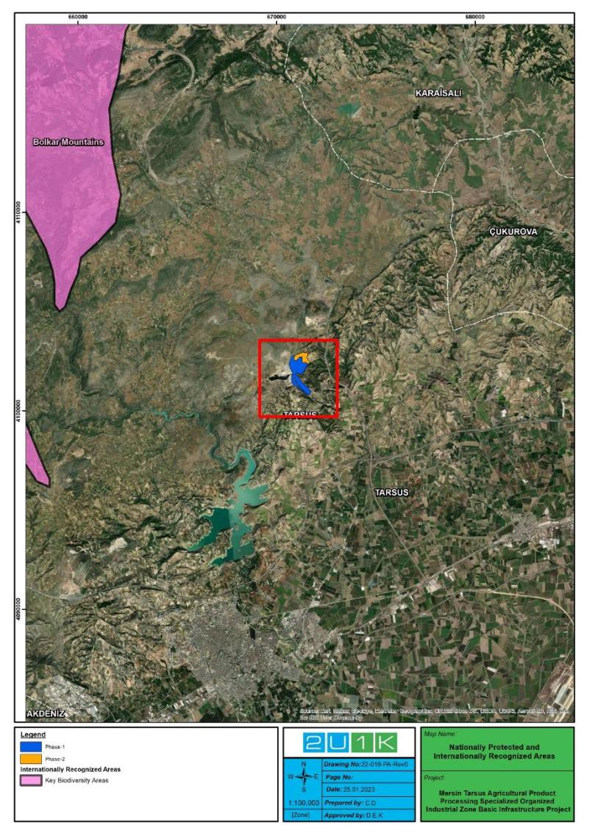
Figure 4-14. Internationally Recognized Areas

Nationally Protected and Internationally Recognized Areas are located a long distance from the project area. However, since the activities to be carried out are limited to the project area, the Nationally Protected and Internationally Recognized Areas are not under any threat due to the activities and are not expected to be damaged.
Although there are IUCN red-listed and endemic species among the species identified in the project area, the distribution of all these species is quite wide. Therefore, the effects of the project area on these species are quite limited. Additionally, there are no “National Protected Areas” or “Internationally Recognized Areas” (such as World Heritage Natural Sites, Biosphere Reserves, Ramsar Wetlands of International Importance, Key Biodiversity Areas, Important Bird Areas, and Alliance for Zero Extinction Sites) within the AoI. At the same time, the AoI does not have the characteristics of a feeding, breeding and stopover areas for migratory species. As a result of this assessment, the Project Area of Influence cannot be classified as a critical habitat.

SOCIAL BASELINE OF THE PROJECT
In this section, quantitative and qualitative data have been compiled for the social baseline of the Project. The purpose of the socio-economic baseline study is to describe socio-economic conditions and trends in areas potentially affected by the Project in order to understand potential impacts and develop appropriate mitigation measures. The social baseline identifies key socio-economic issues of provincial and local communities and establishes a socio-economic database that can be used to monitor changes in affected communities post Project.
The following topics were selected for discussion of social indicators of the settlements around the Project area:
- Cultural Heritage;
- Traffic and Transport;
- Demography and Population,
- Livelihoods and Employment,
- Education and Health Services;
- Vulnerable Groups,
- Infrastructure Services,
- Level of Knowledge about the Project.
A site visit was carried out on 20.12.2022 – 21.12.2022 to see the Project Area, identify sensitives and determine whether there are any formal and informal users on the land. During the site visit, a meeting was held with the TUIOSB and preliminary information about the Project was received. During the field visit, a meeting was held with the headmen of Kurbanlı, Eskişehir and Sağlıklı neighbourhoods.
Secondary data has an important role in understanding the social baseline and potential social risks and impacts. The information obtained from secondary data improves the quality of baseline studies. These data were collected and prepared through regional and national statistics and project documents.

Cultural Heritage
There is an ancient Roman road to the west of the OIZ, approximately 1.5 kilometres from the air distance. There are quarries between OIZ and the ancient Roman road. It is considered that the Project will have no impact on this area. Ancient Roman Road and the Project Area are presented in Figure 5-1.
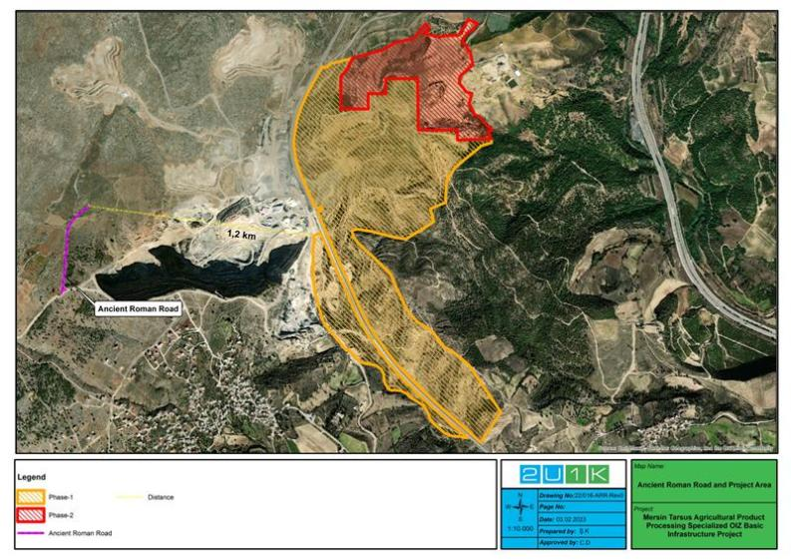
Figure 5-1. Ancient Roman Road and Project Area

Traffic and Transportation
A total of 8.85 km of road is planned to be built within the scope of the Project. Also, the Ankara-Aksaray Road (D750) separating the Project Area will be constructed as an intersection with traffic lights (see Figure 2-2 and Figure 2-14). The widening of the concerned road, which bisects the Project Area, and the construction of the lighted intersection on the road will be carried out by the General Directorate of Highways.
According to the 2020 state highways traffic volume map published by the General Directorate of Highways, the annual average daily number of vehicles on the Ankara-Aksaray Road (D750) passing through the west of the Project Area is 3,673 vehicles. Of these vehicles, 2,377 are automobiles, 419 are medium-load commercial vehicles, 14 are buses, 362 are trucks and 501 are tow trucks.

Demography and Population
The Project is planned to be established by the TUIOSB at Mersin Province, Tarsus District, Kurbanlı, Eskişehir, and Sağlıklı Neighbourhoods. According to 2021 data from the address-based population registration system of TurkStat, the population of Mersin province is 1,891,145. Tarsus has a population of 347,414 (Mersin Governorate, 2021).
During the site visit, headmen were asked questions about demographics and population.

Means of Livelihood and Employment
According to the Ministry of Industry and Technology, Mersin is 25th at the Socio-Economic Development Ranking of Provinces in 2017 (The Ministry of Industry and Technology, 2017). The livelihoods of Mersin district are agricultural production, industry, mining, and port activities. 40% of gross domestic product (gross income) is derived from industry, 30% from agriculture and 10% from trade.
The main agricultural products are wheat, barley, rye, rice, chickpeas, and lentils.
Mersin is the second most developed province in the Mediterranean region, after Adana. The industrial sector mainly produces cement, plastics, fertilizers, fabrics, and furniture.
According to the Ministry of Industry and Technology’s study, Tarsus ranks 4th in Mersin province and 198th in the general ranking in the Socio-Economic Development Ranking of Districts and is in the 2nd tier developed districts category. Agriculture is an important source of income in Tarsus’s economy. The climate is favourable for agriculture, enabling all kinds of production in agricultural lands. In lowland areas, vegetables and fruits are planted in the spring, followed by vegetables, cherries, and grapes. Industry is also among the main sources of livelihood in Tarsus district. These include factories making agricultural tools, machine spare parts, machine tools, packaged food factories, brick and ceramic factories (Tarsus Municipality).

Major Economic Activities in Settlements Located in the Project AoI
Information on economic activities was obtained during key informant interviews with the headmen of the Kurbanlı, Eskişehir and Sağlıklı neighbourhoods in the Project Area. The information provided is given in Table 5-1.
Table 5-1. Common Economic Activities in the Project Area
Settlement Area | Primary Economic Activity | Secondary Economic Activity | Tertiary Economic Activity
Kurbanlı Neighbourhood | Agriculture | Retirement | Husbandry
Eskişehir Neighborhood | Husbandry | Retirement | Agriculture
Sağlıklı Neighborhood | Transportation | Mining | Husbandry
All three neighbourhoods are sharing same kind of economic activities. Their main agricultural products are olive, citrus, wheat, barley, and sunflower. In Kurbanlı, Eskişehir and Sağlıklı Neighbourhood, big cattle and small cattle breeding is practiced.

Education and Health Services
There is a primary school in Sağlıklı neighbourhood. Children of Kurbanlı and Eskişehir neighbourhoods are transported to Sağlıklı neighbourhood. Education and health services close to the Project Area are shown in Figure 5-2.
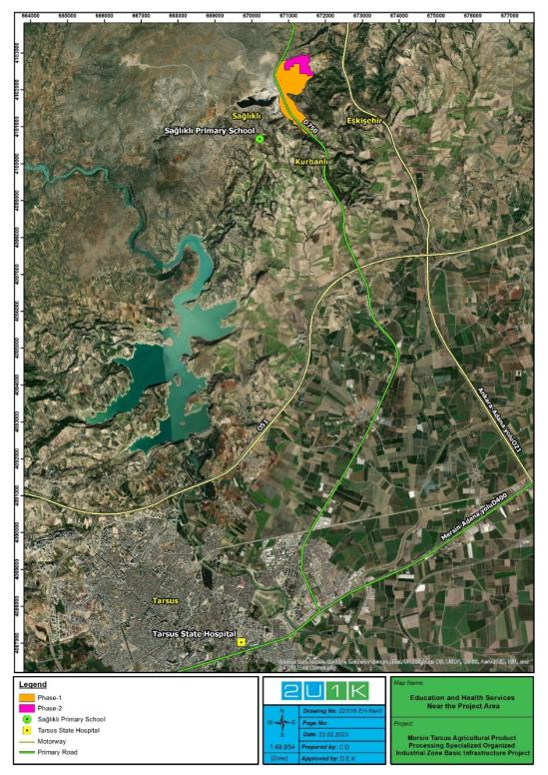
Figure 5-2. Education and Health Services Near the Project Area
In Türkiye, primary health care is the provision of diagnosis, treatment, and rehabilitation services at low cost. The name of this practice in Türkiye is family medicine.
There are 3,000 people per family physician in Türkiye. According to 2020 data, there are 26,594 Family Medicine units in Türkiye. There are 8,015 Family Health Centres. There are 779 Community Health Centres. There are 3,050 112 Emergency Aid Stations and 5,711 112 Emergency Aid Ambulances. According to 2018 TurkStat data, the total number of beds in Türkiye is 231,913 and the number of beds per 1,000 people is 2.83.
This ratio varies in places where the population is below 3,000 people or where access to health centres is difficult. In addition to this, there is a mobile health service for patients who cannot access health services or who have problems in travelling to health centres by their own means. Thus, health workers visit predetermined regions at certain intervals.
According to 2023 data, 30 institutions provide health services in Mersin Province. There are 15 Private Hospitals, 14 State Hospital and a university hospital.
In Mersin Tarsus district, 10 institutions provide health services. There are two (2) Private Hospitals, two (2) Dialysis Centers, one (1) Medical Center, one (1) State Hospital, one (1) Oral and Dental Health Center, one (1) Physical Therapy and Rehabilitation Center, one (1) Gynecology and Obstetrics Hospital, one (1) Ophthalmology Center. Residents of Kurbanlı, Eskişehir and Sağlıklı neighbourhoods are receiving health services from health centers in Tarsus district. All three neighborhoods are located approximately 17 km from Tarsus State Hospital.

Vulnerable Groups
The characteristics of persons belonging to vulnerable groups are as follows:
- Refugees;
- Ethnic minority groups;
- Individuals over 65 years of age living alone;
- Physically or mentally handicapped;
- Those who have a chronic illness or are bedridden;
- Women heads of households;
- Women living alone,
- Poor people who live on state or association aid;
- Nomads.
According to the information provided by the headmen of neighbourhoods, information about vulnerable/disadvantaged individuals/groups was received and the groups identified are presented in Table 5-2.
Table 5-2. Vulnerable/Disadvantaged Individuals/Groups in the Project Area
Settlement | Individuals over 65 years of age living alone | Poor families* | Physically / Mentally disabled | Refugee | Women Living alone
Kurbanli Neighborhood | approximately 20 people | approximately 10 households | 2 people | - | approximately 10 women
Eskisehir Neighborhood | approximately 10 people | approximately 10 households | 1 person | 1 person | between 10-15 households
Saglikli Neighborhood | unknown number | approximately 15 households | approximately 10 people | 1 person | between 25-30 households
Source: Survey study with the headmen, December 2022
* Households, which are depended on social and economic support are defined as Poor Family by headmen.

Seasonal Workers and Unemployed Person
The headmen were also asked if there were unemployed people throughout the settlement and the following answers in Table 5-3 were received.
Table 5-3. Unemployment in the Settlements
Settlement | Villagers who are looking for a job but cannot find it | N | Unemployed individuals in project-affected households
Sağlıklı | Yes | 15 | No
Kurbanlı | Yes | 1 | No
Eskişehir | No | 0 | No
Total |  | 16
Source: Community-Level Survey, Jan. 2023
It was asked whether seasonal workers come to the settlements at certain times of the year, and a positive response was received from the headman of a settlement (see Table 5-4).
Table 5-4. Seasonal Workers
Settlement | Are seasonal workers coming? | Purpose | No. of adult men | No. of adult women | No. of children
Sağlıklı | No | Agriculture | 40 | 10 | 0
Kurbanlı | No | NA | NA | NA | NA
Eskişehir | Yes | Agriculture | 100 | 80 | 20
Total |  |  | 140 | 90 | 20
Source: Community-Level Survey, Jan. 2023
It has been learned that seasonal agricultural workers do not stay within the AoI of the Project. Therefore, no effect is expected on seasonal agricultural workers.

Infrastructure Services
The following table presents the infrastructure services of the neighbourhoods in the social AoI.
Table 5-5. Infrastructure Services of the Neighbourhoods
Settlement | Water Resource | Irrigation Resource | Sewerage System | Waste Management | Mass Transportation Vehicle
Kurbanlı Neighbourhood | Well water | Ground water | Pond | Domestic wastes collected by the municipality | Minibus, personal automobile
Eskişehir Neighbourhood | Ground water | Ground water | Pond | Domestic wastes collected by the municipality | Minibus, personal automobile
Sağlıklı Neighbourhood | Well water | Ground water | Pond | Domestic wastes collected by the municipality | Minibus, personal automobile

Level of Information about the Project

Results of the Key Informant Interviews with Headmen
Community level information was collected through face-to-face key informant interviews with the headmen of Kurbanlı, Eskişehir and Sağlıklı Neighbourhoods on 20.12.2022 – 21.12.2022. The study aims to measure the level of information and to obtain information about the neighbourhood in order for the headmen to have a more realistic view on the possible project impacts and their expectations from the project. The survey provided information that the neighbourhood headman is informed about the Project and in contact with the OIZ management.
Stakeholders will be informed prior to the commencement of construction works in accordance with the environmental and social aspects and best practice mitigation measures given in Section 8 and based on the requirements for disclosure, stakeholder engagement, grievance mechanism.

ENVIRONMENTAL AND SOCIAL IMPACTS OF THE PROJECT
There are currently 30 people working for ground levelling at the Project Area and it is planned to employ a total of 250 people at peak time in the construction phase of the Project. During the operation phase, approximately 3,500 people are planned to be employed by the facilities to be located in the OIZ.
Since there are no exact information about the number of the facilities to be established within the OIZ and how many and which type of facility will be established, estimated information is presented in the subsections regarding the water to be used and the wastewater to be generated.
As a basic infrastructure project, the operation phase of the Project is a project whose environmental impact assessment can be limited in general. In addition to this, as operation and construction phases with the facilities to be established within the OIZ, the construction of Project’s Phase 2 Area, the construction and operation of the WWTP to serve the OIZ and natural gaseous line are not within the scope of loan usage, impact assessments for Project’s Phase 2 Area and WWTP have been included in corresponding subsections as associated facilities when need or/and cannot be separated from the Project. In addition, corresponding impact assessments for these activities have also been included in mitigation measures and monitoring plan tables of the Project.
Description of the Area of Influence
The ESF of WB was developed and replaced the Safeguard Policies of WB with the objective of creating better long-term development outcomes. The environmental and social assessment will be conducted and consider, in an integrated way, all relevant direct, indirect, and cumulative environmental and social risks and impacts of the project, including those specifically identified under ESS1-10. Accordinly, the “Project area of influence” (AoI) is determined.
This AoI is highly impact dependent, such as an emission source’s area of influence might be found with a dispersion model, while a wastewater discharge’s area of influence is related to the characteristics of the effluent and its discharge point. Thus, in the ESMP, the Project’s AoI is defined according to the impact type and magnitude and impact assessment done. Potentially Affected Parties particularly for the settlements in the close vicinity of the Project area that might be of the primary receptors of the impacts such as odour, noise and dust are identified based on the detailed impact assessment results. The settlements shown in Figure 2-5 is an indicative list that includes residential areas that is likely to be affected by direct impacts of the Project. The closest sensitive receptor that is identified within the AoI of the Project Area for the assessment of the social and environmental impacts is the house located at the 23 meters southwest of the Project Area (see. also Figure 2-4 and Figure 2-5). In this context, Project’s AoI for the Assessment of the Social and Environmental Impacts is presented in Figure 6-1.
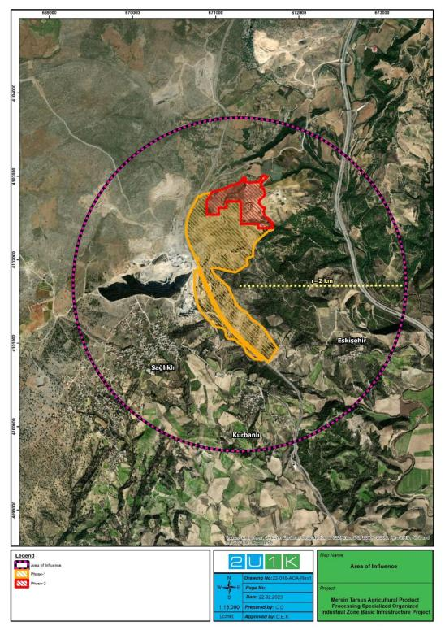
Figure 6-1. Project’s Area of Influence for the Assessment of the Social and Environmental Impacts
The Project will have impact on its surroundings during construction phase physically due to noise generation, increased dust emission, management of excavated soil, and emissions from the construction machinery. In addition, potential risks of labour influx may also pose for nearby communities. Thus, AoI of the Project has been selected with a radius of 2 km by taking the Project Area at the center, including the closest settlements to the Project Area, Evcisuyu Stream from the WWTP discharge point.
The main physical impacts of the operation phase for to be established WWTP, facilities, other buildings in the OIZ and natural gaseous line as associated facilities are wastewater discharge, sludge generation and disposal, greenhouse gas and odour emissions from facility and WWTP units directly, and increased water requirement for all units to be operated in the OIZ. Socially, employment opportunities will be provided for nearby communities.
- Wastewater discharge’s AoI is a section of the Evcisuyu Stream starting from the discharge point and it will be dependent on its quality and quantity, physical-chemical properties of the Evcisuyu Stream water and flowrate, and the region’s meteorological characteristics.
- By the use of good project management practices and application of the sludge treatment and disposal options assessed in the related feasibility report to be prepared, the impact of the sludge generation and disposal is considered to be local and minimal, provided that necessary measures are taken. With good management practices and appropriate mitigation measures any major residual impact of the sludges is not expected.
- For greenhouse gas emissions and odour, considering all of the surface areas of the OIZ units in total, the AoI regarding emissions to the air and odour is expected to be limited to the Project Area. Furthermore, impacts due to GHGs can only be evaluated in a cumulative way and the AoI of such an impact (change in GHG concentration in the atmosphere) can only be evaluated in a global context.

Air Quality

Construction Phase
Within the scope of the construction phase, excavation operations of the Project have been started in the Project Area. In this context, ground levelling in the concerned area has been almost completed and excavation works for basic infrastructure activities will be carried out.
In emission calculations, considering the cumulative environmental impacts, Phase 2 of the Project and adjacent quarries to the Project Area are also included.
In this context, the amount of excavation to be carried out on the total parcel is 3,781,808.69 m³, the amount of excavation to be made on the roads is 1,332,819.90 m³ and a total of 5,114,628.59 m³. The amount of backfilling to be made is 3,645,405.06 m³ for parcel areas, the amount of filling to be made for roads is 1,149,508.82 m³ and a total of 4,794,913.88 m³.
6% of the total area planned to be excavated is topsoil and it is 306,878 m³. Since topsoil density is 1.5 m³/tonnes, the amount of topsoil to be formed in the area is 460,317 tonnes. Topsoil area has been determined on the land and the area is 30,000 m². Currently, stripped topsoil was carried to the region in the Project Area allocated for afforestation (see Figure 4-6).
Excavation material of 94% is 4,807,750.58 m³, soil density is 2.4 m³/tonnes and 11,538,601.39 tonnes of material will be used in backfilling operations.
4,794,913.88 m³ of the 4,807,750.58 m³ excavation material to be excavated will be used in the backfilling and the remaining 12,836.7 m³ excavation material is planned to be sent to the permitted Excavation Storage Areas.
The following dust emission flowrate calculations were made by using emission factors specified in the Table 12.6 of the Regulation on Control of Industrial Air Pollution (RoCIAP), published in the Official Gazette dated 03.07.2009 and numbered 27277 (see Table 6-1).
Table 6-1. Emission Factors to be used in Dust Emission Mass Flowrate Calculations in the RoCIAP
Operation | Uncontrolled | Controlled | Units
Stripping | 0.025 | 0.0125 | kg/tonne
Loading | 0.010 | 0.005
Unloading | 0.010 | 0.005
Transportation (round trip total distance) | 0.7 | 0.35 | kg/km-trip
Laying | 5.8 | 2.9 | kg/ha-day
The dust emission flowrate calculation that may occur during the land preparation and topsoil related activities is given in Table 6-2, the dust emission flowrate calculation that may be generated regarding excavation material is given in Table 6-3, and the total dust emission flowrate from the Project’s two phases (for topsoil and excavation activities) is given in
Table 6-4.
Table 6-2. Calculation of Dust Emission Flowrate that may Occur Regarding Topsoil
Operation Time |  |  | Amount of Production
 |  |  | Time | Tonne
Excavation Period | 18 | months | Annually | 460,317
Monthly | 30 | days | Monthly | 25,573
Daily | 8 | hours | Daily | 852
Shift | 1 |  | Hourly | 107
- Stripping of Topsoil
Generation amount (tonne/hour) x Emission factor (kg/tonne)
1.a Uncontrolled |  | 107 tonnes/hour x 0.025 kg/tonne = 2.675 kg/hour
1.b Controlled |  | 107 tonnes/hour x 0.0125 kg/tonne = 1.3375 kg/hour
- Loading of Topsoil
Generation amount (tonne/hour) x Emission factor (kg/tonne)
2.a Uncontrolled |  | 107 tonnes/hour x 0.010 kg/tonne = 1.0655 kg/hour
2.b Controlled |  | 107 tonnes/hour x 0.005 kg/tonne = 0.5327 kg/hour
- Transportation of Topsoil (852 tonnes/day) (15 trucks of 40 tonnes)
Number of trips (trips/day) x Transport Distance (km) x Emission Factor (kg/km) x day/hour
3.a Uncontrolled |  | 21 trips/day x 1.5 km/trip x 0.70 kg/km x 1day/8 hours = 2.7562 kg/hour
3.b Controlled |  | 21 trips/day x 1.5 km/trip x 0.35 kg/km x 1 day/8 hours = 1.3781 kg/hour
- Unloading of Topsoil
Generation amount (tonne/hour) x Emission factor (kg/tonne)
4.a Uncontrolled |  | 107 tonnes/hour x 0.010 kg/tonne = 1.0655 kg/hour
4.b Controlled |  | 107 tonnes/hour x 0.005 kg/tonne = 0.5327 kg/hour
- Laying of Topsoil
Area (Ha) x Emission factor (kg/Ha-day)
5.a Uncontrolled |  | 3 Ha/24 hours/day x 5.8 kg/Ha-day = 0.725 kg/hour
5.b Controlled |  | 3 Ha/24 hours/day x 2.9 kg/Ha-day = 0.3625 kg/hour
Table 6-3. Calculation of Dust Emission Flowrate that may Occur Regarding Excavation Material
Operation Time |  |  |  | Amount of Production
 |  |  |  | Time |  | Tonne
Excavation Period | 18 | months | Annually |  | 11,538,601.39
Monthly | 30 | days | Monthly |  | 641,033
Daily | 8 | hours | Daily |  | 21,367
Shift | 1 |  | Hourly |  | 2,671
- Removal of Excavation Material (2,671 tons/hour)
Generation amount (tonne/hour) x Emission factor (kg/tonne)
6.a Uncontrolled |  | 2,671 tonnes/hour x 0.025 kg/tonne = 66.775 kg/hour
6.b Controlled |  | 2,671 tonnes/hour x 0.0125 kg/tonne = 33.38 kg/hour
- Loading of Excavation Material (2,671 tons/hour)
Generation amount (tonne/hour) x Emission factor (kg/tonne)
7.a Uncontrolled |  | 2,671 tonnes/hour x 0.010 kg/tonne = 26.71 kg/hour
7.b Controlled |  | 2,671 tonnes/hour x 0.005 kg/tonne = 13.355 kg/hour
- Transportation of Excavation Material to the Area to be Backfilled (21,311 tonnes/day)
Number of trips (trips/day) x Transport Distance (km) x Emission Factor (kg/km) x day/hour
8.a Uncontrolled |  | 35 trips/day x 1 km/trip x 0.70 kg/km x 1day/8 hours = 3.0625 kg/hour
8.b Controlled |  | 35 trips/day x 1 km/trip x 0.35 kg/km x 1 day/8 hours = 1.5312 kg/hour
- Transportation of Excavated Material to Licensed Storage Area (428 tonnes/day)
Number of trips (trips/day) x Transport Distance (km) x Emission Factor (kg/km) x day/hour
9.a Uncontrolled |  | 11 trips/day x 1 km/trip x 0.70 kg/km x 1day/8 hours = 0.9625 kg/hour
9.b Controlled |  | 11 trips/day x 1 km/trip x 0.35 kg/km x 1day/8 hours = 0.4812 kg/hour
- Unloading of Excavation Material to Backfill Area (2,664 tonnes/hour)
Generation amount (tonne/hour) x Emission factor (kg/tonne)
10.a Uncontrolled |  | 2,664 tonnes/hour x 0.010 kg/tonne = 26.64 kg/hour
10.b Controlled |  | 2,664 tonnes/hour x 0.005 kg/tonne = 13.32 kg/hour
Table 6-4. Total Dust Emission Flowrate from the Project’s Two Phases
No | Operation | Uncontrolled (kg/hour) | Controlled (kg/hour)
1 | Stripping of Topsoil | 2.675 | 1.3375
2 | Loading of Topsoil | 1.0655 | 0.5327
3 | Transportation of Topsoil | 2.7562 | 1.3781
4 | Unloading of Topsoil | 1.0655 | 0.5327
5 | Laying of Topsoil | 0.725 | 0.3625
TOTAL |  | 8.287 | 4.144
6 | Removal of Excavation Material | 66.775 | 33.38
7 | Loading of Excavation Material | 26.71 | 13.355
8 | Transportation of Excavation Material to the Area to be Backfilled | 3.0625 | 1.5312
9 | Transportation of Excavated Material to Licensed Storage Area | 0.9625 | 0.4812
10 | Unloading of Excavation Material to Backfill Area | 26.64 | 13.32
TOTAL |  | 124.15 | 62.067
GENERAL TOTAL |  | 132.437 | 66.211

Mass Flowrates from Cumulative Impacts
It is planned that dust emission will occur due to material quarries, the heating of the settlement areas located near the Project Area and the highway.
In this context, there is the quarry mining silica sand named Silis Madencilik near to the Project Area. According to the information received from the concerned quarry authorities; it did not produce silica sand in 2019 and 2020. The last year of its production is 2018 and the reported amount is 400 tonnes/year silica sands. Accordingly, dust emission calculations are given in Table 6-5.
Table 6-5. Dust Emission Flowrate Calculation Generated During Silica Sand Mining
Operation Time |  |  | Amount of Production
 |  |  | Time | Tonne
Excavation Period | 12 | months | Annually | 400
Monthly | 30 | days | Monthly | 33.33
Daily | 8 | hours | Daily | 1.11
Shift | 1 |  | Hourly | 0.139
- Removal of Silica Sand
Generation amount (tonne/hour) x Emission factor (kg/tonne)
1.a Uncontrolled |  | 0.139 tonne/hour x 0.025 kg/tonne = 0.00034 kg/hour
1.b Controlled |  | 0.139 tonne/hour x 0.0125 kg/tonne = 0.000017 kg/hour
- Loading of Silica Sand
Generation amount (tonne/hour) x Emission factor (kg/tonne)
2.a Uncontrolled |  | 0.139 tonne/hour x 0.010 kg/tonne = 0.00013 kg/hour
2.b Controlled |  | 0.139 tonne/hour x 0.005 kg/tonne = 0.000695 kg/hour
- Unloading of Silica Sand (0.139 tons/hour)
Generation amount (tonne/hour) x Emission factor (kg/tonne)
3.a Uncontrolled |  | 0.139 tonne/hour x 0.010 kg/tonne = 0.00013 kg/hour
3.b Controlled |  | 0.139 tonne/hour x 0.005 kg/tonne = 0.000695 kg/hour
- Transportation of Silica Sand
Number of trips (trips/day) x Transport Distance (km) x Emission Factor (kg/km) x day/hour
4.a Uncontrolled |  | 1 trip/day x 1 km/trip x 0.70 kg/km x 1 day/8 hours = 0.0875 kg/hour
4.b Controlled |  | 1 trip/day x 1 km/trip x 0.35 kg/km x 1 day/8 hours = 0.04375 kg/hour
Thus, the total dust emission flowrate from the Silica Sand Mining is calculated in Table 6-6.
Table 6-6. Total Dust Emission Flowrate from Silica Sand Mining
No | Operation | Uncontrolled (kg/hour) | Controlled (kg/hour)
1 | Removal of Silica Sand | 0.00034 | 0.000017
2 | Loading of Silica Sand | 0.00013 | 0.000695
3 | Unloading of Silica Sand | 0.00013 | 0.000695
4 | Transportation of Silica Sand | 0.0875 | 0.04375
TOTAL |  | 0.0881 | 0.045157
On the other hand, there is the limestone quarry operated by Canoğulları Madencilik Nakliye İnşaat A.Ş. near the Project Area. Dust emission flowrate amount was calculated as 14.76 kg/hour in the Project Identification Document of the 1st Capacity Increase Project of the concerned quarry.
In addition to this, dust emission mass flowrate calculations due to the heating of the settlements in the area within a radius of 2 km drawn from the center of the Project Area are given in Table 6-7 and the number of households is accepted as 4 people.
It is assumed that coal is used in households for heating and 1 tonne of coal is used for one winter period in each household and calculated by using the Table 3-3 Tier 1 emission factors in Small Combustion (1.A.4) section of the European Monitoring and Evaluation Programme (EMEP)/European Environment Agency (EEA) Emission Inventory Guidebook 2013. According to EMEP/EEA data, the PM₁₀ emission factor due to coal burning is 404 g/GJ. Accordingly, the annual dust emission for each settlement was calculated as follows. (In the calculations, the calorific value of the coal is 6,000 kcal/kg, and coal is used for heating purposes for 5 months of the year).
For 1 House = 1 household *1,000 kg/year-house * 6,000 kcal/kg * 404 g/GJ / * 1 GJ/ 238,902.95 Kcal * 1 year/150 days *1 day/24 hours * 1 kg/1,000 g = 0.002818 kg/hour
Table 6-7. Heating-Related Dust Emission Mass Flowrates
Settlement | TurkStat 2020 Population (people) | Number of Households (number) | Emission Mass Flowrate (kg/hour)
Gürlü Neighbourhood | 80 | 20 | 0.0564
Sağlıklı Neighbourhood | 1,283 | 321 | 0.9046
Kurbanlı Neighbourhood | 152 | 38 | 0.1071
Eskişehir Neighbourhood | 94 | 24 | 0.0676
TOTAL |  |  | 1.1357
As for the road-related cumulative environmental impacts, according to the 2020 state highways traffic volume map published by the General Directorate of Highways, the annual average daily number of vehicles on the Ankara-Aksaray Road (D750) passing through the west of the Project Area is 3,673 vehicles. Of these vehicles, 2,377 are automobiles, 419 are medium-load commercial vehicles, 14 are buses, 362 are trucks and 501 are tow trucks.
According to the 2020 state highway traffic volume map published by the General Directorate of Highways, the annual average daily number of vehicles on the highway from the Tarsus-Ankara Highway (E90, O-21) passing through the east of the Project Area is 22,830 vehicles. 12,890 of these vehicles are light vehicles and 9,940 are heavy vehicles.
In the calculation of PM₁₀ emissions from vehicles, air emissions in grams per vehicle and km, EMEP/EEA Air Pollutant Emission Inventory Guide (EMEP/EEA 2016 update Jul. 2018) published by the European Environment Agency, Section 1.A.3.b Road Transport emission factors were used.
According to TurkStat 2021 Distribution of Registered Cars by Fuel Type, 24.9% of the vehicles are gasoline, 38.1% diesel, 36.3% LPG, 0.4% hybrid and 0.3% unknown. However, when determining the emission factor, the worst case was considered and the diesel vehicle and conventional driven vehicle class with the largest emission factor were selected.
The impact area includes 4.2 km of Ankara-Aksaray Road and 1.6 km of Tarsus-Ankara Highway.
Mass flowrates calculated according to the emission factors given in the EMEP/EEA Air Pollutant Emission Inventory Guide are given in Table 6-8 and Table 6-9. In this context, the calculation has been made cumulatively due to the quarries very close to the Project Area, which cause permanently continuous intense dust emission. In addition, the main road traffic passing through the Project Area will also have a high impact. Considering these high impacts, dust emission mass flowrate calculation has been made.
Table 6-8. Emission Factors and Dust Emission Mass Flowrates of Vehicles on Ankara-Aksaray Road
Vehicle | Number of Vehicles (day) | Emission Factor (g/km) | Remaining Road within the Area of Influence (km) | Mass Flowrate (kg/hour)
Automobile | 2,377 | 0.2209 | 4.2 | 0.0919
Medium-Load Commercial Vehicle | 419 | 0.356 | 4.2 | 0.0261
Bus | 14 | 0.909 | 4.2 | 0.0022
Truck | 362 | 0.418 | 4.2 | 0.0265
Tow Truck | 501 | 0.491 | 4.2 | 0.0430
TOTAL | 3,673 |  |  | 0.1897
Table 6-9. Emission Factors and Dust Emission Mass Flowrates of Vehicles on the Tarsus-Ankara Highway
Vehicle | Number of Vehicles (day) | Emission Factor (g/km) | Remaining Highway within the Area of Influence (km) | Mass Flowrate (kg/hour)
Automobile | 12,890 | 0.2209 | 1.6 | 0.1898
Tow Truck | 9,940 | 0.491 | 1.6 | 0.3254
TOTAL | 22,830 |  |  | 0.5152
The mass flowrates of the pollutant emissions calculated above are shown in Table 6-10 collectively.
Table 6-10. Total Dust Emission Mass Flowrates
Source | No | Operation | Uncontrolled (kg/hour) | Controlled (kg/hour)
Topsoil and Excavation Operations | 1 | Stripping of Topsoil | 2.675 | 1.3375
 | 2 | Loading of Topsoil | 1.0655 | 0.5327
 | 3 | Transportation of Topsoil | 2.7562 | 1.3781
 | 4 | Unloading of Topsoil | 1.0655 | 0.5327
 | 5 | Laying of Topsoil | 0.725 | 0.3625
 | 6 | Removal of Excavation Material | 66.775 | 33.38
 | 7 | Loading of Excavation Material | 26.71 | 13.355
 | 8 | Transportation of Excavation Material to the Area to be Backfilled | 3.0625 | 1.5312
 | 9 | Transportation of Excavated Material to Licensed Storage Area | 0.9625 | 0.4812
 | 10 | Unloading of Excavation Material to Backfill Area | 26.64 | 13.32
Silica Sand Quarry | 11 | Removal of Silica Sand | 0.00034 | 0.000017
 | 12 | Loading of Silica Sand | 0.00013 | 0.000695
 | 13 | Unloading of Silica Sand | 0.00013 | 0.000695
 | 14 | Transportation of Silica Sand | 0.0875 | 0.04375
Limestone Quarry | 15 | Limestone Mining |  | 14.76
Heating | 16 | Coal Burning in Gürlü Neighbourhood |  | 0.0564
 | 17 | Coal Burning in Sağlıklı Neighbourhood |  | 0.9046
 | 18 | Coal Burning in Kurbanlı Neighbourhood |  | 0.1071
 | 19 | Coal Burning in Eskişehir Neighbourhood |  | 0.0676
Road and Highway | 20 | Ankara-Aksaray Road (D750) |  | 0.1897
 | 21 | Tarsus-Ankara Highway (E90, O-21) |  | 0.5152
GENERAL TOTAL |  |  | 132.5253 | 82.8567
Controlled dust emissions from all emission sources are given in Table 6-9. The concerned value (82,8567 kg/hour) is more than 1 kg/hour, which is the limit value outside the chimney specified within the scope of Annex-2 of the RoCIAP. Therefore, air quality distribution modelling for dust emissions is required to be carried out and contribution values to air pollution should be calculated. Hence, contribution values to air pollution were calculated for the following scenarios within the scope of the air quality distribution modelling study. (Burced Engineering Service Co.Ltd.,The EIA Report of the OIZ, 2022)
Scenario 1: Project Related Dust Emission Operations
Scenario 2: Cumulative (Emissions from the Project, Road, Highway, and Heating) Dust Emission Operations
As a result of the concerned modelling study, it was observed that calculated emissions are below the limit values specified in all scenarios for settling dust and PM₁₀ emissions in the RoCIAP. On the other hand, in terms of international requirement, it is seen that PM₁₀ limit values that are defined in Table 1.1.1: WHO Ambient Air Quality Guidelines in IFC EHS Guidelines are exceeded for both scenarios. These national and international air quality limit values and calculated emission values are presented in Table 6-11.
Table 6-11. National and International Air Quality Limit Values and Calculated Emission Values
Parameter | Duration | Unit | Air Quality Limit Values in the RoCIAP | Air Quality Limit Values in the  IFC EHS Guidelines’ | Calculated Emission Values in Modelling Study
PM₁₀ | 24 hours | µg/m³ | 50¹ | 50² | Scenario 1: 192  exceeded 29 times  Scenario 2: 193  exceeded 29 times
 | Annual |  | 40 | 20 | Scenario 1: 25  Scenario 2: 26
Settling Dust | Short Term Limit Value | mg/m²gün | 390 | - | Scenario 1: 209  Scenario 2: 209
 | Long Term Limit Value |  | 210 | - | Scenario 1: 93  Scenario 2: 93
¹ (not to be exceedance more than 35 times per year)
² (99th percentile (i.e.3-4 exceedance days per year))
Diesel will be used in the construction machines to be used during the construction works of the Project. Diesel, whose characteristics are given in Table 6-12, will be supplied from the nearby fuel sales stations.
Table 6-12. Specification of Diesel
Specification | Unit | Value
Density (at 15 ⁰C) | kg/m³ | 820-845
Polycyclic aromatic hydrocarbons | % weight | 11
Flash Point | ⁰C | 55
Cold Filter Plugging Point | ⁰C
Winter (a) |  | -15
Summer (b) |  | 5
Distillation
Obtained at 250 ⁰C | % volume | 65
Obtained at 350 ⁰C | % volume | 85
The temperature at which 95% (volume/volume) is achieved | ⁰C | 360
Sulphur | mg/kg | 10
Carbon Residue | % volume | 0,3
(at 10% distillation residue)
Viscosity (at 40 ⁰C) | Cst | 2,0-4,5
Copper Strip Corrosion |  | No.1
(3 hours at 50 ⁰C)
Ash | % weight | 0,01
Cetane number |  | 51
Cetane Index | calculated | 46
Water | mg/kg | 200
Total Pollution | mg/kg | 24
Oxidation Stability | g/m³ | 25
Lubrication feature at 60 ⁰C | µm | 460
Corrected wear scar diameter
Emission factors developed by the United States Environmental Protection Agency (U.S.EPA) and given in Table 6-13 were used to calculate the possible emissions from vehicles to be used during the construction works of the Project.

Table 6-13. Emission Factors Originating from Diesel Vehicles (kg/tonne)
Pollutant | Diesel
Carbon Monoxides | 7.2
Hydrocarbons | 16.3
Nitrogen Oxides | 26.6
Sulphur Oxides | 4.8
Source: Compilation of Air Pollution Emission Factors Volume I: Stationary Point and Area Sources”, 4th ed., AP-42, U.S. EPA, Office of Air Quality Planning and Standards, 1985, with updates through September 1991
It is planned to use maximum forty-one (41) construction machines operating at the same time during the construction phase of the Project (see Table 6-21) and there will be no use of construction equipment during the operation phase. With the worst-case assumption that these vehicles will operate at the same time, it is predicted that the maximum amount of diesel fuel a vehicle will consume will be 5 L/hr-vehicle. In this regard, mass flow calculations have been made for exhaust emissions and the calculations are given below.
Density of Diesel = 0.830 kg/L
5 L/hr-vehicle x 0.830 kg/L x 41 vehicles = 170.15 kg/hour = 0.17015 tonne/hr due to usage:
Carbon monoxides : 7.2 kg/tonnes x 0.17015 tonne/hour = 1.23 kg/hr
Hydrocarbons : 16.2 kg/tonnes x 0.17015 tonne/hour = 2.76 kg/hr
Nitrogen Oxides : 26.6 kg/tonnes x 0.17015 tonne/hour = 4.53 kg/hr
Sulphur Oxides : 4.8 kg/tonnes x 0.17015 tonne/hour = 0.82 kg/hour.
The mass flowrates of the exhaust emissions that will arise from the vehicles that will operate during the construction works (lower limit values determining the modelling work requirement in the Annex-2 Table 2.1 of the RoCIAP together with the calculated mass flowrates of the emissions originating from the locations outside the chimney are presented in Table 6-14. All concerned calculated exhaust emission mass flowrate values for the parameters except for the NO_{x} are below the corresponding limit values specified in the RoCIAP.
Table 6-14. Lower Limit Values of Modelling Study with Calculated Exhaust Emissions Mass Flowrates
Emissions | Calculated Exhaust Emissions Mass Flowrates (kg/hr) | Annex-2 Table 2.1 of the RoCIAP  Lower Limit Values for the Locations Outside the Chimney (kg/hr)
Carbon Monoxide (CO) | 1.23 | 50
Sulphur Oxide (SO_{x}) | 0.82 | 6
Nitrogen Dioxide [NO_{x} (as NO₂)] | 4.53 | 4
Total Organic Compounds | 2.56 | 3

The vehicles to be used within the Project Area will be regularly maintained, the exhaust emissions will be measured and recorded by authorized institutions, and the provisions of the “Regulation on Control of Exhaust Gas Emissions” published in the O.G. dated 11.03.2017 and no 30004, will be complied with.
Consequently, considering that the modelling study was prepared with the worst-case scenario in mind, the air quality impact significance in the construction phase of the Project is determined as medium.

Operation Phase
There will be facilities that can generate emissions in the OIZ Area throughout the operation phase. In this regard, these facilities were evaluated as associated facility, and their air quality impact assessments were detailed in this section.
During the operation phase of the OIZ, it is planned to use electrical energy for heating and natural gas as fuel in the facilities where heat treatment is applied. The sectors that the natural gas is planned to be used in the OIZ as follows: Steam Boilers and Pasteurization in Fruit Juice Production, Pulses Drying and Packaging Facilities, Canned Production, Tobacco Processing Facilities. In this context, emission factors for pollutants released into the atmosphere because of burning natural gas in small boilers are given in Table 6-15.
Table 6-15. Emission Factors for Natural Gaseous
Emission Factors for Natural Gaseous
Parameters | Emission Factors in Small Boilers  (kg/10⁶ m³)
NO_{x} | 800.9
CO | 1,345.55
PM | 121.74
TOC | 176.20
SO₂ | 9.61
Source: U.S. Environmental Protection Agency (US EPA)
The quantity of natural gas to be used in the facilities will vary depending on the capacity of the facility to be established, and it is anticipated that an average of 250,000 m³/year natural gas will be used in a facility.
Accordingly, the emission mass flowrate from a facility and its comparison with the limit values given in the RoCIAP are given in Table 6-16. It has been observed that these values are well below the limit values given in Table 2-1 of Annex-2 of the RoCIAP.
Table 6-16. Emission Mass Flowrate and Limit Values to be Formed from a Facility
Parameters | Natural Gas Consumption of a Facility | Emission Factors in Small Boilers  (kg/10⁶ m³) | Emission Mass Flowrate (kg/hour) | Table 2.1 Mass Flowrate kg/hour of Annex 2 of the RoCIAP
NO_{x} | 250,000 m³/year | 800.9 | 0.083 | 40
CO |  | 1,345.55 | 1.401 | 500
PM |  | 121.74 | 0.012 | 10
TOC |  | 176.20 | 0.018 | 30
SO₂ |  | 9.61 | 0.001 | 60
In the facilities to be established in the OIZ, emission measurements will be made in the boilers and process-purpose chimneys during the period when they are put into operation. Steam boiler and chimney system will be compatible with each other in the boilers to be used in the facilities and related TSE standards should be applied in this regard. In this context, the limit values below specified in Table 5.2 of Annex-5 of the RoCIAP should be complied with.
Table 6-17. Combustion Thermal Power Limit Values in the RoCIAP
Fuels | Sulphur dioxide (mg/Nm³) | Carbon monoxide (mg/Nm³) | Nitrogen dioxide (mg/Nm³) | Dust  (mg/Nm³)
Natural Gas, LPG, Refinery gas | 100 | 100 | 800 | 10
Thus, the concerned air quality impact significance in the operation phase of the OIZ is determined as low.

Water Use
Water needs for toilets and baths will be met from the licenced wells. It will be evaluated whether treatment will be required according to the analysis results of the samples to be taken from the wells in accordance with the Regulation on Water Intended for Human Consumption. In addition, it is planned to meet the drinking water need from bottled water. In this context, there will be no water usage from Berdan Dam during construction and operation phase of the Project.

Construction Phase
Water will be required in the Project’s Construction Phase for domestic use.
Construction Phase Daily water requirement = person x avg. water consumption
= 250 person x 181 lt/day-person
= 45,250 lt/day (45.25 m³/day)
Water will be used for ready mixed concrete irrigation, plaster, screed, and other processes during the construction phase. The water requirement for these purposes will be 850 m³/day on average.
In addition, the amount of water to be used per day for dust suppression during the construction phase is calculated below and the amount of water to be used for an area of m² is taken as 1.5 lt/day.
The total area where the dust emission will be = 1,162,900 m²
Maximum amount of water to be used per m² area = 1,162,900 m² x 1.5 lt/day x 1m³/1,000 lt
= 1,744.35 m³/day
Total amount of water to be used = 45.25 m³/day + 850 m³/day + 1,744.35 m³/day
= 2,653.6 m³/day
This value corresponds to approximately 61 % of the Project’s allocated water quantity.
Hence, considering the water quantity calculation, the concerned impact significance in the construction phase of the Project is determined as low.

Operation Phase
Likewise in construction phase, water demand for toilets and baths will be met from the licenced wells, and it is planned to meet the drinking water need from packaged water.
Water will be required in the Project’s Operation Phase for domestic use.
Construction Phase Daily water requirement = person x avg. water consumption
= 3,500 person x 181 lt/day-person
= 633,500 lt/day (633.5 m³/day)
Also, with the commissioning of the OIZ, process water demands will arise from the facilities in different sectors (see Table 6-18).
Table 6-18. Planned Domestic and Process Water Demand Amounts of Facilities in OIZ
Sectors | Personnel  (person) | Process Water Demand  (m³/day) | Domestic Water Demand  (m³/day)
Nuts, Coffee Processing, Tahini, Halva Production and Packaging | 600 | - | 108.60
Spice Processing and Packaging | 210 | 400 | 38.01
Pulses Drying, Screening and Packaging | 180 | 100 | 32.58
Tobacco Processing | 150 | 20 | 27.15
Pasteurized Liquid Egg Production (300 tonnes/day) | 150 | 50 | 27.15
Fruit Juice Production, Fruit Extracts (Vinegar, Molasses, Pomegranate Syrup, Lemon Sauce) Processing | 180 | 1,250 | 32.58
Fisheries Processing, Packaging and Storage | 180 | 300 | 32.58
Processing of Medicinal and Aromatic Plants Production of Herbal Cosmetics | 180 | 50 | 32.58
Canned Food Production | 140 | 1,506.5 | 25.34
Seed Screening, Processing and Packaging | 120 | - | 21.72
Agricultural Machinery Production | 810 | - | 146.61
Other Personnel | 600 | - | 108.60
TOTAL | 3,500 | 3,676.5 | 633.5
TOTAL WATER NEED |  | 4,310 m³/day
Considering the planned domestic and process water demand amounts of facilities in OIZ, TUOISB secured a Groundwater Exploration Document from DSI with water allocation requirement as 4,310 m³/day (see Appendix-C).
Thus, considering the excess water demand quantity to be met from the wells in OIZ Area, the water use impact significance in the operation phase of OIZ is determined as high. In order to mitigate the concerned risk, Sustainable Water Management Plan for the Project should be prepared by TUIOSB before the operation phase of the Project.

Wastewater

Construction Phase
During the construction phase of the Project, domestic wastewater will be generated only from human consumption. Thus, 45.25 m³/day domestic water from employees, with an assumption that all used domestic water will be stored in impermeable septic tank as wastewater to be transferred with permitted septic trucks and sent to be disposed of at nearest WWTP deemed appropriate by the Tarsus Municipality. Thus, considering the wastewater quantity in the construction phase of the Project, the wastewater impact significance in the AoI of the Project is determined as low.

Operation Phase
As the construction and operation of the wastewater treatment plant to be established in the OIZ are not within the scope of loan usage, its impact assessment has been not detailed. But it has been assessed as associated facility.
The domestic wastewater from employees and the process wastewater to be generated in the facilities planned to be established in the OIZ will be treated with its wastewater infrastructure system. In this context, the anaerobic and biological wastewater treatment plant with a capacity of 2,600 m³/day is planned to be established in the OIZ. The proposed system will consist of physical, chemical, biological and sludge treatment units due to the pollution loads of domestic and process wastewater to be generated in the OIZ.
The estimated quantities of domestic and process wastewater that will be generated in the facilities planned to be established in the OIZ Area can been seen in Table 6-19.
Table 6-19. The Estimated Quantities of Wastewater in OIZ
Sectors | Domestic Wastewater  (m³/day) | Process Wastewater (m³/day)
Nuts, Coffee Processing, Tahini, Halva Production and Packaging | 108.60 | 400
Spice Processing and Packaging | 38.01 | 100
Pulses Drying, Screening and Packaging | 32.58 | 20
Tobacco Processing | 27.15 | 50
Pasteurized Liquid Egg Production (300 tonnes/day) | 27.15 | 500
Fruit Juice Production, Fruit Extracts (Vinegar, Molasses, Pomegranate Syrup, Lemon Sauce) Processing | 32.58 | 200
Fisheries Processing, Packaging and Storage | 32.58 | 50
Processing of Medicinal and Aromatic Plants Production of Herbal Cosmetics | 32.58 | 500
Canned Food Production | 25.34 | -
Seed Screening, Processing and Packaging | 21.72 | -
Agricultural Machinery Production | 146.61 | -
Other Personnel | 108.60 | -
TOTAL | 633.5 | 1,820
QUANTITY OF WASTEWATER TO BE TREATED | 2,453.5 m³/day
Domestic wastewater from employees within OIZ and process wastewater to be generated in facility operations are planned to be treated in the wastewater treatment plant (WWTP) with a capacity of 2,600 m³/day. The planned WWTP will consist of the following physical, chemical, biological and sludge treatment units.
- Wastewater Inlet and Screens
- Stone Trap
- Oil and Grease Removal
- Balancing Tank
- Chemical Treatment Unit
  - Coagulation Tank
  - Flocculation Tank
  - Preliminary Settling Tanks
- Biological Treatment Unit
- Final Settling Tanks
- Sludge Thickening and Dewatering Unit
The treated wastewater will meet the criteria in Table 19 of the Regulation on Control of Water Pollution (RoCWP), revised in the Official Gazette dated 17.12.2022 and numbered 32046. The concerned table is presented in Table 6-20. The effluent provided that securing permission from the department in the 6th Region of DSI will be discharged to the Evcisuyu Stream which is approximately 30 meters from the outlet of planned WWTP.
Table 6-20. Discharge Standards for the Treated Process Water to Receiving Environment in the RoCWP for planned WWTP
Parameter | Unit | Composite Sample  2 hours
Chemical Oxygen Demand (COD) | mg/l | 250
Total Suspended Solids (TSS) | mg/l | 200
Oil and Grease | mg/l | 20
Total Phosphorus | mg/l | 2
Total Chrome | mg/l | 2
Chrome (Cr⁺⁶) | mg/l | 0.5
Lead (Pb) | mg/l | 2
Total Cyanide (Cn⁻) | mg/l | 1
Cadmium (Cd) | mg/l | 0.1
Ferrous (Fe) | mg/l | 10
Fluoride (F⁻) | mg/l | 15
Copper (Cu) | mg/l | 3
Zinc (Zn) | mg/l | 5
Mercury (Hg) | mg/l | 0.05
Sulphate (SO₄) | mg/l | 1,500
Total kjeldahl-nitrogen | mg/l | 20
Fish Bioassay (Zsf) | - | 10
pH | - | 6-9
Color | (Pt-Co) | 280
In addition to this, collected wastewater from sink and bath that along a separate line of the OIZ will be directed to the relevant section of the WWTP, which will treat all the wastewater originating from the OIZ (see Figure 2-11). Since the design works of the WWTP has not been completed yet, no detail information could be given about the arrangements to be made in the design of the WWTP. However, after the collected wastewater being treated in WWTP, treated wastewater will be directed to the reservoir with capacity of 1,500 m³ and is planned to be reused within the OIZ for the purposes other than production or potable water. In addition to this, stormwater will be collected with a concerned network and will be diverted to a storage tank with a capacity of 1,800 m³. The collected stormwater is planned to be used for irrigation activities within the OIZ. When the collection tank is full, excess stormwater will be transferred to the receiving body as Evcisuyu Stream to discharge (see Figure 2-12).
There is an important case where the WWTP is not included in the project loan usage but is part of another construction process. Therefore, the WWTP should be operational before the first wastewater generating facility or unit in the OIZ becomes operational. Thus, considering the wastewater generation in the operation phase of the OIZ, the wastewater impact significance in the AoI of the Project is determined as high. In this context, Before the WWTP construction and operation works, it is necessary to complete specific management plans including Sludge Management Plan, Effluent Management Plan and Odour Management Plan. The concerned plans will be prepared by TUIOSB before the operation phase of the Project.

Waste

Construction Phase
According to the preliminary observations in lot 105: parcel no. 1 and 2 of the Project Area, together with the presence of inert wastes from the buildings to be demolished in this relevant area, there are other non-hazardous and hazardous wastes left in the area that should be disposed in accordance with the national legislation. Accordingly, wastes that may arise from the construction phase of the Project and their environmental impact assessments are detailed below.
Domestic Solid Wastes
It is planned that 250 people will work during the peak time of the construction phase of the Project. The amount of domestic solid waste to be generated is calculated by taking the unit amount of 1.21kg/person-day for Mersin Province.
250 persons x 1.21 kg/person-day = 302.5 kg/day.
The municipal wastes to be generated should be collected in containers within the Project Area. The collection of the wastes accumulated in the containers should be carried out by the Municipality of Tarsus and should be transferred to the Mersin Metropolitan Municipality Solid Waste Landfill at certain periods.
Packaging Waste
The ratio of recyclable packaging waste is in metropolitan cities in Türkiye as follows. 48 kg/P-year paper and board, 14 kg/P-year plastic, 6 kg/P-year nylon, 8 kg/P-year metal, 8 kg/P-year glass, in total 84 kg/P-year.
250 persons x 84 kg/P-year = 21,000 kg/year = 57.6 kg/day.
Packaging wastes made of plastic, metal, glass, paper and board, composite and similar materials should be collected separately from other wastes and given to Packaging Waste Collection, Segregation and Recovery Facilities licensed by the MoEUCC.
Excavation Waste
The excavation waste estimated to be generated during the construction phase of the Project is calculated as 4,807,750.58 m³ in the Section 6.1.1. In this context, 4,794,913.88 m³ excavation material to be excavated will be used in the backfilling in Project Area and the remaining 12,836.7 m³ excavation material is planned to be sent to the permitted Excavation Storage Areas.
Construction Waste
Since the title deed processes of lot 105: parcel no. 1 and 2 belonging to the Project have not been completed yet, it has been observed that ground levelling processes have not started in this area. 2U1K also observed the structures of the gas station that was previously operating in this area (see ). Therefore, construction and demolition wastes will be generated from the concerned area. So, management of these wastes should be conducted in compliance with the provisions of the relevant national regulation.
Hazardous Wastes
2U1K observed that there have been hazardous wastes in lot 105: parcel no. 1 and 2 of the Project Area (see Figure 4-5). Hazardous wastes in this area should be transported to licensed haulers and provided to be delivered to licensed disposal and recovery companies as soon as possible. The presence of asbestos containing material was not established within the area. If any asbestos is identified, mitigation measures are identified in the Section 8.1.
During the construction phase of the Project, also paint etc. empty containers of materials to be used due to processes, paint, etc. gloves etc. contaminated with chemicals. waste is likely to be generated. Therefore, collection and disposal of these hazardous wastes should be carried out based on the relevant national regulation.
Waste Tires
It is possible that the end-of-life tire will be formed due to the construction equipment and vehicles to be used during the construction processes. Since the construction machinery and vehicles to be used during the construction works will belong to the contractor companies, the maintenance, repair, and service operations of these vehicles should be carried out by the contractor company. Maintenance, repair, and service operations should not be carried out at the Project Area, and if, for any reason, expired tires occur, the tires should be sent to authorized companies or to licensed tire intermediate storage/recovery facilities.
Waste Batteries and Accumulators
It is probable that waste accumulators will occur due to construction machinery and vehicles to be used during construction processes. Since the construction machinery and vehicles to be used during the construction activity will belong to the contractor company, the maintenance, repair, and service operations of these vehicles should be carried out by the contractor company. Maintenance, repair, and service should not be performed at the Project Area, and in case of any waste accumulator formation for any reason, the waste accumulators should be sent to authorized companies or licensed hazardous waste recycling facilities.
Medical Wastes
The medical needs of the personnel who will work during the construction processes will be met in the health institutions outside the Project Area. Simple first aid equipment to be used in the first response in emergency and important situations will be available at the Project Area, and in case of medical waste resulting from interventions due to a possible accident, it will be sent to licensed medical waste sterilization facilities.
Waste Oils
It is probable that waste oil will be generated from the construction machinery and vehicles to be used during the construction processes. Since the construction machinery and vehicles to be used during the construction activity will belong to the contractor company, the maintenance, repair, and service operations of these vehicles will be carried out by the contractor company. No maintenance, repair and service operations should be carried out at the Project Area, and if waste oil occurs for any reason, waste oil will be sent to authorized institutions and licensed waste oil recovery facilities.
Waste Vegetable Oils
Since the food needs of the personnel who will work during the construction processes will be provided outside the Project Area and the catering will not be carried out in the Project Area, waste vegetable oil is not expected to be generated.
During the construction phase of the Project, it should be ensured that all waste types will be managed in accordance with the concerned national regulations. In this context, considering the waste management primarily in the area where the gas station that was previously operating for the construction phase of the Project, the waste impact significance in the AoI of the Project is determined as high.

Operation Phase
As OIZ’s operation phase and the construction and operation phases of the WWTP to be established in the OIZ are not within the scope of loan usage, their impact assessments have been detailed in this section as associated facility. Wastes that are expected to be generated during the OIZ’s operation phase and their environmental impact assessments are follows.
Domestic Solid Wastes
3,500 people are planned to be employed by the facilities within the OIZ during the peak time of the OIZ’s operation phase. The amount of domestic solid waste to be generated is calculated by taking the unit amount of 1.21kg/person-day for Mersin Province.
3,500 persons x 1.21 kg/person-day = 4,235 kg/day.

Packaging Waste
The ratio of recyclable packaging waste is in metropolitan cities in Türkiye as follows. 48 kg/P-year paper and board, 14 kg/P-year plastic, 6 kg/P-year nylon, 8 kg/P-year metal, 8 kg/P-year glass, in total 84 kg/P-year.
3,500 persons x 84 kg/P-year = 294,000 kg/year = 805.5 kg/day.
Packaging wastes made of plastic, metal, glass, paper and board, composite and similar materials should be collected separately from other wastes and given to Packaging Waste Collection, Segregation and Recovery Facilities licensed by the MoEUCC.
Hazardous Wastes
Hazardous wastes that will originate from the units under the responsibility of the TUIOSB is planned to be temporarily stored separately from other wastes in containers in the Hazardous Waste Temporary Storage Area to be determined in the Wastewater Treatment Plant area. These wastes such as oily gloves and clothes, broken pipes, end-of-life print cartridge and led bulbs will be generated due to maintenance and repair works of the Project. It should be classified according to its characteristics, and on the temporarily stored waste, there will be a hazardous waste label, waste code, amount of stored waste and storage date. Hazardous Wastes arising from the TUIOSB are planned to be stored in the area to be determined in the area connected to the TUIOSB, and the hazardous wastes of the facilities will be stored in the Hazardous Waste Temporary Storage areas that they will be within the boundaries of each facility to be established.
Waste Batteries and Accumulators
During the operation phase of the OIZ, it is possible that waste batteries may occur due to battery use in areas in Office etc. These wastes will be sent to concerned institutions. Since the maintenance, repair, and service operations of the vehicles to be used during the operation phase of the OIZ will be carried out at authorized services, no waste accumulators will be formed OIZ Area. If, for any reason, waste accumulators occur, they will be sent to authorized companies or licensed intermediate storage/recovery facilities.
Medical Wastes
Infirmary units are planned to be established to perform the first response to the accidents that may occur within the structures of the facilities that will operate within the OIZ. In case of serious injuries and accidents, they will be referred to the nearest health institutions. Medical wastes that will be generated in the infirmary to be located within the TUIOSB and each of the facilities should be collected separately from other wastes and should not be mixed with hazardous and domestic wastes. Medical wastes from the infirmary during its activities should be managed in accordance with the Medical Waste Control Regulation.
Waste Tires
Since the maintenance, repair and service operations of the vehicles and equipment to be used during the operation phase of the OIZ should be carried out in authorized services, no tires that have completed their life will be formed in the OIZ Area. If, for any reason, expired tires occur, the tires should be sent to authorized companies or to licensed tire intermediate storage/recovery facilities.
Waste Vegetable Oils
Depending on the working principles of the facilities, the food needs of the personnel can be met from the catering companies, as well as in the cafeterias to be established within the facility. In the event that waste vegetable oil occurs in the facilities to be established, it should be stored in barrels and sent to the Waste Vegetable Oil Recovery Facilities licensed by the MoEUCC with licensed vehicles to be recycled.
Waste Oils
Oil will not be used due to the process in the facilities that will operate within the OIZ Area. There will be waste oil from the maintenance, repair and service of the machinery-equipment and vehicles to be used in the facilities. Since these operations of the vehicles to be used during the operation phase of the OIZ will be carried out at authorized services, no waste oil will be generated in the OIZ Area. If for any reason waste oil occurs, waste oil will be sent to authorized institutions and licensed waste oil recovery facilities.
Electronic Waste
In the OIZ Area, due to maintenance, repair or replacing activities, there will be generation of electronic wastes such as especially cable components and mechanical equipment from fibre optic systems. According to whether it is hazardous or non-hazardous waste, they will be disposed of with the relevant licensed or authorized companies.
Waste Sludge
During the operation phase of the OIZ, waste sludge will be formed in the WWTP to be established for the treatment of wastewater. Considering the quantity of wastewater from the process entering the WWTP, the pollution load of the wastewater and the charging times. It is 0.01 – 1% of the total wastewater entering the WWTP.
In this case, the maximum amount of waste sludge to be formed daily is = 3,300 m³ x 1 = 3,300kg/day (containing 17-22% moisture).
The facilities to be established within the scope of the OIZ are classified as non-hazardous according to the Regulation on Waste Management on a sectoral basis. On the other hand, due to the agricultural machinery production facility to be established within the OIZ, it covers mixed industrial wastewater within the scope of the RoCWP regulation. However, no industrial wastewater will be generated from the agricultural machinery production in the OIZ; only domestic wastewater will be generated. Therefore, it is expected that the waste sludge generated as a result of the treatment of wastewater generated by OIZ activities will be non-hazardous. The concerned waste should be transferred to facilities that have secured Waste Incineration and Co-incineration licenses from the MoEUCC. In this context, Sludge Management Plan of the Project will be implemented.
During the operation phase of the OIZ, there will be waste generation in each facility to be established in the TUIOSB and its facility parcel areas. As a result, it should be ensured that all waste types in the OIZ will be managed in accordance with the concerned national regulations. Hence, considering the waste management in the operation phase of the OIZ, the waste impact significance in the AoI of the Project is determined as high.

Noise

Construction Phase
Within the scope of the Project, there will be noise generation from the construction vehicles and equipment to be used in ground levelling and excavation works. Accordingly, environmental noise limit values for the construction site that are specified in the national regulation named the Regulation on Control of Ambient Noise (RoCAN) and international regulation as Noise Management of IFC General EHS Guidelines are given in Table 6-29. Additionally, the concerned regulation limits the permitted time period for outdoor construction activities in residential areas to between 10:00 and 22:00.
The list of vehicles and equipment to be used in the ground levelling and excavation works in the construction phase of the OIZ can be seen in Table 6-21.
Table 6-21. The List of Vehicles and Equipment to be used in the Ground levelling and Excavation Works
Noise Sources | Number
Excavator | 6
Cylinder | 2
Dozer | 2
Grader | 1
Concrete Mixer | 5
Concrete Pump | 5
Truck | 15
Water Truck | 5
In order to calculate the total sound power levels of the concerned vehicles and equipment in the four octave bands between 500-4,000 Hz. The formulas given according to the engine power levels are used in the 5th article of titled Permissible Sound Power Levels and Noise Marking and Standards in the Regulation on the Ambient Noise Emission Caused by Equipment Used Outdoors. In this regard, the engine sound power levels of the vehicles and equipment to be used are given in Table 6-22.
Table 6-22. Sound Power Levels of Vehicles and Equipment During the Construction
Noise Sources | Number | Sound Power Level (dB)
Excavator (107 kW) | 6 | 104 dBA (P > 55 kw, 82 + 11 log P)
Cylinder (98 kW) | 2 | 107 dBA (P > 70 kw, 86 + 11 log P)
Dozer (97 kW) | 2 | 104 dBA (P > 55 kw, 82 + 11 log P)
Grader (104 kW) | 1 | 104 dBA (P > 55 kw, 82 + 11 log P)
Concrete Mixer (61 kW) | 5 | 101 dBA (P > 55 kw, 82 + 11 log P)
Concrete Pump (209 kW) | 5 | 107 dBA (P > 55 kw, 82 + 11 log P)
Truck (356 kW) | 15 | 110 dBA (P > 55 kw, 82 + 11 log P)
Water Truck (60 kW) | 5 | 101 dBA (P > 55 kw, 82 + 11 log P)
Assuming that the vehicles and equipment to be used within the scope of the Project operate at the same time and in the same place, the total sound pressure level that will emerge under the most adverse conditions has been calculated.
L_{WT}= 10 log∑10 ^{Lwi/10}
L_{WT}= 10 log 5(10^{107/10}) + 5(10^{114/10}) + 5(10^{109/10}) + 5(10^{108/10}) +10(10^{109/10}) + 5(10^{102/10})
L_{WT}= 118.47 dBA
The sound pressure level in the 4-octave band of the total sound power level was calculated according to the formula below and the results are given in Table 6-23.
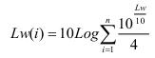
Table 6-23. Distribution of Sound Power Levels to Octave Bands
Noise Sources | Sound Power Levels (dB)
 | 500 Hz | 1,000 Hz | 2,000 Hz | 4,000 Hz
Excavator-Dozer-Grader | 97.98 | 97.98 | 97.98 | 97.98
Cylinder-Concrete Pump | 100.98 | 100.98 | 100.98 | 100.98
Concrete Mixer-Water Truck | 94.98 | 94.98 | 94.98 | 94.98
Truck | 103.98 | 103.98 | 103.98 | 103.98
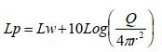
Lp : Noise Level at x Distance
Q : Noise Level Constant ( 2 is taken.)
R : Radius at x Distance
Table 6-24. Sound Pressure Levels in 4 Octave Bands by Distance
Noise Sources | Distance  (m) | Sound Power Levels (dB)
 |  | 500 Hz | 1,000 Hz | 2,000 Hz | 4,000 Hz
Excavator-Dozer-Grader | 50 | 56.02 | 56.02 | 56.02 | 56.02
 | 100 | 50.00 | 50.00 | 50.00 | 50.00
 | 250 | 42.04 | 42.04 | 42.04 | 42.04
 | 500 | 36.02 | 36.02 | 36.02 | 36.02
 | 750 | 32.50 | 32.50 | 32.50 | 32.50
 | 1,000 | 30.00 | 30.00 | 30.00 | 30.00
 | 2,000 | 23.98 | 23.98 | 23.98 | 23.98
Cylinder-Concrete Pump | 50 | 59.02 | 59.02 | 59.02 | 59.02
 | 100 | 53.00 | 53.00 | 53.00 | 53.00
 | 250 | 45.04 | 45.04 | 45.04 | 45.04
 | 500 | 39.02 | 39.02 | 39.02 | 39.02
 | 750 | 35.50 | 35.50 | 35.50 | 35.50
 | 1,000 | 33.00 | 33.00 | 33.00 | 33.00
 | 2,000 | 26.98 | 26.98 | 26.98 | 26.98
Concrete Mixer-Water Truck | 50 | 53.02 | 53.02 | 53.02 | 53.02
 | 100 | 47.00 | 47.00 | 47.00 | 47.00
 | 250 | 39.04 | 39.04 | 39.04 | 39.04
 | 500 | 33.02 | 33.02 | 33.02 | 33.02
 | 750 | 29.50 | 29.50 | 29.50 | 29.50
 | 1,000 | 27.00 | 27.00 | 27.00 | 27.00
 | 2,000 | 20.98 | 20.98 | 20.98 | 20.98
Truck | 50 | 62.02 | 62.02 | 62.02 | 62.02
 | 100 | 56.00 | 56.00 | 56.00 | 56.00
 | 250 | 48.04 | 48.04 | 48.04 | 48.04
 | 500 | 42.02 | 42.02 | 42.02 | 42.02
 | 750 | 38.50 | 38.50 | 38.50 | 38.50
 | 1,000 | 36.00 | 36.00 | 36.00 | 36.00
 | 2,000 | 29.98 | 29.98 | 29.98 | 29.98
It is assumed that the total sound power level is equally distributed over 4 octave bands.
The values calculated in the 4 octave band for the total sound power level are calculated with the formula and the sound pressure levels that will occur in the ambient as a result of the change with the distance are given in Table 6-24, taking into account the correction factor for each frequency given in Table 6-25.
Table 6-25. Correction Factors
Center Frequency (Hz) | Correction Factor
500 | - 3.2
1,000 | 0.0
2,000 | +1.2
4,000 | +1
Atmospheric absorption values for each frequency were calculated regarding to the formula below and relative humidity (Q) was taken as 75%.
Atmospheric absorption in the area is;
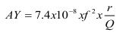
It is calculated with the formula.
F : Frequency (500 – 4,000 Hz),
Q : Relative humidity (75% taken),
r : Distance (m)
Table 6-26. Atmospheric Absorption
Distance (m) | 500 Hz | 1,000 Hz | 2,000 Hz | 4,000 Hz
50 | 0.01 | 0.05 | 0.20 | 0.79
100 | 0.02 | 0.10 | 0.39 | 1.58
350 | 0.06 | 0.25 | 0.99 | 3.95
500 | 0.12 | 0.49 | 1.97 | 7.89
750 | 0.19 | 0.74 | 2.96 | 11.84
1,000 | 0.25 | 0.99 | 3.95 | 15.79
2,000 | 0.49 | 1.97 | 7.89 | 31.57
After deducting the atmospheric absorption values, the final sound pressure level in the 4-octave band of each noise source was calculated regarding to the formula below, and the results are given in Table 6-27.
Lp = Lp – Aatm
Table 6-27. The Final Sound Pressure Levels in the 4-Octave Band
Noise Sources | Distance  (m) | Sound Power Levels (dB)
 |  | 500 Hz | 1,000 Hz | 2,000 Hz | 4,000 Hz
Excavator-Dozer-Grader | 50 | 52.82 | 56.02 | 57.22 | 57.02
 | 100 | 46.80 | 50.00 | 51.20 | 51.00
 | 250 | 38.84 | 42.04 | 43.24 | 43.04
 | 500 | 32.82 | 36.02 | 37.22 | 37.02
 | 750 | 29.30 | 32.50 | 33.70 | 33.50
 | 1,000 | 26.80 | 30.00 | 31.20 | 31.00
 | 2,000 | 20.78 | 23.98 | 25.18 | 24.98
Cylinder-Concrete Pump | 50 | 55.82 | 59.02 | 60.22 | 60.02
 | 100 | 49.80 | 53.00 | 54.20 | 54.00
 | 250 | 41.84 | 45.04 | 46.24 | 46.04
 | 500 | 35.82 | 39.02 | 40.22 | 40.02
 | 750 | 32.30 | 35.50 | 36.70 | 36.50
 | 1,000 | 29.80 | 33.00 | 34.20 | 34.00
 | 2,000 | 23.78 | 26.98 | 28.18 | 27.98
Concrete Mixer-Water Truck | 50 | 49.82 | 53.02 | 54.22 | 54.02
 | 100 | 43.80 | 47.00 | 48.20 | 48.00
 | 250 | 35.84 | 39.04 | 40.24 | 40.04
 | 500 | 29.82 | 33.02 | 34.22 | 34.02
 | 750 | 26.30 | 29.50 | 30.70 | 30.50
 | 1,000 | 23.80 | 27.00 | 28.20 | 28.00
 | 2,000 | 17.78 | 20.98 | 22.18 | 21.98
Truck | 50 | 58.82 | 62.02 | 63.22 | 63.02
 | 100 | 52.80 | 56.00 | 57.20 | 57.00
 | 250 | 44.84 | 48.04 | 49.24 | 49.04
 | 500 | 38.82 | 42.02 | 43.22 | 43.02
 | 750 | 35.30 | 38.50 | 39.70 | 39.50
 | 1,000 | 32.80 | 36.00 | 37.20 | 37.00
 | 2,000 | 26.78 | 29.98 | 31.18 | 30.98
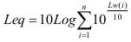
Lday= Leq
Table 6-28. The Final Sound Pressure Levels
Noise Sources | Distance (m) | Total Sound Level (dB)
Excavator-Dozer-Grader | 50 | 61.79
 | 100 | 55.48
 | 250 | 46.77
 | 500 | 39.82
 | 750 | 35.62
 | 1,000 | 32.58
 | 2,000 | 25.04
Cylinder-Concrete Pump | 50 | 64.79
 | 100 | 58.48
 | 250 | 49.77
 | 500 | 42.82
 | 750 | 38.62
 | 1,000 | 35.58
 | 2,000 | 28.04
Concrete Mixer-Water Truck | 50 | 58.79
 | 100 | 52.48
 | 250 | 43.77
 | 500 | 36.82
 | 750 | 32.62
 | 1,000 | 29.58
 | 2,000 | 22.04
Truck | 50 | 67.79
 | 100 | 61.48
 | 250 | 52.77
 | 500 | 45.82
 | 750 | 41.62
 | 1,000 | 38.58
 | 2,000 | 31.04
Equivalent noise levels that will occur if each noise source operates at the same time with the worst-case scenario assumption are calculated and given in Table 6-28.
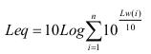

Table 6-29. Estimated Lday Sound Level Values and the National and International Noise Limit Values
Distance (m) | L_{day} (dBA)** | National Noise Limit Value  (dBC)*  Daytime (10:00 and 22:00) | IFC Noise limit Value, One Hour L_{Aeq} (dBA)  Daytime (07:00 – 22:00)
50 | 67.22 | 100 | 55***
100 | 60.91
350 | 52.21
500 | 45.26
750 | 41.05
1,000 | 38.02
2,000 | 30.48
* Maximum impact noise: The largest value of the C-weighted rms-based sound level during the measurement period, measured in dBC,
** A-weighted sound pressure level: An odd-numbered sound level unit obtained with the help of the A-weighting network, which is widely used in noise control and gives more weight to the middle and high frequencies, where the human hearing system is most sensitive to low-pressure sounds and determines the effect from noise.
*** Noise impacts should not exceed the level presented in Table 6-29, or result in a maximum increase in background levels of 3 dB at the nearest receptor location off-site.
The closest settlements to the Project Area are Kurbanlı Neighbourhood approximately 375 meters to the south, Sağlıklı Neighbourhood approximately 465 meters to the west and Eskişehir Neighbourhood 702 meters to the east. The quarries operate at least 30 meters west of the Project Area and the house identified as closest sensitive receptor is located 23 meters southwest of the Project Area (see Figure 2-5).
As seen in Table 6-29, it is estimated that the national and international daytime noise limit value (or result in a maximum increase in background levels of 3 dB) cannot be exceeded for the nearest settlement. On the other hand, it can be easily said that the house as sensitive receptor was exposed to high noise levels before the construction phase of the Project due to the proximity of the quarries. However, in the current situation when the construction works have started and there are no complaints about noise, including the closest sensitive receptor. Hence, as this sensitive receptor point is currently in a noise area due to quarries and the Project construction works, which will include piping and excavation works close to the area, will have a relatively low impact on noise. Thus, the noise impact significance in the AoI of the Project is determined as medium.

Operation Phase
During the operation phase of the facilities that will operate within the OIZ, there is noise generation caused by the machines and equipment. However, since all the facilities to be established in OIZ will be built indoors, it is not expected that the noise will have an environmental impact. Therefore, the noise impact significance for Project’s AoI in this phase of the OIZ is determined as low.

Land Use and Soil Quality

Construction Phase
2U1K observed that ground levelling activities of the Project have been completed except for lot 105: parcel no. 1 and 2 of the Project Area in the current situation. It has been learnt that the previous owner of parcels 105/1 and 105/2 used this area as a repair and maintenance workshop and refuelling place for trucks working in quarries. But, during the site visit of 2U1K, as the title deed processes of the concerned area of the Project had been not finalized, structures belonging to the gas station that was previously operating in this area were observed.
In this context, there is an obligation to manage wastes within the scope of national regulations in the entire Project Area, primarily in this area. It has been learned that the repair and maintenance shop operated by the previous owner of this area was being used as a fuel filling location. As small spot fuel and oil spills were observed at relevant area, the TUIOSB will take a total of ten soil samples, (one at 0-30 cm and the other at 80-100 cm depths), two (2) from each of the five (5) points in the concerned area to be able to assess possible soil contamination in accordance with Regulation on Control of Soil Pollution and Point Source Contaminated Lands. Table 6-30 shows coordinates of the concerned points for soil sampling. Also, the map showing the soil sampling locations is in Figure 6-2.
Table 6-30. Coordinates of the Points for Soil Sampling
Sample Points | Coordinates
 | Latitude | Longitude
SSP-1 | 37.045943° | 34.922327°
SSP-2 | 37.045888° | 34.922359°
SSP-3 | 37.045934° | 34.922282°
SSP-4 | 37.046080° | 34.922173°
SSP-5 | 37.045767° | 34.922581°

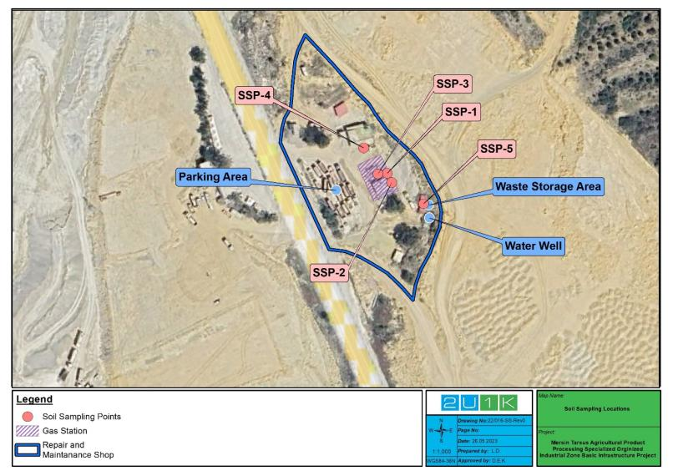
Figure 6-2. Soil Sampling Locations
If soil contamination is detected at the area, Soil Management Plan including studies to be carried out in this area will be prepared and ground levelling works within the area will only be started by the contractor after the rehabilitation of the area in line with the relevant regulation. Consequently, considering the land use and soil quality assessment for the construction phase of the Project, the concerned impact significance in the AoI of the Project is determined as high.

Operation Phase
During operation phase of the OIZ, operational activities will be performed with limited physical interaction with soil environment. In the operation phase of the OIZ, no significant direct impacts on soil are anticipated under normal operating conditions. In general, impacts of operation phase are related with the risks arise during repair and maintenance works. These risks are spillage/leakage of wastewater, oil, and chemicals to soil and the permanent land use change at the Project Area, which is not used for any purpose before the OIZ. Therefore, the concerned impact significance the AoI of the Project is determined as low.

Landscape

Construction and Operation Phases
The Project includes the basic infrastructure of the OIZ. In this sense, there is a landscape change that covers a large area within the AoI of the Project. The all units to be built will be realized in accordance with the planning of the OIZ. For this reason, no effect on the visual effect is expected, and the residual impact for landscape and visual will be negligible throughout the construction and operation phases.
Use of Pesticides
In case of pesticide use during the landscaping works for the operation phase of the Project, in order to ensure compliance with WB ESS 3, the following items shall be taken into consideration.
- where practicable, avoiding or minimizing the use of persistent organic pollutants (POPs) in pesticides formulation.
- Following safety guidelines for the storage, transport, and distribution of pesticides to minimize the potential for misuse, spills, and accidental human exposure.
- Usage of pesticides containing the chemicals listed in The Rotterdam Convention on the Prior Informed Consent Procedure for Certain Hazardous Chemicals and Pesticides in International Trade, Annex III, will be avoided.

Biodiversity and Protected Areas

Construction and Operation Phases
The Project will be located within a modified habitat. The distribution of natural flora and fauna in the project area is very limited. However, according to the IUCN red list; as fauna species Aquila nipalensis and Neophron percnopterus in the EN category and Streptopelia turtur, Emberiza rustica and Testudo graeca in the VU category are located in the project impact area. In addition, the endemic flora species Arabis aubrietioides, Aubrieta canescens, Astragalus condensatus and Marrubium globosum subsp. globosum and the reptilian species Anatolacerta danfordi are known to spread in the project impact area.
Vegetation clearing during the construction phase may result in the destruction of floral species of conservation interest.
Small and less mobile species can become trapped, injured and killed during vegetation clearing and earth works.

Fauna of particular concern in this context include:
- Fossorial mammals (e.g. moles, rodents);
- Nesting birds (ground and tree nesting); and
- Reptiles and amphibians.
Other common causes of fauna injury, death or disturbance during the construction include:
- Vehicle-wildlife collisions access roads;
- Hunting, trapping and poisoning of larger fauna by construction workers and contractors; and
- Fauna trapped/caught in infrastructure, such as fences and excavations
The disturbance and displacement of resident fauna species within the footprint will primarily be caused by light, noise and vibration impacts during construction.
Noise, light and vibration disturbances have the potential to influence breeding, roosting or foraging behaviour of fauna. During the construction phase temporary impacts from the Project are expected. Noise will be the primary disturbance of this nature due to vegetation clearing, excavation, movement of materials and general construction activities. These activities will introduce noise sources to areas not currently exposed to these disturbances. In addition, there may be vibration associated with activities and the movement of any vehicles/machinery
Land preparation has the potential to generate dust which may settle on vegetation adjacent to the construction area (including access roads). Excessive dust deposition on flora may act to suppress growth through limiting photosynthesis and the dusted foliage may also become unpalatable to foraging fauna.
There may be habitat pollution from wastes from construction works.
The clearing of new areas may provide opportunities for the introduction of alien invasive species. Clearance of vegetation and disturbances caused by earthworks can create conditions conducive to the establishment and rapid spread of alien invasive vegetation. If left uncontrolled, alien species can spread exponentially, suppressing, or replacing native vegetation. This may lead to disruption of ecosystem functioning and loss of biodiversity.
Alien invasive plants can potentially be established in all areas where construction activities will disrupt existing vegetation.
Since the activities to be carried out will be limited to the project area, no impact will be of concern for the Nationally Protected Areas and the Internationally Recognized Areas. In addition, the Bolkar Mountains KBA located at a distance of approximately 11 km is not likely to be affected.
Considering the evaluations made, the impact significance of the Project on biodiversity during the construction and operation phases has been determined as medium.

Population / Demography

Construction and Operational Phases
It is foreseen that no accommodation facilities will need to be constructed during the construction activities of the Project. However, containers can be placed on the Project area for those who will work on the Project to rest, eat and for sanitary facilities. These containers will meet standards for worker accommodation prepared by International Finance Corporation (IFC) and European Bank for Reconstruction and Development (EBRD) and approved by the WB.
No negative impact is expected from the Project in terms of population level in settlements expected to be affected during the construction phase of the Project.
Work permits of the workers to be employed within the operational scope of the Project will be monitored by TUIOSB and recruitment will be carried out within the framework of legal practices. Legal work permits will be checked, and recruitment will be carried out to ensure the working conditions detailed in Section 6.14.1 during construction and operation phases. Unregistered, child or forced labour will not be allowed.
To avoid any negative impact on the local community due to the presence of workers during the construction phase and their potential interaction with the local community, contractors are responsible for providing code of conduct training to each worker. Since the proportion of workers to be hired locally is not clear, it will be determined later in the project. The contractor will inform all workers verbally and in writing about the code of conduct during the recruitment phase and a code of conduct document will be signed. TUIOSB will ensure that contractors establish the code of conduct and check that workers are trained in communicating with the public before starting work.
In order manage the workforce influx, which can be observed in any project, people who will work on the project should be quickly accommodated in the region, to avoid a negative impact on the local population (especially where the area is rural, remote, and small). If the workers who will work in the project settle quickly and in a controlled manner in the camp area to be established in case of any settlement need, any negative interaction with the local people will be prevented.
In order to avoid the negative impacts of any workforce influx, TUIOSB and facility owners will give priority to the local people in recruitment, and this will be added to the terms of the contracts of the Contractor and possible subcontractors in order to ensure this. Facility owners will give employment priority to people residing in the settlements in the project AoI, neighbouring districts and Mersin. In contract process, TUIOSB will request the contractor to plan the workforce and request from the contractor to prepare a Workforce Management Plan if the requirement for a workforce other than the one specified in this ESMP is seen. There will be no accommodation within the scope of the project. In case accommodation is provided, it will be in accordance with World Bank standards.TUIOSB and the Contractor shall ensure that Code of Conduct (CoC) and public communication trainings are given to all employees as an orientation training to prevent a possible future dispute.

Cultural Heritage
As a result of the evaluations made, no cultural assets or archaeological artefacts have been identified in the project area. There are ancient Roman Roads within 1,300 meters of the Project boundary, but Project activities are not expected to impact this area. If any archaeological remains or artefacts are found during construction, all activities will be stopped, and the Museum Directorate will be informed in accordance with Article 4 of Law No. 2863. In addition to this, in case of any unexpected event of chance finds during construction, a Chance Find Procedure is prepared. It is presented in Appendix D.

Vulnerable/Disadvantaged Groups
Vulnerable groups refer to people who may be more affected by the potential negative impacts of the project or are less able to access information or get their voice heard and concerns raised. Project specific vulnerable groups are given in Section 5.6.
There are traffic, dust, noise, labour influx and SEA/SH risks that will occur under the Project. Therefore, It is not expected that vulnerable/ disadvantaged groups within the Project's AoI will be particularly adversely affected by the Project. All mitigations measures given in the community health and safety section will be implemented to mitigate the impact on vulnerable groups as well.

Economy / Employment

Construction and Operation Phase
The Project is expected to create temporary employment during construction and permanent employment during operation. Priority will be given to contributing to the local economy through the use of local materials and local procurement of various goods and services during the construction and operation periods. During the operational period, permanent jobs will be created in the local and regional communities. It is planned to employ 250 personnel at peak time during the construction phase of the Project. AoI radius is 2 km as it seen at Figure 61. Kurbanlı, Eskişehir and Sağlıklı Neighborhoods are in this area. Efforts will be made to allocate employment opportunities to the local parties and the settlements within the AoI. However,the proportion of workers to be hired locally is not clear, it will be determined later in the project. Therefore, local employment will be provided from these settlements. The number of people who will work in the facilities during the operation period is expected to be around 3,500.

Land Acquisition
As it is explained in the project description given in Section 2, the Project will be implemented in two phases as Phase 1 and Phase 2. TUIOSB will use loan only for Project’s Phase 1. For the Project’s Phase 2 Mersin Tarsus Agricultural Product Processing Specialized Organized Industrial Zone (OIZ)’s own equity will be invested. In addition, investments will not be made in the Project’s Phase 2 area until the expropriation process of the Project’s Phase 2 area is completed.
In the land acquisition process of the Project, purchasing, expropriation and urgent expropriation methods were used together in Phase 1. Despite all these tools, the agreements were reached with all the accessible shareholders of the private lands, and the shares were acquired with consent. Treasury lands were purchased.
At the stage of determination of expropriation costs -under the Turkish legal framework- a valuation committee consisting of a minimum of three persons internally appointed by the agency responsible for land acquisition determines the estimated value of the immovable property to be expropriated, having regard to the information and documents to be obtained from expert persons, institutions, and authorities. A Valuation Commission was established by the Investment Monitoring Coordination Presidency within the Governorship of Mersin Province. Detailed information on the process is provided in Ex-post Social Assessment Report.
The land valuation procedure is based on the Expropriation Law. The Valuation Commission consisted of the members of the following institutions:
- Monitoring Coordination Presidency of Mersin Governorship,
- Tarsus District Municipality
- Mersin Tarsus Agricultural Product Processing Specialized Organized Industrial Zone
- Tarsus District Directorate of Agriculture and Forest
In the Project Area covering Phase 1, three (3) private plots and 13 public plots (Treasury) are affected by the Project. It is presented in Table 631.

Table 6-31. Characteristics of the affected parcels before acquisition in Phase 1 area of the Sub-project
No | Province | District | Settlement | Parcel no | Owner | Type | Ownership status | Acquisition method | Acquisition status | Affected fixed asset | User, if any | Usage | Size (m²) | Compensation amount (TRY)
1 | Mersin | Tarsus | Kurbanlı | 102/5 | 36 shareholders (See Appendix A5) | Field | Private | Acquired by agreement/consent | Completed | No | No | NA | 7696,21 | 169.434,16
 |  |  |  |  | 22 shareholders (See Appendix A6) |  |  | Expropriation | Completed | No | No | NA
2 | Mersin | Tarsus | Kurbanlı | 189/3 | Treasury | Stony, brush | Public | Purchase | Completed | No | No | NA | 148588,92 | 57.949,68
3 | Mersin | Tarsus | Kurbanlı | 104/1 | Treasury | Raw land | Public | Purchase | Completed | 2 old buildings belonging to National Real Estate | A family (2 PAPs) as an informal user of the affected structure | House | 2000,08 | 118.107,02
4 | Mersin | Tarsus | Kurbanlı | 104/2 | Treasury | Stony, brush | Public | Purchase | Completed | No | No | NA | 43991,90 | 17.156,84
5 | Mersin | Tarsus | Kurbanlı | 204/1 | Treasury | Stony, brush | Public | Purchase | Completed | No | No | NA | 4104,48 | 1.600,75
6 | Mersin | Tarsus | Kurbanlı | 107/3 | Treasury | Stony, brush | Public | Purchase | Completed | No | No | NA | 4439,14 | 1.731,26
7 | Mersin | Tarsus | Kurbanlı | 205/1 | Treasury | Stony, brush | Public | Purchase | Completed | No | No | NA | 11937,80 | 4.655,74
8 | Mersin | Tarsus | Kurbanlı | 205/2 | Treasury | Field | Public | Purchase | Completed | No | No | NA | 4540,47 | 1.770,78
9 | Mersin | Tarsus | Kurbanlı | 205/3 | Treasury | Stony, brush | Public | Purchase | Completed | No | No | NA | 15779,73 | 6.154,09
10 | Mersin | Tarsus | Kurbanlı | 198/8 | Treasury |  | Public | Purchase | Completed | No | No | NA | 2949,72 | 1.150,39
11 | Mersin | Tarsus | Kurbanlı | 105/1 | 1 Owner | Brush | Private | Acquired by agreement/consent | Completed | No | No | NA | 2500,14 | 82.179,60
12 | Mersin | Tarsus | Kurbanlı | 105/2 |  | Raw land | Private | Acquired by agreement/consent | Completed | 5 buildings, 6 trees | Owner | Commercial | 2910,29 | 612.446,46
13 | Mersin | Tarsus | Kurbanlı | 189/12 | Treasury | Row land | Public | Purchase | Completed | No | No | NA | 2857,82 | 1.971,90
14 | Mersin | Tarsus | Kurbanlı | 189/11 | Treasury | Plot | Public | Purchase | Completed | No | İSDEMİR | Commercial | 283156,57 | 195.378,03
15 | Mersin | Tarsus | Kurbanlı | 189/4 | Treasury | Industrial land | Public | Purchase | Completed | No | İSDEMİR | Commercial | 294191,92 | 114.734,85
16 | Mersin | Tarsus | Eskişehir | 0/680 | Treasury | Plot | Public | Purchase | Completed | No | İSDEMİR | Commercial | 181445,55 | 125.197,43

According to land acquisition information, land acquisition has been completed in most of the area. On the other hand, the land acquisition process continues in one of the three (3) private plots due to multiple shareholders. There are 57 shareholders in this private parcel (parcel no 102/5). While 35 shareholders have completed land acquisition through agreement, 22 shareholders could not be reached, and expropriation was resorted to, and the compensation deposited in an escrow account.. The other two parcels (105/1, 105/2) belong to a single person and both parcels were acquired by agreement. It has been learnt that the previous owner of parcels 105/1 and 105/2 used this area as a repair and maintenance workshop and refuelling place for trucks working in quarries.
7 buildings on 2 parcels were affected by the land acquisition of the sub-project. 5 of them (commercial) were on 1 private land (105/2) and 2 of them (residential and commercial) were on 1 public land (104/1).
There was also an informal user in the area that TUIOSB used as an administrative building during the site visit. Previously, a family (an elderly mother and an adult son) lived in the old building. The building was built between 1981-1984 by the deceased husband of the elderly woman. However, this is not documented. In the past years, the family was making an adequate pay to the state called ecr-i misil because they were the occupiers of the public land. Documents regarding these payments are from 2014 and earlier. However, the family representative (son of the old woman) declared that they made this payment in the following years. They have another house on the neighbouring plot which they formally own. This house was neglected. The governor's office helped the elderly woman to move to her own house by repairing this neglected building and giving some household items to the old woman.
Nomads are another group displaced by the project. It was determined that two (2) nomad families engaged in animal husbandry used the project area. When the land was transferred to the OIZ, the village headman showed the two (2) nomad families another place and currently they are staying there.
Ex-post surveys have been conducted for issues related to land acquisition and monitoring activities are discussed in that document. See Ex-Post Social Assessment for details on land acquisition.

Labour Conditions

Construction and Operation Phases
Labour Management Plan (LMP) has been prepared for Türkiye Organized Industrial Zones Project. It aims to project workers’ rights and ensure the management and control of activities that may pose labour-related risks. It describes how MoIT will comply with the requirements of World Bank Environmental and Social Standard 2 (ESS 2), “Labour and Working Conditions”, and with Turkish labour, employment and occupational health and safety laws.
TUIOSB will be responsible for work force during the construction and operation phases. Türkiye is currently in the middle of the harmonisation process with the European Union and labour laws are being reviewed to ensure compliance. The Project will comply with national labour, social security and occupational health and safety laws and the principles and standards of the International Labour Organization convention. Based on the national principles contained in the International Labour Organization convention, the Project Proponent will take the following measures:
- Not use or employ children during the construction phase under 18 years of age,
- Not use or employ forced labour and ensure a Human Resources Policy in compliance with the European Convention on Human Rights and the Turkish Constitution,
- Elimination of discrimination based on language, race, sex, political opinion, philosophical belief, and religion in labour relations,
- Ensuring workers' access to the right to collective bargaining (Law No. 6356 on Trade Unions and 4857 Labour Law on Collective Bargaining),
- Ensure access to an effectively functioning Project grievance mechanism.
- Ensure workers are provided with written contracts containing i.a. job description, working hours, information about their rights and duties, code of conduct and information of workers’ GM.
- In order to reduce the possible impacts on the neighbourhoods, facilities such as food, sanitary facilities and resting areas will be provided within the Project Area in accordance with the use of the employees.
The Labour Law (4857) applies to all workplaces and their employers, employees, employers' representatives, and workers' representatives, regardless of their field of activity.

Training
According to LMP, project workers will receive OHS training at the beginning of their employment, as induction, and on a regular basis thereafter, to cover legislative requirement. Training will cover the relevant aspects of OHS associated with daily work, including the ability to stop work without imminent danger and respond to emergency situations. Training records will be kept on file. These records will include a description of the training, the number of hours of training provided, training attendance records, and results of evaluations.
In addition, the contractor will provide training to the personnel who will work during the execution of the works on the environmental and social impacts that should be considered during the field works and which are included in the ESMP document. The Contractor shall inform its personnel, subject to the supervision of the TUIOSB, on the implementation of all measures to prevent and/or minimise environmental and social impacts during construction.
Training on code of conduct will be provided to workers. The Code of Conduct will include practices to prevent SEA/SH. It will be the contractor's responsibility to provide regular induction training to employees, including but not limited to social induction and HSE training.
The Contractor shall ensure that site personnel are trained as a matter of priority on the work to be performed by the employee and workplace-specific risks and protection measures before actually starting work.
In addition, training will be given separately on the risks that may arise due to situations such as workplace or job change, change of work equipment, application of new technology.
Trainings will be repeated at regular intervals, taking into account the changing and emerging new risks specified in the Regulation on the Procedures and Principles of Occupational Health and Safety Trainings of Employees. Information and training activities will be carried out not only for employees but also on measures to be taken for public health and safety.
The contractor is required to demonstrate the knowledge, skills, behaviours, and attitudes that the site personnel should have on occupational health and safety, environmental and social issues separately and in a measurable form (CV documenting previous experience, certificates, and training documents, etc.).
Measurement and evaluation should be carried out at the end of the training. According to the results of the evaluation, it can be determined whether the training is effective or not and if necessary, changes can be made in the training programme or trainers, or the training can be repeated.

Community Health and Safety
Public health and safety issues are associated with risk factors that may arise from the construction and operation phases of the Project. It is anticipated that local communities may be affected by dust, traffic, and noise, especially during the construction period. The nearest school and mosque in the Project Area are shown in Figure 6-3.
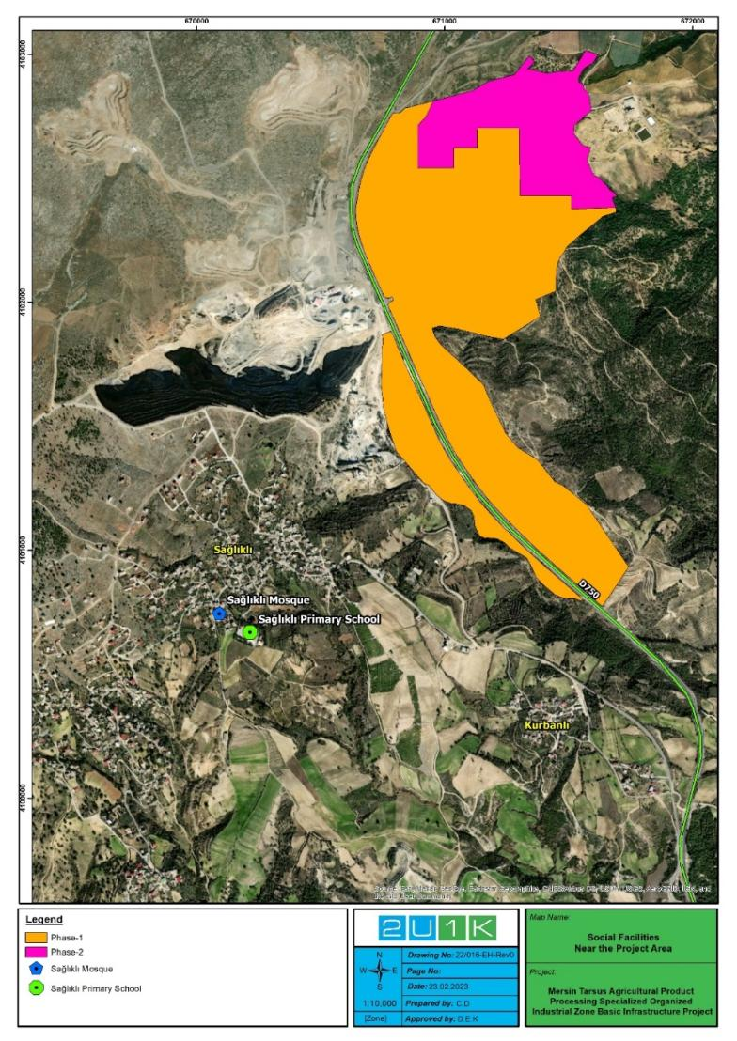
Figure 6-3. Social Facilities Near the Project Area

In order to minimize the impact of traffic activities expected to intensify during the construction phase, working hours should be adjusted according to peak transportation hours. Relevant stakeholders will be consulted to determine a common working strategy for construction activities to be carried out on the route of areas such as schools and hospitals. Construction activities to be carried out in front of or around hospitals and/or health institutions will be planned in a way that does not prevent the public from accessing these services. Special crossings will be developed with additional measures for the elderly, pregnant women, young children and persons with disabilities.
In addition, during site preparation and construction activities, the contractor will ensure that health and safety measures are taken, such as timely notification of the public about construction plans and locations, use of appropriate warning signs and markings to identify construction areas, and watering during dry seasons. Failure to fully enclose construction areas and install necessary warning signs may result in accidents that threaten public health and safety.
During construction works, intersections will be added to existing roads and road widening works will be carried out. Damage to road surfaces due to traffic caused by heavy construction equipment will be rehabilitated by the contractor. Damages to infrastructure elements on private lands due to construction activities will be compensated by the Contractor and TUIOSB. Mitigation measures will be implemented by the contractor. In order to make a clear assessment, the current condition of roads and existing infrastructure can be documented (e.g. by photographs) by the contractor prior to the start of construction works.
Local communities around the project area may be exposed to physical hazards related to project components during the construction phase, such as noise exposure, dust emissions, electrical hazards, traffic accidents, etc. In addition, confined spaces or fall hazards may occur due to unsupervised infrastructure. In order to protect local people around the Project from physical hazards, the Project area will be fenced, and construction activities will be announced to local people, businesses and government agencies at least two (2) days in advance. During the operation phase of the Project, since the Project area will be a closed area, all works such as maintenance etc. do not pose a risk.

Occupational Health and Safety

Construction and Operation Phases
The construction phase of the Project requires the use of equipment. Working in basic infrastructure project brings with it physically demanding conditions for workers. There are difficult working areas such as working at height, energy-containing circuits, heavy equipment, slippery walkways. During the construction works, the contractor will prepare an Emergency Preparedness and Response Plan and Occupational Health and Safety Management Plan in accordance with Turkish legislation and ILO standards:
- Law on Occupational Health and Safety (No. 6331) (OG. date: 30.06.2012 and no 28339)
- Regulation on Occupational Health and Safety in Construction Works (OG. date: 05.10.2013 and no 28786)
- Regulation on the Use of Personal Protective Equipment in Workplaces (OG. dated 02.07.2013 and no 28695)
- Regulation on the Procedures and Principles of Occupational Health and Safety Trainings of Employees (OG. date: 15.05.2013 and no 28648)
- ILO Conventions including Occupational Safety and Health Convention (No. 155), Occupational Health Services Convention (No. 161), and Safety and Health in Construction Convention (No. 167)
- Regulation on Protection of Employees from Noise-Related Risks (OG. date: 28.07.2013 and no 28721)
- Regulation on Protection of Buildings Against Noise (OG. date: 31.05.2017 and no 30082)
- Regulation on Protection of Employees from Vibration-Related Risks (OG. date: 22.08.2013 and no 28743)
- Regulation on Occupational Health and Safety Risk Assessment (OG. date: 29.12.2012 and no 28512)
- Regulation on Emergencies in Workplaces (OG. date: 18.06.2013 and no 28681)
- Regulation on Disaster and Emergency Response Services (OG. date: 24.02.2022 and no 31760)
- Regulation on Fight Against Dust (OG. date: 05.11.2013 and no 28812)
- Regulation on Health and Safety Measures in Working with Chemicals (OG. date: 12.08.2013 and no 28733)
- Regulation on Health and Safety Measures in Working with Asbestos (OG. date: 25.01.2013 and no 28539)
- Regulation on Protection of Employees from the Hazards of Explosive Environments (OG. date: 30.04.2013 and no 28633)
- Regulation on General Lighting (OG. date: 27.07.2013 and no 28720)
- Regulation on Electrical Installers (OG. date: 08.08.1983 and no 18129)
- Regulation on Health and Safety Measures in Working with Displayed Tools (OG. date: 16.04.2013 and no 28620)
- Regulation on Groundings in Electrical Facilities (OG. date: 21.08.2001 and no 24500)
- Regulation on Equipment and Protective Systems Used in Possible Explosive Environment (2014/34/EU) (OG. date: 30.06.2016 and no 29758)
- Regulation on Machinery Protectors (OG. date: 17.05.1983 and no 18050)
- Regulation on Machinery Safety (2006/42/EC) (OG. date: 03.03.2009 and no 27158)
- Regulation on Health and Safety for the Use of Work Equipment (OG. date: 25.04.2013 and no 28628)
- Regulation on Health and Safety Measures to be taken in Workplace Buildings and Extensions (OG. date: 17.07.2013 and no 28710)
- Regulation on Organized Industrial Zones Implementation (OG. date: 02.02.2019 and no 30674)
- Regulation on Occupational Health and Safety Committees (OG. date: 18.01.2013 and no 28532)
- Regulation on Occupational Health and Safety Services (OG. date: 29.12.2012 and no 28512)
- Regulation on Duties, Authorities, Responsibilities and Training of Occupational Safety Experts (OG. date: 29.12.2012 and no 28512)
- Regulation on Occupational Health and Safety in Temporary or Limited Period Work (OG. date: 23.08.2013 and no 28744)
- Regulation on Manual Handling Works (OG. date: 24.07.2013 and no 28717)
- Regulation on Health and Safety Signs (OG. date: 11.09.2013 and no 28762)
- Regulation on Stopping Work in Workplaces (OG. date: 30.03.2013 and no 28603)
- Regulation on Preparation, Completing and Cleaning Works (OG. date: 28.04.2004 and no 25446)
- Regulation on First Aid (OG. date: 29.07.2015 and no 29429)
- WB EHS Guidelines for Water and Sanitation
- WB EHS Guidelines for Telecommunications
- WB EHS Guidelines for Electric Power Transmission and Distribution
In addition to preparing its own OHS management plan, the Contractor will also ask the subcontractor to prepare an OHS management plan in line with the OHS requirements of the Project. These conditions will be added to the tender documents to be prepared for construction tenders. The OHS Plan for the construction phase will include, but is not limited to, the following measures to prevent accidents and risks:
- All Project personnel will comply with environmental, health and safety policies and guidelines.
- Before the start of the studies, an OHS Management Plan will be prepared, which will also include measures for COVID-19 and/or other pandemic/communicable disease risks. Emergency plan and Risk assessments for OIZ and all subcontractors should also be updated in line with against COVID-19 and/or other pandemic/communicable disease in workplaces required measures
- These plans should include but not limited to followings:
  - Personal hygiene (especially before and after mask usage),
  - Mask usage, how to use it and its standards (TS EN 14683, TS EN 149, or TSE K 599 etc.),
  - Social distancing rule,
  - Placing visual/written banners and posters in visible places to encourage and inform employees, visitors and related persons about respiratory hygiene and cough etiquette regarding potential measures to minimize contamination,
  - Paying special attention to the implementation of cleaning and disinfection measures in common areas (toilets, halls, corridors, elevators, etc.),
  - Disposal of relevant wastes in line with the "COVID-19 Measures in the Management of Personal Hygiene Material Wastes such as Disposable Masks, Gloves",
  - Updating the occupational health and safety training of employees and addressing additional topics in order to ensure a healthy and safe working life and due to the emergence of new risks arising from changing conditions about COVID-19 and/or other pandemic/communicable disease.
- In order to minimize the risks and dangers that may arise in terms of human health and safety (eg natural disasters, accidents, equipment failures, etc.), safe working environments will be created at the work sites, and physical hazards and risks will be prevented.
- Within the scope of OHS measures and practices, the relevant plans, and procedures of the concerned Turkish legislation and the Project will be complied with.
- Employees will be informed about the hazards that may arise from their work, thus creating a safer working environment.
- Employees will be trained in accordance with the Regulation on the Procedures and Principles of Occupational Health and Safety Training. In this context, a training program will be prepared, training records will be kept, and evaluation activities will be carried out after the trainings.
- All employees will be provided with personal protective equipment (PPE) and necessary training will be provided for their use.
- Work areas will be equipped with warning signs (eg "Danger", "Entry Forbidden" etc.) in accordance with the nature and potential risks of the work to be done in that area.
- All necessary precautions will be taken in the Project Area to prevent possible fires caused by construction activities. Uncontrolled fires inside and outside the field will be prevented. Measures to be taken to prevent fires are as follows:
  - Fire extinguishers shall be prominently and evenly located outdoors, near passageways and in or near fire cabinets in easily accessible locations. Extinguishers should not be located behind doors, in closed cupboards other than fire cupboards, in deep recesses in walls or on or near heating appliances.
  - In cases where the safety of the work equipment depends on the installation and assembly conditions, the equipment must be periodically inspected by persons authorised to carry out periodic inspections after installation and before first use, after major maintenance and repair work and whenever the location changes.
  - Occupational Health and safety instructions and work permit procedures should be prepared.
- Smoking is prohibited in areas where there is a fire hazard. All employees should be familiar with what to do in the event of a fire.
- Project personnel will include first aid trained personnel. In emergencies that require intervention, the personnel will be referred to the nearest health centre by appropriate vehicles. The Contractor will implement the adequacy of the technical requirements of the machinery, equipment, and tools to be used in the activities.
- Moving parts of machinery and equipment shall be equipped with suitable protective systems (eg metal shields, etc.) that minimize the risk of injury or damage to the person using the machine or equipment. The machinery used during construction must be regularly inspected.
- All employees who work at height need suitable training in working on different pieces of equipment, and such work must be planned appropriately. Safety approaches and precautions should be adopted, such as:
  - Where practical, avoid the need to work at height.
  - Put collective measures in place where working at height can’t be avoided to prevent falls. Such as the use of equipment to provide an extra level of safety to reduce the risk of a fall—for example, a scaffold with a double guard-rail or edge protection. Minimize the consequences of a fall by providing a safety net.
  - Never stand behind large operating plant machinery and never stand under suspended loads.
  - Avoid working close to moving object and be careful of their surroundings, especially if they do not have lights or beepers.
  - Always ensure you have a banksman to guide plant vehicles
- Personal factors that can create and control risks during activities (e.g., long hair, use of jewellery and accessories, clothing, etc.) will be removed from the site with the regulations brought by the field management. Project personnel will be informed about the concerned legislation within the scope of the training program.
- Drivers and operators will be trained to comply with traffic rules and to control the vehicles and equipment they use against the risks and dangers arising from vehicle traffic. Required traffic signs will be placed at the Project Area and its surroundings. Machine operators and other workers will be informed and warned about the related signs. Waste that will be generated within the scope of the construction phase of the Project will be managed within the scope of the Regulation on Waste Management and its negative effects on public health will be minimized.
- The areas to be excavated will not be accessible except by authorized personnel. Loading and unloading activities are carried out together with the persons who will supervise the personnel who will carry out the activity.
- Persons and/or organizations with the necessary permits will be assigned to ensure the security of the Project Area. These persons and/or organizations will regularly monitor the facility and its surroundings. The private security practices within the scope of the Project and the authorities of the authorities will comply with the provisions of the Regulation on the Implementation of the Private Security Services Law.
- In addition to the security monitoring of the Project Area, a closed-circuit camera system to be installed at appropriate distances (e.g., 30-40 m) at the site boundary will be provided to provide security monitoring, day, and night monitoring at the entire field.
- Since the works will be carried out in areas close to the public, public access to these areas will be restricted in any way. If it is necessary to dig a ditch for the night, the area will be adequately illuminated by the TUIOSB, the required signs will be placed, and the area will be surrounded by barriers.
- An adequate OHS organizational structure will be established as defined in local legislation and the required number of OHS officers should be assigned to be on site during working hours.
- Before starting work, a risk assessment will be prepared, implemented, and personnel will be trained on possible risks.
- OHS Personnel will inspect the site on a daily basis and if any additional risks are observed, relevant plans and trainings will be renewed.
- An Emergency Preparedness and Response (EPR) Plan will be prepared and implemented to cover issues related to communicable diseases and the COVID-19 pandemic.
- The TUIOSB will ensure that contractors have ethical codes / code of conduct (CoC)s and this CoCs will be signed at the beginning of the work. Employees should be trained/informed about the rules applicable in the field, especially for interacting with the local community.
- Where a worker may be exposed to any chemical, physical danger or biological hazard that could adversely affect his or her health, appropriate preventive measures will be taken, including:
  - Replacing dangerous goods with harmless or less dangerous goods, if possible,
  - Taking technical measures to the plant, machinery, equipment, or process,
  - Taking other effective measures, including the use of PPE and protective clothing, when it is not possible to comply with the above measures,
- Adequate precautions shall be taken to protect against danger when workers must enter any area where a toxic or harmful substance may be present or where there may be a lack of oxygen or a flammable atmosphere.
- Wastes will not be disposed of at the construction site or disposed of in a way that is harmful to health.
- Sub-Contractors must implement the safety guidelines, such as:
  - All sub-contractors must ensure compliance with health and safety documents and equipment.
  - Prior to commencement of work, subcontractors' employees will be given informative training on the facility's health and safety rules.
  - The contractor is responsible for the project's OHS management practices or OHS rules in accordance with the OHS rules in the legislation.
Mitigation measures to be taken during the operation phase are listed below:
- The Project Area will be fenced, access to local people and wildlife will be controlled, and encroachment will be prevented. The entrance of employees and third parties to the facility will be made in a controlled manner.
- PPE will be provided to the workers according to the nature of the work to be done. Necessary training will be provided for their use.
- Smoking will be prohibited in places where the risk of fire is high. In case of fire, all employees will be informed about the action plan.
- All equipment will be operated in proper working condition.
- In maintenance and repair activities, the procedures approved by the TUIOSB and the conditions in the technical specifications of the supplier companies will be followed.
- Required health and safety signs and traffic signs will be placed around the facility. Employees will be informed and warned about subject markings.
- Trainings will be given to employees including operating and maintenance personnel in line with Regulation on the Procedures and Principles of Occupational Health and Safety Trainings, and measurement and evaluation activities will be carried out after the training.
- Entries of operation and maintenance employees and third parties will be made in a controlled manner.
- Equipment meeting international standards in terms of electrical performance and safety will be used.
- After the construction works of the facility is finalized, necessary electrical tests will be performed to check that the electrical connections and other related equipment are made correctly before the facility is commissioned.
- Before the facility is put into operation, an Emergency Preparedness and Response Plan will be prepared, including communicable diseases and the COVID-19 pandemic.
- Automatic cleaning screens should be used instead of manual cleaning screens to prevent cleaners from entering the ducts.
- Appropriate ventilation systems should be installed in places where methane accumulation is expected.
- Railings will be placed around all tanks and pits.
- The TUIOSB will prepare a Confined Spaces Entry Procedure in line with the WBG EHS Guidelines and applicable national requirements.
- All employees who work at height need suitable training in working on different pieces of equipment, and such work must be planned appropriately. Safety approaches and precautions should be adopted, such as: Where practical, avoid the need to work at height.
- Put collective measures in place where working at height can’t be avoided to prevent falls. Such as the use of equipment to provide an extra level of safety to reduce the risk of a fall—for example, a scaffold with a double guard-rail or edge protection. Minimise the consequences of a fall by providing a safety net.
- Wear the necessary P.P.E. such as a safety harness.
- Sites should always be planned to manage plant and pedestrian interface where physical barriers and suitable segregation is in place.
To reduce risks, workers should:
  - Never stand behind large operating plant machinery and never stand under suspended loads.
  - Avoid working close to moving object and be careful of their surroundings, especially if they do not have lights or beepers.
  - Always ensure you have a banksman to guide plant vehicles when reversing or manoeuvring on a public road.
  - Always wear PPE (Personal Protective Equipment) such as a hard hat and high visibility jacket to ensure he/she is seen.
- Managers and Site supervisor on construction sites must effectively manage the site so that workers can move around it safely. Risks should always be reported and sorted to reduce the chances of injury. To reduce harm due to Slips, Trips and Falls;
  - Keep work and storage areas tidy and designate specific areas for waste collection.
  - Where surfaces are slippery with mud, they should be treated with stone.
  - Where surfaces are slippery with ice, they should be treated with grit.
  - All slippery areas should be signposted, and footwear with a good grip should be worn.
- Both trainings and incidents (fatalities, lost time incidents, outbreak of pandemic or communicable diseases, social unrest, etc.) will be recorded.
- In the event of any significant incident or near miss (e.g. environmental, social, labour or lost-time incidents) TUIOSB shall inform the MoIT and WB within three business days. Then, within 30 days, a report on the root causes of the incident and the corrective actions to be taken will be presented to the MoIT and WB.
- The TUIOSB will train operators working with disinfectants on safe handling practices and emergency response procedures.
- The TUIOSB will distribute sufficient personal gas detection equipment to its employees.
- The TUIOSB will advise people with asthma, diabetes, or immunosuppression not to work in treatment plants and auxiliary facilities due to the higher risk of infection.
- An adequate OHS organizational structure will be defined as defined in local legislation and the required number of OHS officers should be assigned to be on site during working hours.
- A risk assessment will be prepared, and employees will be trained on risks before the operational activities of the Project begins.
- OHS Personnel will inspect the site on a daily basis and if any additional risks are observed, related plans and trainings will be renewed.
- Before the operational activities of the Project, an OHS Management Plan will be prepared, which will also include measures for COVID-19 and/or other pandemic/communicable disease risks.
- The TUIOSB will ensure that all activities comply with national standards and WBG EHS Guidelines.

As fire wate flowrate is calculated in the Project planning, it was taken as 5 lt/sec for secondary pipes, 10 lt/sec for main pipes and 10 lt/sec for main pipe. Fire hydrant was formed according to the specification criteria. When calculating the storage volume, 1/4 of the daily water consumption was considered. Fire water reserve volume is predicted as 360 m³ by assuming that there will be two fires lasting five (5) hours.The TUIOSB will ensure that contractors are reputable and legitimate businesses and have an appropriate Environmental and Social Management System (ESMS) to operate in accordance with the working conditions provided by the TUIOSB. The TUIOSB will monitor the performance of contractors to ensure that human rights policy and the right to work of all employees are properly exercised. The TUIOSB will provide contract workers access to the general grievance mechanism to be established for the Project.
As a result, it was assessed that OHS impact significance in the AoI of the Project is determined as high for the construction phase, medium for the OIZ’s operation.

Traffic and Transportation

Construction and Operation Phases
There are additional impacts requiring special mitigation measures (such as new access road arrangements or arrangements at critical locations) are expected, as there are activities that will generate heavy traffic in the Project Area, such as the transport of heavy materials or construction crews, during both construction and operation periods.
For earthmoving trucks, times of low traffic density should be preferred, and necessary warning signs should be placed on special access roads. Personnel operating vehicles and construction equipment will be specially assigned and provided with traffic and road safety training. Construction machinery and equipment will be regularly maintained and regulatory speed limits for construction vehicles will be adhered to, and this should be included in the site transport and traffic management plan to be prepared by the Contractor.
Prior to construction activities, the Contractor shall install all signs, barriers and control devices needed to ensure safe use of the road by traffic and pedestrians, as required by the transport and traffic management plan to be prepared.
In the current situation of the land preparation works, most of the excavation works in the Project Area have been completed and the excavated soil has been used for backfilling within the Project Area. Accordingly, it is planned to use the remaining excavation soil to be excavated for backfilling too. If it is required to be taken out of the Project Area, it will be sent to the permitted disposal area by authorized vehicles.
During the OIZ’s operation phase, it can be seen that a similar kind of impact will bring additional traffic load to the AoI of the Project with the facilities and OIZ’s units to be established.
Therefore, impact significance in the AoI of the Project for the traffic and transportation is determined as medium during both construction and operation of the Project.

ENVIRONMENTAL AND SOCIAL ASPECTS, AND BEST PRACTICE MITIGATION MEASURES
The activities to be performed in the scope of the Project are presented in Table 7-1 and considered for the assessment of the best practice mitigation measures defined for the Project.
The activities to be carried out within the scope of the Project will be in compliance with the most up-to-date national legislation and WB standards. Where Turkish legislation differs from WB Policies, the stricter one will be applied for the implementation of the Project.
The mitigation plans prepared for the construction and operation phases are presented in Section 7.1 and Section 7.2, respectively. Activities to be performed in the scope of the Project are presented in .
Table 7-1. Activities to be performed in the Scope of the Project
ENVIRONMENTAL/SOCIAL REVIEW
Activities to be carried out as part of on-site works | Activity | Status
 | - Building improvement | [X] Yes | [ ] No
 | - New minor construction works | [X] Yes | [ ] No
 | - Individual wastewater treatment system | [ ] Yes | [X] No
 | - Historical building(s) and sites | [ ] Yes | [X] No
 | - Land acquisition | [X] Yes | [ ] No
 | - Hazardous or toxic materials | [X] Yes | [ ] No
 | - Impacts on forestlands and/or protected areas | [ ] Yes | [X] No
 | - Medical waste collection / management | [ ] Yes | [X] No
 | - Traffic and Pedestrian Safety | [X] Yes | [ ] No

Mitigation Plan for the Construction Phase of the Project
No. | Topic | Definition of Potential Impact | Type of Impact | Impact Significance Before Mitigation | Cost | Measures to be Taken | Responsibility | Key Performance Indicators
C1 | Disclosure | Insufficient information | Adverse | Low | No additional costs | - Before the start of construction works, the local people and all relevant stakeholders will be informed of the works to be performed and the measures to be taken.  - The information on the start and finish dates of construction and working periods and the permits obtained from the government agencies will be shown by the TUIOSB in a signboard that is easily visible to all personnel at the construction site. | Contractor  Construction Supervision Consultant  TUIOSB | - Number and nature of grievances  - Percentage of closed grievances within the target timeframe
C2 | Occupational Health and Safety (OHS) | Inadequate workers health and safety conditions | Adverse | High | No additional costs | - Occupational Health and Safety Management Plan and Emergency Preparedness and Response Plan will be prepared for the construction phase of the Project.  - These plans should include but not limited to followings:  - Personal hygiene (especially before and after mask usage),  - Mask usage, how to use it and its standards (TS EN 14683, TS EN 149, or TSE K 599 etc.),  - Social distancing rule,  - Placing visual/written banners and posters in visible places to encourage and inform employees, visitors and related persons about respiratory hygiene and cough etiquette regarding potential measures to minimize contamination,  - Paying special attention to the implementation of cleaning and disinfection measures in common areas (toilets, halls, corridors, elevators, etc.),  - Disposal of relevant wastes in line with the "COVID-19 Measures in the Management of Personal Hygiene Material Wastes such as Disposable Masks, Gloves",  - Updating the occupational health and safety training of employees and addressing additional topics in order to ensure a healthy and safe working life and due to the emergence of new risks arising from changing conditions about COVID-19 and/or other pandemic/communicable disease.  - All Project personnel will comply with environmental, health and safety policies and guidelines.  - The PMU to be formed by the Consultant and the contractor's project team will include staff(s) (at least one environmental and social expert and OHS expert with a Class A specialization certificate) who will take part in full-time and effectively control the implementation of the Project. She/he shall monitor the site implementations.  - All employees who work at height need suitable training in working on different pieces of equipment, and such work must be planned appropriately. Safety approaches and precautions should be adopted, such as:  - Where practical, avoid the need to work at height.  - Put collective measures in place where working at height can’t be avoided to prevent falls. Such as the use of equipment to provide an extra level of safety to reduce the risk of a fall—for example, a scaffold with a double guard-rail or edge protection. Minimize the consequences of a fall by providing a safety net.  - Never stand behind large operating plant machinery and never stand under suspended loads.  - Avoid working close to moving object and be careful of their surroundings, especially if they do not have lights or beepers.  - Always ensure you have a banksman to guide plant vehicles  - Consultant and TUIOSB will make sure that the measures provided below are taken by the contractor and enforce necessary actions/sanctions in case lack of these measures on site. In accordance with the Occupational Health and Safety Regulation in Construction Works, the required person, information, plan, and organization will be provided.  - To control the cases (fire, earthquake, etc.) which may occur during the construction activities under the project, and which require urgent action, an Emergency Response Plan will be prepared and shared with all employees.  - Measures to be taken to prevent fires are as follows:  - Fire extinguishers shall be prominently and evenly located outdoors, near passageways and in or near fire cabinets in easily accessible locations. Extinguishers should not be located behind doors, in closed cupboards other than fire cupboards, in deep recesses in walls or on or near heating appliances.  - In cases where the safety of the work equipment depends on the installation and assembly conditions, the equipment must be periodically inspected by persons authorised to carry out periodic inspections after installation and before first use, after major maintenance and repair work and whenever the location changes.  - Occupational Health and safety instructions and work permit procedures should be prepared.  - The TUIOSB will require all employees and contractors to adhere to local and international health and safety legislation and guidelines. Workers will be provided with all necessary personal protective equipment (PPE) (hard hats, safety harnesses, protective coveralls, glasses, gloves, armour-clad shoes, etc.).  - Smoking is prohibited in areas where there is a fire hazard. All employees should be familiar with what to do in the event of a fire.  - Non-smoking areas will be allocated at the construction site.  - Appropriate hand and face washing facilities will be provided to the employees, and also shower facilities for dusty works.  - Technical and OHS training, including the code of conduct indicating the possible risks regarding the work site and works to be carried will be given to workers by the contractor. These will include regular trainings to workers on COVID-19 symptoms, how to be protected and what to do when symptoms appear. Training will also be given on risks that may arise due to changes in workplace or job, change of work equipment, application of new technology. Information and training activities will be carried out not only for the employees, but also about the measures to be taken for public health and safety.  - All employees will be informed about working conditions, job definitions, responsibilities, relations with the local community and potential work risks.  - Workers will be required to comply with all OHS regulations given in Table 3-1 and necessary inspections will be made.  - The contractor formally agrees that all work will be carried out in a safe and disciplined manner and is designed to minimize risks on neighbouring residents and environment.  - All activities will be implemented in line with both the Law on Occupational Health and Safety and its relevant regulations which presented in Table 3-1, and also the WBG EHS Guidelines.  - The contractor will ensure a safe working environment for the workers in line with international best practice and Turkish Legislation including the health and safety measures related to COVID-19 provided by the Ministry of Health and Ministry of Family and Social Services.  - Before the construction works start, a Risk Assessment study will be implemented for all works to be carried out. Emergency Plan will be prepared and put into practice. Both the Risk assessment and Emergency Response Plans will take into consider the COVID-19 risks and other communicable disease risks, as relevant.  - Emergency teams will be formed, and drills and training programs will be carried out in line with emergency scenarios.  - Employees will have a good command of emergency plans, and the grievance will be reported to the authorized teams and resolved, if they require urgent action.  - Project and site-specific OHS Management Plan based on construction site OHS risk assessment and that will also cover measures to address COVID-19 and/or any other pandemic/communicable disease risk, which will be in line with the WBG EHS Guidelines (both general and sector specific) should be developed before the commencement of works and implemented on site.  - Appropriate signposting of the sites will be provided and then workers will be informed of key rules and regulations to follow.  - OHS trainings and toolbox talks will be provided to the employees including the code of conduct indicating the possible risks regarding the work site and works to be carried out. These will include regular trainings to workers on COVID-19 symptoms, how to be protected and what to do when symptoms appear.  - First aid kit will be kept available at the construction site, taking into account that first aid response may be required before the casualty is referred to the nearest healthcare provider.  - Both trainings and incidents (fatalities, lost time incidents, accident investigation and root cause analysis, any significant events including spills, fire, outbreak of pandemic or communicable diseases, social unrest, etc.) will be recorded.  - Project personnel will include first aid trained personnel. In emergencies that require intervention, the personnel will be referred to the nearest health centre by appropriate vehicles. The Contractor will implement the adequacy of the technical requirements of the machinery, equipment, and tools to be used in the activities,  - Moving parts of machinery and equipment shall be equipped with suitable protective systems (eg metal shields, etc.) that minimize the risk of injury or damage to the person using the machine or equipment. The machinery used during construction must be regularly inspected.  - Personal factors that can create and control risks during activities (e.g., long hair, use of jewellery and accessories, clothing, etc.) will be removed from the site with the regulations brought by the field management. Project personnel will be informed about the concerned legislation within the scope of the training program.  - Drivers and operators will be trained to comply with traffic rules and to control the vehicles and equipment they use against the risks and dangers arising from vehicle traffic. Required traffic signs will be placed at the Project Area and its surroundings. Machine operators and other workers will be informed and warned about the related signs. Waste that will be generated within the scope of the construction phase of the Project will be managed within the scope of the Regulation on Waste Management and its negative effects on public health will be minimized.  - Persons and/or organizations with the necessary permits will be assigned to ensure the security of the Project Area. These persons and/or organizations will regularly monitor the facility and its surroundings. The private security practices within the scope of the Project and the authorities of the authorities will comply with the provisions of the Regulation on the Implementation of the Private Security Services Law.  - In addition to the security monitoring of the Project Area, a closed-circuit camera system to be installed at appropriate distances (e.g., 30-40 m) at the site boundary will be provided to provide security monitoring, day, and night monitoring at the entire field.  - An adequate OHS organizational structure will be established as defined in local legislation and the required number of OHS officers should be assigned to be on site during working hours.  - In the event of any significant incident (e.g. environmental, social, labour or lost-time incidents) the Contractor shall immediately notify TUIOSB shall inform the MoIT and WB within three business days. Then, within 30 days, a report on the root causes of the incident and the corrective actions to be taken will be presented to the MoIT and WB. Also, all incidents will also be reported to Social Security Institution.  - Guidance, directives and recommendations of Ministry of Health, Ministry of Family and Social Services, WHO and the WB shall be followed, and all relevant necessary measures shall be taken, both for occupational health and safety of employees and for workplaces, in case of an outbreak of any other pandemic/communicable disease including COVID-19.  - Areas where excavation work is to be carried out will not be accessible other than the authorized personnel. The loading and unloading activities shall be carried out together with the persons to oversee the personnel to carry out the activity.  - Since the works will be performed at areas close to the public, the public access to these areas shall be restricted by any means. If a trench needed to be left open for night, the sufficient illumination of the area shall be ensured by the Contractor and necessary signs shall be placed, and the area shall be enclosed with barriers.  - Installation of concrete moulds, concreting, installation of water tank etc. may require working at height, working in confined space etc. Therefore, relevant procedures such as Confined Space Entry Procedure, Working at Height Procedure, etc. will be prepared in accordance with applicable national requirements and internationally accepted standards.  - Adequate and appropriate training in confined space hazard control, atmospheric testing, use of required PPE as well as the serviceability and integrity of PPE shall be verified before workers are required to enter a permitting confined space. In addition, adequate and appropriate rescue and/or rescue plans and equipment shall be in place before the worker enters the confined space. In the event of an accident, coordination will be established with the emergency response teams to ensure that the most accurate first aid is given. The Emergency Action Plan will be revised in accordance with the operational period and necessary training will be given to all personnel.  - Only personnel holding the height work permit will work at height, and safeguarding measures (guardrails, fall arrest) will be in place.  - The areas to be excavated will not be accessible except by authorized personnel. Loading and unloading activities will be carried out together with the persons who will supervise the personnel who will carry out the activity.  - The construction areas will be surrounded, and necessary security measures will be taken, no one will be allowed to enter except for the staff.  - The WBG General Environment, Health and Safety Guidelines will apply.  - Equipment that meets international standards in terms of performance and safety will be used.  - All equipment used during the construction phase will be kept in good working condition.  - The contractor will assign a full-time staff responsible for OHS with relevant certification and experience and monitor field practices.  - Sub-Contractors must implement the safety guidelines, such as:  - All sub-contractors must ensure compliance with health and safety documents and equipment.  - Prior to commencement of work, subcontractors' employees will be given informative training on the facility's health and safety rules.  - The contractor is responsible for the project's OHS management practices or OHS rules in accordance with the OHS rules in the legislation. | Contractor  Construction Supervision Consultant  TUIOSB | - % of scheduled HSE Inspection  - % of attendance at HSE meetings  - % of closing of Non Compliance Reports (NCRs)  - Reporting safe observations  - Reporting unsafe observations  - Reporting near misses  - % of Toolbox attending  - % of Risk Assessment compliance  - % of Legal Requirements compliance  - Results of scheduled audits  - HSE training carried out to training matrix  - > 90% of all training to matrix  - % of attendance at scheduled trainings  - Engagement in HSE program by individual managers and supervisors  - Engagement in HSE program by contractor’s
C3 | Economy / Employment | Child labour, forced labour and unregistered employment  Contribution to economy | Adverse | Low | No additional costs | - Care will be taken to contributing to the local economy through the use of local materials and to procuring various goods and services from local resources.  - Priority should be given to the local labour where possible and practical.  - Efforts will be exercised to allocate employment opportunities to the local parties and the settlements within the AoI.  - The work permits of the employees will be controlled within the scope of the Project, prohibiting, forced labour, and child labour under the age of 18.  - Employees will be trained to prevent discrimination in the workplace.  - Necessary measures will be taken by contractor to make sure that workers coming from outside the city will be given a training program on dialogue and communication with local communities, and that there are no social or cultural issues between host communities and external workers. It is the Consultant’s responsibility to ensure that the contractor complies with the determined criteria. | Contractor  Supervision Consultant  TUIOSB | - Number and nature of grievances  - Percentage of closed grievances within the target timeframe
C4 | Social Life | Potential Community Disturbance | Adverse | Low | No additional costs | - The Contractor will provide training to the site personnel on environmental and social issues. It is the Consultant’s responsibility to ensure that the contractor complies with the determined criteria.  - The operations to be carried out during construction works will be performed not to restrict / hinder the social and economic life of local people.  - To avoid any impact on the safety and daily life of communities, safety and information signs will be placed on site before the work.  - The public, and nearby institutions and organizations, and hospitals and schools will be informed at least two days before starting repair / maintenance works that may cause disturbance temporarily.  - The construction activities to be performed around or in front of hospitals and/or healthcare providers will be planned not to hinder the public access to these services and the opinions of the relevant stakeholders will be sought in order to determine the common working strategy in this regard.  - The TUIOSB will ensure that contractors establish the code of conduct and will check that workers will be given training especially on communication with local people of foreign nationality public before starting work, so that local people of foreign nationality will not be adversely affected by external workers. | Contractor  Construction Supervision Consultant  TUIOSB | - Number and nature of grievances  - Percentage of closed grievances within the target timeframe
C5 | Labour and Working Conditions | Improper Working Conditions,  Child labour, forced labour and unregistered employment | Adverse | Medium | No additional costs | - Labour Management Plan will be prepared for the construction phase of the Project.  - All workers will be issued written contract containing job description, work hours, salary, rights and duties, code of conduct, and information about GM for workers.  - Workers will be allowed to have access to the Grievance mechanism and will be required to be aware about this Mechanism.  - All workers will be given training on discrimination and codes of conduct. The trainings given to the employees will be explanatory about the concepts of sexual harassment and abuse, gender-based violence, abuse, and intervention with harassment. At the same time, through the trainings, it will be ensured that workers learn the Grievance mechanism of the Project (explained in detail in the Project's SEP document) and the steps to be followed in exercising their legal rights. Access to the Grievance mechanism will be easy and effective. The grievance mechanism officer designated for the Project will be announced to all employees during the trainings to be given before starting work. There will be brochures and posters containing the grievance mechanism and the contact information of the authorized person in places such as the cafeteria, canteen and service areas used by the employees.  - Minimum legal labour standards will be met (child/forced labour, anti-discrimination, working hours, minimum wages) as per International Labour Organization (ILO) regulations.  - At the same time, the Operational Policies of the World Bank given in Chapter 3 and the national legislation given in Table 3-1 will be complied with in terms of the working conditions.  - Workers will be provided hygienic and adequate facilities.  - Workers will be allowed to have access to primary healthcare on site, enabling the provision of prescriptions.  - Discrimination based on language, race, gender, political thought, philosophical belief, and religion will be avoided in business relations.  In addition, according to the Labour Management Procedure prepared for Türkiye Organised Industrial Zones Project;  - Rest Breaks  - Leaves,  - Overtime Work,  - Labour disputes,  - Freedom of association,  - Collective dismissal will be handled according to ESS2 and Turkish Labour Law-4857. | Contractor  Construction Supervision Consultant  TUIOSB | - Number and nature of grievances  - Percentage of closed grievances within the target timeframe
C6 | Community Health and Safety | Community health and safety risks | Adverse | Medium | No additional costs | - Community Health, Safety and Security Management Plan will be developed and implemented for the construction phase of the Project.  - To minimize the impact of the traffic activities that are expected to intensify during the construction phase, the working hours will be adjusted according to the peak hours of transportation.  - Special crossings will be created by taking additional measures for the elderly, pregnant women, people with small children and the disabled.  - Relevant stakeholders will be consulted to determine a common working strategy for construction activities to be carried out on the route of areas such as schools and hospitals.  - Construction activities to be carried out in front of or around hospitals and/or health institutions will be planned in a way that does not prevent the public from accessing these services.  - During construction works, intersections will be added to existing roads and road widening works will be carried out.  - The project area will be fenced to avoid physical hazards to the communities associated with the Project.  - Contractors will take necessary health and safety measures, such as using appropriate warning signs and signboards, arranging time schedule of noisy works (mostly after 9:00 AM before 6 PM), making the regular maintenance of the machinery, replacement or repairment of part which cause noise and performing watering in dry seasons, under the management of the TUIOSB during site preparation and construction activities so that the public is informed of the construction plan and locations in a timely manner and the construction sites are determined.  - Care will be taken to ensure that warning signs are visible at night and in bad weather conditions.  - The adequate number of appropriate firefighting equipment will be kept available at construction sites at all times.  - An emergency action plan will be prepared and implemented in order to be able to take and manage measures to protect public health and safety. Project employees, local people and response teams will be informed about this plan.  - Local people will be informed about possible dangers and precautions to be taken with brochures that will be placed on signs and notice boards to be hung in various areas in the neighbourhood.  - Detailed information on the use of the Grievance mechanism and contact information on the grievance mechanism officer will be made available to the public. (via the project website, information brochures left at the Headmen offices, posters and hand brochures in places such as schools, health centres, hospitals, mosques, which are the common areas used by the community intensively).  - Damages that may occur on the road surfaces due to traffic caused by heavy construction machinery during construction works on existing roads will be repaired by the contractor. In case of any damage to infrastructure elements on private lands due to construction activities, mitigation measures will be taken by the contractor.  - In order to make a clear assessment, the current condition of roads and existing infrastructure can be documented (e.g. by photographs) by the contractor prior to the start of construction works.  - Trainings will be provided to Project staff on risks such as SEA/SH. | Contractor  Construction Supervision Consultant  TUIOSB | - Number of communicable and non-communicable diseases and injuries experienced.  - Number of community health safety & security complaints from local communities as recorded in the grievance register.  - Number of reported community health & safety incidents  - Number of reported noise incidents
C7 | Land Use and Soil Quality | Damages to adjacent lands and structures | Adverse | High | No additional costs | - As spot fuel and oil spills were observed at relevant area, the TUIOSB will take a total of 10 soil samples (one at 0-30 cm and the other at 80-100 cm depths) two (2) from each of the five (5) points in Lot 105 of the Project Area to be able to assess possible soil contamination in accordance with Regulation on Control of Soil Pollution and Point Source Contaminated Lands (see Table 6-30 and Figure 6-2)  - If soil contamination is detected at the area, ground levelling works within the area will only be started by the contractor after the rehabilitation of the area in line with the relevant regulation.  - Soil Management Plan will be prepared for the construction phase of the Project.  - Any unintended damages caused to adjacent land and structures during construction will be compensated and repaired by TUIOSB/Contractor as per RF of the overall project.  - If grievances are received regarding unauthorized use of privately-owned lands, damage to neighbouring lands, etc. through the Grievance mechanism to be established, assessments / investigations will be performed on a case-by-case basis, and corrective actions will be planned and implemented, where necessary.  - Materials will be stored in closed and sheltered areas.  - If it is required to provide an additional space for closed and sheltered areas, the contractor will fulfil temporary rental formalities or obtain relevant permits. | Contractor  Construction Supervision Consultant  TUIOSB | - Number and nature of grievances  - Percentage of closed grievances within the target timeframe
C8 | Stakeholder Engagement | Communication issues with the stakeholders | Adverse | Low | No additional costs | - An adequate timing will be planned for interaction / communication with communities and for engagement.  - Regular consultations will be carried out with the authorities and communities regarding the project management.  - Comprehensive information on the stakeholder engagement is provided in SEP of the Project and the SEP will be updated and implemented throughout the Project. | Contractor  Construction Supervision Consultant  TUIOSB | - Number and nature of grievances  - Percentage of closed grievances within the target timeframe  - Records of stakeholder engagement activities
C9 | Land Acquisition | Loss of land and livelihood | Adverse | Medium | No additional costs | - In the case of additional land requirements in future, the Project Company will choose to directly purchase land based on willing buyer-willing  - In accordance with RF of the project, unless there is a willing buyer-willing seller sale case, the following measures will be applied:  - The Project Company will monitor the land acquisition process in rules of IFC PS5.  When necessary;  - Depreciation payment for structures,  - Institutional cooperation for the development of pastures,  - Employment opportunities for households affected by land acquisition,  - Agricultural support and grant application consultancy service,  - Possibility of harvest or crop payment,  - Information to prevent replanting of lands,  - Diesel and fertilizer support. | Supervision Consultant  TUIOSB | - Number and nature of grievances  - Monitoring reports
C10 | Grievance mechanism | Grievance Issues | Adverse | Low | No additional costs | - An efficient Grievance mechanism will be initiated to all stakeholders individuals to voice their concerns on the Project. | Contractor  Construction Supervision Consultant  TUIOSB | - Number and nature of grievances  - Percentage of closed grievances within the target timeframe
C11 | Documentation | Missing documentation | Adverse | Low | No additional costs | - All specified management plan including Contractor Management Plan for the construction phase of the Project will be developed and implemented.  - All activities, information meetings, opinions/suggestions, grievances, etc. provided during the construction period will be documented continuously. | Contractor  Construction Supervision Consultant  TUIOSB | N/A
C12 | Sustainable Development Goals | Failure to set sustainable goals | Adverse | Low | No additional costs | - Throughout the life of the project, workers will be recruited from the region as much as possible.  - Throughout the life of the project, priority will be given to working with local suppliers and procuring services from the local employees in the service industry, as much as possible (fuel supply, vehicle maintenance/food, beverage, and spare parts supply, etc.). | Contractor  Construction Supervision Consultant  TUIOSB | N/A
C13 | Traffic and Pedestrian Safety | Direct and indirect threats posed by construction activities against traffic and pedestrians | Adverse | Medium | No additional costs | - Transport and Traffic Management Plan will be prepared for the construction phase of the Project.  - For earthmoving trucks, times of low traffic density should be preferred, and necessary warning signs should be placed on special access roads.  - Personnel operating vehicles and construction equipment will be specially assigned and provided with traffic and road safety training.  - Construction machinery and equipment will be regularly maintained and regulatory speed limits for construction vehicles will be adhered to, and this should be included in the site transport and traffic management plan to be prepared by the Contractor.  - Actions will be taken to ensure that any vehicles operating during the construction period obey the set speed limit (30 km/hr).  - Traffic and warning signs will be placed around and near the project area.  - The project area will be made visible.  - Local people will be informed about potential hazards and risks through brochures and posters left in common areas frequently used by local people such as headman's offices, hospital, health centre, mosque, coffee house and marketplace.  - The activities affecting the local traffic will be planned considering the rush hours of the traffic as much as possible.  - All drivers involved in the project will be informed about road safety, speed limits, and traffic rules to be followed during the project, and requirements to be observed.  - The weight of all vehicles will not exceed the legal limits according To Highway Traffic Regulation which is given in Table 3-1.  - In case of hazardous chemical or waste storage on site, the transfer of these wastes will be performed out by licensed carriers not to pose a threat to community health.  - The routes developed in agreement with the competent authorities will be used for special cargos. The designated routes will be programmed to prevent traffic congestion on the roads and will be published in advance to prevent possible disturbance.  - The arrangements in traffic will be discussed with the Municipality and planned jointly.  - To prevent unauthorized access to the construction site, the construction site will be surrounded by fence/curtain/protection tape, and uncontrolled entrances will be prevented. | Contractor  Construction Supervision Consultant  TUIOSB | - Number of non-compliances against the mitigation controls identified in Traffic Management Plan  - Number of drivers found to be exceeding speed limits or driving unsafely  - Number of road traffic accidents involving:  - Accidental injuries and deaths,  - Spillages (such as cargo or fuel),  - Wildlife-vehicle collisions.  - Number of traffic-related grievances
C14 | Air Quality | Air pollution from Construction Works | Adverse | Medium | No additional costs | - Dust Management Plan will be prepared for the construction phase of the Project.  - Dust from outdoor sources will be minimized by employing control measures such as covering the piles and increasing the moisture content.  - Dust suppression techniques such as the application of water or non-toxic chemicals will be used to minimize dust from vehicle movements.  - Truck loading and unloading operations will be carried out with due care, and materials will be prevented from scattering around.  - Modern equipment and vehicles that can meet the applicable emission standards will be selected for construction works.  - All vehicles will have exhaust emission permits and all vehicles will be regularly maintained.  - Exhaust systems and emission levels of machinery and vehicles will be checked by the contractor.  - Project Grievance mechanism will be implemented.  - In case of any complaints, air quality measurement will be carried out at the nearest sensitive receptors in accordance with international standards, and the results will be recorded.  - Speed limits will be set for construction equipment, and actions will be taken to ensure that such limits are complied with.  - During transportation, excavated materials will be covered with nylon canvas or materials with grain size larger than 10 mm  - Any damage caused by inadequate dust suppression measures (i.e. pollution of the surrounding area, transport to a residential area by wind, dust deposits by the wind, etc.) will be compensated by the contractor. | Contractor  Construction Supervision Consultant  TUIOSB | - Air Quality incidents  - Air Quality incidents  - Records of Non-Compliance with air quality standards  - Violation on speed limit  - Community complaints related to air pollution
C15 | Noise | Noise from Construction Works | Adverse | Medium | No additional costs | - Noise Management Plan will be prepared for the construction phase of the Project.  - Residents living near the project area will be informed during the construction phase.  - Construction works will be planned in consultation with local communities, and operations with the highest noise generation potential will be scheduled during the time of the day that will cause minimum disturbance.  - Noise control devices, such as temporary noise barriers and deflectors, will be used for operations causing impact as well as exhaust silencers for combustion engines.  - Use of roads close to the settlements in transportation activities for the project will be avoided or minimized.  - Equipment and vehicles used externally will be regularly maintained.  - "Low noise" equipment will be used as much as possible during the construction phase. Where construction equipment is provided with impermeable acoustic covers or enclosures, covers will be kept closed while equipment is in operation.  - When equipment is not working, they will be turned off or reduced to the minimum level.  - Vibration levels will be monitored in case of complaints, and measures will be taken to reduce vibration if standards are exceeded.  - Noise measurement will be carried out at the complaint area in accordance with the international standard, in case of any complaints. | TUIOSB  Construction Supervision Consultant  Contractor | - Noise and Vibration incidents  - Records of Non-Compliance with Project standards  - Number of noise-related community grievances
C16 | Waste Management | Wastes of Construction Works | Adverse | High | No additional costs | - Waste Management Plan and Pollution Prevention Plan will be prepared for the construction phase of the Project.  - It should be ensured the waste management primarily in the area where the gas station that was previously operating. In this context, Waste Management Plan to be prepared will include special measures for the removal of the inert wastes from the buildings used as gas station previously.  - During the construction period, any waste will be collected separately at source, and stored in the temporary waste storage area in compliance with the relevant national regulations.  - Topsoil will be separated from general trash and organic, liquid, and chemical wastes on site, and stored in appropriate containers.  - Construction wastes will be regularly collected by licensed collectors at the permitted excavation waste storage site of the Municipality.  - Waste disposal records will be kept regularly. To keep these records, a Waste Registry Information Form will be prepared, which will contain information on the waste code, amount, and transfer and disposal method as presented in the Waste Management Regulation – ANNEX 4.  - Where appropriate, waste can be reused or recycled.  - Mitigation measures during the land preparation and construction phase of the Project are follows.  - Identify waste collection and disposal pathways for all major waste types expected from demolition and construction activities,  - Separate mineral construction and demolition wastes from general refuse, organic, liquid, and chemical wastes by on-site sorting and stored in appropriate containers,  - Collect construction waste and dispose properly to the designated locations,  - Whenever feasible, reuse and recycle appropriate and viable materials (except asbestos).  - Temporarily store all hazardous or toxic substances on site in safe containers labelled with details of composition, properties, and handling information,  - Place containers of hazardous substances in leak-proof containers to prevent spillage and leaching,  - Transport waste to official landfills and dispose excess excavated material at sites agreed with the local authorities,  - Do not use paints with toxic ingredients or solvents, or lead-based paints.  The presence of contaminated lands or asbestos containing material was not established. If any asbestos is identified, asbestos management of the Project is follows.  - If asbestos is located on Project Area, mark it clearly as hazardous material,  - When possible, appropriately contain and seal asbestos to minimize exposure,  - Treat asbestos prior to removal (if removal is necessary) with a wetting agent to minimize asbestos dust,  - Handle and disposed asbestos using skilled & experienced professionals,  - If asbestos material is being stored temporarily, securely enclosed it inside closed containments and mark appropriately. Take security measures against unauthorized removal from the area,  - Do not reuse the removed asbestos | TUIOSB  Construction Supervision Consultant  Contractor | - Total waste generated  - Ratio of recovered/reused/ recycled waste to total waste generated  - Complaints on wastes to be raised by community  - Records of penalty related to waste management
C17 | Domestic Waste | Waste management failure, pollution from waste | Adverse | Low | No additional costs | - Any domestic waste generated will be sorted at source (plastic, glass, paper, etc.), and reusable waste will be recycled.  - Unrecyclable waste will be collected in closed sanitary trash bins and will be disposed of by the solid waste collection system of Mersin/Tarsus Municipalities periodically. | TUIOSB  Construction Supervision Consultant  Contractor | - Total waste generated  - Ratio of recovered/reused/ recycled waste to total waste generated
C18 | Waste Oils | Waste management failure, pollution from waste | Adverse | Low | No additional costs | - If different categories of oils are generated from the works at the construction site, these oils will be stored separately.  - Containers where waste oils are stored will be kept closed and protected from stormwater, and they will be kept impermeable ground.  - Waste oils will only be transported by licensed transportation companies and will only be delivered to licensed recycling or disposal facilities. | TUIOSB  Construction Supervision Consultant  Contractor | - Total waste generated  - Ratio of recycled to total waste generated
C19 | Waste Batteries and Accumulators | Waste management failure, pollution from waste | Adverse | Low | No additional costs | - Waste batteries will be collected separately from other wastes, delivered to authorized organizations and recycled.  - Waste batteries and accumulators will be delivered to waste battery and accumulator disposal facilities within the Municipal borders through authorized transportation companies. | TUIOSB  Construction Supervision Consultant  Contractor | - Total waste generated  - Ratio of recycled total waste generated
C20 | End-of-life Tires | Waste management failure, pollution from waste | Adverse | Low | No additional costs | - In cases when tires of the vehicles to be changed during construction activities; end-of-life tires will be delivered to the companies that distributes and sells tires via the authorized transportation companies. | TUIOSB  Construction Supervision Consultant  Contractor | - Total waste generated  - Ratio of recycled waste to total waste generated
C21 | Excavation Soil, Construction and Demolition Wastes | Waste management failure, pollution from waste, loss of topsoil | Adverse | Low | No additional costs | - Stripped topsoil should continue to be transported to the area allocated for afforestation in the Project Area.  - Before starting excavation works elsewhere where there is topsoil, concerned topsoil will be stripped to a sufficient depth (minimum 20 cm) prior to the start of the construction activities. To avoid soil compaction, stripping operation will not be done when soil is wet. Average height of topsoil stacks will be 1.5 meters. Side slope of these stacks will not exceed 3:1 (h:v).  - Consideration will be given to recycling of excavation soil and construction wastes and especially to their reuse as infrastructure material.  - For a robust recycling and disposal system, waste will be sorted at source.  - Removal of the excavated material, which will not be used for backfilling, from the site will be performed at regular intervals without waiting. TUIOSB plans to backfill excavation soil in a region within the boundaries of the Project Area. In case of a change in planning, these materials will be transferred to permitted excavation waste storage area by licensed transportation companies. | TUIOSB  Construction Supervision Consultant  Contractor | - Total waste generated  - Ratio of recovered/reused/ recycled waste to total waste generated  - Ratio of allocated stripped topsoil / remained topsoil on site
C22 | Wastewater and Water Management | Wastewater management failure, pollution from wastewater | Adverse | Low | No additional costs | - The number of employees at peak time during the construction phase of the Project is expected to be 250.  - Surface runoff or wastewater generation due to dust suppression activities will be prevented.  - The limited amount of domestic wastewater generated at site will be sent to a temporary isolated impermeable septic tank, then it will be sent to the nearest WWTPs after pumped-out from septic tanks by sewer trucks periodically.  - The units of the Project that are in touch with water, wastewater and chemicals will be constructed with using concrete with appropriate cement ratio and durability in order to provide basement impermeability. Thus, no leakages to soil and groundwater will occur during the construction phase of the Project.  - Construction activities may pose the potential for accidental release/leakages of petroleum-based products, such as lubricants, hydraulic fluids, or fuels during their storage, transfer, or use in equipment. All chemical storage containers, including diesel fuel, and hazardous liquid waste drums/containers should be placed in secondary containment so as to minimize the risk of soil, surface water and groundwater contamination during construction phase.  Therefore, the wastewater generation and its impact on the environment will be negligible. | TUIOSB  Construction Supervision Consultant  Contractor | - Minimization and continued improvement in the number of the reported water quality related incidents.  - Zero NCRs per year  - Zero grievances per year  - No significant adverse impact  - No infrastructure damage and damage to loads/humans
C23 | Hazardous Materials | Pollution from hazardous materials | Adverse | High | No additional costs | - Chemical Spill Emergency Management Plan will be prepared for the construction phase of the Project.  - If hazardous wastes are stored in the project area, those wastes will be stored in containers that are strong, leak-proof, safe and in accordance with internationally recognized standards. The containers will bear "hazardous waste" label, with the amount, content, properties, storage conditions and storage date of the stored material indicated on the containers.  - Containers containing hazardous materials will be placed in sealed vessels to prevent spills and leaks.  - Hazardous wastes will be transported by licensed waste transportation companies and will be disposed of at licensed facilities.  - Toxic paints, solvents or lead-based paints will not be used.  - Hazardous chemicals and wastes likely to be generated at the construction site will be stored not to pose a threat to community health.  - The disposal of hazardous chemicals and wastes that may be generated at the construction site will be carried out at licensed facilities under the supervision of authorized companies and experts. | TUIOSB  Construction Supervision Consultant  Contractor | - Ratio of hazardous waste generated to total waste (by contamination + by generation)  - Number of incidents caused by hazardous materials
C24 | Cultural Heritage | Loss of cultural heritage | Adverse | Low | No additional costs | - Any artifacts found during the construction works will be indicated and recorded as “chance finds”. A “Chance Find Procedure” , annexed to this ESMP, has been prepared for the steps to be followed and implemented after the chance finding.  - The Cultural and Natural Assets Conservation Boards will be informed about the chance finds and the approval of the Conservation Board, who is responsible for the area where the construction site is located, will be required. No demolition/construction work will be carried out when awaiting the said approval.  - All relevant actions for demolition, postponing or rescheduling of construction activities regarding the chance finds will be put into effect.  - Any correspondence on this subject will be updated in accordance with all decisions taken, and all documents will be submitted as annexed to ESMP. | TUIOSB  Construction Supervision Consultant  Contractor | - Number of chance find records and reports
C25 | Biodiversity | Habitat loss due to vegetation clearance,  Fauna injury, death or disturbance,  Trapped/caught fauna in infrastructure, such as fences and excavations, The disturbance and displacement of resident fauna species, Noise, light and vibration disturbance, Dust generation, Habitat pollution due to waste from construction works, Introduction of alien invasive species. | Adverse | Medium | No additional costs | - Pre-construction biodiversity survey will be conducted to identify biodiversity sensitivities before starting construction activities.  - If reptile and bird species are encountered in the project area, they will not be disturbed especially during breeding, feeding, and wintering periods, the eggs of these species will not be damaged, and these eggs must not be collected even if they are empty.  - If individuals belonging to amphibians, reptiles and mammals are detected, they will be carefully moved to another safe place. Special attention will be paid to threatened and endemic species.  - After the ground has been cleared and the amphibians, reptiles and mammals to be encountered at the site have been transported, the surface soil will be carefully stripped. During the stripping, some amphibians, reptiles and mammals can be seen again in the excavated soil. All these animals will be collected and moved to a suitable habitat nearby.  - Waste from construction works and activities will be stored in designated areas and then disposed of. Solid waste will not be allowed to be left in natural habitats.  - Solid and liquid waste will never be poured into the stream, they will be collected in a designated area and disposed of by licensed companies or municipalities.  - Paint, solvent, etc., which may pose a threat to the freshwater ecosystem. Chemicals will be collected separately and disposed of by licensed companies.  - As mentioned in the “Air Quality” section, measures will be taken to reduce dust and air quality.  - As mentioned in the “Noise” section, measures to reduce noise will be taken.  - Environmental Awareness training will be provided to all staff to raise awareness about the impacts of disturbance, waste and spills on habitats and fauna.  - Rapid replanting (i.e. planting native herbaceous species and/or planting native shrubs/trees) in bare soil with native or semi-natural vegetation will reduce the spread of alien species.  - Any invasive flora species will be prevented from entering the project area and its surroundings. For this purpose, especially the tools used for plant cleaning and/or plant transfer will be washed/cleaned before use.  - In order to avoid the risk of pest/invasive species in the project area, project workers will not be allowed to bring live animals or plants to the construction site.  - Planting of alien species will be prohibited in the Project Area or project-related areas, including the landscaping of re-vegetated areas.  - An Invasive Species Management Plan will be produced and implemented, detailing the measures necessary to manage any risk of introduction/spread of invasive species during the construction of the Project.  - Invasive species will not be used in the replanting/seeding activities to be carried out due to the Project.  - Lighting for construction and security purposes will be inward and downward to minimize light pollution in remote areas and to minimize disturbance to nocturnal wildlife, birds and invertebrates. | TUIOSB  Construction Supervision Consultant  Contractor | - Zero damage to natural habitats, wetlands and sites  - Zero loss of threatened and endemic species

Mitigation Plan for the Operation Phase of the Project
No. | Topic | Definition of Potential Impact |  | Type of Impact | Impact Significance Before Mitigation | Cost | Measures to be Taken |  | Responsibility | Key Performance Indicators
O1 | Labour and Working Conditions | Improper Working Conditions  Child Labour, forced Labour and unregistered employment |  | Adverse | Medium | No additional costs | - Labour Management Plan will be developed and implemented for the operation phase of the Project.  - Workers will be familiar with the Grievance mechanism officer and will be enabled to have access to and be aware of the Grievance mechanism.  - All workers are receiving written contract with job description, wages, work hours etc.  - Minimum legal labour standards will be met (child/forced labour, anti-discrimination, working hours, minimum wages) as per ILO regulations.  - At the same time, WB ESSs given in Chapter 3 and the national legislation given in Table 3-1 will be complied with in terms of the working conditions.  In addition, according to the Labour Management Procedure prepared for Türkiye Organised Industrial Zones Project;  - Rest Breaks  - Leaves,  - Overtime Work,  - Labour disputes,  - Freedom of association,  - Collective dismissal will be handled according to ESS2 and Turkish Labour Law-4857. |  | TUIOSB | - Number and nature of grievances  - Percentage of closed grievances within the target timeframe
O2 | Occupational Health and Safety | Inadequate workers health and safety conditions |  | Adverse | Medium | No additional costs | - Occupational Health and Safety Management Plan will be developed and implemented for the operation phase of the Project.  - Before starting work, employees will be knowledgeable about job descriptions, responsibilities, relationships with the local people, and risks that may threaten occupational health and safety.  - Workers will be provided with appropriate induction, health and safety training and information.  - All equipment used during the operation phase will be kept in good working condition.  - Emergency Preparedness and Response Plan will be prepared for a potential accident and emergency. Emergency teams will be formed, and drills and training programs will be carried out in line with emergency scenarios.  - Employees will have a good command of emergency plans, and the grievance will be reported to the authorized teams and resolved, if they require urgent action.  - In case of any potential accident involving injury during the operation phase, the equipment for the first aid will be kept available at the rehabilitation centre, taking into account that first aid response may be required before the casualty is referred to the nearest healthcare provider.  - The TUIOSB formally agrees that all work will be carried out in a safe and disciplined manner and is designed to minimize risks on neighbouring residents and environment.  - All activities will be implemented in line with both the Law on Occupational Health and Safety and its relevant regulations, and also the WBG’s EHS Guidelines.  - Both trainings and incidents (fatalities, lost time incidents, outbreak of pandemic or communicable diseases, social unrest, etc.) will be recorded.  - In the event of any significant incident (e.g. environmental, social, labour or lost-time incidents) TUIOSB shall inform the MoIT and WB within three business days. Then, within 30 days, a report on the root causes of the incident and the corrective actions to be taken will be presented to the MoIT and WB.  - Equipment that meets international standards in terms of performance and safety will be used in the Project. |  | TUIOSB | - % of scheduled HSE Inspection  - % of attendance at HSE meetings  - % of closing of NCRs  - Reporting safe observations  - Reporting unsafe observations  - Reporting near misses  - % of Toolbox attending  - % of Risk Assessment compliance  - % of Legal Requirements compliance  - Results of scheduled audits  - HSE training carried out to training matrix  - > 90% of all training to matrix  - % of attendance at scheduled trainings  - Engagement in HSE program by individual managers and supervisors  - Engagement in HSE program by contractor’s
O3 | Economy/Employment | Child labour, forced labour and unregistered employment  Contribution to economy |  | Adverse | Low | No additional costs | - Care will be taken to contributing to the local economy through the use of local materials and to procuring various goods and services from local resources.  - Priority should be given to the local labour where possible and practical.  - Efforts will be exercised to allocate employment opportunities to the local parties and the settlements within the AoI.  - The work permits of the employees will be controlled within the scope of the Project, prohibiting use of forced labour, and child labour under the age of 18.  - Employees will be trained to prevent discrimination in the workplace.  - Necessary measures will be taken by contractor to make sure that workers coming from outside the city will be given a training program on dialogue and communication with local communities, and that there are no social or cultural issues between host communities and external workers. It is the Consultant’s responsibility to ensure that the contractor complies with the determined criteria. |  | TUIOSB | - Number and nature of grievances  Percentage of closed grievances within the target timeframe
O4 | Community Health and Safety | Community health and safety risks |  | Adverse | Medium | No additional costs | - Community Health, Safety, and Security Management Plan and Transport and Traffic Management Plan will be developed and implemented for the operation phase of the Project.  - The public, and nearby institutions and organizations, and hospitals and schools will be informed at least two days before starting repair / maintenance works that may cause disturbance temporarily.  - The grievance mechanism officer will be introduced to the local people and updated information about the grievance mechanism will continue to be provided. In case of an update in the documents, the updated information will be announced to the local people through the relevant headman's office.  - Trainings will be provided to Project staff on risks such as SEA/SH. |  | TUIOSB | - Number of communicable and non-communicable diseases and injuries.  - Number of community health safety & security complaints from local communities as recorded in the grievance register  - Number of reported community health & safety incidents  - Number of reported noise incidents
O5 | Grievance mechanism | Grievance issues |  | Adverse | Low | No additional costs | - An efficient Grievance mechanism will be initiated to allow all stakeholders to voice their concerns on the Project. |  | TUIOSB | - Number and nature of grievances  - Percentage of closed grievances within the target timeframe
O6 | Stakeholder Engagement | Communication issues with the stakeholders |  | Adverse | Low | No additional costs | - Stakeholder Engagement Plan will be developed and implemented for the operation phase of the Project.  - Interaction / communication will be established with communities, and adequate timing will be planned for engagement activities. Additionally, regular consultations will be carried out with the authorities and communities regarding the project management. |  | TUIOSB | - Number and nature of grievances  - Percentage of closed grievances within the target timeframe  - Records of stakeholder engagement activities
O7 | Air Quality and Energy Saving | Low air quality |  | Adverse | Low | No additional costs | - Vehicles and equipment to be used during the operation phase will be regularly maintained, and maintenance records will be kept.  - Where possible, electric powered vehicles and equipment will be used instead of fossil fuel ones.  - During the operation phase, emissions that may cause air pollution due to the treatment process will be minimized by providing good operating conditions. |  | TUIOSB | - Number and nature of grievances  - Percentage of closed grievances within the target timeframe
O8 | Water Use and Wastewater | Sewage Overflows  Discharge of treated effluent |  | Adverse | High | No additional costs | With regard to well which is currently used and to be used later by TUIOSB Management for water network, considering the water that will be needed due to capacity increase, Sustainable Water Management Plan for the Project should be prepared.  The number of employees in the facilities within the planned OIZ operation is expected to be about 3,500. The environmental impacts will be high due to the demand for excess water use from groundwater, WWTP to be established in the OIZ Area and the discharge of treated wastewater into the Evcisuyu Stream as receiving environment. In this context, Sustainable Water Management Plan will be developed and implemented.  Effluent Management Plan shall be prepared and implemented that includes measures and procedures for operational activities.  - Broken pipes and other repairs to be undertaken without delay,  - Pumps and pumping stations to be adequately maintained,  - All storage tanks and drums will be placed on concrete areas with proper secondary containments. When necessary; spill kits, absorbent pads or materials and adsorbent sands will be provided near the chemical storage areas at all times.  - System overflows will be prevented as much as possible by using level meters,  - Bypass of the treatment system will be avoided, if not possible, will be minimized,  - Effluent water quality of the Project will comply with the limit values stipulated in National Legislation and World Bank Group’s General EHS Guidelines, the more comprehensive and strict ones will be considered.  - An Emergency Preparedness and Response Plan will be developed and implemented, |  | TUIOSB | - Minimization and continued improvement in the number of the reported water quality related incidents.  - Zero NCRs per year  - Zero grievances per year  - No significant adverse impact  - No infrastructure damage and damage to loads/humans
O9 | Odour | Odour nuisance |  | Adverse | Medium |  | An Odour Management Plan will be prepared and implemented that offers strategies to ensure the following especially at the WWTP area: The first level measures:  - Prevention of wastewater influents which exceed treatment plant capacity.  - Reduction of solid waste and activated sludge amounts.  - Increasing disposal frequency of screenings.  - Proper and timely disposal of sludge to prevent flies and odour.  - Increasing aeration rate in biological treatment process.  - Addition of chlorinated water to sludge thickeners if activated sludge is in open area.  - Addition of lime to activated sludge.  - Keeping water level under control in order to prevent turbulence as a result of instant decrease of water.  - If odour nuisance prevails after the proper implementation of first level measures, the second level measures shall be taken. These are:  - Addition of oxidizing material (such as hydrogen peroxide, sodium hypochloride) (oxidizing materials, prevent generation of especially hydrogen sulphide). Addition of sodium hydroxide can also be considered. Sodium hydroxide will dissolve hydrogen sulphur gas in water.  - Preventing anaerobic bacteria with control of pH levels or disinfection.  - Oxidizing odorous compound by the help of chemicals.  - Planting trees in the WWTP area and the buffer zone around the treatment plant for the prevention of odour distribution.  - If nuisance still prevails after implementation of first and second measures, the final measure shall be determined as:  - Enclosing of preliminary treatment units, aeration tanks and bio-P tanks  - Apart from that, following mitigation measures will be implemented throughout the Project.  - Establishment of an operating grievance redress mechanism to manage odour related grievances.  - Maintaining pipelines and ensuring effective management and operation of the sewerage system including effective maintenance of all elements of the sewerage system and rapid response to emergencies.  - Regular maintenance and cleaning works shall be conducted on the machinery and equipment in order to prevent occurrence of odour.  - Regular and sufficient ventilation at the pumping stations will be provided.  - Trees will be planted around the pumping station areas |  | TUIOSB | - Grievance Records  - Odour Measurement Results  - Monitoring Report Findings
O10 | Waste and Chemical Management | Waste generation |  | Adverse | High | No additional costs | - Waste Management Plan will be prepared for the operation phase of the Project.  - Waste will be characterized based on their composition, source, types, generation rates or local legal requirements.  - In addition to the adoption of waste prevention strategies, putting recycling plans into practice will considerably reduce the total amount of waste.  - If waste materials are still generated after appropriate waste prevention, reduction, reuse, and recycling measures are put into action, all necessary measures will be taken to avoid potential effects of waste material treatment and disposal on human health and the environment.  - The following measures will be taken, including the oils, greases to be used during maintenance activities and chemicals used during the operation of the Project. All storage tanks and drums will be placed on concrete areas with proper secondary containments. When necessary; spill kits, absorbent pads or materials and adsorbent sands will be provided near the chemical storage areas at all times. |  | TUIOSB | - Total waste generated  - Ratio of hazardous waste generated to total waste (by contamination + by generation)  - Ratio of recovered/reused/ recycled waste to total waste generated
O11 | Waste Batteries and Accumulators | Waste generation |  | Adverse | Low | No additional costs | - Waste batteries will be collected separately from other wastes, delivered to authorized organizations and recycled.  - Waste batteries and accumulators will be delivered to waste battery and accumulator disposal facilities within the Municipal boundaries through authorized transportation companies. |  | TUIOSB | - Total waste generated
O12 | Medical Waste | Waste generation |  | Adverse | Low | No additional costs | - Infirmary is planned within the Project. Thus, red plastic bags of the following qualities will be used: Bearing the 'International Biohazard' emblem, Resistant to tearing, puncture, explosion, transportation, made of medium density polyethylene, equipped with seal, with double bottom seam and without bellows, with a 100-micron thick double layer, having a minimum lifting capacity of 10 kilograms, and Bearing 'Caution Medical Waste' warning on both sides. Medical waste will be collected by being filled in coloured plastic bags or boxes made of laminated cardboard or containers of the same qualities at a maximum rate of 3/4. Medical waste bags / containers will be delivered to the nearest healthcare provider or the nearest municipality without being compressed with the help of transportation companies authorized for the transportation of such wastes. |  | TUIOSB | - Total waste generated
O13 | Sludge Disposal | Waste Sludge generation |  | Adverse | High | No additional costs | - After stabilization and dewatering, the excess sludge will be analysed to determine compliance with the Annex-2 of the Regulation on Landfilling of Wastes and if it is deemed appropriate,  - Sludge Management Plan will be implemented. |  | TUIOSB | - Total waste sludge generated  - Ratio of hazardous waste sludge to total waste sludge generated
O14 | Biodiversity | - Disturbance of fauna species due to project  Loss of fauna species due to hunting  Accidental or deliberate damage to habitat or species by the working staff  Spread of invasive species  Loss of flora | Adverse |  | Medium | No additional costs |  | - Species are encountered in the project area, they must not be disturbed especially during breeding, feeding, and wintering periods, the eggs of these species will not be damaged, and these eggs must not be collected even if they are empty,  - Necessary measures will be taken to prevent hunting activities in the project area and its immediate surroundings.  - Project workers will not be allowed to bring any live animals or plants into the construction site to avoid the risk of pest/invasive species establishing in the Project Area,  - Operation sites will be fenced in order to prevent fauna species’ entrance into these areas.  - Mitigation measures to reduce noise, dust and air pollution will be taken.  - Materials will not be poured into the bed of stream.  - The natural structure of the riparian vegetation, which is a spawning and shelter area for many aquatic and terrestrial organisms, will not be interfered with in any way.  - An Invasive Species Management Plan will be produced and implemented, detailing the measures necessary to manage any risk of introduction/spread of invasive species. | TUIOSB | - Zero damage to natural habitats, wetlands and sites  - Zero loss of threatened and endemic species
O15 | Landscape | Soil Contamination |  | Adverse | Medium | No additional costs | In case of pesticide use during the landscaping works for the operation phase of the Project,  - where practicable, avoiding or minimizing the use of persistent organic pollutants (POPs) in pesticides formulation.  - Following safety guidelines for the storage, transport, and distribution of pesticides to minimize the potential for misuse, spills, and accidental human exposure.  - Usage of pesticides containing the chemicals listed in The Rotterdam Convention on the Prior Informed Consent Procedure for Certain Hazardous Chemicals and Pesticides in International Trade, Annex III, will be avoided |  | TUIOSB | - Spill incident  - Non-Compliance with Project standards  Number of soil-related community grievances

ENVIRONMENTAL AND SOCIAL MONITORING PLAN
The monitoring, review and audit program detailed in Section 8.1 and Section 8.2 will be implemented during construction and operation phases to monitor the implementation of the environmental and social commitments of this ESMP requirements. According to ESMF, MoIT PIU environmental and social experts shall monitor the sites on quarterly/biannually basis during construction/operation phases, depending on the sub-project scope. More frequent monitoring may be conducted if needed to ensure compliance with the mitigation measures and resolution of any issues that are noted. Monthly monitoring activities will be carried out by Construction Supervision Consultant and TUIOSB, and E&S compliance will be reported regularly to MoIT. MoIT will carry out its supervision monitoring as required and report to World Bank semi-annually on the progress and updates.
Key performance indicators (KPIs) of this procedure will be monitored, verified, and evaluated within the scope of the project monitoring phase. The KPIs are presented in Table 8-1 below.
Table 8-1. Key Performance Indicators for both construction and operation phases of the Project
KPI | Target
Air Quality
Air Quality incidents | Minimization and continued improvement in the number of the reported air quality related incidents.
Non-Compliance with air  quality standards | Zero complaints per year
Community complaints | Minimization and continued improvement in the number of air quality related community complaints.
Violation on speed limit | Minimization and continued improvement in the number of reported violations on speed limit
Odour
Odour incidents | Minimization and continued improvement in the number of the reported odour related incidents.
Non-Compliance with odour standards | Zero complaints per year
Community complaints | Minimization and continued improvement in the number of odour related community complaints.
Noise
Noise and Vibration incidents | Minimize and continued improvement in number of reported noise and vibration related incidents.
Non-Compliance with Project standards | Zero Non-Compliance Reports (NCRs) per year
Number of noise-related community grievances | Zero grievances per year
Water / Wastewater
Spill incident | Minimization and continued improvement in the number of the reported water quality related incidents.
Non-Compliance with Project standards | Zero NCRs per year
Wastewater collection system | Zero grievances per year
Groundwater levels of the community/private wells | No significant adverse impact
Water quality analyses | Meeting set national and international water quality standards for surface and groundwater impacted and/or near the Project
Flood incidents | No infrastructure damage and damage to loads/humans
Waste
Waste Generation | Total waste generated  Ratio of hazardous waste generated to total waste (by contamination + by generation)
Waste Disposal | Ratio of recovered/reused/recycled waste to total waste generated
Sludge Disposal
Waste Sludge Generation | Total waste sludge generated
Waste Sludge Disposal | Ratio of hazardous waste sludge to total waste sludge generated
Soil
Spill incident | Minimization and continued improvement in the number of the reported soil quality related incidents.
Non-Compliance with Project standards | Zero NCRs per year
Number of soil-related community grievances | Zero grievances per year
Traffic
Number of non-compliances against the mitigation controls identified in Traffic Management Plan | Decreasing number/ continuous improvement in number of reported non-compliances
Number of drivers found to be exceeding speed limits or driving unsafely | Zero exceedance per year
Number of road traffic accidents involving:  Accidental injuries and deaths,  Spillages (such as cargo or fuel),  Wildlife-vehicle collisions. | Zero accidents per year
Number of traffic-related grievances | Zero grievances per year
Health, Safety and Environment
% of scheduled HSE Inspection | >90
% of attendance at HSE meetings | >90
% of closing of NCRs | 100
Reporting safe observations | 100%
Reporting unsafe observations | 100%
Reporting near misses | 100%
% of Toolbox attending | >90
% of Risk Assessment compliance | >90
% of Legal Requirements compliance | 100%
Results of scheduled audits | >85
HSE training carried out to training matrix  > 90% of all training to matrix | >90
% of attendance at scheduled trainings | >90
Engagement in HSE program by individual managers and supervisors | >90
Engagement in HSE program by contractor’s | >90
Labour and Working Conditions
Number of worker grievances closed out within the target timeframe | Zero worker grievances closed out of time
Community Health and Safety
Number of communicable and non-communicable diseases and injuries. | Negative Trend
Number of community health safety & security complaints from local communities as recorded in the grievance management system. | Decreasing number/ continuous improvement in number of complaints
Number of reported community health & safety incidents | Zero incidents per year
Number of reported noise incidents | Zero incidents per year

Monitoring Plan for the Construction Phase
Issue | Monitoring Location | Timing / Frequency of Monitoring | Parameters Monitored | Monitoring Method | Target/ threshold values | Legal Requirements for monitoring | Key Performance Indicators | Cost | Responsible Party
Disclosure | Settlements near the project area | During Construction  Monthly | Grievance Records | - On-site inspections  - Minutes of meetings  - Grievance mechanism records | All grievances closed-out within the target timeframe | - Regulation on Assessment and Management of Environmental Noise  - Regulation on Air Quality Assessment and Management  - WB ESS-10 | - Minimum number and nature of grievances  - Percentage of closed grievances according to number of grievances within the target timeframe | Brings no additional cost | TUIOSB Contractor  Construction Supervision Consultant
Labour Conditions | Project area | Monthly | Grievance Records | - Internal and external audits  - Grievance records  - Accident records  - Training records  - Sample contracts  - Human Resource Policy  - Number of the local employees  - Legal work permit | All grievances closed-out within the target timeframe | - Labour Law (No. 4857)  - Law on Trade Unions and Collective Bargaining Agreements  - ILO International Regulations | - Minimum number and nature of worker grievances  - Percentage of closed grievances according to number of grievances within the target timeframe | No additional costs | TUIOSB  Contractors  Construction Supervision Consultant
Occupational Health and Safety | Project area  Settlements near the project area | Daily | Safe conditions on the construction site  Risk analysis and procedures  Disease  Incidents  Grievances  Toolbox talks and trainings  HSE Inspection  Legal Requirements  EPRP | - On-site inspections  - Interviews with employees  - Complaint records  - Training and toolbox records  - Contract examples  - Internal and external audits  - Accident and near miss records  - Drill records | The targets are expressed numerically in Table 9-1 | - Occupational Health and Safety Law  - Regulation on Emergency Responses at Workplaces  - Regulation on Fire Protection of Buildings  - Regulation on Health and Safety Signs  - Regulation on Occupational Health and Safety Risk Assessment  - Regulation on Occupational Hygiene Measurement, Test, and Analysis Laboratories  - Regulation on the Health and Safety Measures to be Taken in the Workplace Buildings  - Regulation on First Aid  - Regulation on Procedures and Principles of Occupational Health and Safety Training of Employees  - Regulation on Protection of Employees from Noise-Related Risks  - Regulation on Health and Safety Requirements for the Use of Work Equipment | - % of scheduled HSE Inspection  - % of attendance at HSE meetings  - % of closing of NCRs  - Reporting safe observations  - Reporting unsafe observations  - Reporting near misses  - % of Toolbox attending  - % of Risk Assessment compliance  - % of Legal Requirements compliance  - HSE training carried out to training matrix  - > 90% of all training to matrix  - % of attendance at scheduled trainings  - Engagement in HSE program by individual managers and supervisors  - Engagement in HSE program by contractor’s | No additional costs | TUIOSB  Contractors  Construction Supervision Consultant
Community Health & Safety | Project area  Residential areas around project area | Daily | Safety conditions at the site  Fencing of construction site  Warning signs and flashlights  Grievances  Incidents  Accidents | - Records of comments/ suggestions/ grievances  - Site Audits  - Training records | Decreasing number/ continuous improvement in number of complaints  Zero incidents per year | - Public Health Law  - Health and Safety Signs Regulation | - Minimum number of communicable and non-communicable diseases and injuries.  - Minimum number of community health safety & security complaints from local communities as recorded in the grievance management system.  - Minimum number of reported community health & safety incidents  - Minimum number of reported noise incidents | No additional costs | TUIOSB  Contractors  Construction Supervision Consultant
Documentation | Project area | During the construction period, the contractor will report the ESPRs monthly to the TUIOSB, the TUIOSB to MoIT every monthly together with the Grievance Register. Moreover, MoIT, will compile these ESMRs and report them to WB biannually together with the Project Progress Report. | N/A | - On-site inspection  - Record control | N/A | WB ESS-10 | N/A | No additional costs | TUIOSB  Contractors  Construction Supervision Consultant
Land Use | Project area  Settlements near the project area | Monthly | Grievance Records | - Grievance mechanism  - Compensation for unintended damages to land and structures during construction | All grievances closed-out within the target timeframe | - WB ESS-5  - Soil Conservation and Land Use Law No. 5400 | - Minimum number and nature of grievances  - Percentage of closed grievances according to number of grievances within the target timeframe | No additional costs | TUIOSB  Contractors  Construction Supervision Consultant
Land Acquisition | Project area | During Construction | Grievance Records | - Grievance mechanism  - On-site inspection | All grievances closed-out within the target timeframe | - WB ESS-5  - Expropriation Law No: 2942 | - Percentage of closed grievances according to number of grievances within the target timeframe | No additional costs | TUIOSB  Supervision Consultant
Grievance mechanism | Project area  Settlements near the project area | Monthly | Grievance Records | - View/suggestion/ grievance records  - On-site inspection | All grievances closed-out within the target timeframe | ESMF  ESCP  WB ESS-10 | - Minimum number of grievances  - Percentage of closed grievances according to number of grievances within the target timeframe | No additional costs | TUIOSB  Contractors  Construction Supervision Consultant
Sustainable Development | Settlements near the project area | Monthly | N/A | - View/suggestion/grievance records  - Product supply records  - List of employees  - On-site inspection | N/A | WB ESS-10 | N/A | No additional costs | TUIOSB  Contractors  Construction Supervision Consultant
Air Quality | Project area  Settlements and the house near the project area | During Construction  In case of grievance  Monthly | PM2.5 and PM10  Grievance Records | - On-site inspections  - PM2.5 and PM10 Measurements to be performed in case of grievance | - Minimization and continued improvement in the number of the reported air quality related incidents.  - Zero complaints per year  - Minimization and continued improvement in the number of air quality related community complaints. | - Regulation on Air Quality Assessment and Management or WB General EHS Guidelines: Environmental Air Emissions and Ambient Air Quality (the stricter limit values will be applied)  - WB ESS-10  - WB ESS-3 | - Air Quality incidents  - Non-Compliance with air quality standards  - Community complaints related to air pollution | No additional costs | TUIOSB  Contractors  Construction Supervision Consultant
Noise | Project area  Settlements and house near the project area | During Construction  In case of grievance  Monthly | Sound Power Level (dB) LAeq for daytime  Grievance Records | - Monitoring conducted at the nearest sensitive receptors using noise measuring devices  - On-site inspections  - Measurements to be performed in case of grievance | - Minimize and continued improvement in number of reported noise and vibration related incidents.  - Zero NCRs per year  - Zero grievances per year | Regulation on Control of Ambient Noise or WB General EHS Guidelines: Environmental Noise Management (the stricter limit values will be applied)  ESS10 Stakeholder Engagement and Information Disclosure | - Noise and Vibration incidents  - Non-Compliance with Project standards  - Noise-related community grievances | No additional costs | TUIOSB  Contractors  Construction Supervision Consultant
Waste Management | Project area | During Construction  Daily | - Temporary waste storage area conditions  - Waste amount  - Recovery / reuse / recycle ratio | - Waste records  - On-site inspection | - Minimization of total waste generated  - Minimize the ratio of hazardous waste generated to total waste (by contamination + by generation)  - Increasing the ratio of recovered/reused/recycled waste to total waste generated | - Regulation on Hazardous Waste Control  - Packaging Waste Control Regulation  - Waste Management Regulation  - WB General EHS Guidelines: Environmental Waste Management  - WB ESS3 | - Waste Generation  - Waste Disposal | No additional costs | TUIOSB  Contractors  Construction Supervision Consultant
Domestic Waste | Project area | During Construction  Daily | - Waste amount  - Recovery /reuse /recycle ratio | - Waste records  - On-site inspection | - Minimization of total waste generated  - Increasing the ratio of recovered/reused/recycled waste to total waste generated | - Packaging Waste Control Regulation  - Waste Management Regulation  - WB ESS3 | - Waste Generation  - Waste Disposal | No additional costs | TUIOSB  Contractors  Construction Supervision Consultant
Waste Oils | Project area | During Construction  Weekly | - Waste amount  - Waste storage conditions  - Recovery /reuse/ recycle ratio | - Visual observations  - Waste records | - Minimization of total waste generated  - Increasing the ratio of recycled waste to total waste generated. | Waste Oil Control Regulation | - Waste Generation  - Waste Disposal | No additional costs | TUIOSB  Contractors  Construction Supervision Consultant
Waste Batteries and Accumulators | Project area | During Construction  Monthly | - Waste amount  - Recovery /reuse/ recycle ratio | - Waste records | - Minimization of total waste generated  - Increasing the ratio of recycled waste to total waste generated. | Waste Battery and Accumulator Regulation | - Waste Generation  - Waste Disposal | No additional costs | TUIOSB  Contractors  Construction Supervision Consultant
Excavation Soil, Construction and Debris Demolition Wastes | Project area | During Construction  Daily | - Waste amount and storage conditions  - Transfer records | - On-site inspection | - Minimization of total waste generated  - Minimization of ratio of excavation waste to total waste. | Regulation on the Control of Excavation Soil, Construction and Demolition Wastes | - Waste Generation  - Waste Disposal | No additional costs | TUIOSB  Contractors  Construction Supervision Consultant
Wastewater and Water Management | Project area | During Construction  At the beginning of the project. | - Sewer connection permit or wastewater pull-out records. | - Official Letter regarding permit. | - Permit in place or wastewater pull-out records | - Regulation on Control of Water Pollution  - WB General EHS Guidelines: Environmental Wastewater and Ambient Water Quality  - WB ESS 3 | - Permit or  - Records | No additional costs | TUIOSB  Contractors  Construction Supervision Consultant
Hazardous Waste Management | Project area | During Construction  Daily | - Waste amount and storage conditions | - Waste records  - On-site inspection | - Minimization of total waste generated  - Minimize the ratio of hazardous waste generated to total hazardous waste (by contamination + by generation)  - Increasing the ratio of recovered/recycled hazardous waste to total waste generated | - Waste Management Regulation  - WB General EHS Guidelines: Environmental Waste Management  - WB ESS 3 | - Waste Generation  - Waste Disposal | No additional costs | TUIOSB  Contractors  Construction Supervision Consultant
Cultural Heritage | Project area  Settlements near the project area | Throughout the construction  Monthly | - Existence of a Chance Find | - On-site inspection  - Existence of a Chance Find Procedure | Zero Grievance Records | - Law on the Conservation of Cultural and Natural Properties  - Chance Find Procedures  - WB ESS-8 | - Minimum number of chance find records and reports | No additional costs | TUIOSB  Contractors  Construction Supervision Consultant
Direct and indirect threats posed by construction activities against traffic and pedestrians | Project area | During Construction  Daily | Grievance  Information gathered through Public Consultation  Information on available pedestrian ways  Existence and number of warning signs properly installed at designed location  Training records for drivers  Availability of ERP. | On-site inspection | - Number of non-compliances against the mitigation controls identified in Traffic Management Plan  - Zero number of drivers found to be exceeding speed limits or driving unsafely  - Number of road traffic accidents involving:  Zero accidental injuries and deaths,  Zero traffic-related grievances,  Driver training records,  Existence of ERP,  Installation of warning signs. | Occupational Health and Safety Law | - Minimum number of non-compliances against the mitigation controls identified in Traffic Management Plan  - Minimum number of drivers found to be exceeding speed limits or driving unsafely  - Minimum number of road traffic accidents involving:  Accidental injuries and deaths,  Spillages (such as cargo or fuel),  Wildlife-vehicle collisions,  Number of traffic-related grievances. | No additional costs | TUIOSB  Contractors  Construction Supervision Consultant
Access to the Construction Site  Security Fence Protection Tape | Settlements near the project area | During Construction  Daily | Grievance | On-site inspection | Zero Number of unauthorized accesses to the project area | Occupational Health and Safety Law | Minimum number of unauthorized accesses to the project area | No additional costs | TUIOSB  Contractors  Construction Supervision Consultant
Biodiversity | Project area | Pre-construction,  During Construction  Daily | Encounters with threatened and endemic species  Incidents | - On-site inspection  - Accident records | - Zero damage to natural habitats, wetlands  - Zero loss of threatened and endemic species | WB ESS-6 | - Minimum ratio of damage to natural habitats, wetlands  - Minimum number of threatened and endemic species injuries and deaths | No additional costs | TUIOSB  Contractors  Construction Supervision Consultant
Non-Compliances and Corrective Action Suggestions with key findings of Project’s Ex-Post Social Assessment (EPSA) study | Project area | Times specified in Table 6.1 of the Project’s EPSA Report | Follow-up of Table 6 1. given in the Project EPSA Report (Table of Non-Compliances and Corrective Actions Suggestions) | - Full implementation | - Full compliance | WB ESS-4 | - All actions to be completed | No additional costs | TUIOSB

Monitoring Plan for the Operation Phase
Issue | Monitoring Location | Timing / Frequency of Monitoring | Parameters Monitored | Monitoring Method | Target/ threshold values | Legal Requirements for monitoring | Key Performance Indicators | Cost | Responsible Party
Disclosure | Settlements near the project area | During the lifetime of the project  Daily | Grievance Records | - On-site inspections  - Minutes of meetings  - Grievance mechanism records | All grievances closed-out within the target timeframe | - Regulation on Assessment and Management of Environmental Noise  - Regulation on Air Quality Assessment and Management  - WB ESS-10 | - Minimum number and nature of grievances  - Percentage of closed grievances according to number of grievances within the target timeframe | Brings no additional cost | TUIOSB
Labour Conditions | Project route and maintenance areas | Monthly | Grievance Records | - Internal and external audits  - Grievance records  - Accident records  - Training records  - Sample contracts  - Human Resource Policy  - Number of the local employees  - Legal work permit | All grievances closed-out within the target timeframe | - Labour Law (No. 4857)  - Law on Trade Unions and Collective Bargaining Agreements  - ILO International Regulations | - Minimum number and nature of worker grievances  - Percentage of closed grievances according to number of grievances within the target timeframe | No additional costs | TUIOSB
Occupational Health and Safety | Project area  Settlements near the project area | Monthly | Disease  Incidents  Grievances  Trainings  HSE Inspection  Legal Requirements  Compliance with Emergency Plans | - On-site inspections  - Interviews with employees  - Complaint records  - Training records  - Contract examples  - Internal and external audits  - Emergency Plans  - Accident records | The targets are expressed numerically in Table 9-1. | - Occupational Health and Safety Law  - Regulation on Emergency Responses at Workplaces  - Regulation on Fire Protection of Buildings  - Regulation on Health and Safety Signs  - Regulation on Occupational Health and Safety Risk Assessment  - Regulation on Occupational Hygiene Measurement, Test, and Analysis Laboratories  - Regulation on the Health and Safety Measures to be Taken in the Workplace Buildings  - Regulation on First Aid  - Regulation on Procedures and Principles of Occupational Health and Safety Training of Employees  - Regulation on Protection of Employees from Noise-Related Risks  - Regulation on Health and Safety Requirements for the Use of Work Equipment | - % of scheduled HSE Inspection  - % of attendance at HSE meetings  - % of closing of NCRs  - Reporting safe observations  - Reporting unsafe observations  - Reporting near misses  - % of Toolbox attending  - % of Risk Assessment compliance  - % of Legal Requirements compliance  - Results of scheduled audits  - HSE training carried out to training matrix  - > 90% of all training to matrix  - % of attendance at scheduled trainings  - Engagement in HSE program by individual managers and supervisors  - Engagement in HSE program by contractor’s | No additional costs | TUIOSB
Community Health & Safety | Project area  Residential areas around project area | Monthly | Grievances  Incidents  Accidents | - Records of comments/ suggestions/ grievances  - Site Audits  - Training records | No significant increase in communicable and non-communicable disease and injury rates per 1,000 residents per annum.  Decreasing number/ continuous improvement in number of complaints  Zero incidents per year | - Public Health Law  - Health and Safety Signs Regulation | - Minimum number of communicable and non-communicable diseases and injuries.  - Minimum number of community health safety & security complaints from local communities as recorded in the grievance management system.  - Minimum number of reported community health & safety incidents  - Minimum number of reported noise incidents | No additional costs | TUIOSB
Documentation | Project area | The arrangements and measures made at the site and the situations encountered will be reported to the Project ESPRs as monthly period by the contractor during the construction phase together with the Grievance Register. The TUIOSB will report ESMRs monthly. | N/A | - On-site inspection  - Record control | N/A | WB ESS-10 | N/A | No additional costs | TUIOSB
Grievance mechanism | Project area  Settlements near the project area | Monthly | Grievance Records | - View/suggestion/grievance records  - On-site inspection | All grievances closed-out within the target timeframe | ESMF  ESCP  WB ESS-10 | - Minimum number and nature of grievances  - Percentage of closed grievances according to number of grievances within the target timeframe | No additional costs | TUIOSB
Waste Management | Project area | During the lifetime of the project.  In case of grievance  Daily | - Waste amount  - Recovery / reuse / recycle ratio | - Waste records  - On-site inspection | - Minimization of total waste generated  - Minimize the ratio of hazardous waste generated to total waste (by contamination + by generation)  - Increasing the ratio of recovered/reused/ recycled waste to total waste generated | - Regulation on Hazardous Waste Control  - Packaging Waste Control Regulation  - Waste Management Regulation  - Waste Oil Control Regulation  - Waste Battery and Accumulator Regulation  - Medical Waste Control Regulation  - WB ESS3  - WB General EHS Guidelines: Environmental Waste Management | - Waste Generation  - Waste Disposal | No additional costs | TUIOSB
Sludge | Project area | During the lifetime of the project.  In case of grievance  Daily | - Waste amount  - Hazardous ratio of the disposal waste sludge | - Waste records  - On-site inspection | - Minimization of total waste generated  - Minimize the ratio of hazardous waste generated to total waste | - Regulation on Landfilling of Wastes | - Waste Generation  - Waste Disposal | No additional costs | TUIOSB
Treated Wastewater | Discharged point and Evcisuyu Stream | During the lifetime of the project.  In case of grievance  Daily | - Analysis Parameters  - Chemical Oxygen Demand (COD)  - Total Suspended Solids (TSS),  - Oil and Grease,  - Total Phosphorus,  - Total Chrome, Chrome (Cr⁺⁶),  - Lead (Pb),  - Total Cyanide (Cn⁻),  - Cadmium (Cd),  - Ferrous (Fe),  - Fluoride (F⁻),  - Copper (Cu),  - Zinc (Zn),  - Mercury (Hg),  - Sulphate (SO₄),  - Total kjeldahl-nitrogen,  - Fish Bioassay (Zsf),  - pH and Color | - Sampling Analysis results | - Minimization and continued improvement in the number of the reported water quality related incidents.  - Compliance with the national regulation limit values for corresponding parameters  - Zero NCRs per year  - Zero grievances per year  - No infrastructure damage and damage to loads/humans | - Regulation on Control of Water Pollution  - WB General EHS Guidelines: Environmental Wastewater and Ambient Water Quality  - WB ESS 3 | - Minimum spill incident  - Treated wastewater quality analyses  - Non-Compliance with Project standards  - Wastewater collection system  - Minimum flood incidents | No additional costs | TUIOSB
Odour | WWTP Area, Discharged point and Evcisuyu Stream | During the lifetime of the project.  In case of grievance  Daily | - Odour concentration (Odour Unit/m³) | - Sampling Analysis results | - Minimization and continued improvement in the number of the reported odour related incidents  - Zero NCRs per year  - Zero grievances per year  - Odour Management Plan | - Regulation on the Control of Odour-Creating Emissions | - Minimum odour incidents  - Non-Compliance with odour standards  - Community complaints | No additional costs | TUIOSB
Water Use | Project area and OIZ | During the lifetime of the project.  Monthly | - Water Flowrate | - Permit for Wells  - With well counter or water meter reading | - Permit in place.  - Sustainable Water Management  - No significant adverse impact | - WB ESS-3  - Permitted flowrate of water for each well | - Permit  - Percentage of used water flowrate for each well  - Groundwater levels of the community/private wells | No additional costs | TUIOSB
Non-Compliances and Corrective Action Suggestions with key findings of Project’s Ex-Post Social Assessment (EPSA) study | Project area | Times specified in Table 6.1 of the Project’s EPSA Report | - Follow-up of Table 6 1. given in the Project EPSA Report (Table of Non-Compliances and Corrective Actions Suggestions) | - Full implementation | - Full compliance | - WB ESS-4 | - All actions to be completed | No additional costs | TUIOSB

STRUCTURE AND ORGANIZATIONAL CHART OF THE PROJECT OWNER
The Project is executed by the Regional Manager, Deputy Regional Manager (B.Sc. Civil Engineer, technical operations), Project Coordinator, Social Coordinator under the coordination and direction of the Chairwoman of the Board of the TUIOSB. The organizational chart of the Project is presented in Figure 9-1.
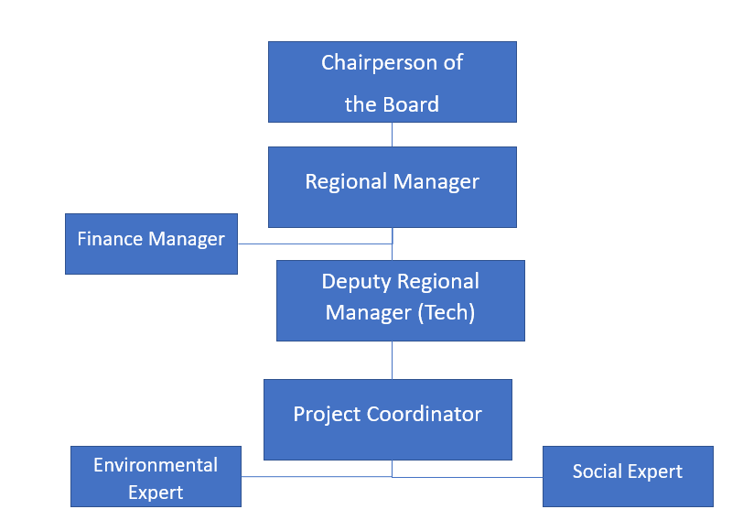
Figure -. Organizational Chart (for both construction and operation phases) of TUIOSB Basic Infrastructure Project
The Project Owner, in collaboration with relevant third parties, including but not limited to the Consultant company appointed in line with the requirements and scope defined, will establish, maintain and promote, as required, a Project-specific organizational structure that defines roles, responsibilities and authority for the implementation of ESMP and SEP as provided as a model in Figure 9-2.
Specific personnel with clear boundaries of responsibility and authority will be appointed, including management representatives. The Project-specific organizational structure to be developed will include executives, who will coordinate and manage the Project, the Technical and Financial Experts who will be in charge of construction and operational phases of the Project, and at least one Social Expert, one Environmental Expert and one OHS Expert. Core environmental and social responsibilities should be well defined and communicated to the relevant personnel and the rest of the Project Management Unit. Additionally, personnel should have adequate knowledge, skills and experience to competently and efficiently take specific measures and actions required under ESMP.
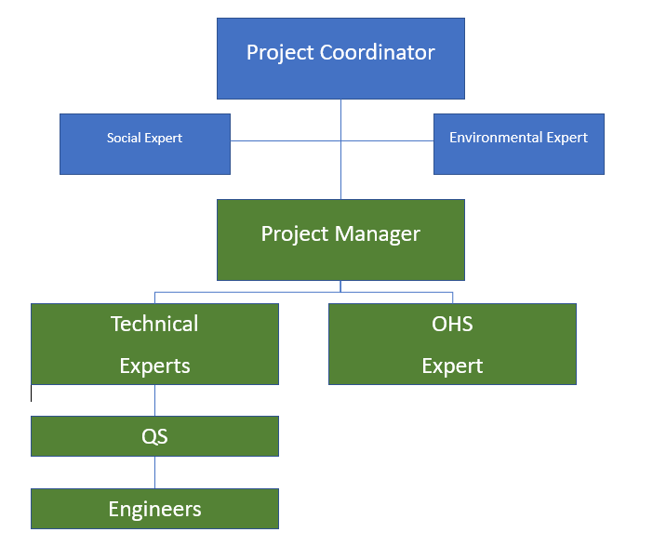
Figure 9-2. Organizational Chart of Project Management Unit

Roles and Responsibilities
The implementing organisation of the project is the Ministry of Industry and Technology of the Republic of Türkiye. MoIT will provide loans to the borrowing OIZs as a sub-borrower. The General Directorate of Industrial Zones of MoIT is the responsible Project Implementation Unit (PIU) coordinating overall project activities on a day-to-day basis. The PIU includes environmental and social experts with sufficient qualifications and experience to manage the implementation of the ESMP and SEP and related requirements.
The Supervisory Consultant, who will be responsible for detecting nonconformities, notifying TUIOSB and monitoring corrective actions within the scope of the Project, will be selected by the tender to be opened by TUIOSB. This tender will be held in accordance with the WB Procurement Regulations and companies that have been banned from public tenders will not be included in the tender process. The result of the tender will be approved by the MoIT.
Non-conformities identified during audits will be managed through a process tailored to the severity of the situation. Non-conformities are divided into 4 categories: minor non-conformities, Level 1, 2, 3 non-conformities.
Minor nonconformities can be overcome with minor measures. Level 1 non-conformities are non-conformities that do not pose a major immediate risk to health, environment, society, or safety. Level 2 nonconformities apply to all nonconformities that represent a risk with significant consequences for health and/or the environment, society or safety. Level 3 non-conformities apply to all non-conformities that cause harm to health or the environment or represent a high safety hazard or high social risk. Details of the process to be followed regarding non-conformities are given in the SEP.
Organizational chart of TUIOSB and organizational chart of Project coordination unit are presented in Figure 2-15 and Figure 2-16.
Project's organizational management is presented in Table 9-1.
Table 9-1. Project’s Organizational Management
Responsible Party | Terms of Reference
TUIOSB | - TUIOSB is the implementer and beneficiary of this Project.  - TUIOSB will be responsible for providing technical and data support during the supervision of contractor and the preparation of technical and financial feasibility reports regarding projects.  - TUIOSB will check both the technical and administrative progress of contract packages and the implementation of the points provided in ESMP and SEP on site together with Environmental, Social and OHS Experts (at least one Social Expert, Environmental Expert and OHS Expert) who will be involved in the Project Organization Chart.  - TUIOSB will present ESMRs prepared by the contractor to the MoIT monthly.  - TUIOSB evaluates, reviews the Consultant’s monthly monitoring report, and submits it to the PIU.
Supervisory Consultant | - TUIOSB will appoint a Supervisory Consultant having a range of specialties to inspect the contractor's activities on a daily basis. Apart from the guidance to the given to TUIOSB about WB ESSs and also the public consultation and announcement requirements and the project documents in compliance with WB requirements.  - As part of ESMP, implementation of the measures identified for the construction phase will be coordinated by Environmental, Social and OHS Experts (at least one Social Expert, Environmental Expert and full-time OHS Expert) who will be involved in the Project Organizational Chart. The said experts will be responsible for taking actions required to eliminate/minimize environmental and social impacts in line with ESMP and for putting monitoring plans into practice.  - The Supervisory Consultant will be responsible for preparing the bid documents during the implementation, conducting bidding processes. The legal requirements of the WB will be followed, the following the Construction Contract and cooperating with the MoIT for the supervision of construction activities.
Contractor | - The construction works under the contract packages included in the scope of the ESMP will be carried out by contractors.  - Contractors will be responsible for observing the liabilities provided in the ESMP. Issues related to the implementation of the ESMP will be examined by the contractor during the preparation of the bid, and proposals will be submitted considering the ESMP prepared by the MoIT.  - The ESMP includes the monitoring tables that describe the possible negative effects of the operations to be carried out during the construction phase of the project and the measures to be taken to minimize these effects and the conditions for putting these measures into action. Additionally, the said tables include the entities and organizations (project stakeholders) responsible for the aforementioned items.  - During the construction phase, the contractor will provide training to the personnel who will take part in the project, including the measures within the scope of ESMP, to raise awareness of environmental, occupational and worker health and safety, community health and safety and social issues.  - The contractor will submit their monthly ESPRs to TUIOSB.  - In case of contingencies such as environmental, social, and labor issues or accident or loss of time, the contractor will immediately inform TUIOSB and the Supervisory Consultant. TUIOSB will inform the MoIT. The MoIT will forward to WB within three working days by risk level. A report on the root causes of the incident and the corrective actions to be taken will be submitted to the MoIT and the WB within 30 days.
Project Coordinator | - Overall responsibility for the ESMP implementation,  - Ensure that ESMP provisions are implemented to mitigate environmental and social impacts,  - Undertake monitor of the implementation of the ESMP, and  - Prepare quarterly or semi-annual environmental and social monitoring reports for submission to the lenders.
Social Expert | - Adopt and implement Stakeholder Engagement Plan (SEP);  - Establish an official worker and public grievance mechanism;  - Record grievances;  - Disclosure to complainant.
Environmental Expert | - Ensures that the environmental management systems of the project comply with the ESMP.
Project Manager | - Ensure that ESMP provisions are implemented to mitigate environmental and social impacts;  - Ensure that all workers, participate in training sessions on ESMP. Maintain a record of training and conduct of awareness sessions for staff to ensure compliance with environmental and safety commitments stated in ESMP ;  - Undertake monitor of the implementation of the ESMP ;  - Prepare quarterly or semi-annual environmental and social monitoring reports for submission to the Lenders, if requested.
Technical Experts | - Responsible for project design.

STAKEHOLDER MANAGEMENT UNDER ESMP
A stakeholder is defined as any person, organisation or group that may be affected by the project or has an interest in the project and its impacts. Internal and external stakeholders (including vulnerable individuals/groups) are defined in the table below to identify which stakeholders will be directly or indirectly - positively or negatively - affected ("affected parties") or have an interest in the project ("other interested parties"):
Table 10-1. Stakeholder Groups
Stakeholder Groups | Stakeholder Type
 | Type of Impact | Cause of Impact/interest |  | Affected Party | Interested Party
Internal Stakeholders
- TUIOSB Personnel;  - Contractors and Employees. |  | Direct Exposure | Project Development, Implementation and  Employment |  | √
Government / Authorities
- Ministry of Energy and Natural Resources;  - District Governorate of Tarsus;  - Provincial Governorate of Mersin;  - Mersin Provincial Directorate of Environment Urbanization and Climate Change;  - Mersin Chamber of Commerce and Industry;  - District Health Directorate of Tarsus;  - Ministry of Industry and Technology;  - Provincial Directorate of National Education;  - Organized Industrial Zones Supreme Organization (OSBÜK). | Indirect Exposure |  | Relation of the Project with Healthcare, Environmental and Social institutions during construction and operational phases |  |  | √
Municipalities
- Municipality of Tarsus;  - Metropolitan Municipality of Mersin. | Direct Exposure |  | Project Development, Implementation and  Employment |  |  | √
Neighbourhood
- Kurbanli Neighbourhood;  - Eskisehir Neighbourhood;  - Saglikli Neighbourhood. | Direct Exposure |  | Commissioning,  Potential noise and dust emission during the construction phase |  | √
Businesses
- Quarries operating in the region. | Direct Exposure |  | Commissioning,  Potential noise and dust emission during the construction phase |  | √
NGO
- Tarsus Environmental Protection Culture and Art Center Association | Indirect Exposure |  | The pollution load of the discharged river will be reduced. |  |  | √
Vulnerable/Disadvantaged Individuals or Groups
- Individuals over 65 years of age living alone  - Poor families  - Physically / Mentally disabled  - Refugee  - Women Living alone | Direct Exposure |  | Commissioning,  Potential noise and dust emission during the construction phase |  | √

Stakeholder engagement activities will be the responsibility of a staff member from the Public Relations Unit who will be assigned by TUIOSB to implement the SEP, or a specially appointed person with the necessary qualifications to fulfil this task. The ultimate responsibility for the implementation of the SEP rests with TUIOSB. Throughout the construction and operation phases, TUIOSB will keep the following information up to date and accessible and will provide information on Project developments and implementation:
- Key Project phases and timetables (e.g. obtaining permits, commencement of construction or operation activities, construction programme, etc;
- Any Project-related disruptions (e.g. road closures, access and infrastructure disruptions);
Significant consultations/meetings that may have consequences that may affect the community and local people;
- Environmental, health and safety performance (e.g. information on accidents, monitoring results).

Previous Stakeholder Engagement Activities
Within the scope of the project, two different stakeholder consultations meetings were held regarding the existing area and the additional area related to the project.
The public consultation meeting related to the existing area was held on 07.12.2017 at 14.00 on 07.12.2017 at Ali Ergezer Meeting Hall of Tarsus Chamber of Agriculture. The Public Consultation Meeting was announced on 25.11.2017 with an advertisement in Yeni Doğuş newspaper.
In the public consultation meeting held on 07.12.2017, information about the project area, the area where it is going to be established, the workflow chart and process of the facility, possible social and environmental impacts, and measures to be taken were provided with slides. In addition, the opinions of the stakeholders regarding the said information were also received.
During the public consultation meeting, it was suggested that adding the location of the area as "Kumgediği" to the name of the project could avoid confusion as there are several OIZs in the vicinity of Tarsus District. This amendment was not implemented as it was not deemed necessary. In addition, the question of who will take part in the Specialized Organized Industrial Zone Enterprising Committee has been addressed and it has been stated that the people who will work in the OIZ should be selected from the region. These issues are evaluated in the EIA Report.
The public consultation meeting regarding the additional area was held on 08.06.2021 at 14.00 on the terrace floor of Kurbanlı Neighbourhood Mosque in Kurbanlı District of Tarsus District of Mersin Province. The Public Consultation Meeting was announced with an advertisement in Yeni Doğuş newspaper on 28.05.2021.
The public consultation meeting was held on 08.06.2021 and information about the additional area, distance to settlements, facilities to be located in the OIZ, social and environmental impacts and measures to be taken, possible social and environmental impacts and measures to be taken were provided with slides. In addition, the opinions of the stakeholders regarding the information in question were also received.
Following these meetings, a site visit was conducted on 20.12.2022 - 21.12.2022 and primary data on the communities living around the Project area and potential project impacts were collected through key informant interviews with the mukhtars of Kurbanlı, Eskişehir and Sağlıklı neighbourhoods during the site visit. Interviews were also conducted with a nomadic family on the border of the Project area and former beneficiaries of the TUIOSB administrative building.
The information obtained from the interviews summarises the current situation of the neighbourhood in general. This information has been shared in the previous sections of this document.

Grievance Mechanism
The Grievance Mechanism is to provide access to an effective procedure for people affected or interested parties in the project. Grievances can be an indicator of stakeholder concerns and can escalate if not identified and resolved. Identifying and responding to grievances supports the development of positive relationships between Project staff, local communities, and other stakeholders.
The Structured Grievance Mechanism aims to ensure that Project-related grievances are addressed through a transparent and impartial process. The grievance procedure will start from the pre-construction phase of the Project and will be periodically publicised to all stakeholders involved in the SEP. A separate GM for the project workers is included in the LMP:
The methods used to publicise the existence of the grievance mechanism should be culturally appropriate and in line with the ways in which stakeholders usually obtain information. Women and men may access information differently and it should be ensured that both have equal access to information. Stakeholders will be able to share their views and grievances through a range of options such as letters, e-mails, grievance boxes and face-to-face meetings throughout the life of the Project.
The project-based GM is intended to serve as a mechanism to:
- Allow identification and impartial, timely and effective resolution of issues project-related issues raised by the public, stakeholders and project workforce (in a separate GM);
- Strengthen project accountability vis-à-vis the public, including project affected stakeholders and workforce;
- Provide channels for the stakeholders, other interested partis and project workforce to provide feedback and raise concerns.
Having an effective GM in place will also serve the objectives of reducing conflicts and risks such as external interference, corruption or mismanagement; improving the quality of project activities and results; and serving as an important feedback and learning mechanism for project management regarding the strengths and weaknesses of project procedures and implementation processes.
Handling SEA/SH issues: the grievance mechanism for workers shall include handling any case of sexual exploitation and abuse (SEA) and sexual harassment (SH). A SEA/SH confidential referral pathway will be established and updated in line with existing procedures of the country. The GM for the project workers will also be used for addressing SEA/SH-related issues and will have in place mechanisms for confidential reporting with safe and ethical resolution of SEA/SH issues. Further, the GM will also have in place processes to immediately notify both the MoIT and the World Bank of any SEA/SH complaints, with the consent of the survivor. Thus, the existing GM will also be strengthened with procedures to handle allegations of SEA/SH violations. SEA/SH related complaints from local communities will also be addressed through the existing grievance mechanism and managed sensitively and confidentially.
In order to provide an effective grievance mechanism, grievance mechanism will be managed in accordance with the following principles:
- Accessibility and inclusiveness: The grievance mechanism should be accessible to all project-affected parties, irrespective of their backgrounds or circumstances. It should be designed in a manner that considers cultural appropriateness and provides no-cost access to all stakeholders. It should also not prevent access to judicial or administrative remedies.
- Transparency and timeliness: The grievance mechanism should address concerns promptly and effectively. It should operate in a transparent manner and provide culturally appropriate and readily accessible information to all project-affected parties. The Borrower should inform the community about the grievance process during its engagement activities and make a record of the responses to all grievances publicly available.

- Discretion, objectivity, and sensitivity: The handling of grievances should be done in a culturally appropriate manner, ensuring discretion, objectivity, and sensitivity towards the needs and concerns of the project-affected parties. The mechanism should also allow for anonymous complaints to be raised and addressed.
- Design and scale: The design and scale of the grievance mechanism should be project-specific, taking into account factors such as the project context, scale, and scope, the number of project beneficiaries, capacity, cultural attitudes toward lodging grievances, available resources, and technological constraints. Existing formal or informal mechanisms identified during the environmental and social assessment may be utilized, supplemented as needed with project-specific arrangements.
- Establishing the mechanism: The grievance mechanism should be established as early as possible in project development and supported by appropriate human and financial resources. It should specify the means by which grievances can be submitted and received, assign responsibility for processing grievances, establish timelines for processing complaints, and include a process for registering and monitoring grievances. Larger or more complex projects may require multiple locations, means, and methods for receiving, processing, and monitoring grievances.
- Accessibility and advertising: The grievance procedures should be simple and easy to understand, publicly advertised through accessible and appropriate channels such as newspapers, radio broadcasts, or other mediums. The expected timelines for acknowledgment, response, and resolution should be indicated. It is essential to ensure accessibility for disadvantaged or vulnerable individuals or groups, and all grievances received and responses provided should be documented.
- Balanced actions and resolution: Actions taken on grievances or suggestions should be informed and balanced. The time frame for grievance resolution depends on factors such as urgency, research, investigation, consultation, funding, and capacity. The grievance mechanism should provide indicative time frames for acknowledgment, interim responses, and, where possible, final resolution. Grievances that require coordination among multiple departments/agencies or detailed investigation may take longer, and this should be communicated to the concerned parties when acknowledging receipt of the grievances.
- Confidentiality and non-retaliation: Grievance mechanisms should ensure confidentiality, impartiality, objectivity, and timely handling of grievances. In countries where anonymous grievances are not permitted, the Borrower may consider engaging third-party entities to facilitate their submission. Users of the grievance mechanism should not be subject to retaliation, abuse, or any kind of discrimination.

Existing GMs

GM at National Level
CİMER is an abbreviation for "Presidential Communication Centre". It is a public relations practice established to facilitate the use of the right to petition and the right to information guaranteed by the Constitution. It is carried out under the responsibility of the Public Relations Department of the Presidential Communication Directorate.
CİMER is the name of the electronic system and the applications made are sent to the relevant public institution from approximately 60 thousand administrative units registered in the system and are processed and responded by the receiving institution. CİMER is a platform where you can submit all kinds of opinions and suggestions regarding public policies within the framework of the "participatory management" approach, as well as the use of petition and information rights.
In addition to CİMER, there is the Foreigners Communication Center (YIMER) which provides a centralized complaint system for foreigners. Foreigners use YIMER to submit all kinds of requests, complaints, compliments and inquiries without experiencing language barriers.

GM at Ministry Level
In accordance with the World Bank's ESS10 requirements, an appropriate grievance mechanism (GM) has been established for the Project and is currently operational. For the proper and timely functioning of this mechanism, a GM focal point to oversee the entire process has been appointed as part of the project team of the Ministry of Industry and Technology. The GM focal point will also be responsible for reporting on the grievance redress process of the project for monitoring purposes. This person will also be responsible for coordination to ensure the smooth functioning of the grievance mechanism under the project.
MoIT receive formal requests and grievances through the Presidential Communication Center (CIMER). Other than CIMER, MoIT can receive formal grievances either as official petitions or through its online web channels. In accordance with the requirements of the World Bank, an expert will be assigned to function as the GM focal point of the project, who will receive grievances regarding the project through all available GMs. The GM will also allow submission of anonymous grievances through CIMER.
Additionally, requests, grievances and suggestions can be sent to Department of Personnel (for MoIT) either electronically (online correspondence system) or paper-based petitions for project workers, who are staff of MoIT. Requests, grievances, and suggestions received in this way are evaluated in every 20 business days. The evaluation results are listed internally on the grievance system and can be accessed by employees through their own intranet. The grievances which are relevant to this Project, received through this system will also be reported to GM focal point.

Project Level Grievance Mechanism
Project Implementation Unit (PIUs) in TUIOSB will be responsible for overall management and supervision of the project including compliance with SEP requirements as well as managing grievances. TUIOSB has its own grievance mechanisms in place which allows its employees, contractors, and stakeholders to raise workplace related concerns and grievances. For this purpose, there are “Request and Complaint Boxes” in various parts in buildings. Additionally, requests, grievances and suggestions can be received by the TUIOSB through paper-based petitions. Any request, suggestion or grievances can be sent to the TUIOSB via ‘Send Message’ and ’Communication’ sections of their websites. Furthermore, any personnel may share his/her request, suggestion or grievance to Regional Directorate and the Board of Directors.
PIU will require contractors to develop and implement a grievance mechanism for their workforce including sub-contractors, prior to the start of works. The construction contractors will prepare their Labour Management Procedure before the start of civil works, which will also include detailed description of the workers’ grievance mechanism.
The workers’ grievance mechanism will include:
- a procedure to receive grievances such as comment/complaint form, suggestion boxes, email, a telephone hotline;
- stipulated timeframes to respond to grievances and to resolve cases;
- a register sheet to record and track the timely resolution of grievances; and
- a responsible department to receive, record, address and track resolution of grievances.
The workers grievance mechanism will be described in staff induction trainings, which will be provided to all project workers. The mechanism will be based on the following principles:
- The process will be transparent and allow workers to express their concerns and file grievances;
- There will be no discrimination against those who express grievances, and any grievance will be treated confidentially;
- Anonymous grievances will be treated equally as other grievances, whose origin is known; and
- Management will treat grievances seriously and take timely and appropriate action in response.

REPORTING
The Contractor presents the monthly Environmental and Social Progress Report (ESPR), to the Construction Supervision Consultant. The Construction Supervision Consultant adds the Contractor's monthly ESPR to its own monthly Environmental and Social Monitoring Report (ESMR) and forwards it to the TUIOSB as Project Management Unit (PMU). The PMU evaluates, reviews the Construction Supervision Consultant’s monthly ESMR, and submits it to the Project Implementation Unit (PIU) of MoIT.
Subsequently, the MoIT will perform its own supervision and monitoring along with the information obtained from the TUIOSB through its Construction Supervision Consultant E&S team’s reports. After that the MoIT will prepare Environmental and Social Report (ESR) to cover summary of these ESMRs and submit it to the World Bank (WB) quarterly. During the operation phase, the social and environmental impacts, if any, will be evaluated and presented to the WB and MoIT biannually.
Reporting processes that should be put into action during the implementation phase of the project and the requirements of such processes are presented in Table 11-1.
Table 11-1. Reporting Process Requirements and Distribution of Roles
Responsible Party | Roles & Responsibility
WB | - Quarterly Environmental and Social Reports (ESRs) submitted by the PIU will be reviewed.  - Together with the PIU, it will carry out site visits periodically.
Project Implementation Unit (PIU) | - Quarterly inform the WB with ESRs to include summary of monthly Environmental and Social Monitoring Reports (ESMRs) on the progress and updates. Quarterly ESRs will highlight any issues arising from non-compliance with ES requirements and how it has been/is being addressed from the ES safeguards point of view.  - Submitting the quarterly Grievance Mechanism Report (GMR) to WB  - Site visits will be carried out periodically and environmental and social issues will be examined on site. Findings after site visit will be included in the quarterly ESRs.
Project Management Unit (PMU) | - Review and submit monthly ESMRs to PIU  - Submitting the monthly GMR to cover both Consultant’s GMR and Contractor GMR to PIU  - Follow up construction activities in coordination with Construction Supervision Consultant
Construction Supervision Consultant | - Prepare and submit monthly ESMR to PMU including monthly Environmental and Social Progress Report (ESPR) from the contractor. Monthly ESMRs will highlight any issues arising from non-compliance with ES requirements and how it has been/is being addressed from the ES safeguards point of view.  - Submit the monthly Grievance Mechanism Report to PMU prepared in line with the complaint received and combine it with monthly the Grievance Mechanism Report prepared by the Contractor.  - Follow up and audit the contractor's activities on a daily basis in line with the ES measures and commitments
Contractor | - Prepare and submit monthly ESPRs covering the progress of the construction and environmental and social issues to the Construction Supervision Consultant  - Submit the monthly GMR to Supervisor

CONCLUSION
This ESMP identifies the potential impacts that may arise during construction and operation phases of the Project and proposed appropriate mitigation measures to effectively address these impacts. In conclusion, the Project can be carried out in an environmentally and socially sustainable manner on full implementation of this ESMP as there are no likely major or irreversible negative impacts.
During the construction period before mitigation measures are implemented:
Land use and soil quality, waste and chemical management, noise, OHS impacts are rated as high. Labour conditions, air quality, CHS and traffic and pedestrian safety impacts are rated as medium.
During the operation period:
Water use, wastewater, waste, and chemical management impacts are assessed as high. Labour conditions, OHS, odour and CHS impacts are assessed as medium.
Monthly monitoring activities will be carried out by Construction Supervision Consultant and TUIOSB, and E&S compliance will be reported regularly to MoIT. MoIT will carry out its supervision monitoring as required and report to World Bank semi-annually on the progress and updates. Monitoring reports will aim to identify environmental, social, OHS related risks and impacts. Grievances will also be included in the monitoring reports.
As part of the requirements stipulated by WB, ESMP is to be publicly disclosed by the TUIOSB’s and the WB’s website. ESMP will be reviewed, updated, and approved if necessary. For each approved updated version of this ESMP, the TUIOSB will be responsible for the disclosure of the updated documents.

REFERENCES
Burced Engineering Service Co.Ltd.,The EIA Report of the OIZ. (2022). The EIA Report of the Mersin Tarsus Agricultural Product Processing Specialized Organized Industrial Zone. Bursa.
Interim Advice for IFC Clients on Safe Stakeholder Engagement in the Context of COVID-19. (2020, May). Retrieved from https://www.ifc.org/wps/wcm/connect/30258731-0e7d-4cb2-863c-a6fb4c6d0d95/Tip+Sheet_Interim+Advice_StakeholderEngagement_COVID19_May2020.pdf?MOD=AJPERES&CVID=n9s.b9a
Mersin Governorate. (2021). Retrieved from http://www.mersin.gov.tr/nufus-ve-dagilim
Optimal Project Management, The Feasibility Report of the Project. (2022). The Feasibility Report of the Project. İstanbul.
Şen Engineering, The Geological-Geotechnical Survey Report of the Project Area. (2018). The Geological-Geotechnical Survey Report of the Project Area. Tarsus.
Tarsus Municipality. (n.d.). Retrieved from https://www.tarsus.bel.tr/tr/tarsus/ekonomisi.aspx
The Ministry of Industry and Technology. (2017). Socio-economic Development Ranking of Provinces and Regions SEGE-2017. Retrieved from https://www.sanayi.gov.tr/merkez-birimi/b94224510b7b/sege/il-sege-raporlari

Appendix-A
Land Title Deed Records

Project Area Title Deed Records
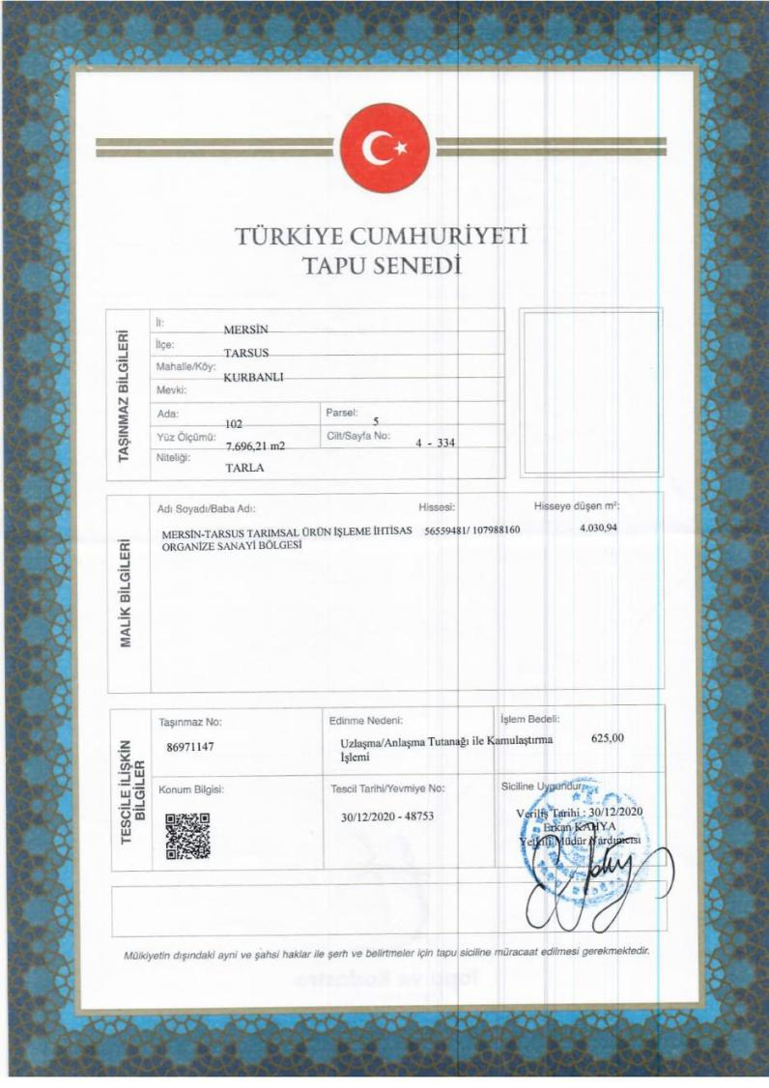
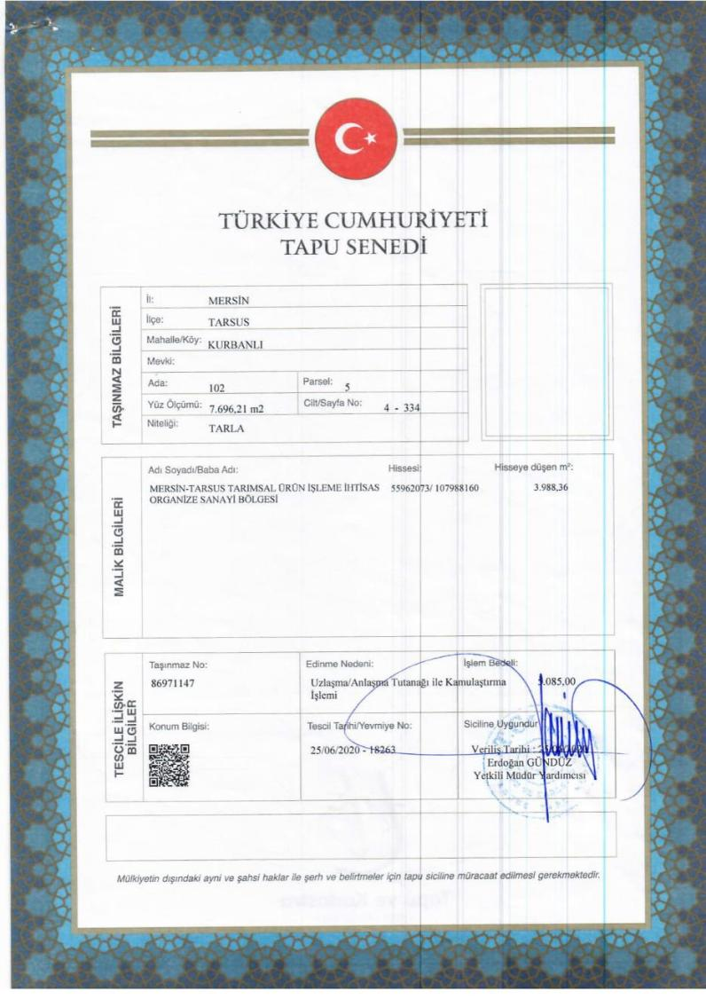
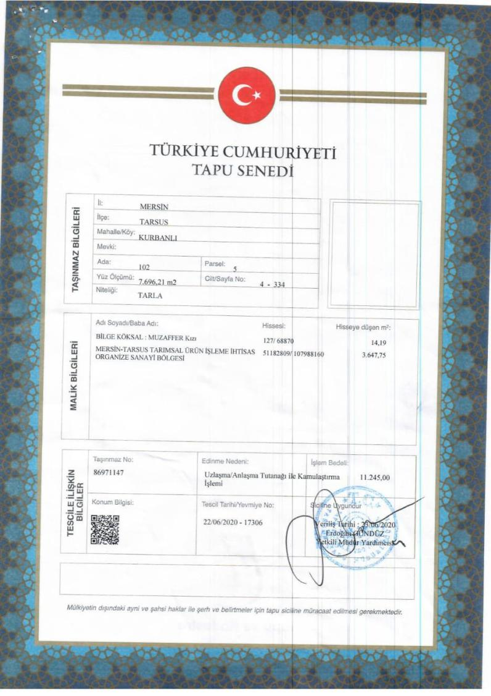

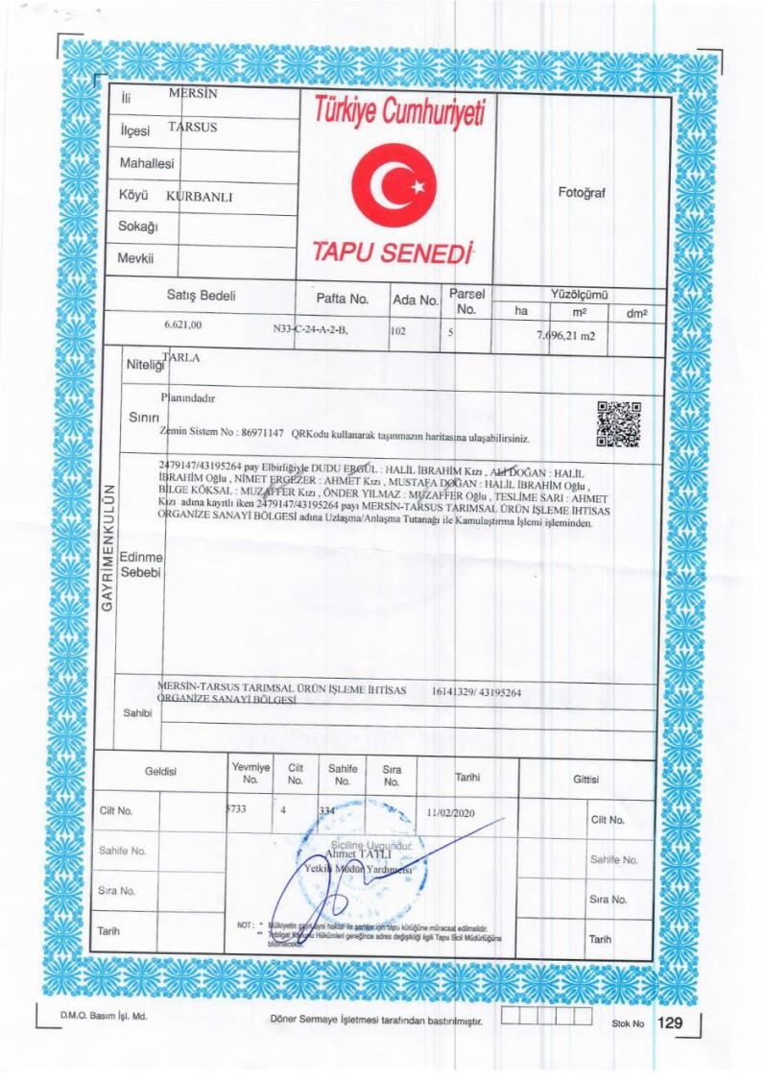
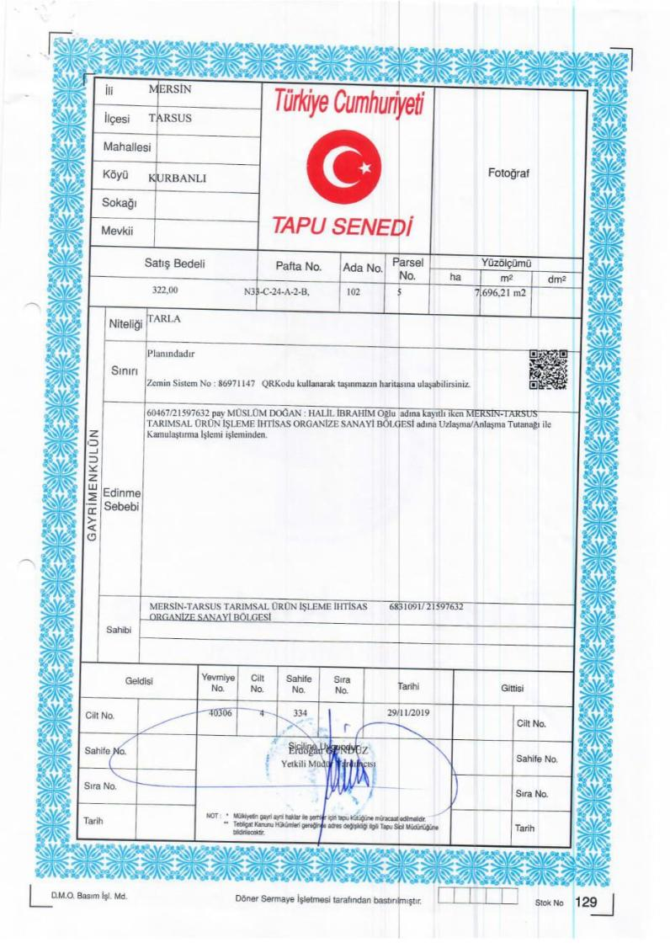

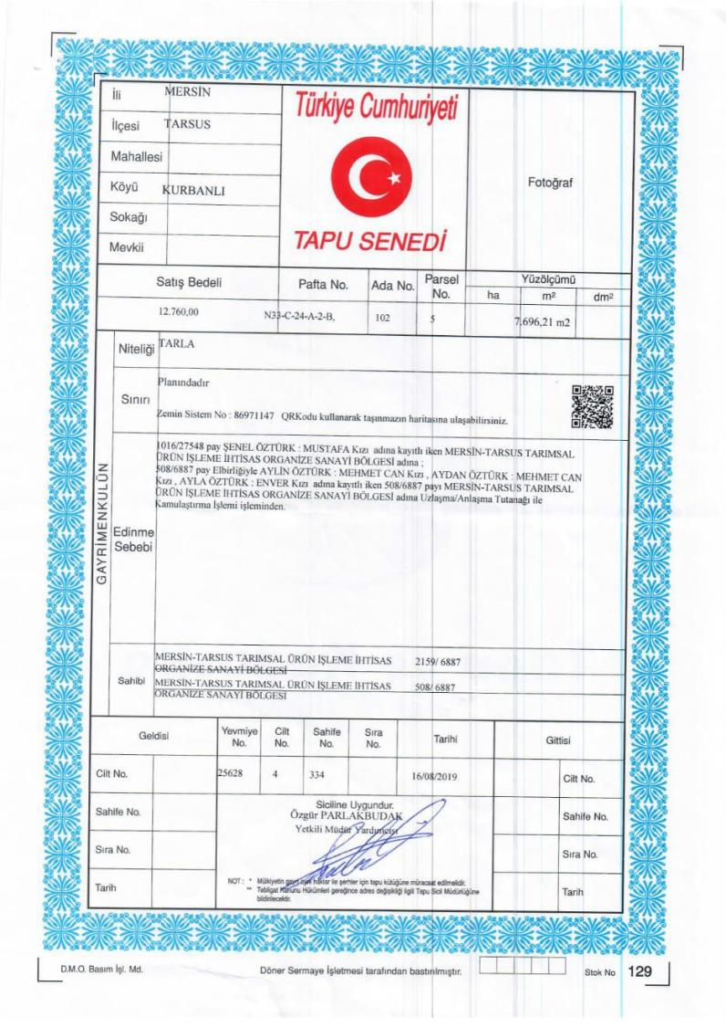

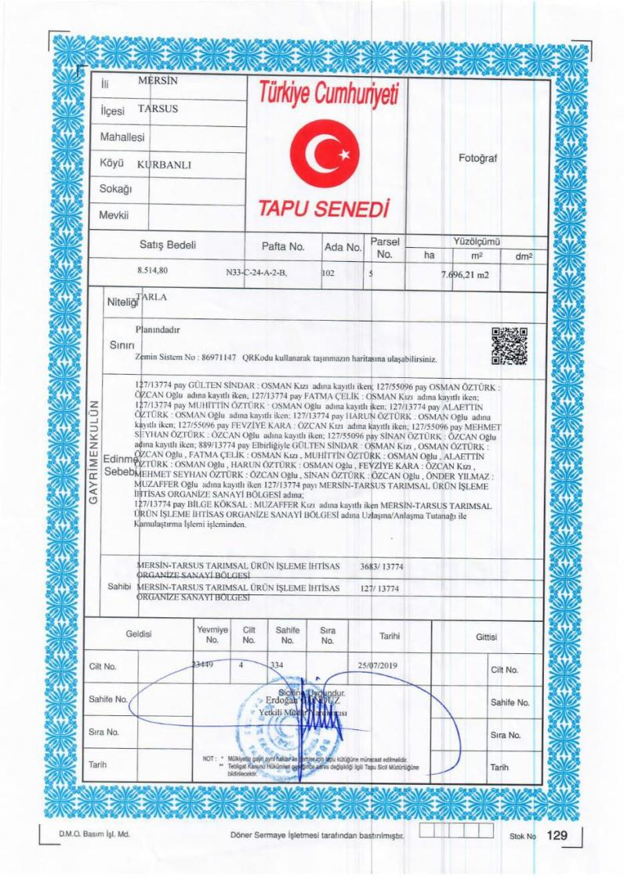

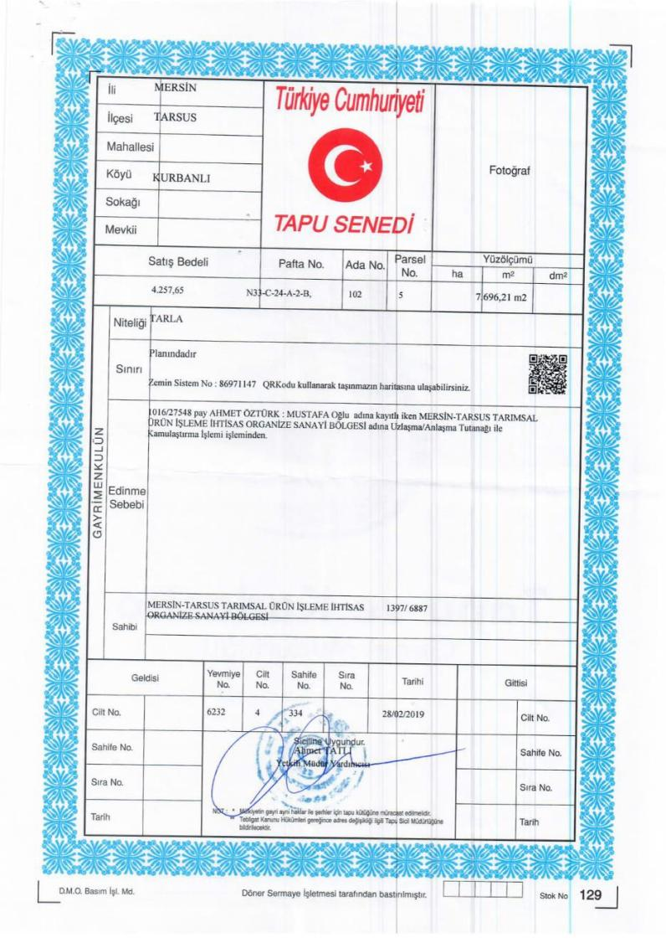

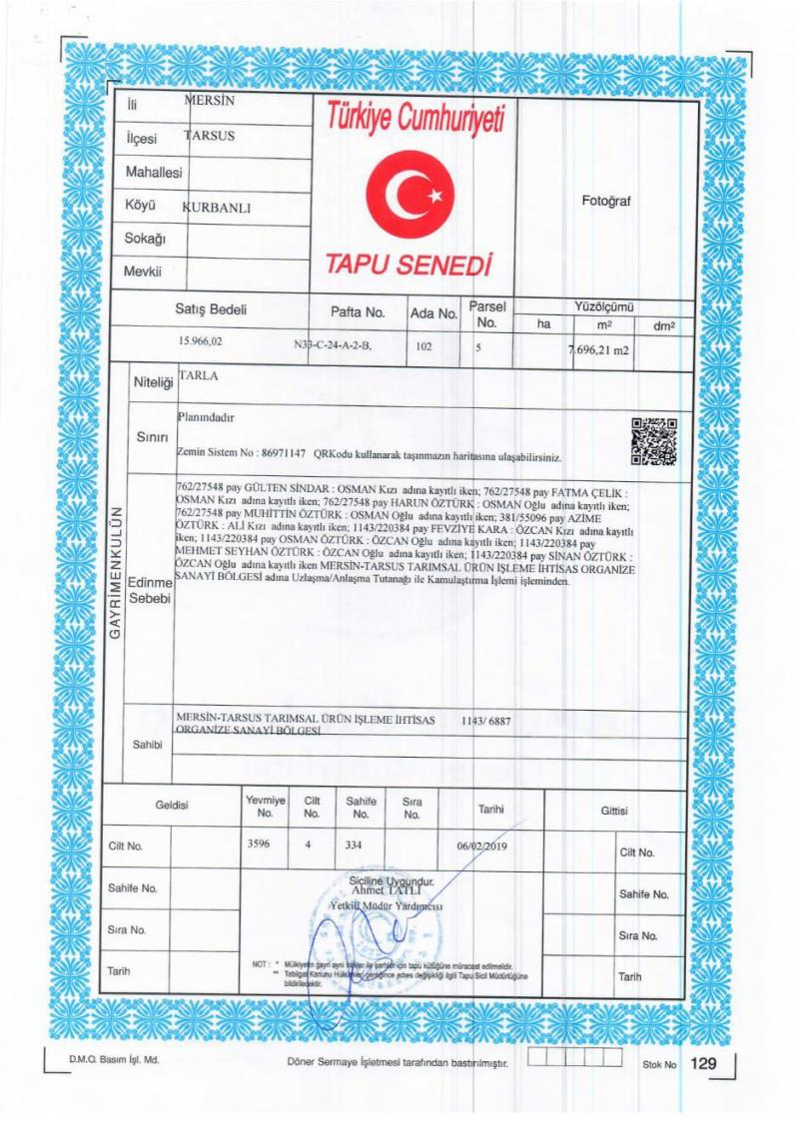

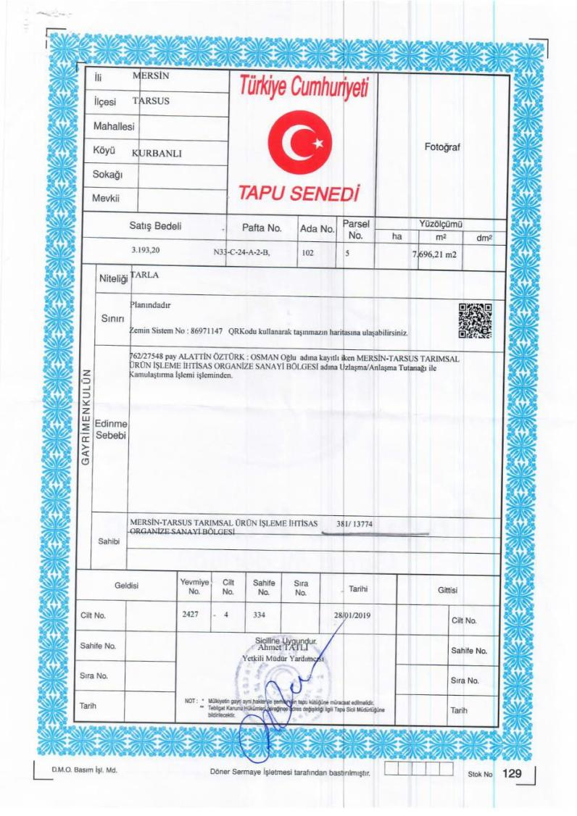
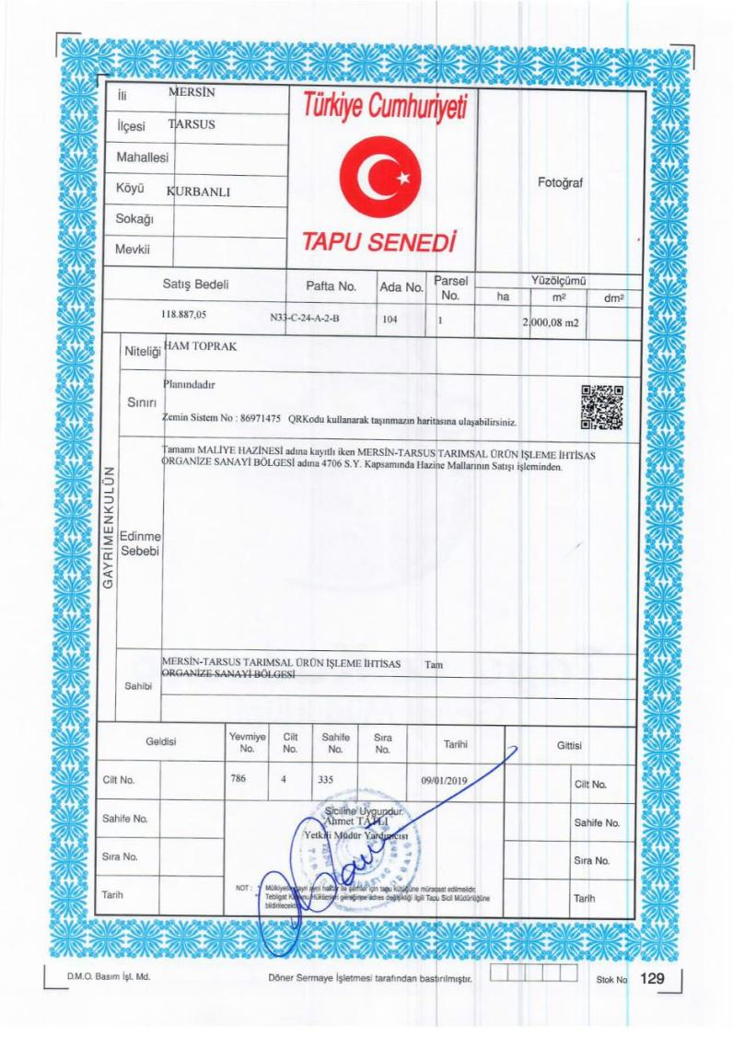

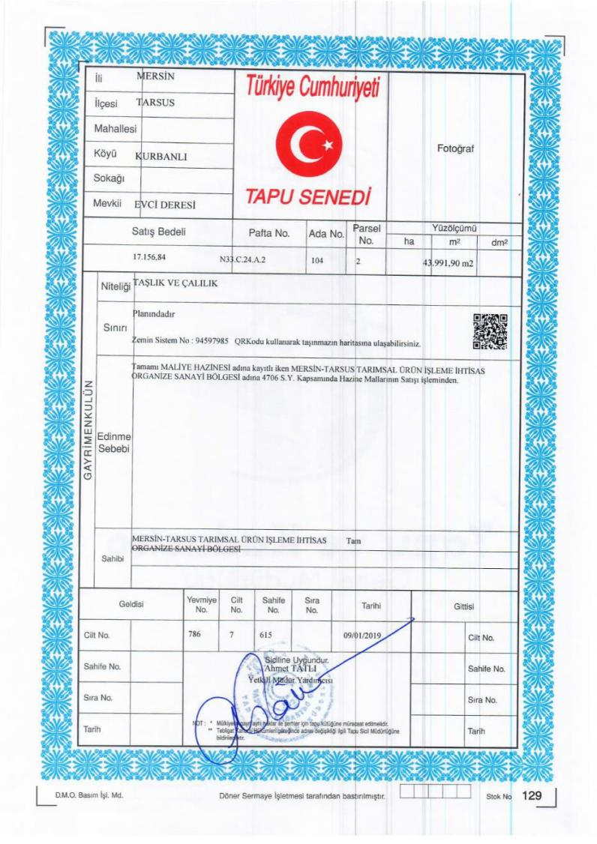

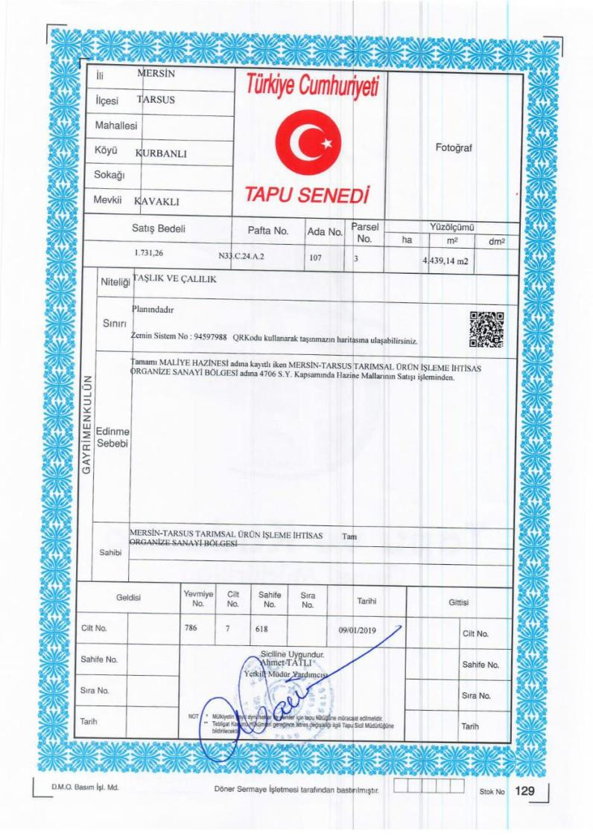

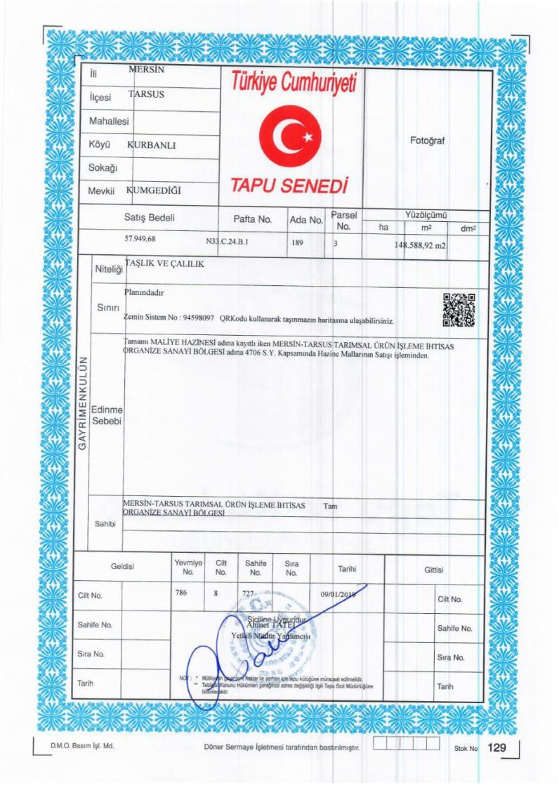
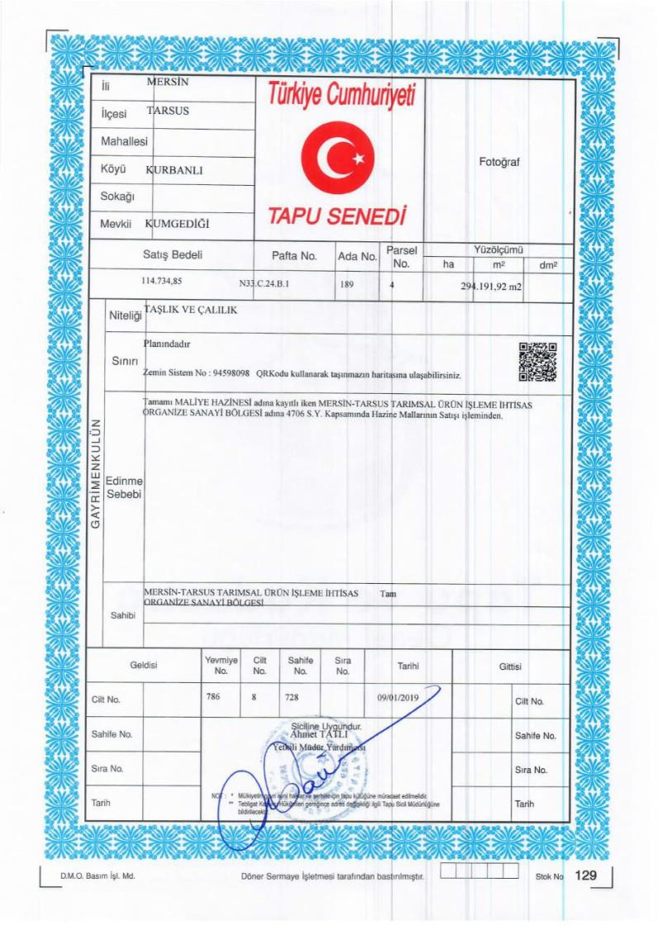

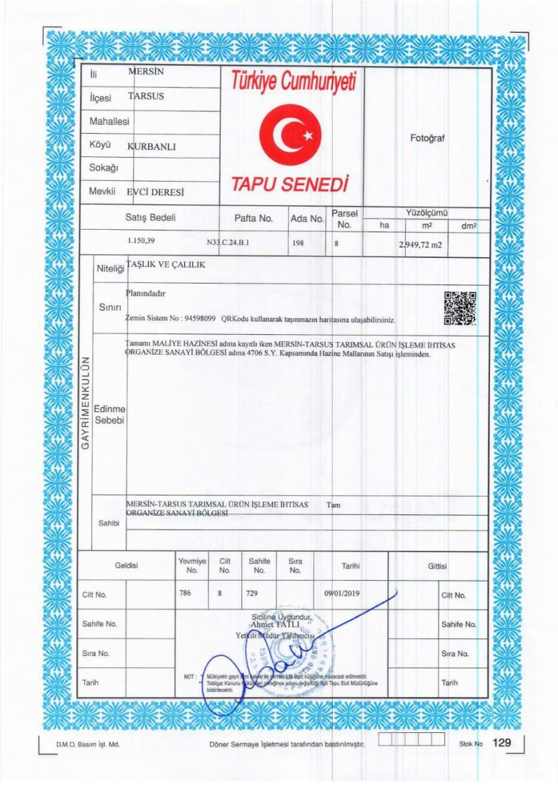
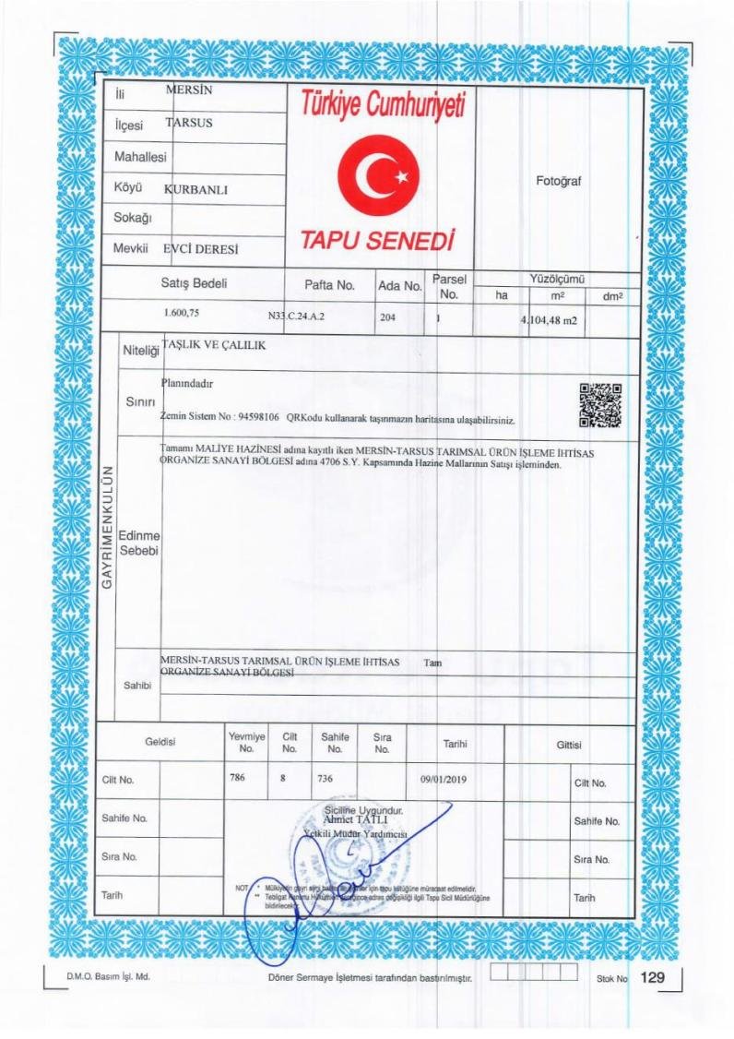

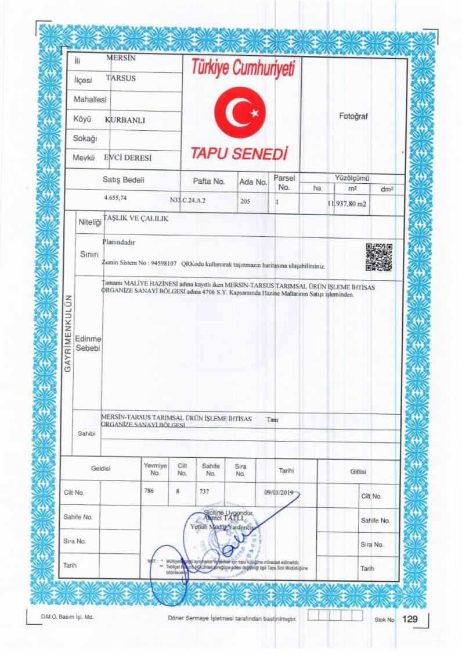

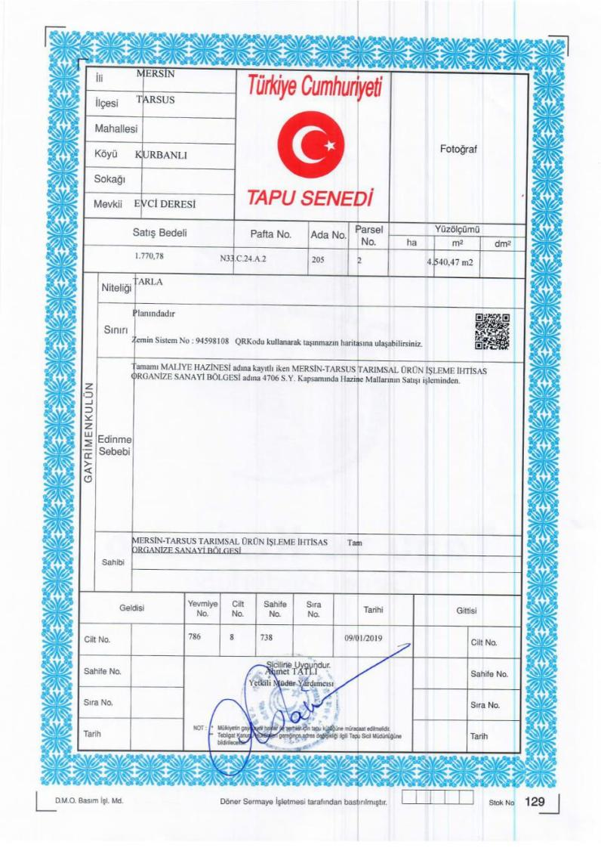

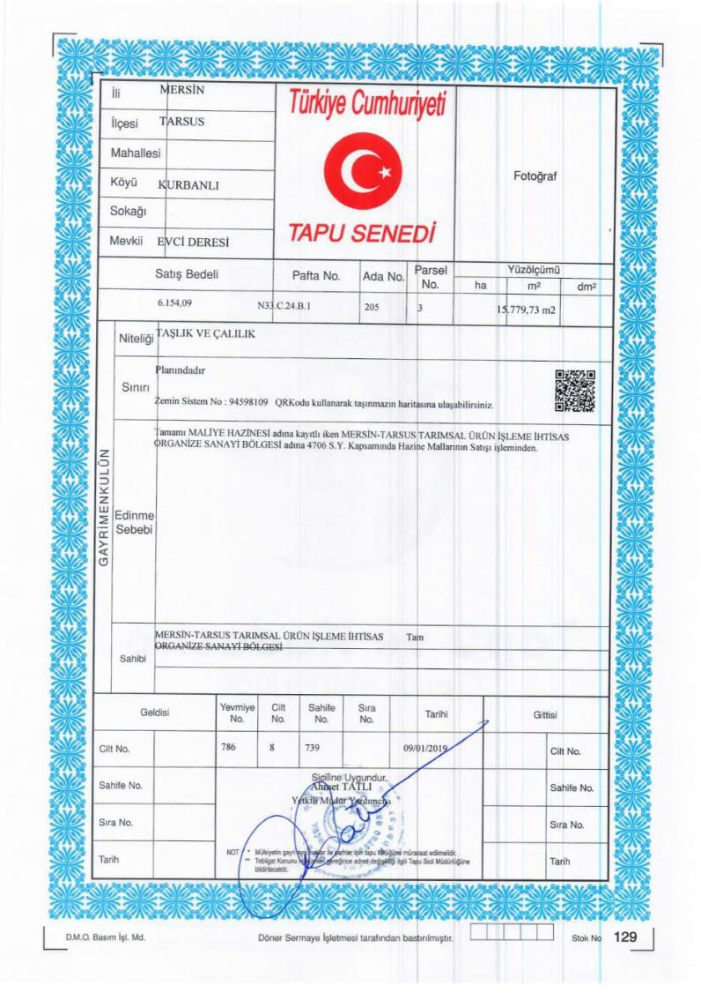

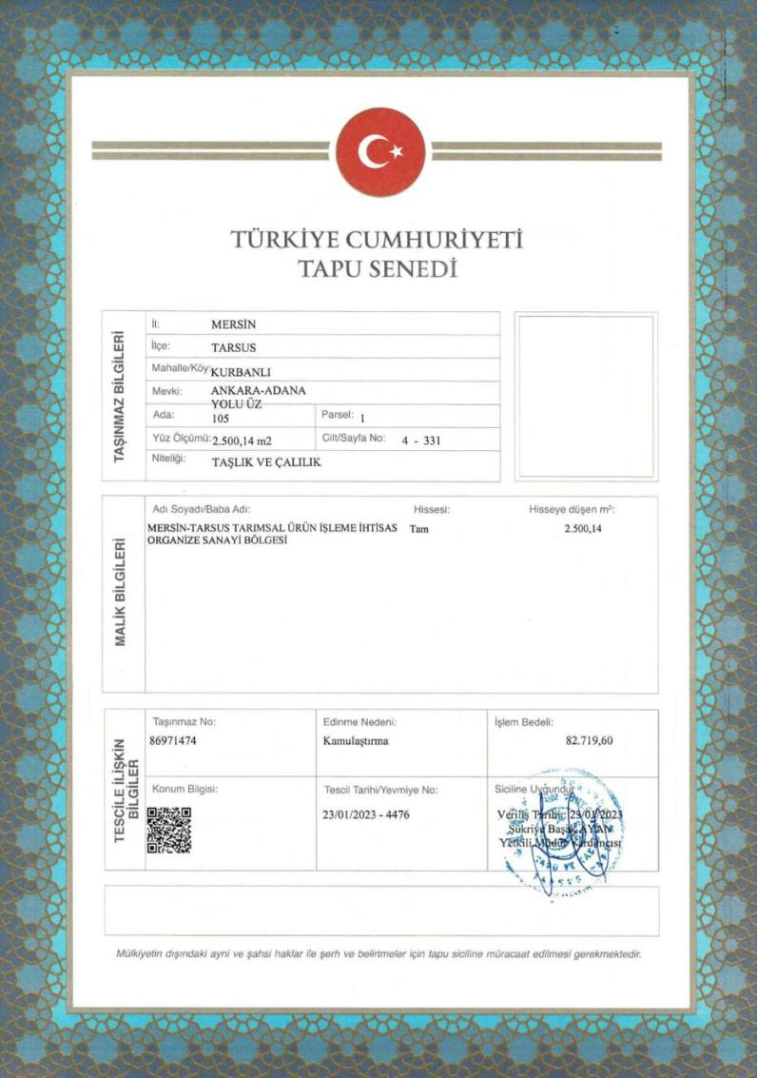
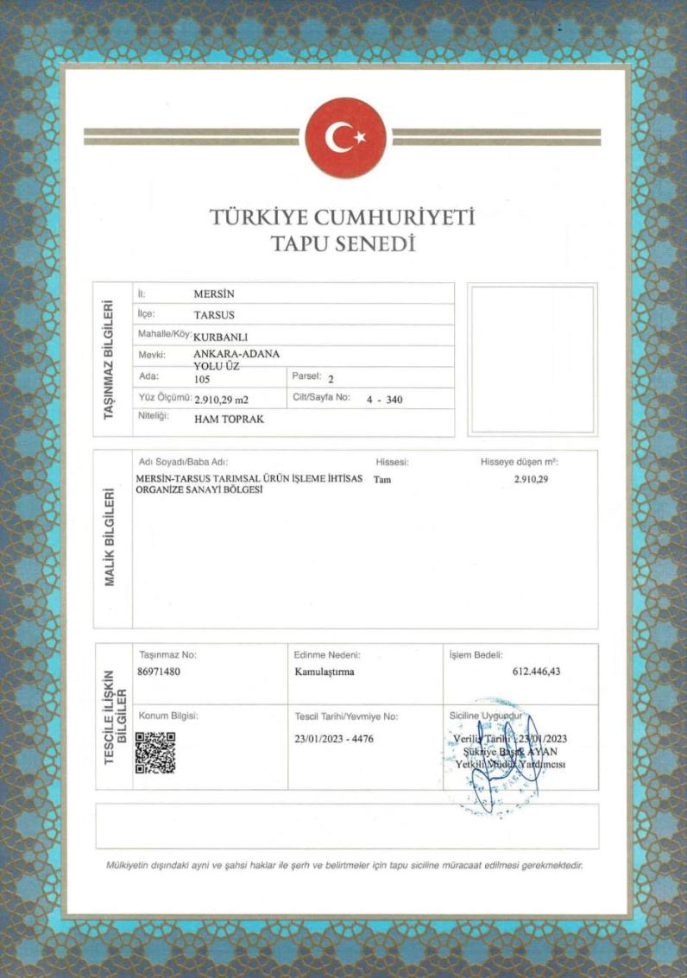

Appendix-B
EIA Positive Certificates

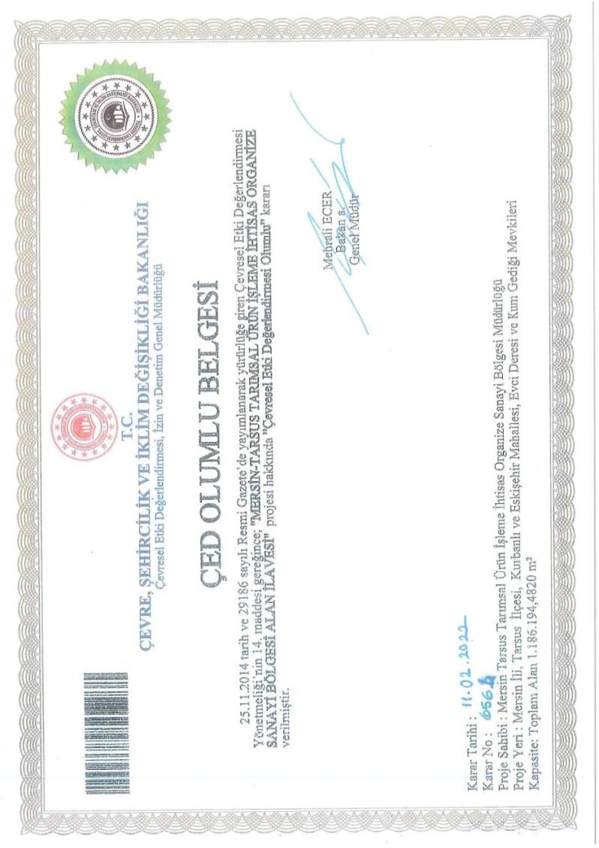
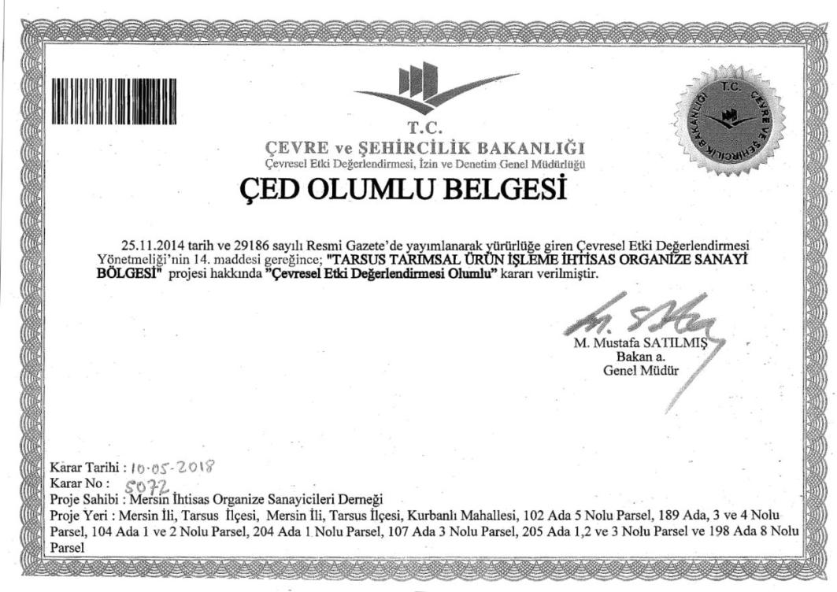

Appendix-C
Permits and Opinion Letters

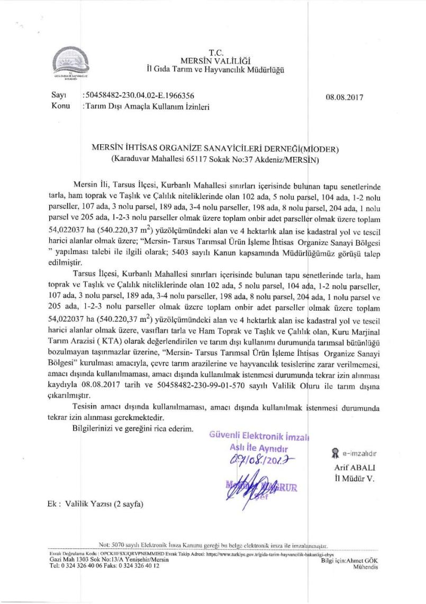
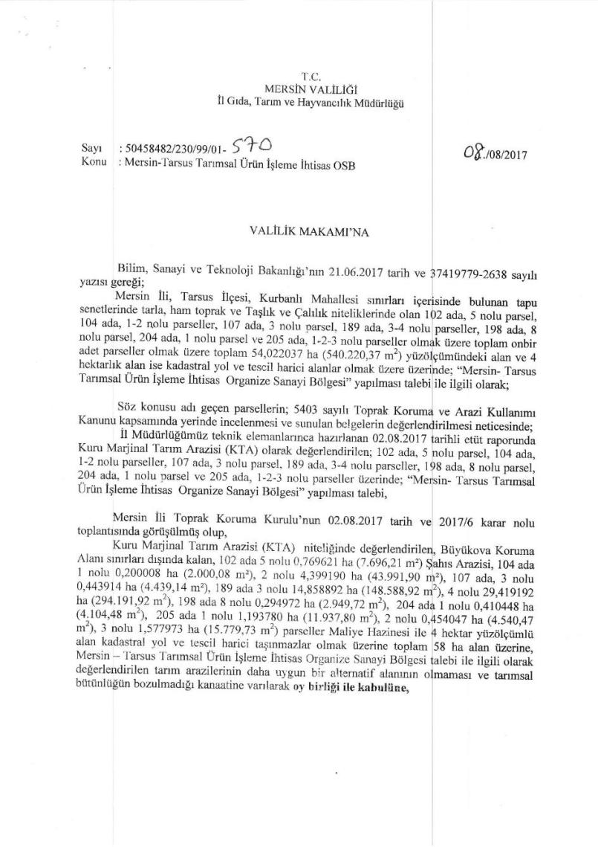
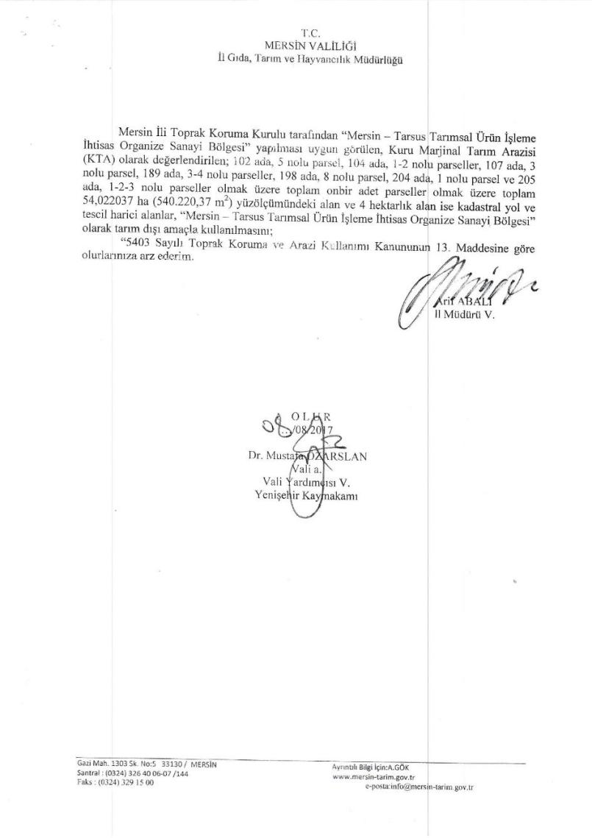
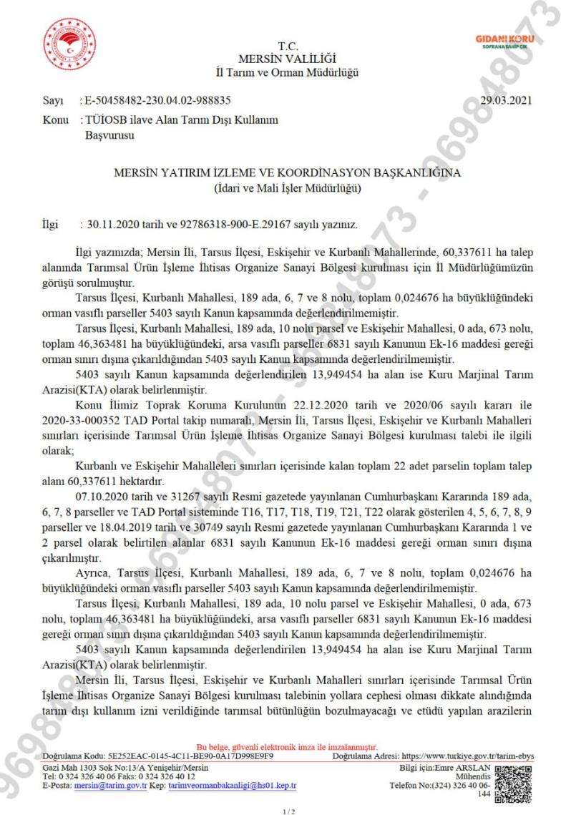
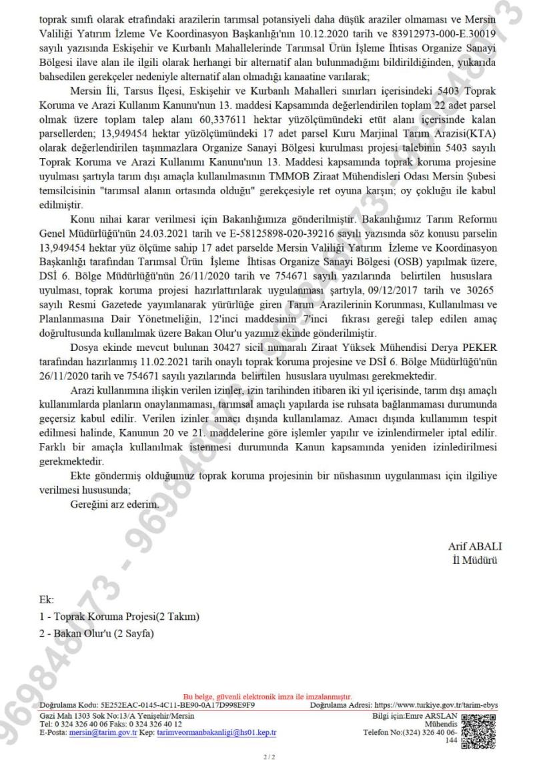
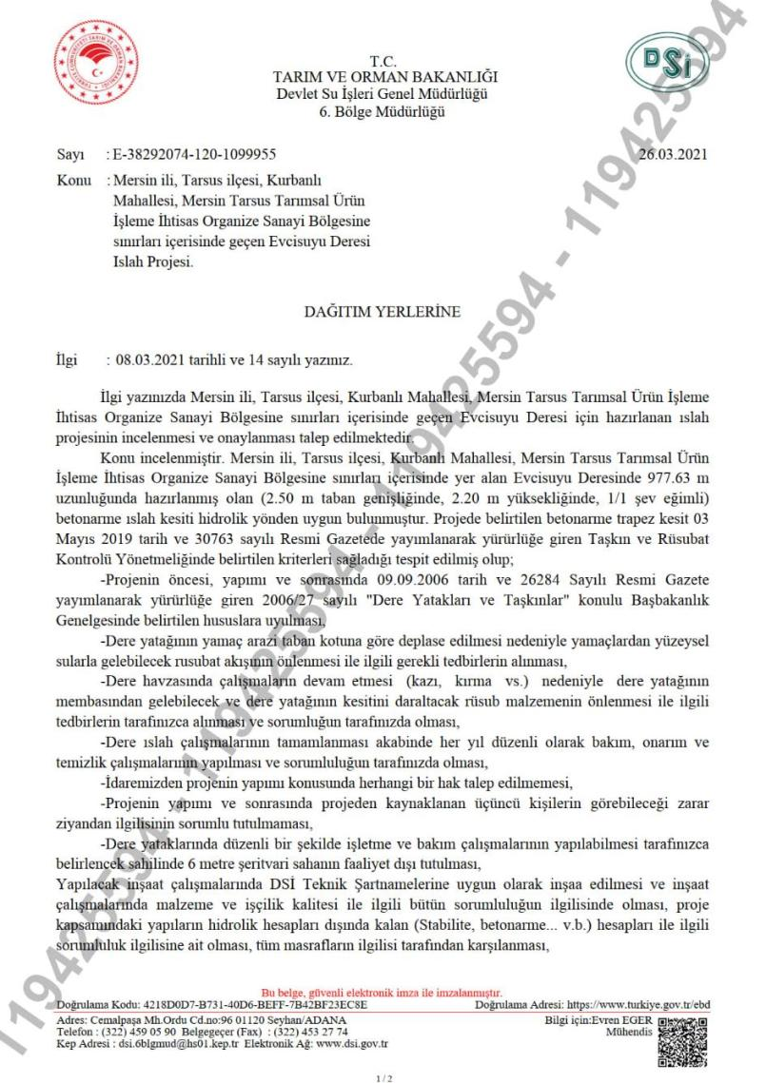
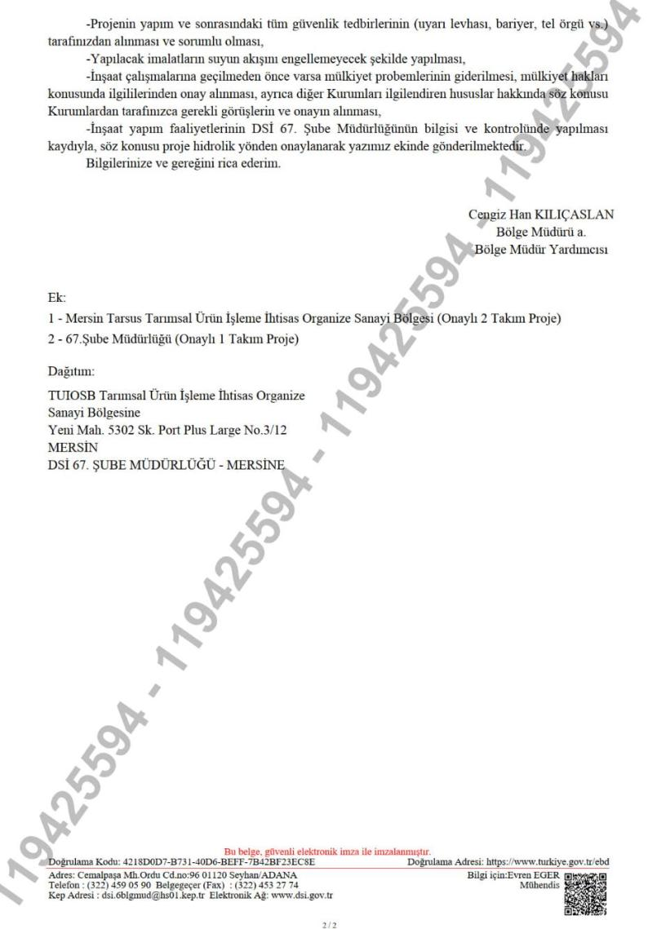
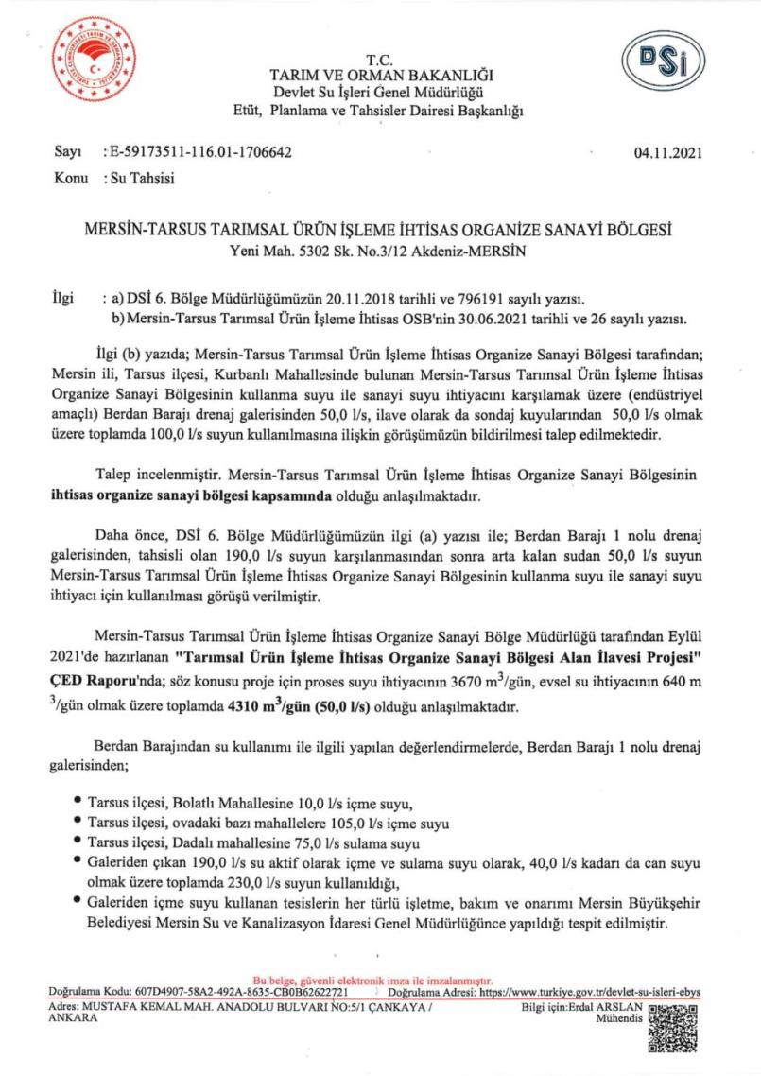
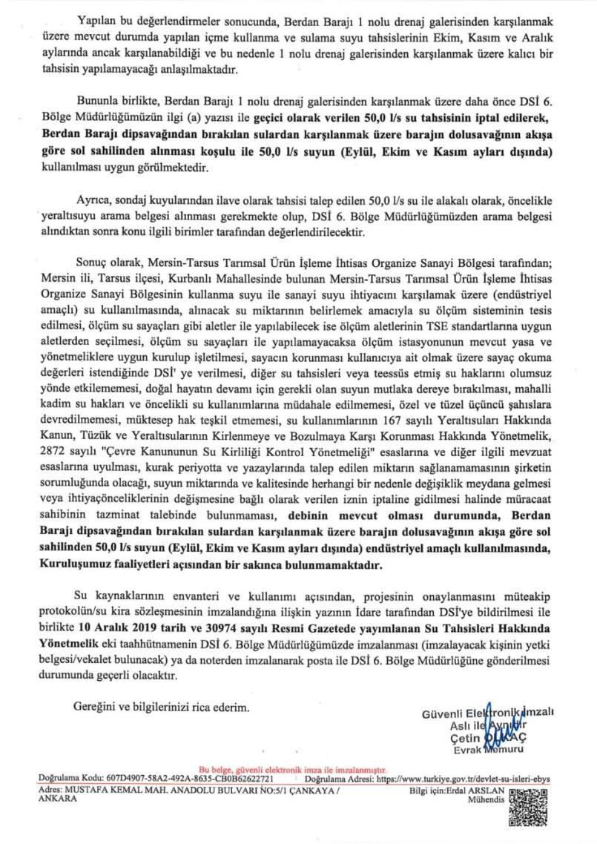
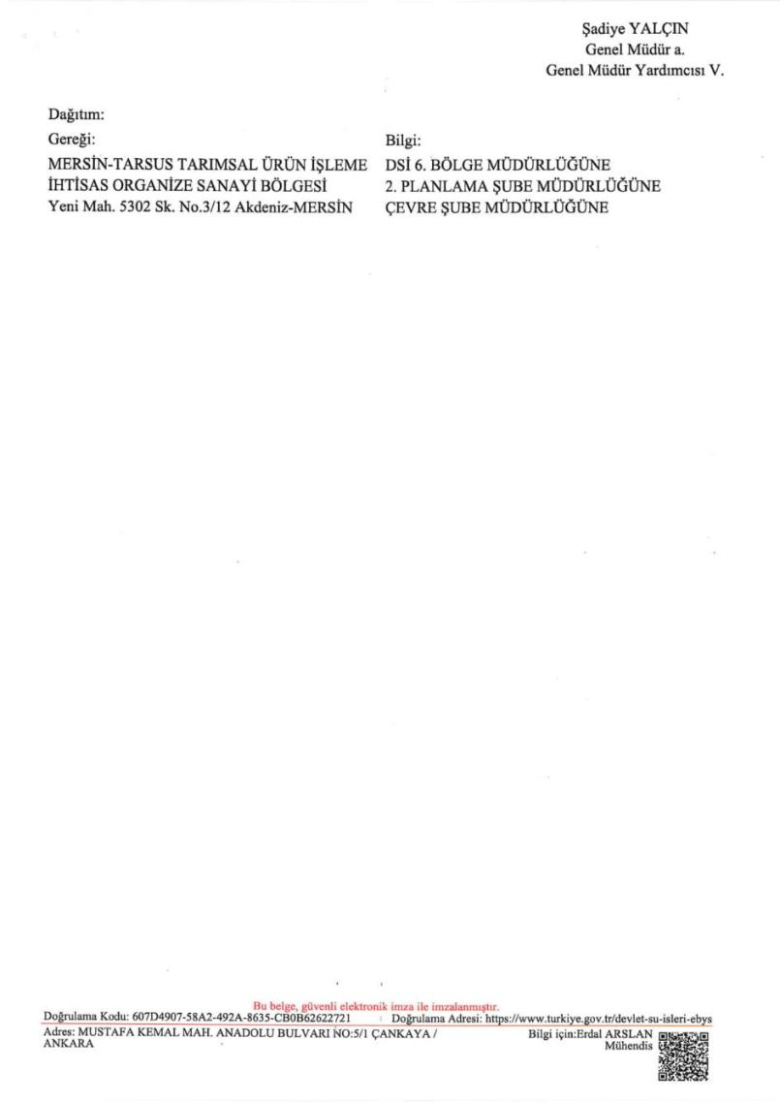
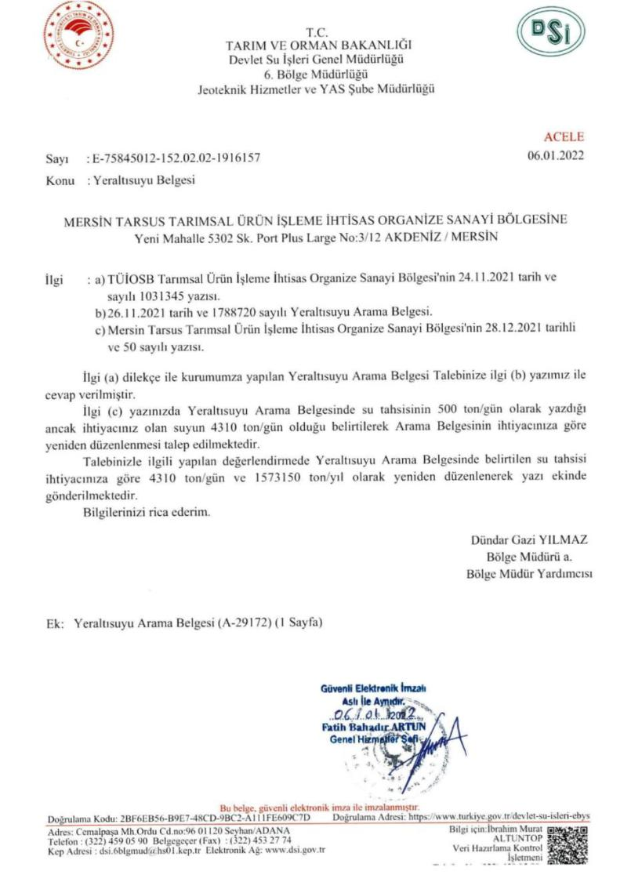
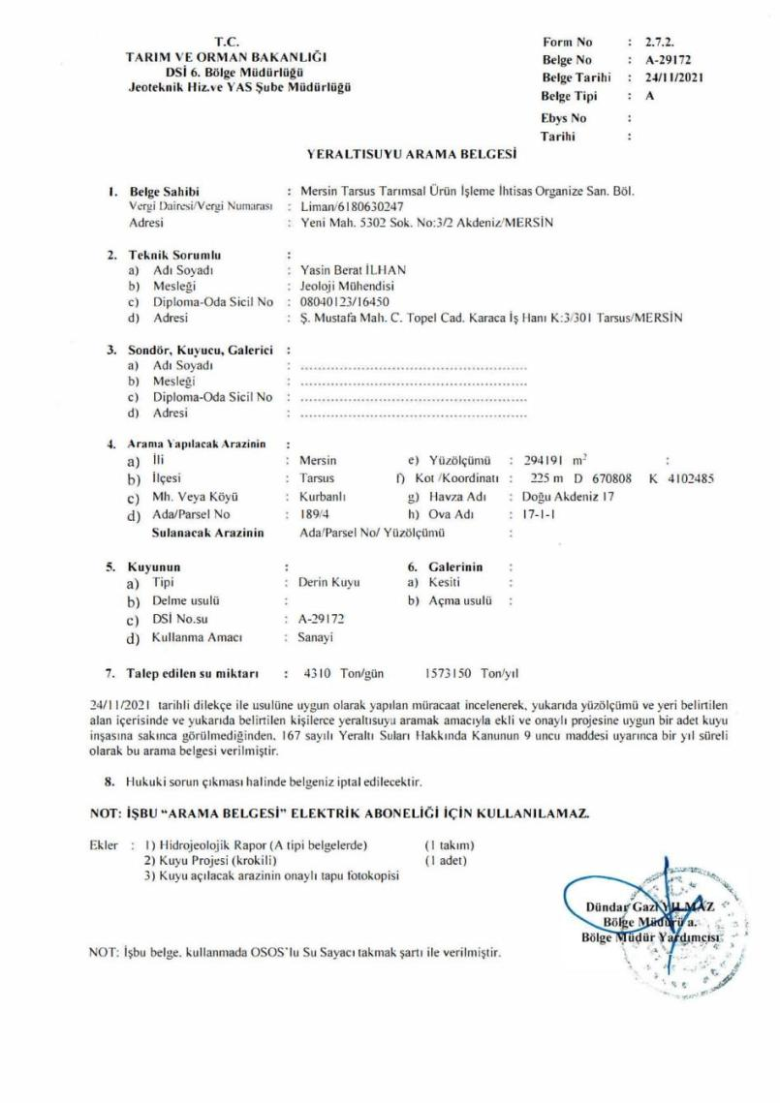
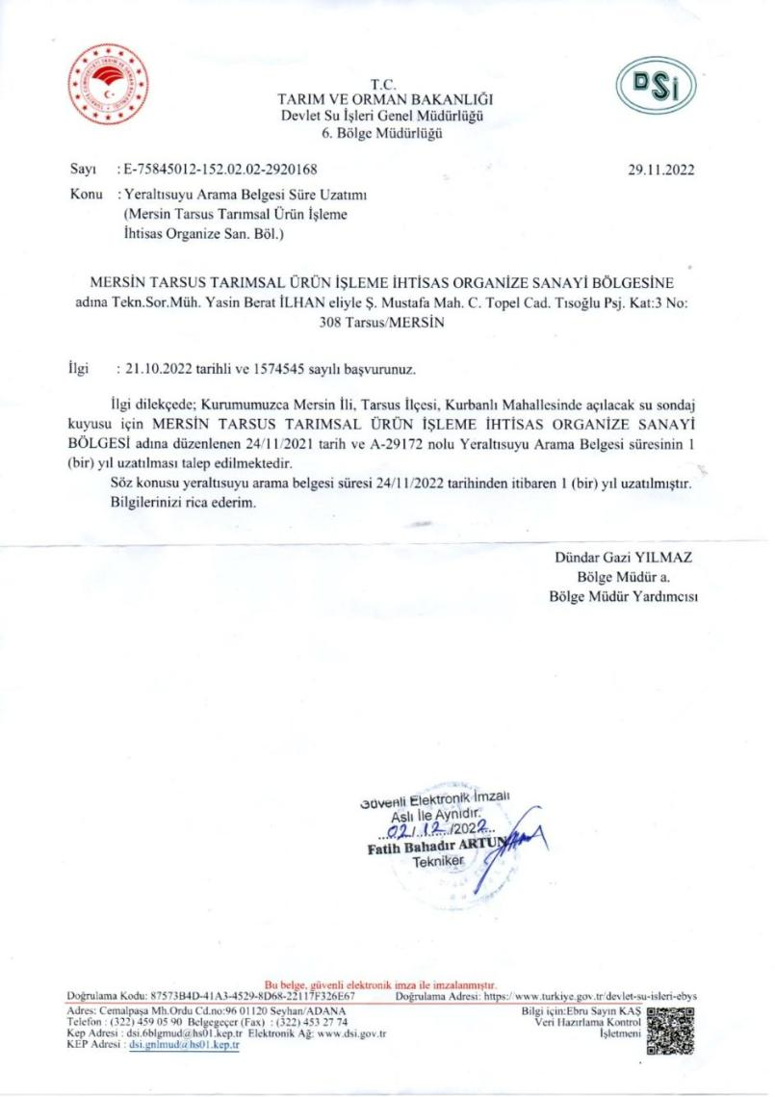
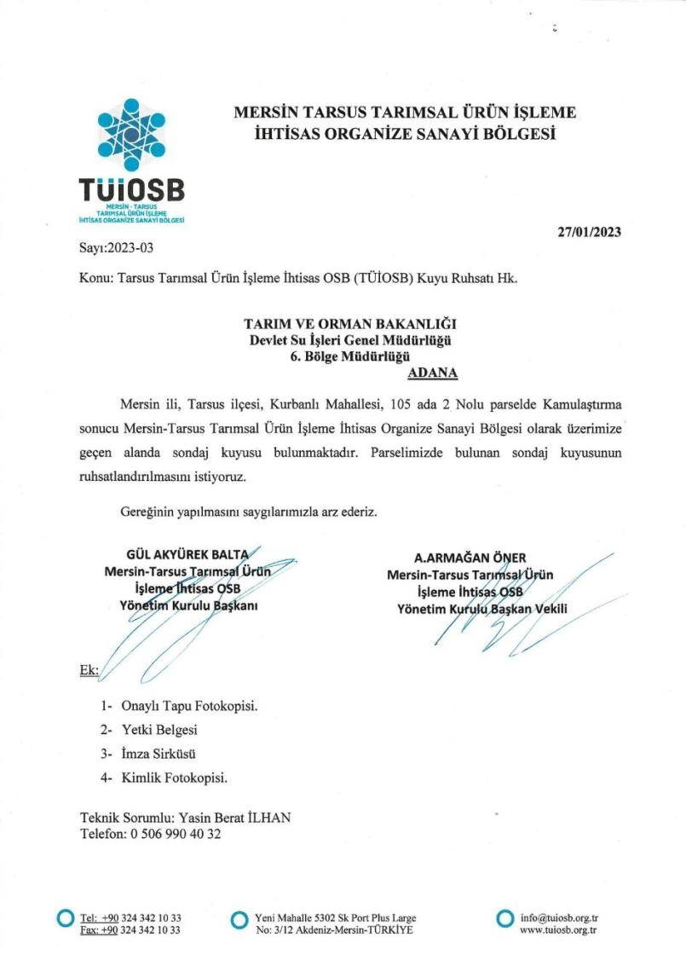

Appendix-D Chance Find Procedure

INTRODUCTION
This document is intended to avoid potential impacts of the Project on any cultural heritage during land preparation works, including excavation. At the baseline studies, field survey and literature review were conducted for the Project and its vicinity to identify potential archaeological and immovable cultural properties. No archaeological or immovable cultural property was encountered during the study.
This Procedure is a part of the general package as an appendix to the Environmental and Social Management Plan (ESMP) developed for the Project.

SCOPE
Types of Cultural Heritage Covered by This Procedure
Tangible Cultural Heritage
Tangible (physical) cultural heritage refers to movable or immovable objects, sites, structures, groups of structures, and natural features and landscapes that have archaeological, paleontological, historical, architectural, religious, aesthetic, or other cultural significance.
ROLES AND RESPONSIBILITIES
Roles | Responsibilities
Contractors | - Compliance with the Chance Find Procedure provided in contractor agreements  - Provide appropriate training and information to the worksite personnel who work in the projects and who may disturb the cultural heritage so that they understand their responsibilities for cultural heritage
Project Owner (TUIOSB) | - Ensure compliance of the project with the Project Standards and other requirements given in this Plan  - General responsibility for the scope and implementation of the Plan  - Development, monitoring and revision of this Plan  - Fulfilment of cultural heritage evaluation processes  - Ensure that the operations do not disturb cultural properties and sites without the approval of the relevant authority  - Investigation, reporting and monitoring of unauthorized damages to the worksite as well as of procedure violations  - Management of amendments to laws or policies  - Coordination with the organizations involved in the implementation and other stakeholders
All Workers | - Learn about the Chance Find Procedure through induction training and any other training provided

PROJECT STANDARDS
- Law on the Conservation of Cultural and Natural Properties (LCCNP) (No: 2863),
- World Bank Protection Policy on Physical Cultural Resources (ESS-8),
- Convention Concerning the Protection of the World Cultural and Natural Heritage (World Heritage Convention).
CHANCE FIND PROCEDURE
Initial Approach Adopted by the Contractor
- Action 1: Immediately stop all construction works in the vicinity of the chance find, in case of discovery of archaeological finds;
- Action 2: Immediately notify the project manager and/or environmental department;
- Action 3: Take photographs or make technical drawings;
- Action 4: Record the location of the location by keeping all remains in their position (without moving them);
- Action 5: Prevent damage to or loss of movable objects by encircling the area;
- Action 6: Contact an archaeologist from a local university for guidance;
- Action 7: Prepare the Chance Find Form.
Approach Adopted by the Archaeologist
Based on the description of the find, the archaeologist will make recommendations on actions to be taken by phone/e-mail or visit. The Project team will take into account the following possible strategies, if the archaeologist(s) confirm(s) the presence of archaeological finds/remains/sites:
Strategy 1: Avoidance by partial or full project redesign or relocation
In case of any archaeological find or discovery, TUIOSB will provide the relevant information to authorities. This responsibility will apply even if the project is redesigned or relocated. In any case, the relevant governmental body will be informed of the archaeological find or discovery.
Strategy 2: Implementation of worksite protection measures
This option includes the implementation of site protection measures such as fencing or blockage. As per LCCNP No. 2863, any archaeological find is the property of the Republic of Türkiye, and governmental bodies will decide on the geographical scope and implementation of site protection measures.
Strategy 3: Rescue or emergency excavation
If TUIOSB fails to relocate or redesign the Project, this may require rescue or emergency excavation works. If notification is stipulated by LCCNP, an application will be lodged to governmental bodies. If an official application is lodged, the relevant Regional Board will be allowed to make a decision.
After the permit is obtained, archaeological excavations will be performed with the attendance of scientific consultants from the archaeological departments of universities. Following the completion of archaeological excavations, the results will be submitted to relevant governmental bodies for the final decision to be taken for the progress of the Project.
Procedure for the Discovery of Potential Human Remains
Identification of human remains is very clear in terms of graves or burial sites. If a grave or burial site is found, the procedures to be followed are not different from the procedure applicable to archaeological finds as per Article 6 of LCCNP. Modern burials or forensic human remains will not be addressed within the scope of LCCNP.
KEY PERFORMANCE INDICATORS
The key performance indicators to be used during the implementation of this Procedure are set out below.
Key Performance Indicators (KPIs)
No | KPIs | Target | Monitoring Measure
1 | Non-conformities reported during the year with respect to key management controls identified in this Plan | Minimization of reported non-conformities, aiming at zero | Database  Reporting  Inspection Reports
2 | Number of complaints lodged by local communities during the year regarding cultural heritages | Investigation of complaints about cultural heritage (disrespect, destruction, removal, sale of artefacts) and fulfilment of relevant actions.  - Provision of prompt response to complaints from local communities regarding the misbehaviour of personnel regarding cultural properties | Database  Grievance Mechanism Records  Reporting

Sample Chance Find Form
Place: | Chance Find No: | Date:
Location Data:
Coordination:
Elevation:
Brief Area Description:
Chance Type: | Archaeological Items  Metal Finds  Terracotta Finds  Pottery Shards  Glass Finds | Sculpture etc.  Human / Animal Bone  Unidentified
Temporary Measures
Photograph

Discoverer's Name-Last Name:
Signature:

Facilities or activities that are not funded as part of the project and, in the judgment of the Bank, are: (a) directly and significantly related to the project; and (b) carried out, or planned to be carried out, contemporaneously with the project; and (c) necessary for the project to be viable and would not have been constructed, expanded or conducted if the project did not exist. For facilities or activities to be Associated Facilities, they must meet all three criteria.
https://documents1.worldbank.org/curated/en/604561468170043490/pdf/602530WP0worke10Box358316B01PUBLIC1.pdf
As the ESMP was being prepared, the territorial plan containing the OIZ Area, where additional OIZ Area was not included (since no updates were made by the MoEUCC in the concerned plan) was shared.
Coordination of Information on the Environment CORINE https://land.copernicus.eu/pan-european/corine-land-cover/clc2018
Davis, P.H. (ed.). (1965-1988). Flora of Türkiye and the East Aegean Islands, vol. 1-10, Edinburgh Univ. Press: Edinburgh.
Ekim, T. ve ark. Türkiye Bitkileri Kırmızı Kitabı. Türkiye Tabiatını Koruma Derneği. Yayın No:18 (2000).
Baran, İ. (2005). Türkiye Amfibileri ve Sürüngenleri. Tübitak Popüler Bilim Kitapları, Ankara.
http://www.turkherptil.org/
Özeti, N. ve İ., Yılmaz 1994 Türkiye amfibileri. Ege Üniversitesi Fen Fakültesi, Kitaplar Serisi: 151, Ege Üniversitesi Basımevi, Bornova-İzmir.
Baran, İ. (2005). Türkiye Amfibileri ve Sürüngenleri. Tübitak Popüler Bilim Kitapları, Ankara.
http://www.turkherptil.org/
BirdLife International 2003 BirdLife's online World Bird Database: Search for Species. Version 2.0. Cambridge, UK: BirdLife International. Available: http://www.birdlife.org
Kiziroglu, I. (2009). The Pocket Book for Birds of Türkiye, ISBN: 975-7460-01-X, Ankamat Matbaası, Ankara, 564 s.
https://ebird.org/home
A Demirsoy, N Yiğit – 2003, Memeliler: Türkiye omurgalıları: Türkiye omurgalı faunasının sistematik ve biyolojik özelliklerinin araştırılması ve koruma önlemlerinin saptanması
After the earthquake, the neighborhood headmen were contacted via telephone. In the Kurbanlı neighborhood, one family affected by the earthquake settled in their own house. In Sağlıklı neighborhood, three families came, one permanent and the other two temporary. The number of settled families was low and there was no demographic change.
TurkStat, Daily Amount of Water Usage Per Capita (Liters/Person-Day) Data (Mersin), 2018
Prof.Dr.İzzet Öztürk, Dr. Hacer Timur, Dr. Ufuk Koşkan 2005, Principles of Wastewater Treatment, MoEUCC
TurkStat, Daily Amount of Water Usage Per Capita (Liters/Person-Day) Data (Mersin), 2018
TurkStat, Daily Amount of Municipal Waste Per Capita (Kg/Person-Day) Data (Mersin), 2020
Solid Waste Management and Recovery, Environmental Protection and Packaging Waste Recovery and Recycling Foundation (ÇEVKO) Publications
TurkStat, Daily Amount of Municipal Waste Per Capita (Kg/Person-Day) Data (Mersin), 2020
Solid Waste Management and Recovery, Environmental Protection and Packaging Waste Recovery and Recycling Foundation (ÇEVKO) Publications
https://documents1.worldbank.org/curated/en/604561468170043490/pdf/602530WP0worke10Box358316B01PUBLIC1.pdf
The total area is approximately 101 hectares. However, 9400 square metres of parcel 189/11 in Kurbanlı neighbourhood and 66650 square metres of parcel 0/680 in Eskişehir neighbourhood will be included in Phase 2. Therefore, the area to be used for Phase 1 is approximately 92 hectares.
Since the shareholders could not be reached, it was acquired by expropriation.
The name given to the compensation received from the person who makes use of an immovable property that does not belong to him/her without a lease contract and constitutes the compensation for the use.
https://www.csgb.gov.tr/media/42182/isyerlerinde-koronaviruse-covid-19-karsi-alinmasi-gereken-onlemler.pdf
Land acquisition covers displacement of people, change in livelihoods, and seizure of private properties. This applies to acquired/assigned lands, and affects the residents and/or slum dwellers and business owners on the lands acquired in the said way.
Toxic/hazardous materials include asbestos, toxic paints, harmful solvents, lead paint removal, etc.
As mentioned in the United Nations Development Cooperation Strategy Türkiye 2016-2020 Government of The Republic of Türkiye and The United Nations System in Türkiye, Sustainable, Inclusive Growth and Development Goals.
The Parcel-Based Geotechnical Report of the Project

