|  |
| --- |
| **Directorate of MERSIN TARSUS AGRICULTURAL PRODUCT PROCESSING SPECIALIZED ORGANIZED INDUSTRIAL ZONE**  **MERSIN TARSUS AGRICULTURAL PRODUCT PROCESSING SPECIALIZED ORGANIZED INDUSTRIAL ZONE**  **BASIC INFRASTRUCTURE PROJECT**  açık hava, gök, doğa, dağ içeren bir resim  Açıklama otomatik olarak oluşturuldu  **Ex-Post Social Assessment**  **(EPSA)** |
| **JUNE 2023**  **ANKARA** |

**MERSIN TARSUS AGRICULTURAL PRODUCT PROCESSING SPECIALIZED**

**ORGANIZED INDUSTRIAL ZONE**

**BASIC INFRASTRUCTURE PROJECT**

Ex-Post Social Assessment

(EPSA)

|  |  |  |  |  |  |  |  |
| --- | --- | --- | --- | --- | --- | --- | --- |
| **Version** | **Revision** | **Date** | **Prepared by** | **Quality Management by** | **Controlled by** | | **Approved by** |
| Draft | A.0 | February 2023 | Feray Artar | Esra Okumuşoğlu | Onur Ali Taşkın | Özge Uysal | Emre Kaya |
| Sociologist | Geological Engineer | Sociologist | Environmental Engineer | Environmental Engineer |
|  |  |  |  |  |

|  |  |  |  |  |  |  |  |
| --- | --- | --- | --- | --- | --- | --- | --- |
| Draft | A.1 | June 2023 | Feray Artar | Esra Okumuşoğlu | Onur Ali Taşkın | Özge Uysal | Emre Kaya |
| Sociologist | Geological Engineer | Sociologist | Environmental Engineer | Environmental Engineer |
|  |  |  |  |  |

REVISION CODES: A: DRAFT, B: FINAL DRAFT, C: FINAL

**PROJECT NO: 22/016**

**JUNE 2023**

|  |  |
| --- | --- |
| **CLIENT:** | **CONSULTANT:** |
| metin içeren bir resim  Açıklama otomatik olarak oluşturuldu |  |
| Mersin Tarsus Tarımsal Ürün İşleme  İhtisas Organize Sanayi Bölgesi  Müdürlüğü  Yeni Mah. 5302 Sokak Port Plus Large  No: 3/12  Akdeniz- Mersin / Turkiye  : +90 0 (324) 342 10 33  : +90 0 (324) 342 10 33 | Tepe Prime İş ve Yaşam Merkezi  Mustafa Kemal Mahallesi Dumlupınar  Bulvarı No: 266 B Blok Kat: 2 Daire: 38  Çankaya - Ankara / Turkiye  : +90 (312) 295 62 48  : +90 (312) 295 62 00 |

This Report has been prepared by 2U1K Engineering and Consulting Inc. on behalf of Directorate of Mersin Tarsus Agricultural Product Processing Specialized Organized Industrial Zone. No part of this report may be reproduced, distributed, or transmitted in any form or by any means, including printing, photocopying, microfilm, or other electronic or mechanical methods ; nor may be used for any purpose other than for which it is produced without the prior permission of the 2U1K Engineering and Consultancy Inc. 2U1K Engineering and Consultancy Inc.is certified according to the ISO 9001:2015, ISO 14001:2015 and ISO 45001:2018 integrated management system.

## TABLE OF CONTENTS

**Page**

TABLE OF CONTENTS i

LIST OF TABLES iii

LIST OF FIGURES iv

**ABBREVIATIONS** vi

EXECUTIVE SUMMARY 1

1. INTRODUCTION 4

1.1. Description of the Project 4

1.2. Capacity of the TUIOSB 5

1.3. E&S Status of the Sub-Project 6

1.4. The Basis and Target of the EPSA 7

2. LEGAL FRAMEWORK 10

2.1. National Legal Framework 10

2.2. International Requirements 10

2.3. Gaps between national legal framework and international requirements 11

2.4. Commitments of Resettlement Framework 15

3. LAND ACQUISITION PROCESS 17

3.1. Acquisition Approach and Evaluation 17

3.2. Acquisition Process Applied 17

3.2.1. Acquisition of Private Lands 24

3.2.1.1. Mersin Tarsus Kurbanlı Parcel no: 102/5 24

3.2.1.2. Mersin Tarsus Kurbanlı Parcel no: 105/1 and 105/2 24

3.2.1.3. Unviable Lands 25

3.2.1.4 Rental Lands 25

3.2.2. Acquisition of Public Lands 25

3.2.3. Acquisition of Affected Buildings 26

3.2.3.1. Affected buildings on Mersin Tarsus Kurbanlı Private Parcel no: 105/2 26

3.2.3.2. Affected building on Mersin Tarsus Kurbanlı Public Parcel no: 104/1 27

3.2.4. Additional land need 28

3.3. Entitlement Matrix (EM) 28

4. PROJECT’S LAND-BASED IMPACTS AND GROUPS IMPACTED 32

4.1. Data Collection Methodology of EPSA 32

4.2. Project Affected Settlements and Communities 34

4.3. Project Affected Houses and Physical resettlement 36

4.3.1. Affected house on Mersin Tarsus Kurbanlı Public Parcel no: 104/1 36

4.4. Project Affected Households and Livelihoods 37

4.4.1. Agriculture 37

4.4.2. Animal husbandry 37

4.4.3. Benefiting from natural resources 41

4.4.4. Fishing 41

4.4.5. Beekeeping 41

4.5. Project Affected Businesses 42

4.5.1. 5 buildings on the private parcel no. 105/2 42

4.5.2. İSDEMİR operation area on public parcels no 189/11, 189/4 and 0/680 42

4.5.3. Old shop on Mersin Tarsus Kurbanlı public parcel no: 104/1 42

4.6. Vulnerable Groups 42

5. STAKEHOLDER ENGAGEMENT 45

5.1. Stakeholder Engagement Activities Carried Out 45

5.2. Information Disclosure 47

5.3. Project’s Grievance Redress Strategy 47

6. NON-COMPLIANCES AND CORRECTIVE ACTION SUGGESTIONS 49

7. APPENDICES 52

Appendix A. Official expropriation documents on the parcel 102/5 52

Appendix A1. 102/5 – Case report for the unreachable shareholders of the parcel 53

Appendix A2. 102/5 – Public interest decision 54

Appendix A3. 102/5 – Decision on the need for expropriation 55

Appendix A4. 102/5 – Expropriation request letter 56

Appendix A5. 102/5 – Shares acquired by agreement/consent 57

Appendix A6. 102/5 – Shares acquired by expropriation 60

Appendix B. Official Expropriation documents on 105/1 and 105/2 62

Appendix B1. Public interest decision 63

Appendix B2. Urgent Expropriation Decision (Article 27) 64

Appendix B3. Agreement Minutes – 105/1 65

Appendix B4. Agreement Minutes – 105/2 66

Appendix B5. Valuation reports for 105/1 and 105/2 67

Appendix C. Example public land title deed transferred to the OIZ 76

Appendix D. Protocol/consent with İskenderun Demir, Çelik A.Ş (İSDEMİR) 77

Appendix E. Adequate pay (Ecrimisil) payment documents for public parcel no. 104/1 (2014, 2008) 79

Appendix F. Ministry of Agriculture Fertilizer and Diesel Support Amounts (Tarım Bakanlığı Gübre ve Mazot Destek Miktarları) 80

Appendix G. Expenditure documents related to physical resettlement in parcel no. 104/1 81

Appendix H. Photographs of the family's renovated house under the influence of Physical Resettlement 91

Appendix I. Declaration of informal house owner (parcel numbered 104/1) 98

## LIST OF TABLES

**Page**

**Table 1‑1.** E&S documents recommended for the subproject 7

**Table 1‑2.** TUIOSB land use and acquisition impacts by RF coverage 8

**Table 2‑1.** National legal framework 10

**Table 2‑2.** Requirements of WB 10

**Table 2‑3.** Gap analyses 11

**Table 3‑1.** Characteristics of the affected parcels before acquisition in Phase 1 area of the Sub-project 19

**Table 3‑2.** List of affected buildings 26

**Table 3‑3.** Buildings on parcel no. 105/2 and expropriation payments (private) 26

**Table 3‑4.** Entitlement Matrix (EM) 29

**Table 4‑1.** Sampling summary 33

**Table 4‑2.** Number of affected parcels per settlements 34

**Table 4‑3.** Actual estimated populations of the affected settlements 34

**Table 4‑4.** Past populations change in affected settlements 34

**Table 4‑5.** Seasonal migration 35

**Table 4‑6.** Future populations change expectation in affected settlements 35

**Table 4‑7.** Livelihood sources of the settlements 35

**Table 4‑8.** The products produced in the settlements affected by the project 37

**Table 4‑9.** Indirect impacts on agricultural activity 37

**Table 4‑10.** The number of households engaged in animal husbandry and animals in the settlements 38

**Table 4‑11.** The animal products produced in the settlements 38

**Table 4‑12.** Grazing activities on affected public lands 38

**Table 4‑13.** Households grazing animals on affected public lands 39

**Table 4‑14** Benefiting from the forestlands/natural resources 41

**Table 4‑15** Fishing activities in the Project area 41

**Table 4‑16.** Bee keeping activities in the settlements 41

**Table 4‑17.** Public lands where ISDEMIR operated 42

**Table 4‑18.** Vulnerable PAPs affected by the land acquisition of the sub-project 43

**Table 4‑19.** Unemployment in the settlements 43

**Table 4‑20.** Seasonal workers 43

**Table 5‑1.** Institutional opinions on site selection 45

**Table 5‑2** Negotiations during the land acquisition process 46

**Table 5‑3.** Grievance Mechanism Contact Information 48

**Table 6‑1.** Table of Non-Compliances and Corrective Actions Suggestions 50

## LIST OF FIGURES

**Figure 1‑1.** TUIOSB 3D Image 5

**Figure 3‑1.** View Before the Expropriation-1 21

**Figure 3‑2.** View Before the Expropriation-2 22

**Figure 3‑3.** View Before the Expropriation-1 23

**Figure 3‑4.** Repaired old building on parcel no. 104/1 27

**GLOSSARY**

**Consultation:** The process of sharing appropriate information about the project and enabling stakeholders to express their concerns and enabling their views to be taken into account in project design and environmental and social performance.

**Grievance Mechanism:** It is a mechanism that has been developed for potential use by project stakeholders to raise their concerns and grievances and achieve timely,mutually agreed resolutions for their grievances. It ensures that complaints and grievances are addressed through a transparent and impartial process.

**Organized Industrial Zones (OIZ)**: the good and service production zones, which are formed by allocating the land parcels, the borders of which are approved, for the industry in a planned manner and within the framework of certain systems by equipping such parcels with the necessary administrative, social, and technical infrastructure areas and repair, trade, education, and health areas as well as technology development regions within the ratios included in zoning plans and which are operated in compliance with the provisions of this law in order to ensure that the industry gets structured in approved areas, to prevent unplanned industrialization and environmental problems, to guide urbanization, to utilize resources rationally, to benefit from information and informatics technologies, and to ensure that the types of industries are placed and developed within the framework of a certain plan

**Stakeholder:** Refers to individuals or groups who: (a) are affected or likely to be affected by the project (*project-affected parties*); and (b) may get involved directly or/and have an interest in the project (*other interested parties*).

**Stakeholder Engagement Plan (SEP):** SEP is a useful tool for timely disclosure of project information including about potential environmental and social risks associated with the project, managing communications with the project stakeholders. The goal of this SEP is to improve and facilitate decision making and create an atmosphere of understanding that actively involves project-affected people and other stakeholders in a timely manner, and that these groups are provided sufficient opportunity to voice their opinions and concerns that may influence Project decisions.

**The Project**: Refers to Turkiye Organized Industrial Zones Project

**The Sub-Project:** Mersin Tarsus Agricultural Product Processing Organized Industrial Zone Main Infrastructure Project

**ABBREVIATIONS**

|  |  |
| --- | --- |
| ABPRS | Address Based Population Registration System |
| CHS | Community Health & Safety |
| CIMER | Presidential Communication Center |
| CLO | Community Liaison Officer |
| DSI | State Hydraulic Works |
| E&S | Environmental & Social |
| EIA | Environmental Impact Assessment |
| EHS | Environmental, Health and Safety |
| EPSA | Ex-Post Social Assessment |
| ESIA | Environmental and Social Impact Assessment |
| ESMP | Environmental and Social Management Plan |
| ESS | Environmental and Social Standard |
| ETL | Energy Transmission Line |
| GM | Grievance Mechanism |
| HSE  İSDEMİR | Health Safety and Environment  İskenderun Demir-Çelik AŞ |
| KPI | Key Performance Indicator |
| LA | Land Acquisition |
| M&E | Monitoring & Evaluation |
| MoAF | Ministry of Agriculture and Forest |
| MoEU | Ministry of Environment and Urbanization |
| MoIT | Ministry of Industry and Technology |
| NGO | Non-governmental Organization |
| OIZ | Organized Industrial Zone |
| OIZSO | Organized Industrial Zones Supreme Organization |
| PAB | Project Affected Business |
| PAP | Project Affected People |
| PAS | Project Affected Settlement |
| PAH | Project Affected Houses |
| PCM | Public Consultation Meetings |
| PIU | Project Implementation Unit |
| PMU | Project Management Unit |
| RAP | Resettlement Action Plan |
| SEP | Stakeholder Engagement Plan |
| TUIOSBTUIOSB | Mersin Tarsus Agricultural Product Processing Organized Industrial Zone |
| TOBB | The Union of Chambers and Commodity Exchanges of Turkiye |
| TUBİTAK | Scientific and Technological Research Council of Turkiye |
| TurkStat | Turkish Statistical Institute |
| WB | World Bank |

# EXECUTIVE SUMMARY

The main objective of Turkiye Organized Industrial Zones Project of Ministry of Industry and Technology (MoIT) is to increase the efficiency, environmental sustainability and competitiveness of selected OIZs in Turkiye. For this purpose, the World Bank (WB) financing will be used for Sub-Projects in selected OIZs. One of the Sub-Projects is Main Infrastructure Project of Mersin Tarsus Agricultural Product Processing Organized Industrial Zone (TUIOSB)TUIOSB. The basic infrastructure will be built on the developing OIZ area. The project aims to increase the attractiveness of the Mersin Tarsus Agricultural Product Processing Organized Industrial Zone TUIOSB for investors by providing the basic infrastructure.

Mersin Tarsus Agricultural Product Processing Specialized Organized Industrial Zone Basic Infrastructure Project (the Project) will be implemented in two phases as Phase 1 and Phase 2. The Directorate of Mersin Tarsus Agricultural Product Processing Specialized Organized Industrial Zone (TUIOSB or Project Owner) will use loan only for Project’s Phase 1. The Project’s Phase 2 will be invested with the use of TUIOSB’s own equity. The scope of this Ex-Post Social Assessment (EPSA) report is the Phase 1 area whose land acquisition process has been completed between 2018-2022. Therefore, the land acquisition process and outcomes need to be examined retrospectively to assess its compliance with ESS5 and the RF of the project, and to identify any gap-filling measures.

During the preparation phase, OIZs prepared Environmental and Social (E&S) Screening Reports for all sub-projects and submitted them to MoIT. These documents, in which the environmental and social impacts of the projects were screened, were reviewed by MoIT experts. As a result of the information obtained in the screening study, a risk analysis was made as well as the E&S Screening Report. As a result of the risk analysis, the sub-project was evaluated in the “moderate” risk group within the scope of E&S standards. Accordingly, preparation of an EPSA is recommended for the sub-project (Phase 1).

Ministry of Industry and Technology (MoIT) has prepared a Resettlement Framework (RF) [1] to determine land use and land acquisition procedures in line with WB's "Environmental and Social Standards (ESS) 5: Land Acquisition, Restrictions on Land Use and Involuntary Resettlement " of the Turkiye Organized Industrial Zones Project. According to RF, project-related land acquisition or restrictions on land use may cause physical displacement (relocation, loss of residential land or loss of shelter), economic displacement (loss of land, assets or access to assets, leading to loss of income sources or other means of livelihood) or both and they will be evaluated by OIZs.

In the land acquisition process of the project, purchasing, expropriation and urgent expropriation methods were used together. At the end agreements were reached with all the accessible shareholders of the private lands, and the shares were acquired with consent so that there was no need for involuntary acquisition in their case. Since the multiple shareholders of only 1 private land could not be reached, the expropriation application was made for a total of 22 shares. An account was opened in their names in the public bank and compensations were deposited into that account. These shareholders do not live in the project area and their shareholding ratios are low.

The parcels affected by the the ProjectTUIOSB are 3 private lands and 13 public lands (Treasury) were affected by the sub-project.

**Acquisition of Private Lands**

3 private lands parcels were going to be affected by the project. Two of them were owned by the same person and his lands were transferred to OIZ by agreement. 1 private land is owned by 57 shareholder. Agreement negotiations were conducted , and the small shares were transferred to OIZ with consent from 35 reachable shareholders. 22 shareholders could not be reached, or they did not come to the agreement meeting, according to local information because they do not live in this region and their shares are low.

**Acquisition of Affected Buildings**

7 buildings on 2 parcels were affected by the land acquisition of the sub-project. 5 of them (commercial) were on 1 private land (105/2) and 2 of them (residential and commercial) were on 1 public land (104/1).

According to valuation results of parcel 105/2 396,266.40 TRY depreciation has been deducted. However, this deduction does not comply with the principle of compensation in replacement cost of ESS5.

There was one old building on parcel 104/1. The building belongs to the National Real Estate Agency and a payment was made for the building to the National Real Estate. Previously, a family (an elderly mother and an adult son) lived in the old building. The building was built between 1981-1984 by the deceased husband of the elderly woman. They formally own another house on the neighboring plot. This house was neglected. The governor's office helped the elderly woman to move to her own house by repairing this neglected and giving some household items to the old woman. However, no compensation was provided for the replacement cost for the house.

The findings of the EPSA field study are:

* No agricultural activity was found on 3 private lands affected by the project's land acquisition.
* No informal user in the public lands in Phase 1 area.
* 10 people affected by animal grazing activities in the project area have been identified.
* According to EPSA studies, there is no forestland affected by the sub-project, however, it has been examined whether the benefiting activities of natural resources are affected by the sub-project. No benefiting activity and loss of income is identified.
* It has been learned that there is no affected fishing activity in the settlements.
* There were no beehives in the Project AreaTUIOSB area permanently and the beekeeping activity will not be affected by the land use of the sub-project.
* Vulnerable household members were identified in the households affected by land acquisition of the sub-project.

EPSA includes a gap analysis, identifying some gaps between national land acquisition practices and international requirements. For this reason, EPSA is concluded by a NON-COMPLIANCES AND CORRECTIVE ACTION SUGGESTIONS section to fill these gaps

* Loss of structures and other fixed assets on the land (barns, shacks, wells, fences, etc.);
* Loss of or access limitations to communal lands (pasture lands etc.);
* Loss of Houses;
* Vulnerable groups.

See Table 6-1 for gaps have been identified and rectifying measures have been formulated.

# INTRODUCTION

## Description of the Project

The main objective of Turkiye Organized Industrial Zones Project of Ministry of Industry and Technology (MoIT) aims to increase the efficiency, environmental sustainability and competitiveness of selected OIZs in Turkiye. For this propose, the World Bank (WB) financing will be used for Sub-Projects in selected OIZs. One of the Sub-Projects is Main Infrastructure Project of Mersin Tarsus Agricultural Product Processing Organized Industrial Zone (TUIOSB in brief). The basic infrastructure will be built on the developing OIZ area.

The Project will be implemented in two phases as Phase 1 and Phase 2. TUIOSB will use loan only for Project’s Phase 1. The Project’s Phase 2 will be invested with the use of TUIOSB’s own equity. Phase 1 corresponds to 92.64 hectares where the first phase of the Project will be implemented (Project Area).

The project aims to increase the attractiveness of the TUIOSB for investors by providing the basic infrastructure. Within the scope of this project;

* 977.633 m diversion canal,
* 8.85 km road,
* 8.135 km clean water line,
* 9.435 km process water (treated wastewater) line,
* 5.05 km stormwater line,
* 3.998 km wastewater line,
* 15.370 km electricity distribution line,
* 3.581 km environmental lighting line,
* 4 electricity distribution centers,
* 110 lighting poles,
* 143 LED armatures,
* One (1) set of SCADA and
* One (1) set Telecom infrastructure is planned.

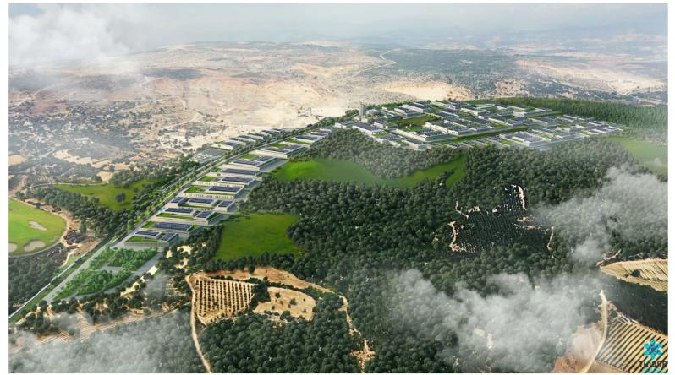

**Figure 1‑1.** TUIOSB 3D Image

## Capacity of the TUIOSB

The production process issues of the facilities to be established within the scope of the Specialized Organized Industrial Zone are determined by the investors who filled in the Investor Preliminary Request Form of the Organized Industrial Zones Site Selection Regulation, which entered into force by publishing the Official Gazette dated 18.11.2015 and numbered 29536, and submitted it to Mersin Specialized Organized Industrialists Association. Accordingly, the processes envisaged to take place in the Agricultural Product Processing Specialized Organized Industrial Zone include;

* Nuts, Coffee Processing,
* Tahini, Halva Production and Packaging,
* Spices Processing and Packaging,
* Pulses Drying, Screening and Packaging Plant,
* Tobacco Processing Plant,
* Pasteurized Liquid Egg Production, Fruit Juice Production,
* Fruit Extracts (Vinegar, Molasses, Pomegranate Syrup, Lemon Sauce) Processing,
* Fisheries Processing, Packaging and Storage,
* Processing of Medicinal and Aromatic Plants,
* Herbal Cosmetics Production,
* Canned Food Production,
* Seed Sieving, Processing and Packaging,
* Agricultural Product Processing Machinery Production.

Social areas, technical infrastructure areas and wastewater treatment plant area will also be included in the Specialized Organized Industrial Zone. As social facilities, there will be a gas station, a mosque, an administration building, school, social areas and restaurants and green areas. Technical infrastructure areas will be comprised of, a substation, natural gas power plant (Distribution Centre), fire station, water tank and pump station, sewage system, pumping station, potable and potable water line, stormwater collection system, electricity distribution system, communication (Telephone, Internet) distribution Line and a generator unit.

## E&S Status of the Sub-Project

During the preparation phase, OIZs prepared Environmental and Social (E&S) Screening Reports for all sub-projects and submitted them to MoIT. These documents, in which the environmental and social impacts of the projects were screened, were reviewed by MoIT experts. As a result of the information obtained in the screening study, a risk analysis was made as well as the E&S Screening Report. As a result of the risk analysis, the sub-project was evaluated in the “moderate” risk group within the scope of E&S standards.

According to E&S Screening Report of TUIOSB, activity has not yet started in TUIOSB. The newly emerging OIZ adopts a sustainability policy. EIA Positive Certificate dated 11.02.2022 and numbered 5072 has been obtained; the correspondence regarding water use is included in the EIA. Environmental permits will be obtained for each facility after the enterprises begin. Since the OIZ has been newly established, it will be created in parallel with the Peripheral Unit Infrastructure investments and commitments written in the EIA Report will be complied with. Environmental Permits and Licenses Owned by the Companies are attached to the Screening report.

In general, there are plants in the form of small bushes and the tree cutting process will not take place. It is foreseen that there may be filling processes due to the rough structure of the land. There is no need for blasting due to the structure of the ground. Waste and chemical storage will be carried out in accordance with the relevant regulations.

There will be no blasting. According to the modeling study included in the EIA, the noise levels likely to occur during the construction phase of the facility are below the limit values for the nearest settlement. During the construction, dust and exhaust gases will be generated due to the use of liquid fuels of construction machinery. During operation, heat treatment will be applied in some facilities. However, the relevant regulation limit values will be taken into account in the designs.

Domestic waste and construction waste is expected. With the waste management plan to be prepared, waste management will be carried out according to local and international standards.

The project is expected to increase the traffic load in the region. Community Health and Safety Plans will be prepared for the construction and operation phases in the project area and potential risks will be discussed in detail. The sub-project does not cause any access restriction to the commuters/pedestrians/ business and trades.

According to the feasibility report of the Sub-Project, it is foreseen that the employment capacity will increase due to the increase in production and capacity with the OIZ's activation.

According to E&S Screening report, Environmental and social risks are determined according to the WB ESSs and ESMF of the Project. The overall environmental and social risk of the subproject is rated as “Moderate”. E&S documents that are recommended for the subproject are given in Table 1‑1.

**Table 1‑1.** E&S documents recommended for the subproject

| **E&S Document** | **Explanation** | **Recommended** |
| --- | --- | --- |
| EIA | National EIA is completed. | X |
| ESMP | A site-specific ESMP will be required since the overall risk of the subproject is “Moderate”. | ✓ |
| ESIA | A detailed ESIA will not be required since the overall risk of the subproject is “Moderate”. | X |
| SEP | A site-specific SEP will be required. | ✓ |
| LMP | Labour Management Plan (LMP) of the TOIZP will be used. The LMP for contractors will also comply with the labour legislation (Labour Law no. 4857), occupational health and safety plan and procedures (Occupational Health and Safety Law no. 6331) and Social Insurance Law no. 5510 in addition to the Labour Management Procedures of the TOIZP. | ✓ |
| RP/EPSA | A site-specific EPSA will be required as there has been an expropriation within the last 5 years. | ✓ |

## The Basis and Target of the EPSA

Ministry of Industry and Technology (MoIT) has prepared a Resettlement Framework (RF) [2] to determine land use and land acquisition procedures in line with WB's "Environmental and Social Standards (ESS) 5: Land Acquisition, Restrictions on Land Use and Involuntary Resettlement " of the Turkiye Organized Industrial Zones Project.

ESS5 recognizes that project-related land acquisition and restrictions on land use can have adverse impacts on communities and individuals. According to RF, project-related land acquisition or restrictions on land use may cause physical displacement (relocation, loss of residential land or loss of shelter), economic displacement (loss of land, assets or access to assets, leading to loss of income sources or other means of livelihood) or both. The term “involuntary resettlement” refers to these impacts. Resettlement is considered involuntary when affected persons or communities do not have the right to refuse land acquisition or restrictions on land use that result in displacement.

Experience and research indicate that physical and economic displacement, if unmitigated, may give rise to severe economic, social and environmental risks: production systems may be dismantled; people face impoverishment if their productive resources or other income sources are lost; people may be relocated to environments where their productive skills are less applicable and the competition for resources greater; community institutions and social networks may be weakened; kin groups may be dispersed; and cultural identity, traditional authority, and the potential for mutual help may be diminished or lost. For these reasons, involuntary resettlement should be avoided. Where involuntary resettlement is unavoidable, it will be minimized and appropriate measures to mitigate adverse impacts on displaced persons (and on host communities receiving displaced persons) will be carefully planned and implemented.

RF commits to the preparation of sub-project-based Resettlement Plans (RPs) for situations where land acquisition (such as purchase, expropriation, etc.) has not yet taken place and recommends managing the impacts in the Table 1‑2.

**Table 1‑2.** TUIOSB land use and acquisition impacts by RF coverage

| **RF of the Parent/Main Project** | **TUIOSB Main Infrastructure Project** |
| --- | --- |
| For projects with minor land acquisition or restrictions on land use, as a result of which there will be no significant impact on incomes or livelihoods, sub-project specific RPs will establish eligibility criteria for affected persons, set out procedures and standards for compensation, and incorporate arrangements for consultations, monitoring and addressing grievances. | There is minor land acquisition or restrictions on land use, as a result of which there will be no significant impact on incomes or livelihoods. |
| For projects causing physical displacement (if any), the plan will set out the additional measures relevant to relocation of affected persons. | There is a physical displacement case. |
| For projects involving economic displacement with significant impacts on livelihoods or income generation, the plan will set out the additional measures relating to livelihood improvement or restoration. | There is no economic displacement with significant impacts on livelihoods or income generation. |
| For projects that may impose changes in land use that restrict access to resources in legally designated parks or protected areas or other common property resources on which local people may depend for livelihood purposes, the plan will establish a participatory process for determining appropriate restrictions on use and set out the mitigation measures to address adverse impacts on livelihoods that may result from such restrictions. | The project imposes changes in land use that restrict access to resources in common property resources on which local people may depend for livelihood purposes. |

However, the land acquisition process of Phase 1 of the TUIOSBProject was completed between 2018-2022. Therefore, the impacts in Table 1‑2 need to be examined retrospectively. According to RF of the parent/main project of MoIT, “if land acquisition procedures were completed at the time this RF is approved, MoIT will conduct social screening to determine whether environmental and social due diligence assessment or review is required for the sub project. Any legacy issues, such as ongoing cases, unresolved disputes or open grievances pertaining to previous land take will require the preparation of an Ex-Post Social Assessment. The Ex-Post Social Assessment will be prepare to ensure that land acquisition was completed in accordance with the objectives and principles of ESS5. Should the Ex-Post Social Assessment reveal that a sub-project is noncompliant with ESS5, the Project Owner will take necessary actions defined under this RF to ensure that all land acquisition works are scaled up and gaps are bridged, mitigating or compensating for impacts generated by the sub-project(s). Although previous land acquisition works may have been conducted by affiliated municipalities or governorships, the Project Owner will be responsible for bridging the gaps identified in the Ex-Post Social Assessment prepared by MoIT. The Project Owner will be accountable for the implementation of the activities/actions defined in the Assessment as well as any additional costs that these actions may generate. Bank finances will not be utilized to carry out any past or future land acquisition related expenses. All costs will be covered by the Project Owner.

Therefore, instead of an RP, this Ex-Post Social Assessment (EPSA) report has been prepared for Phase 1 area by independent experts on behalf of TUIOSB. The main purpose of the report is to examine the process and social and livelihood impacts of the land acquisition undertaken by the TUIOSBProject, including retrospective land acquisition processes, and to provide corrective actions to ensure compliance with WB ESS5 (See Chapter 6).

# LEGAL FRAMEWORK

## National Legal Framework

The acquired lands were taken over according to the expropriation process specified in the Expropriation Law.

**Table 2‑1.** National legal framework

|  |  |
| --- | --- |
| **Legislation** | **Explanation** |
| Expropriation Law (No. 2942) | If and when it is required for the public interest, the Expropriation Law sets the procedures of the expropriation of immovable owned by real persons or legal identities subject to private law, the calculation of the expropriation fee and the registration of the immovable asset and its appurtenances in the name of the expropriation administration. |
| Notification Law (No. 7201) | The Notification Law No. 7201, with its amendments in 2003, 2008 and 2011, provides the basis for a process of notification for property owners. It consists of specific procedures to be followed to reach a range of public and private owners, including those whose addresses are unknown. |
| Land Registry Code (Official Gazette No. 28738) | This code aims to keep the land registry records in order concerning Civil Law (No. 4721). It comprises of the principles and procedures pertaining to ownership, limited real and individual rights of immovable assets, and their entry, amendment, cancellation, and rectification to the land registry. |

## International Requirements

Within the scope of the project, WB E&S Standards will be applied. Below are the key ESSs for EPSA.

**Table 2‑2.** Requirements of WB

|  |  |  |
| --- | --- | --- |
| **WB Requirement** | | **Explanation** |
| ESS1 | Assessment and Management of Environmental and Social Risks and Impacts | The World Bank requires the assessment, management and monitoring of the environmental and social risks and impacts of the projects supported by the Bank to ensure that projects are environmentally and socially compliant and sustainable. |
| ESS5 | Land Acquisition, Restrictions on Land Use and Involuntary Resettlement | ESS5 aims to prevent or, where unavoidable, minimize involuntary resettlement by exploring project design alternatives; to provide timely compensation for loss of assets at replacement cost, assist affected persons to improve the livelihoods and living standards of economically and physically displaced individuals. To ensure appropriate disclosure of information, meaningful consultation, and the informed participation of those affected. |
| ESS10 | Stakeholder Engagement and Information Disclosure | An open and transparent relationship between the Borrower and project stakeholders is a key element of good international practice, and effective stakeholder engagement improves the environmental and social sustainability of projects. |

## Gaps between national legal framework and international requirements

The RF of the Main Project has identified strategies to fill the gaps between national laws and international requirements. Accordingly, This EPSA takes an approach that takes into account the following gaps and strategies.

**Table 2‑3.** Gap analyses

| **Topic** | **Gap** | **Strategy in RF** | **EPSA findings** |
| --- | --- | --- | --- |
| Informal users/ owners | Turkish legislation does not require payment of compensation to tenants and unofficial users of land/properties. But, according to the amendment on Article 19 of Expropriation Law, persons who have spent money and constructed/erected buildings or other structures on the lands of other persons are compensated at full cost for trees and material costs for buildings. But material costs need to be at replacement cost according to Bank’s operational policies. | According to Bank’s ESSs, as well as official users of the land, unofficial users of the land are also defined as PAPs.  According to Bank’s procedures, persons who have spent money and constructed buildings or other structures on the lands of other persons are compensated at full replacement cost. They are also compensated for standing crops and economic trees they planted on the land they use unofficially, and assistance if needed to restore income/livelihood lost as a result of being displaced from the land in question.  Compensation provided will ensure that the livelihoods of renters and other informal users of land are not affected. In addition to the legal compensation amount for the official landowners, for other people who have no legal rights, any additional costs to fulfil requirements of Bank standards will be covered by OIZs.  Tenants, public land users and squatters would be entitled to the replacement cost of what they have invested in the land. | There is no current informal users identified by ESPA study. But before the expropriation, one owner of a house on public land and 2 nomad families lived in a tent on the project area in the past according to information obtained and evaluated in the scope of EPSA. |
| According to Turkish legislation, only people who lose legally owned land are considered as PAPs. Thus, the possible losses of other project affected persons such as the non-title holders and users of public lands, host population, nomadic/migrants (using the project area) or economically displaced people are not recognized and there are no provisions to mitigate the adverse effects of the projects on these people. In Turkish legislation, most of these groups are not considered as PAP. | For such people who are affected and fall under the definition of ESS5, mitigation measures such as occupational education or some job opportunities etc. will be provided in addition to compensation for investments in the land and assistance in moving to a place where they can live and work legally. |
| Replacement cost | According to Turkish legislation, only the legal property owners can get monetary compensation and there is a clause in the law indicating that depreciation shall be deducted in the valuation process for the buildings (for expropriation), which may cause the expropriation value to be less than the full replacement cost as defined in ESS5 (which does not allow for applying depreciation). | The difference between full replacement cost and compensation to be paid (set out in the valuation methodology of the relevant law) will be provided by OIZs.  Legal landowners will therefore be compensated for loss of land, and tenants, public land users and squatters would be entitled to the replacement cost of what they have invested in the land. | There is deduction for depreciation. Corrective actions are suggested within the scope of EPSA (See Chapter 6). |
| Unviable lands | Request for the expropriation of unviable land due to partial expropriation: According to law, landowners subject to partial expropriation have a right to request the expropriation of the remaining land within 30 days. | ESS5 does not define a time limit for such requests. If there is a partial expropriation request for the remaining part of the land, the sub-borrower will ensure to receive this request within 30 days. | The lands are not divided and fragmented. Not applicable for sub-project. |
| Resettlement Planning | There is no statutory arrangement for preparation of a Resettlement Plan covering all displaced persons and host families. | Therefore, the preparation of RPs by the MoIT will be required. If land is acquired before the subloan agreement is signed, environmental and social due diligence will be carried out (Ex Post Social Assessment outline provided in Annex 3). Also, for the projects that entail additional land acquisition in the future, proactive study and reporting will be carried out by the sub-borrowers. | TUIOSB has prepared this EPSA for Phase 1 area. |
| Public Information Disclosure, Consultation and Participation | There are no provisions regarding information disclosure to public, public consultation and participation in the Turkish legislation regarding land acquisition. In the scope of normal expropriation procedures, an invitation letter is sent to property owners for the aim of informing and inviting rightful owner to negotiations within 15 days. Therefore, the rightful owner becomes aware of land acquisition and has the opportunity to negotiate and/or challenge the proposed compensation amount. ESS5 requires full public disclosure of RF and RPs. | For this project, MoIT, designated state authority and OIZs are responsible for arranging with project-affected people consultation meetings before land acquisition procedures begin to inform them about the land requirements of the sub-projects as well as the availability of an RF, the draft RPs that include entitlements, and resettlement planning and implementation if any. In addition, the RF and RPs will be disclosed at the local level and on MoIT’s website.  The MoIT and OIZs will also notify the other affected groups and stakeholders in addition to the people who have legal rights, including those who have made investments in public land or are occupying the land without formal rights, and tenants, through an official registration mail as they notify the land and property owners and with consultations. In the letter, information about the related sub-projects and impacts due to land requirements will be provided. | The land acquisition process of Phase 1 of this project was completed between 2018-2022. Still, affected people will be included in the information sharing and consultation processes as included in the project-specific SEP. |
| Grievance Mechanism (GM) | There are channels for lodging grievances under different laws of Turkey (2942 Expropriation Law, 3071 Grievances Law, and 4982 Access to Information Law), but these are through more formal and legalistic mechanisms. | For this project, a project GM will be developed within MoIT and the OIZs, consisting of accessible and documented grievance redress handling at sub-project levels. These project level GMs are supplementary, but do not substitute for the formal legal mechanisms (national level), which remain available to PAPs who choose to pursue them. | There will be a GM of the sub-project as seen in the project-specific SEP and Chapter 5 of this EPSA. |

## Commitments of Resettlement Framework

In order to close the gaps mentioned above, RF includes the following commitments, and these commitments are also binding for the sub-projects that will prepare the RP and EPSA. According to RF of the Parent/Main project, land acquisition and physical/economic resettlement will be governed by the following principles:

* The relevant Turkish legislation and World Bank ESS5 will both be followed, in cases where there are gaps between the legal regimes, measures will be taken to meet the standards set in ESS5.
* The property and inheritance rights of persons will be respected.
* Potential economic and social impacts of land acquisition/resettlement on affected persons (on livelihood of them also) will be assessed.
* Categories of stakeholders, including vulnerable groups, will be identified and consulted with.
* Categories of affected persons and their respective entitlements will be identified.
* The public will be fully informed, and processes will be transparent. Furthermore, affected persons will be meaningfully consulted, they will be given opportunities to participate in planning and implementation of resettlement programs.
* All possible steps will be taken to minimize acquisition of productive, privately owned land and to avoid acquisition of residential areas (and thus involuntary resettlement) through careful selection of the needed sites.
* Valuation of land, businesses, and other assets for which compensation is given will be based on the full replacement cost as defined in ESS5. The Environmental and Social Standards of WB require that all affected assets (land and structures) are compensated at their replacement cost. Replacement cost of an affected asset is equivalent to the amount required to replace the asset in its existing condition. The replacement cost of structures should be equal to the cost of constructing/purchasing a new structure, without making any deductions for depreciation.
* In the case of agricultural land, valuation of the land will include assessment of the value of standing crops as well as comparison against land lost to the project and total land holding or land used to sustain land-based income in order to define livelihood impacts generated by the land-based assets.
* In cases when there are people working on the affected land or in impacted businesses, who are not landowners (tenants, users, or wage earners), the compensation should ensure that they will be the same or better off than before the project.
* Regardless of the formality of ownership, for those whose livelihood depends on land and common resources, (including common lands), the compensation provided would be at the level to ensure that the affected people could restore their livelihood to pre-displacement levels.
* If the land needed for expropriation is public land used informally, the project affected people, without formal title, will be compensated for the crops and any investment they have made on the land. Where applicable, the project will make arrangements to allow people without formal titles to obtain adequate housing with security of tenure. In the case where land is needed on a temporary basis, owners will be compensated in full market rental price for the period during which the land is used and the land will be given back to the owner in the same condition as before it was rented.
* In exceptional cases if resettlement is unavoidable, in addition to the full replacement cost, affected people will be provided assistance for relocation and related expenses in line with the resettlement plans. Resettlement activities will be conceived and executed as sustainable development programs, providing sufficient investment resources to enable displaced persons to share in project benefits.
* Transitional support, or other special assistance programs for vulnerable groups (if any) including the persons without any immovable property, will be provided.
* The project will define, establish, implement and monitor grievance mechanism (pursuant to project SEP) allows to collect land-based impact related grievances as well as to designate relevant staff /unit to prepare, carry out and monitor and RP implementation in line with the WB procedures and this RF.
* Any such infrastructure facilities as roads, water pipelines, and communication networks etc. disrupted by the construction of sub-projects will be replaced or compensated for.
* All needed steps will be taken to ensure compensation, registration and transfer issues are resolved with right holders without seeking court intervention, unless unavoidable.
* Affected people will be compensated in full before construction begins and all activities and procedures will be formally documented.

# LAND ACQUISITION PROCESS

## Acquisition Approach and Evaluation

In the land acquisition process of the project, purchasing, expropriation and urgent expropriation methods were used together. However, despite all these tools, the agreements were reached with all the accessible shareholders of the private lands, and the shares were acquired with consent.

At the stage of determination of expropriation costs -under the Turkish legal framework- a valuation committee consisting of a minimum of three persons internally appointed by the agency responsible for land acquisition determines the estimated value of the immovable property to be expropriated, having regard to the information and documents to be obtained from expert persons, institutions and authorities. A Valuation Commission was established by the Investment Monitoring Coordination Presidency within the Governorship of Mersin Province. Detailed information on the process is provided in *3.2 Acquisition Process Applied*.

The land valuation procedure is based on the Expropriation Law. The Valuation Commission consisted of the members of following institutions:

* Monitoring Coordination Presidency of Mersin Governorship,
* Tarsus District Municipality,
* TUIOSB,
* Tarsus District Directorate of Agriculture and Forest.

## Evaluation of Valuation Process

The gaps between the national expropriation documents and the ESS5 replacement cost compensation principle were first identified by the Resettlement expert consulting an appraiser. These are:

* Depreciation and wreckage deductions made in house compensations,
* Depreciation deductions made in building compensations,
* Wood price deductions made in tree compensations.

It was examined whether these deductions existed in the Appreciation Reports.

According to the 3rd article of the Capital Markets Board (CMB) Communiqué on Valuation Standards in the Capital Markets (III-62.1), which was published in the Official Gazette dated 01.02.2017 and numbered 29966, It is obligatory to comply with the published International Valuation Standards.

An appraiser was consulted and it was determined that the valuation of the lands was in accordance with ESS5, but the valuation of fixed assets was not in accordance with ESS5. The assessments on fixed assets have been presented in related sections of this report.

The valuation of the lands has been made high considering the necessity of expropriation. Therefore, this valuation complies with the principle of compensation at replacement cost. At the very beginning of the expropriation process, the values were calculated at the market price in order to reach an agreement. Therefore, the agreement/consent ratio is high.

## Acquisition Process Applied

TUIOSB

The parcels affected by the TUIOSB project are listed Table 3‑1 below. Accordingly, 3 private lands and 13 public lands (Treasury) were affected by Phase 1 area of the sub-project. The shares of most private lands were purchased with consent. Public lands were purchased from the Treasury. See Table 3‑1 for details on affected lands.

**Table 3‑1.** Characteristics of the affected parcels before acquisition in Phase 1 area of the Sub-project

| **No** | **Province** | **District** | **Settlement** | **Parcel no** | **Owner** | **Type** | **Ownership status** | **Acquisition method** | **Acquisition status** | **Affected fixed asset** | **User, if any** | **Usage** | **Size (m2)** | **Compensation amount (TRY)** |
| --- | --- | --- | --- | --- | --- | --- | --- | --- | --- | --- | --- | --- | --- | --- |
| 1 | Mersin | Tarsus | Kurbanlı | 102/5 | 36 shareholders (See Appendix A5) | Field | Private | Acquired by agreement/consent | Completed | No | No | NA | 7696,21 | 169.434,16 |
| 22 shareholders (See Appendix A6) | Expropriation[3] | Completed | No | No | NA |
| 2 | Mersin | Tarsus | Kurbanlı | 189/3 | Treasury | Stony, brush | Public | Purchase | Completed | No | No | NA | 148588,92 | 57.949,68 |
| 3 | Mersin | Tarsus | Kurbanlı | 104/1 | Treasury | Raw land | Public | Purchase | Completed | 2 old buildings belonging to National Real Estate | A family (2 PAPs) as an informal user of the affected structure | House | 2000,08 | 118.107,02 |
| 4 | Mersin | Tarsus | Kurbanlı | 104/2 | Treasury | Stony, brush | Public | Purchase | Completed | No | No | NA | 43991,90 | 17.156,84 |
| 5 | Mersin | Tarsus | Kurbanlı | 204/1 | Treasury | Stony, brush | Public | Purchase | Completed | No | No | NA | 4104,48 | 1.600,75 |
| 6 | Mersin | Tarsus | Kurbanlı | 107/3 | Treasury | Stony, brush | Public | Purchase | Completed | No | No | NA | 4439,14 | 1.731,26 |
| 7 | Mersin | Tarsus | Kurbanlı | 205/1 | Treasury | Stony, brush | Public | Purchase | Completed | No | No | NA | 11937,80 | 4.655,74 |
| 8 | Mersin | Tarsus | Kurbanlı | 205/2 | Treasury | Field | Public | Purchase | Completed | No | No | NA | 4540,47 | 1.770,78 |
| 9 | Mersin | Tarsus | Kurbanlı | 205/3 | Treasury | Stony, brush | Public | Purchase | Completed | No | No | NA | 15779,73 | 6.154,09 |
| 10 | Mersin | Tarsus | Kurbanlı | 198/8 | Treasury |  | Public | Purchase | Completed | No | No | NA | 2949,72 | 1.150,39 |
| 11 | Mersin | Tarsus | Kurbanlı | 105/1 | 1 Owner | Brush | Private | Acquired by agreement/consent | Completed | No | No | NA | 2500,14 | 82.179,60 |
| 12 | Mersin | Tarsus | Kurbanlı | 105/2 | Raw land | Private | Acquired by agreement/consent | Completed | 5 buildings, 6 trees | Owner | Commercial | 2910,29 | 612.446,46 |
| 13 | Mersin | Tarsus | Kurbanlı | 189/12 | Treasury | Raw land | Public | Purchase | Completed | No | No | NA | 2857,82 | 1.971,90 |
| 14 | Mersin | Tarsus | Kurbanlı | 189/11 | Treasury | Plot | Public | Purchase | Completed | No | İSDEMİR | Commercial | 283156,57 | 195.378,03 |
| 15 | Mersin | Tarsus | Kurbanlı | 189/4 | Treasury | Industrial land | Public | Purchase | Completed | No | İSDEMİR | Commercial | 294191,92 | 114.734,85 |
| 16 | Mersin | Tarsus | Eskişehir | 0/680 | Treasury | Plot | Public | Purchase | Completed | No | İSDEMİR | Commercial | 181445,55 | 125.197,43 |

Satellite images of the parcels in the Project area before and during construction are given below.

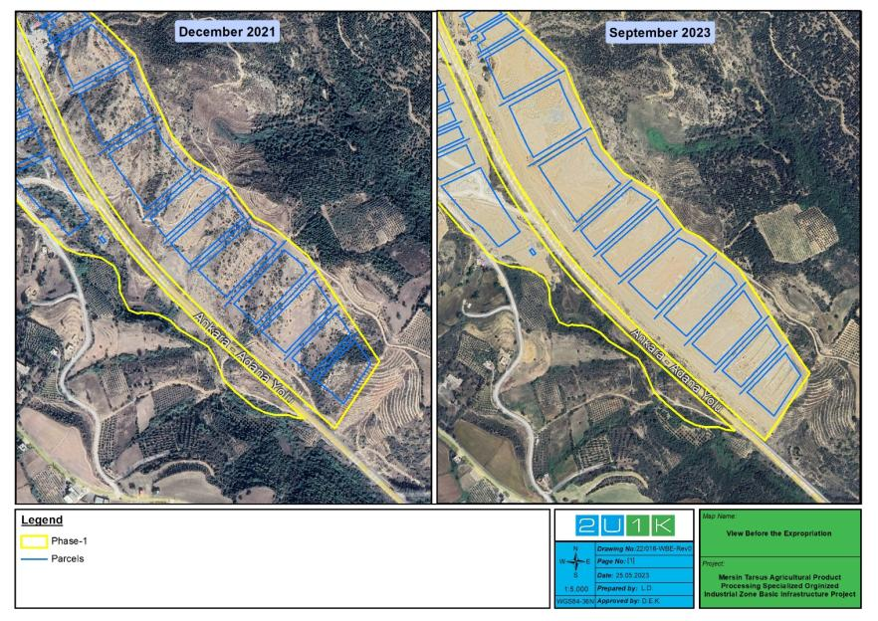

**Figure 3‑1.** View Before the Expropriation-1

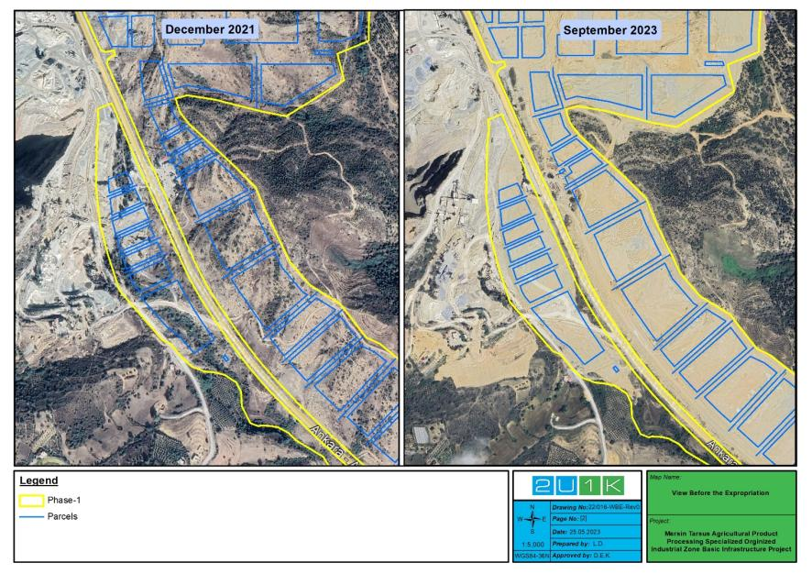

**Figure 3‑2.** View Before the Expropriation-2

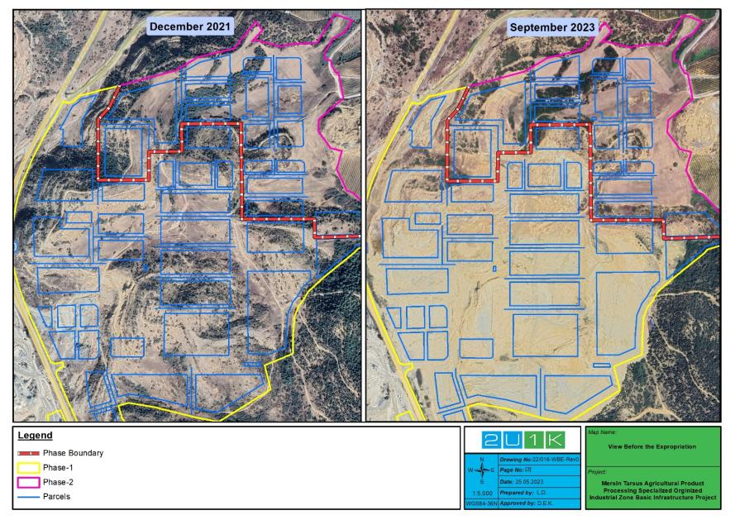

**Figure 3‑3.** View Before the Expropriation-1

### Acquisition of Private Lands

Within the scope of the sub-project, 3 private lands were needed as seen in Table 3‑1. Details regarding the acquisition process of 3 private lands are presented below.

### Mersin Tarsus Kurbanlı Parcel no: 102/5

The first parcel was multi-shareholder (57). Shares were obtained by consent/agreement from available shareholders (35). The expropriation process was applied for 22 shareholders who could not be reached.

The land acquisition documents such as Decision on the need for expropriation (18.09.2018), Expropriation request letter (28.09.2018), Public interest decision (4.12.2018), Case report for the unreachable shareholders of the parcel (10.02.2021) are provided in Appendix A. Expropriation Value Determination and Registration lawsuit filed by Mersin Governorship Investment Monitoring Coordination Presidency for the acquisition of the shares belonging to the unreachable shareholders was concluded positively and the shares belonging to the unreachable shareholders were registered in the disposal of TUIOSB (See Appendix A1 for the case report). The expropriation requirement/need decision (Appendix A3), the expropriation request letter (Appendix A4), the public interest and expropriation decision (Appendix A2) are presented in the appendices.

There was no fixed asset (building, structure, tree, etc.) or income generating activities the land.

### Mersin Tarsus Kurbanlı Parcel no: 105/1 and 105/2

Urgent expropriation decision[4] was taken for two parcels (Mersin Tarsus Kurbanlı 105/1 and 105/2) (for urgent expropriation decision see Appendix B2). Two of the lands to be acquired in the second phase were private land and belonged to one Project Affected People (PAP). Despite the urgent expropriation decision, two parcels were received with agreement/consent (see Appendix B3 and B4 for agreement minutes). In this case, although an urgent expropriation decision was taken, it did not need to be implemented.

The land acquisition documents such as Public interest decision (24.05.2022), Urgent Expropriation Decision (Article 27) (3.08.2022), Valuation reports for 105/1 and 105/2 (19.10.2022) are provided in Appendix B. Positive evaluations made in the expert report prepared within the scope of Article 27 Urgent Expropriation case enabled the acquisition of two lands with compensation at the replacement cost. These positive reviews include:

* The types of the lands in the title deeds are stony-bush (105/1) and raw land (105/2). However, the expert appreciated that the lands were suitable for agricultural activities and two parcels were evaluated as dry agricultural land. Thus, the valuation was made using the net income method.
* While calculating the net income on the lands, the unit (m2) price was found to be 28.58 TRY and the unit price was increased to 32.87 TRY by applying a 15% objective value increase to it.
* Additionally, 10% increase in value was applied, taking into account the non-agricultural qualities of the lands (such as being close to main roads).

There are no trees in parcel no. 105/1. The following 6 trees were identified in parcel no. 105/2 and an evaluation was made according to 2021 data of the District Directorate of the Ministry of Agriculture and Forestry. No deductions were made in the calculation of the compensation for trees, such as the cost of wood or cutting costs, and compensation was provided for the replacement cost.

* 2 eucalyptus trees 10 years old,
* 1 eucalyptus tree 25 years old,
* 1 eucalyptus tree 40 years old,
* 1 loquat tree 10 years old,
* 1 pine tree 40 years old.

### Unviable Lands

The lands were not divided, the whole was taken. There are no unviable lands.

### Rental Lands

There is no need to rent any lands for the construction of the Sub-project.

### Acquisition of Public Lands

OIZ undertook the acquisition, transfer and entry of land registered with other government departments.

* The acquisition of Treasury land is processed by purchase. For the sample title deed registered in the name of OIZ, see Appendix C.
* The usage rights of 3 Treasury lands formally used by İskenderun Demir-Çelik AŞ (İSDEMİR) were acquired by protocol (Appendix D).
* The lands belong to other state authorities /public institutions were not affected by the sub-project.
* Lands allocated for forestland were acquired through changing the status from forest to Treasury land and were treated as Treasury land.[5]
* There is a limited impact on Pasturelands by the Project.

### Acquisition of Affected Buildings

7 buildings on 2 parcels were affected by the land acquisition of the sub-project. 5 of them were on 1 private land and 2 of them were on 1 public land (Table 3‑2). The socio-economic impacts of the acquisition of 6 commercial and 1 residential building are presented in Chapter 4.

**Table 3‑2.** List of affected buildings

|  |  |  |  |  |  |  |  |
| --- | --- | --- | --- | --- | --- | --- | --- |
| **No** | **Settlement** | **Parcel** | **Size (m2)** | **Ownership status** | **Owner** | **Using status** | **User** |
| 1st Building | Mersin Tarsus Kurbanlı | 105/2 | 16.20 | Private | 1 PAP | Commercial | Owner (These buildings were used for vehicle maintenance, repair and gas filling) |
| 2nd Building | 314.90 | Commercial |
| 3rd Building | 68.62 | Commercial |
| 4th Building | 10.54 | Commercial |
| 5th Building | 28.90 | Commercial |
| 6th Building | Mersin Tarsus Kurbanlı | 104/1 | App. 200 | Public | Treasury | Residential | A family (2 PAPs) as an informal user of the affected structure |
| 7th Building | Commercial (restaurant and barn) |

### Affected buildings on Mersin Tarsus Kurbanlı Private Parcel no: 105/2

According to the evaluation expert report, there were 5 old and worn buildings used at the construction site in Mersin Tarsus Kurbanlı parcel no. 105/2. The buildings were used as maintenance, repair and parking areas for trucks by the owner of the land/buildings. See Chapter 4 for more detailed information on the livelihood impacts of land acquisition.

The value of the buildings on the land has been calculated with current prices by using the “Approximate Unit Costs of 2022/3 Buildings to be Used in the Calculation of Architecture and Engineering Service Fees” published in the Official Gazette dated 13 September 2022 and numbered 31952 by the Ministry of Environment, Urbanization and Climate Change, based on the on-site observation on 19.10.2022. Valuation results (For the valuation report see Appendix B5) and depreciation deduction amounts are as in Table 3‑3.

**Table 3‑3.** Buildings on parcel no. 105/2 and expropriation payments (private)

|  |  |  |  |  |
| --- | --- | --- | --- | --- |
|  | **Size (m2)** | **Expropriation payment (TRY)** | **Depreciation deduction rate (%)** | **Depreciation deduction amount (TRY)** |
| 1st Building | 16.20 | 23,328.00 | 40 | 15,552.00 |
| 2nd Building | 254.90 | 367,056.00 | 40 | 244,704.00 |
| 60.00 | 23,400.00 | 40 | 15,600.00 |
| 3rd Building | 68.62 | 82,344.00 | 50 | 82,344.00 |
| 4th Building | 10.54 | 10,118.40 | 60 | 15,177.60 |
| 5th Building | 28.90 | 5,722.20 | 80 | 22,888.80 |
| **Total** |  | **511,968.60** |  | **396,266.40** |

*Source: Case Expert Reports, 2022*

### Affected building on Mersin Tarsus Kurbanlı Public Parcel no: 104/1

There was one old building on this parcel. The building belongs to the National Real Estate Agency and a payment for the building was made to the National Real Estate.

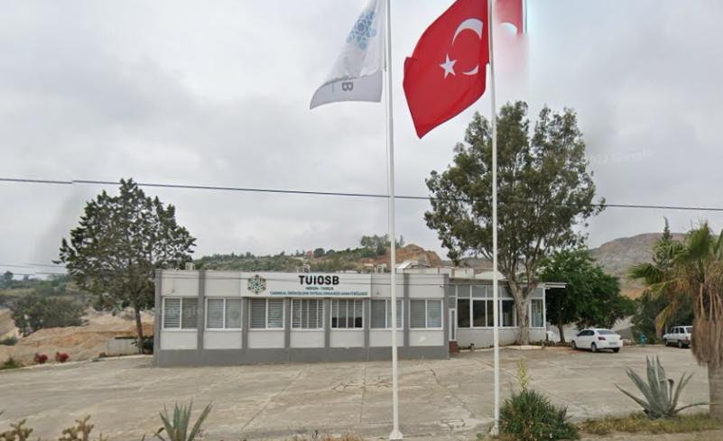

**Figure 3‑4.** Repaired old building on parcel no. 104/1

Previously, a family (an elderly mother and an adult son) lived in the old building. The building was built between 1981-1984 by the deceased husband of the elderly woman. However, this is not documented. In the past years, the family was making an adequate pay to the state called adequate pay[6] because they were the occupiers of the public land. Documents regarding these payments are from 2014 and earlier (see Appendix E). However, the family representative (son of the old woman) declared that they made this payment in the following years also. They have another house on the neighboring plot which they own formally. This house was neglected. The governor's office helped the elderly woman to move to her own house by repairing this neglected house on their own plot and giving some household items to the old woman (for payments documents see Appendix G and for the photos of the family's renovated house see Appendix H). The informal house owner has also declared in writing that she gave up her rights in the affected house affected by the Project in exchange for the renovation of her own house (see Appendix I). For more details see Section *4.3 Project Affected Houses and Physical Resettlement.* For corrective actions suggested to fill the gap between national and international requirements on this issue, see *Chapter 6 NON-COMPLIANCES AND CORRECTIVE ACTION.*

### Additional land need

According to RF, for the projects that entail additional land acquisition in the future, proactive study and reporting will be carried out by the sub-borrowers. In case additional land acquisition is required in the future, proactive study and reporting will be carried out and entitlements in Table 3‑4 will be provided.

## Entitlement Matrix (EM)

Entitlements divided by PAP categories for a land acquisition process in line with WB ESS5 are as presented in the matrix below for Resettlement Plans to be prepared under the Main Project of the MoIT. This EM was used in the corrective actions suggested in Chapter 6.

If new land use/acquisition is required for the sub-project due to the high inflation level in Turkey, the inflation difference between the valuation and payment dates will need to be calculated. For this, calculations should be made by taking into account the Domestic Producer Price Index (D-PPI) values.

**Table 3‑4.** Entitlement Matrix (EM)

| **No** | **PAP category** | **Entitlements** | **Evaluation** |
| --- | --- | --- | --- |
| 1 | Loss of entire land holding (landowner) | Full replacement cost (market prices + transaction costs). Maximum effort to avoid land take before harvest (on agricultural lands). | When the Valuation Reports are examined, it is seen that no deductions have been made in the land and tree value calculations, and that the valuations are in accordance with international standards. According to the 3rd article of the Capital Markets Board (CMB) Communiqué on Valuation Standards in the Capital Markets (III-62.1), which was published in the Official Gazette dated 01.02.2017 and numbered 29966, It is obligatory to comply with the published International Valuation Standards”. For this reason, the valuation was made in accordance with ESS5. |
| 2 | Partial loss of land (landowner) | Full replacement cost of the part of land lost. (market prices + transaction costs). Maximum effort to avoid land take before harvest (on agricultural lands). | There is no partial land acquisition in the TUIOSB sub-project. |
| 3 | Unviable, redundant parcels of land/structures (landowner) | If the remaining parcel of land after expropriation of a part of it is not economically viable, it will also be acquired and compensated (at full replacement cost) if the owner so desires. | In the TUIOSB sub-project, the lands are not divided; There is no partial expropriation. No unviable, redundant lands were detected in the EPSA field study. |
| 4 | Loss of structures and other fixed assets on the land (barns, shacks, wells, fences, etc.) | Full replacement cost. Depreciation will not be deducted. Additional supports such as moving allowances and transitional allowance. Depending on the case, income restoration assistance package such as equivalent of 6 months of minimum wage or a job opportunity or other social support mechanisms facilitated by OIZs will be provided. | Efforts were made to avoid physical and economic displacement during the acquisition of the buildings. However, full replacement cost compensation was not paid for the structures, and one informal owner of a building on public land was provided with additional support rather than land compensation. For corrective actions suggested under EPSA, see Chapter 6. |
| 5 | Loss of or access limitations to communal lands (pasture lands etc.) | Fee for fodder (Hay) and other compensations to be paid to relevant state authority. Provide alternative access ways and proper passages to pasturelands areas. Where livelihood depends on such lands, land users engaged in animal husbandry to be provided with 2 years of feed support. | Due to the TUIOSBProject’s land acquisition, 7 households were identified that were affected by livestock grazing activities. For corrective actions suggested under EPSA, see Chapter 6. |
| 6 | Loss of Crops, trees, and other land-based products | The crop value (market price) and investment amount made for the crop (input, labor, age of trees). Each crop and/or tree will be considered according to its characteristics (annual or perennial, maturity, average yield on a minimum of 3 years etc.) | No deductions were made in the calculation of tree compensation, such as the cost of wood or cutting costs, and compensation was provided for the replacement cost. |
| 7 | Loss of land needed on a temporary basis | The market rental price for the duration of the lease. The land should be returned to the project affected individual, in the same condition as it was taken. If agricultural land and crops are lost during the lease, the owner should be compensated for the crop losses for the duration of lease. If land is used for business and income is affected during the lease, the business shall be compensated for losses for the duration of the lease. | There is no temporary land requirement under the TUIOSB sub-project. All construction activity will remain within the OIZ area and the OIZ is not yet operational. |
| 8 | Loss of Houses | Full compensation based on the replacement cost in a similar/comparable area plus moving and transitional allowance (depending on the case, income restoration assistance package such as equivalent of 6 months of minimum wage or a job opportunity or other social support mechanisms facilitated by municipality and/ or other institutions). Depreciation will not be deducted. | There is 1 physical resettlement case. No compensation was provided as this house is on public land. Instead of; supports such as relocation support, preparation of a new house, renovation, furniture assistance were provided by the Municipality. Because PAP had another neglected house of her own. For corrective actions suggested under EPSA, see Chapter 6. |
| 9 | Legal Renters | Assistance with finding a new place and moving and transition allowance. If lease is terminated early, compensation to ensure that renters do not suffer losses. | There were no tenants in the lands and structures affected by the TUIOSB sub-project. |
| 10 | Employees or workers on the land or businesses | Compensated for their income earned from the land, crops, and any investment made on the land, in a manner that they will be the same or better off than before the project. For employees and workers additional allowance (depending on the case, income restoration assistance package such as equivalent of 6 months of minimum wage or a job opportunity or other social support mechanisms facilitated by municipality and/ or other institutions) will be paid. | No loss of business occurred due to TUIOSB sub-project’s land acquisition. EPSA fieldwork showed no workers on the affected lands (most of the affected lands are not agricultural). |
| 11 | Informal users | Compensated for the crops and the value (at full replacement cost) of other investments made on the subject land. Assisted in their effort to improve their livelihoods and standard of living to restore them to pre-displacement levels. | No current informal users of public lands is identified in the scope of EPSA study. But before the expropriation, one owner of a house in public land and 2 nomad family lived in a tent on the project area in the past learned and evaluated in the scope of EPSA. |
| 12 | Businesses affected Full replacement cost of affected business place. | Transitional assistance to re-establish business in new location and compensation for lost income (depending on case and time lost) as necessary. | There were commercial buildings influenced by the TIUOIZ sub-project. However, the loss of business was not experienced. For details see 4.5 Project Affected Businesses. |
| 13 | Communal land and assets affected | Full replacement cost, or alternative compensation, with the agreement of the community. | There are no communal assets or lands belonging to the Village Legal Entities. |
| 14 | People who have lost more than 10% of their land | Assist PAPs to ensure that livelihoods are restored. Replacement cost of the loss of land/assets; additional compensation measures. | No farmer is identified in the EPSA study, who lost 10% or more of land assets. However, the land was not under cultivation before the expropriation. |
| 15 | Vulnerable groups[7] who demonstrate they have suffered negative livelihood impact | Assist PAPs to ensure that livelihoods are restored. Depending on case, livelihood restoration package such as Equivalent of 6 months of minimum wage or depending on case, a job opportunity or other social support mechanisms facilitated by OIZs. | EPSA determinations on vulnerable groups Presented in the Section 4.6 Vulnerable Groups section. For corrective actions suggested under EPSA, see Chapter 6. |

*Source: RF of the Main Project, Feb. 2021.*

# PROJECT’S LAND-BASED IMPACTS AND GROUPS IMPACTED

## Data Collection Methodology of EPSA

In the EPSA study, quantitative and qualitative data collection techniques were used together. The main data sources of the EPSA works were the official Land Acquisition (LA) documents such as;

* Expropriation and Public interest decisions,
* Land valuation reports,
* E&S Screening Report,
* Expropriation List,
* Case records.

In addition to these, a field study was carried out (January 2023). Semi-structured interviews were conducted (Community-level survey - CLS) with the headmen of Kurbanlı, Eskişehir and Sağlıklı settlements. The settlements of Kurbanlı and Eskişehir were affected by the land acquisition. The lands in Sağlıklı were not affected by the land acquisition, but it has been included in the field study of EPSA because it is close to the sub-project area and there might be land use and access barriers.

CLS includes the questions on:

* LA impacts
* Project affected PAPs
* Complaints
* Impacts on livelihood
* Vulnerable groups
* Suggestions
* Population
* Livelihood pattern
* Needs of the settlement

Semi-structured interviews (Household-level survey - HLS) were conducted with the 10 PAPs who were identified with CLS. There was one group of PAPs identified. These are PAPs whose animal grazing activity was affected.

Apart from this group, no HLS application was made for other groups as no PAPs benefitting from forests, experiencing agricultural access barriers, pursuing beekeeping or fishing activities were identified.

HLS includes the questions on:

* LA impacts
* Complaints
* Impacts on livelihood
* Vulnerabilities
* Suggestions
* Household population
* Livelihood pattern of the household
* Needs of the household

Finally, unstructured in-dept interviews were conducted with PAPs directly affected by expropriation of the sub-project. These PAPs are:

1. Owner of private parcels no. 105/1 and 105/2
2. One of the shareholders of the private parcel no. 102/5
3. Representative of the physically displaced household whose house on public parcel no. 104/1 was affected

The distribution of 16 consultations carried out within the scope of EPSA fieldwork is presented in the Table 4‑1.

**Table 4‑1.** Sampling summary

|  |  |  |  |  |  |
| --- | --- | --- | --- | --- | --- |
| **Settlement** | **No. of CLS** | **No. of HLS** | | **No. of in-dept interviews** | |
| With PAPs whose agricultural activity on public lands was affected. | With PAPs whose animal grazing activity was affected. | With PAPs who were owner of the affected private lands | Physically displaced PAPs |
| Kurbanlı | 1 | 0 | 2 | 2 | 1 |
| Eskişehir | 1 | 0 | 3 | 0 | 0 |
| Sağlıklı | 1 | 0 | 5 | NA[8] | NA |
| Total | 3 | 0 | 10 | 2 | 1 |

The following issues were analyzed for ESS5 compliance in the light of the data obtained from the above-mentioned sources.

* Project affected settlements and communities,
* Project affected houses and physical resettlement,
* Project affected households and livelihoods,
* Project affected businesses,
* Vulnerable groups.

## Project Affected Settlements and Communities

According to E&S Screening Report, neighborhoods located around the project area are:

* Kurbanlı neighbourhood, app. 500 m south
* Sağlıklı Neighbourhood, app. 975 m west
* Eskişehir Neighbourhood, app. 958 m east

According to E&S Screening Report, there was no objection from the institutions or the people living in the surrounding area during the OIZ site selection and zoning plan preparation process. There are no ongoing court cases involving the OIZ.

Two settlements were affected by the land acquisition. The number of parcels to be used are from two settlements are shown in Table 4‑2 below.

**Table 4‑2.** Number of affected parcels per settlements

|  |  |  |
| --- | --- | --- |
| **Settlement** | **No. of parcels** | **%** |
| Sağlıklı | 0 | 0 |
| Kurbanlı | 15 | 93.75 |
| Eskişehir | 1 | 6.25 |
| **Total** | **16** | **100.00** |

*Source: Community-Level Survey, Jan. 2023*

Populations of the settlements are in Table 4‑3.

**Table 4‑3.** Actual estimated populations of the affected settlements

|  |  |  |  |  |
| --- | --- | --- | --- | --- |
| **Settlement** | **No. of Households** | **No. of people (Total)** | **No. of man** | **No. of woman** |
| Sağlıklı | 550 | 1630 | 820 | 810 |
| Kurbanlı | 56 | 300 | 150 | 150 |
| Eskişehir | 69 | 110 | 55 | 55 |
| **Total** |  |  |  |  |

*Source: Community-Level Survey, Jan. 2023*

A headman declared that there has been a change in the population of the settlement in the last 5 years.

**Table 4‑4.** Past populations change in affected settlements

|  |  |  |
| --- | --- | --- |
| **Settlement** | **Population changes in the last 5 years** | **Direction of change** |
| Sağlıklı | No | NA |
| Kurbanlı | No | NA |
| Eskişehir | Yes | Decrease |

*Source: Community-Level Survey, Jan. 2023*

It was asked whether people living in the settlement migrated during certain parts of the year and the following answers in Table 4‑5 were received.

**Table 4‑5.** Seasonal migration

|  |  |  |  |  |  |
| --- | --- | --- | --- | --- | --- |
| **Settlement** | **Seasonal migration from the settlement** | **Purpose** | **No. of adult man** | **No. of adult woman** | **No. of children** |
| Sağlıklı | Yes | Agricultural working | 40 | 10 | 0 |
| Kurbanlı | No | NA | NA | NA | NA |
| Eskişehir | No | Agricultural work | 100 | 80 | 20 |
| **Total** |  |  | **140** | **90** | **20** |

*Source: Community-Level Survey, Jan. 2023*

The headmen were asked whether they expected a population change in the future and it was learned that they expected a population increase due to the increase in employment opportunities stemming from the OIZ (Table 4‑6).

**Table 4‑6.** Future populations change expectation in affected settlements

|  |  |  |  |
| --- | --- | --- | --- |
| **Settlement** | **Migration from the settlement** | **Migration to the settlement** | **Reasons** |
| Sağlıklı | Will decrease | Will increase | OIZ employment opportunities |
| Kurbanlı | Will decrease | Will increase | OIZ employment opportunities |
| Eskişehir | No change expectation | Will increase | OIZ employment opportunities |

*Source: Community-Level Survey, Jan. 2023*

For the livelihoods of the affected settlements see Table 4‑7.

**Table 4‑7.** Livelihood sources of the settlements

| **Livelihood sources** | **Sağlık** | **Kurbanlı** | **Eskişehir** |
| --- | --- | --- | --- |
| **Order of priority** | | |
| Agriculture – crop production | 3 | 1 | 3 |
| Animal husbandry | 4 | 5 | 1 |
| Beekeeping |  |  |  |
| Forestry |  |  |  |
| Tourism |  |  |  |
| Trade |  |  |  |
| Craftsmanship |  |  |  |
| Pension | 5 | 2 | 2 |
| Construction and industrial labor |  | 3 |  |
| Agricultural labor |  |  |  |
| Mining labor | 1 |  |  |
| Transportation | 2 |  | 4 |
| Social aids and supports |  | 4 | 5 |
| Real estate revenues |  |  |  |

*Source: Community-Level Survey, Jan. 2023.*

## Project Affected Houses and Physical resettlement

### Affected house on Mersin Tarsus Kurbanlı Public Parcel no: 104/1

There was one old building on this parcel. This building and the land on which it is located were purchased by TUIOSB from National Real Estate as mentioned before. The building was built by a real person (man) and used as a shop in the past. Later, the wife of the man (and her son) started to live on the top floor of this building. The woman declares that she paid adequate pay (ecrimisil) to the state for the land. It is not known what year the last adequate pay payment was made, but was able to submit a payment document for 2014 as presented in Appendix E.

No compensation was paid to the woman living in the house on public land. Instead, her old house on the next parcel, which she had inherited from her parents , was renovated and she was helped to move there. . This house was neglected. The governor's office helped the elderly woman to move to her own house by repairing this neglected house (expansion, plastering, painting, pouring concrete in front of the house, landscaping etc.) and giving some household items (such as a refrigerator, wardrobe) 194,935.44 TL worth to the old woman in 2019 (for payments documents see Appendix G and for photos of renovated house see Appendix-H).

Because, as mentioned before in Table 2‑3, according to Bank’s ESSs, as well as official users of the land, unofficial users of the land are also defined as PAPs. Persons who have spent money and constructed buildings or other structures on the lands of other persons are compensated at full replacement cost. Compensation provided will ensure that the livelihoods of renters and other informal users of land are not affected. In addition to the legal compensation amount for the official landowners, for other people who have no legal rights, any additional costs to fulfil requirements of Bank standards will be covered by OIZs. Tenants, public land users and squatters would be entitled to the replacement cost of what they have invested in the land.

Additionally, although, Turkish legislation does not require payment of compensation to tenants and unofficial users of land/properties, according to the amendment on Article 19 of Expropriation Law, persons who have spent money and constructed/erected buildings or other structures on the lands of other persons are compensated at full cost for trees and material costs for buildings. But material costs need to be at replacement cost according to Bank’s operational policies.

Everyone around will witness that the house was built by them. The shop on the ground floor of the house was no longer active and livestock activity could not be sustained because the woman was getting old. Therefore, there is no loss of livelihood, but there is a physical resettlement impact.

For corrective actions to fill the gap between national and international requirements, see *Chapter 6 NON-COMPLIANCES AND CORRECTIVE ACTION.*

## Project Affected Households and Livelihoods

### Agriculture

The products produced in the settlements affected by the project are presented in Table 4‑8.

**Table 4‑8.** The products produced in the settlements affected by the project

|  |  |  |
| --- | --- | --- |
| **Settlement** | **Agricultural products produced in the settlement** | |
| Product | Amount produced (kg) |
| Sağlıklı | Olive | 60000 |
| Fig | 50000 |
| carob | 50000 |
| sunflower | 70000 |
| wheat | 70000 |
| Kurbanlı | Olive | 10000 |
| Wheat | 100000 |
| Sunflower | 100000 |
| Eskişehir | Citrus | 10000 |
| Peach | 7000 |
| Olive | 10000 |
| Wheat | 750000 |
| Sunflower | 400000 |

*Source: Community-Level Survey, Jan. 2023*

Within the scope of EPSA studies, no agricultural activity was found on 3 private lands affected by the project's land acquisition. Additionally, it was learned that there is no existing informal user in the public lands in Phase 1 area. One owner of a house in public land and 2 nomad family lived in a tent on the project area in the past were identified and included in the scope of EPSA.

The headmen were also asked about the indirect impacts on agricultural activity. Information received that irrigation systems and access roads are not affected by the project (Table 4‑9).

**Table 4‑9.** Indirect impacts on agricultural activity

|  |  |  |
| --- | --- | --- |
| **Settlement** | **Are there any irrigation systems remaining in the OIZ area?** | **Are there any households that will have difficulty/barrier access to agricultural lands?** |
| Sağlıklı | No | No |
| Kurbanlı | NA (no irrigation in the settlement) | No |
| Eskişehir | No | No |

*Source: Community-Level Survey, Jan. 2023*

### Animal husbandry

The number of households engaged in animal husbandry and animals in the settlements is presented in Table 4‑10 below.

**Table 4‑10.** The number of households engaged in animal husbandry and animals in the settlements

|  |  |  |  |
| --- | --- | --- | --- |
| **Settlement** | **Animal type** | **No. of households engaged animal husbandry** | **No. of animals** |
| Sağlıklı | Cattle | 150 | 400 |
| Small cattle | 20 | 15000 |
| Kurbanlı | Cattle | 1 | 3 |
| Small cattle | 4 | 300 |
| Eskişehir | Cattle | 0 |  |
| Small cattle | 5 | 700 |

*Source: Community-Level Survey, Jan. 2023*

According to the information received from the headmen, the animal products produced in the settlements are as follows (Table 4‑11).

**Table 4‑11.** The animal products produced in the settlements

|  |  |  |  |
| --- | --- | --- | --- |
| **Settlement** | **Animal product** | **To sell (kg/month)** | **House consumption (kg/month)** |
| Sağlıklı | Dairy Products (oil, yogurt, cheese) | 15000 |  |
| Milk | 30000 |  |
| Kurbanlı | Dairy products (cheese, oil) | Unknown | 500 |
| Egg |  | 600 pieces |
| Milk | 9000 | 1000 |
| Eskişehir | Animal product cheese | 700 | 700 |
| Milk |  | 20000 |

*Source: Community-Level Survey, Jan. 2023*

The answers of the headmen about the impacts on animal husbandry are in Table 4‑12 below. 10 people affected by animal grazing activities in the project area have been identified.

**Table 4‑12.** Grazing activities on affected public lands

|  |  |  |  |  |
| --- | --- | --- | --- | --- |
| **Settlement** | **Are there any households grazing livestock in the OIZ area?** | **Access barrier to pastures?** | **No. of households** | **Alternative pasture opportunity?** |
| Sağlıklı | Yes | No | 5 | No |
| Kurbanlı | Yes | No | 2 | Yes, but insufficient |
| Eskişehir | Yes | No | 3 | Yes, but insufficient |
| **Total** |  |  | **10** |  |

*Source: Community-Level Survey, Jan. 2023*

The 10 households mentioned by the headmen were reached within the scope of the EPSA field study. 3 out of 10 people declared that the animal grazing activity was not affected by the sub-project. The responses received are summarized in Table 4‑13 below.

**Table 4‑13.** Households grazing animals on affected public lands

| **Household no** | **H4** | **H5** | **H6** | **H7** | **H8** | **H9** | **H10** | **H11** | **H12** | **H13** |
| --- | --- | --- | --- | --- | --- | --- | --- | --- | --- | --- |
| **Province** | Mersin | Mersin | Mersin | Mersin | Mersin | Mersin | Mersin | Mersin | Mersin | Mersin |
| **District** | Tarsus | Tarsus | Tarsus | Tarsus | Tarsus | Tarsus | Tarsus | Tarsus | Tarsus | Tarsus |
| **Settlement** | Sağlıklı | Sağlıklı | Sağlıklı | Sağlıklı | Sağlıklı | Kurbanlı | Kurbanlı | Eskişehir | Eskişehir | Eskişehir |
| **Main livelihood** | Animal husbandry[9] | Animal husbandry | Animal husbandry and paid working | Animal husbandry[10] | Animal husbandry | Declared that animal grazing activity and livelihood of the household was not affected by the OIZ project | Animal husbandry | Declared that animal grazing activity and livelihood of the household was not affected by the OIZ project | Declared that animal grazing activity and livelihood of the household was not affected by the OIZ project | Agriculture and Animal husbandry |
| **Cattle asset** | 0 | 0 | 0 | 0 | 0 | 0 | 0 |
| **Small cattle asset** | 130 | 180 | 150 | 100 | 250 | 800 | 100 |
| **Purpose of the activity** | Selling animals | Selling animals and animal products | Selling animals and animal products | Selling animals and animal products | Selling animals and animal products | Selling animals and animal products | Selling animals and animal products |
| **Alternative pasture** | No | No | Yes | No | No | No | Yes |
| **Negative characteristics of alternative pasture** | NA | NA | Far / difficult to access | NA | NA | NA | Space is small / insufficient |
| **Local employment opportunity** | No | Yes, there is a member who can work in the OIZ | Yes, there is a member who can work in the OIZ | Yes, there is a member who can work in the OIZ | Yes, there is a member who can work in the OIZ | Yes, there is a member who can work in the OIZ | No |
| **Need of vocational trainings** | No | Yes | Yes | Yes | Yes | No answer | No |
| **Vulnerabilities** | Member without social security | Member without social security and with chronic disaster | No | No | No | Disabled member | No |
| **Adverse impact** | Impact on agriculture and animal husbandry | Impact on animal husbandry | Impact on animal husbandry | No | Impact on animal husbandry | No answer | Pollution of water and environment due to wastes |
| **Positive impact** | Employment for youth | Employment for youth, men and women | Employment for youth, men and women | Employment for youth, men and women | Employment and trainings for youth, men and women | Employment | Employment for youth, men and women |
| **Communication preference** | Headman | Headman | Headman | Face to face meetings | Face to face meetings | Headman | Web site |
| **Experience of benefiting from agricultural grants and supports** | No | No | No | No | No | No | No |
| **Assistance request/need to benefit from agricultural grant supports** | No | No | No | No | No | No | No |
| **Household population** | 1 w, 2 m = 3 | 4 w, 2 m =6 | 2 w, 2 m = 4 | 2 w, 4 m = 6 | 2 w, 2 m = 4 | 7 w, 5 m = 12 | 1 w, 2 m = 3 |

### Benefiting from natural resources

There are forest lands in neighboring parcels around the sub-project area, but the forest area was not of such a quality that any resource utilization took place. According to the E&S Screening report, no adverse effects are expected on forests due to OIZ activities. According to EPSA studies, there is no forestland affected by the sub-project, however, it has been examined whether the benefiting activities of natural resources are affected by the sub-project. No benefiting activity and loss of income was identified (Table 4‑14).

**Table 4‑14** Benefiting from the forestlands/natural resources

|  |  |  |
| --- | --- | --- |
| **Settlement** | **Are there any households benefiting from forests?** | **Do you think these people will lose income due to the project?** |
| Sağlıklı | No | No |
| Kurbanlı | NA | No |
| Eskişehir | No | No |

*Source: Community-Level Survey, Jan. 2023*

### Fishing

There is Evcisuyu Stream at a distance of 30 m from the project area, İncirli Kuruderesi at a distance of 335 m, Sepetçi Stream at a distance of 563 m and Kosun Stream at a distance of 1341 m. It has been learned that there is no affected fishing activity in the settlements (Table 4‑15).

**Table 4‑15** Fishing activities in the Project area

|  |  |
| --- | --- |
| **Settlement** | **Fishing activity in the settlement** |
| Sağlıklı | No |
| Kurbanlı | No |
| Eskişehir | No |

*Source: Community-Level Survey, Jan. 2023*

### Beekeeping

It was learned that there were no beehives in TUIOSB area permanently and the beekeeping activity will not be affected by the land use of the sub-project (Table 4‑16).

**Table 4‑16.** Bee keeping activities in the settlements

|  |  |  |
| --- | --- | --- |
| **Settlement** | **Bee keeping activity in the settlement** | **Were they using the OIZ area?** |
| Sağlıklı | No | NA |
| Kurbanlı | Yes | Sometimes. They were coming from another village. There are no beehives in the OIZ area permanently. |
| Eskişehir | No | NA |

*Source: Community-Level Survey, Jan. 2023*

## Project Affected Businesses

### 5 buildings on the private parcel no. 105/2

Worn out buildings on the land (105/2) were used for commercial purposes by the land owner. However, it was not used as any facility, but only as a park and repair area. According to the interview made with the parcel owner on January 24, 2023, he was planning demolish these buildings and did not suffer any income loss due to expropriation. The expropriation has already been carried out by consent/agreement (Appendix B4).

### İSDEMİR operation area on public parcels no 189/11, 189/4 and 0/680

There was İSDEMİR activity area which produces silica sand (10,000 tons/year) on the affected 3 public lands (Table 4‑17). An agreement/protocol (Appendix D) was signed with İSDEMİR, the money was paid and the remaining areas within the project area were emptied by İSDEMİR. Therefore, their current operation site is located at one border of the OIZ site. According to the agreement, 500 thousand tons of the soil from the project excavation will be given to İSDEMİR for processing, and the excavated soil is stored on site. An agreement has been reached on issues such as the use of excavation, compensation for workplace losses, and there is no loss of business.

**Table 4‑17.** Public lands where ISDEMIR operated

|  |  |  |  |  |  |
| --- | --- | --- | --- | --- | --- |
| **Province** | **District** | **Settlement** | **Parcel** | **Owner** | **Type** |
| Mersin | Tarsus | Kurbanlı | 189/11 | Treasury | Plot |
| Mersin | Tarsus | Kurbanlı | 189/4 | Treasury | Industrial land |
| Mersin | Tarsus | Eskişehir | 0/680 | Treasury | Plot |

### Old shop on Mersin Tarsus Kurbanlı public parcel no: 104/1

There was a workplace in the past on public parcel no 104/1. At some point of time , the wife of the informal owner of the building started to live on the upper floor of this shop (See Physical displacement section). The shop downstairs was run by the woman's son for a while. According to the information received in the interview with him, he was no longer working. Therefore, no loss of business occurred due to the land acquisition of the project.

## Vulnerable Groups

In the interviews with the headmen, it was questioned whether there were people from the following groups among the people who were directly or indirectly affected by the land use and land acquisition of the project, and 2 disabled individuals were identified.

* Woman head of household
* Elderly (65+)
* People with disability
* People who are dependent on home due to chronic illness
* Illiterate adult
* People who do not speak Turkish
* Nomads

**Table 4‑18.** Vulnerable PAPs affected by the land acquisition of the sub-project

|  |  |  |  |
| --- | --- | --- | --- |
| **Settlement** | **Vulnerable PAPs** | **Vulnerability** | **No. of PAPs** |
| Sağlıklı | Yes | People with disability | 1 |
| Kurbanlı | Yes | People with disability,  Elderly woman (physically displaced) | 2 |
| Eskişehir | No | NA | NA |
| **Total** |  |  | **3** |

*Source: Community-Level Survey, Jan. 2023*

Additionally, vulnerable household members were identified in all 3 households whose grazing activity was affected by the sub-project (Phase 1 area), although their land or house was not directly affected by the project's land acquisition (see **Table *4*‑*13***).

The headmen were also asked if there were unemployed people throughout the settlement and the following answers in Table 4‑19 were received. However, no unemployment was detected in the households affected by the project's land acquisition.

**Table 4‑19.** Unemployment in the settlements

|  |  |  |  |
| --- | --- | --- | --- |
| **Settlement** | **Villagers who are looking for a job but cannot find it** | **N** | **Unemployed individuals in project-affected households** |
| Sağlıklı | Yes | 15 | No |
| Kurbanlı | Yes | 1 | No |
| Eskişehir | No | 0 | No |
| **Total** |  | **16** |  |

*Source: Community-Level Survey, Jan. 2023*

It was asked whether seasonal workers come to the settlements at certain times of the year, and a positive response was received from the headman of a settlement (Table 4‑20).

**Table 4‑20.** Seasonal workers

|  |  |  |  |  |  |
| --- | --- | --- | --- | --- | --- |
| **Settlement** | **Are seasonal workers coming?** | **Purpose** | **No. of adult men** | **No. of adult women** | **No. of children** |
| Sağlıklı | No | NA | NA | NA | NA |
| Kurbanlı | No | NA | NA | NA | NA |
| Eskişehir | Yes | Agriculture | 100 | 80 | 20 |
| **Total** |  |  | **100** | **80** | **20** |

*Source: Community-Level Survey, Jan. 2023*

It has been learned that seasonal agricultural workers do not stay and work in the OIZ area. Therefore, no effect was detected on seasonal agricultural workers.

According to studies conducted before EPSA, there were nomads (2 families) using the Project area for animal husbandry and they were staying there in winter, as it was an empty and unused land. When the land was transferred to the OIZ, the village headman showed the 2 nomad families another place and currently they are staying there. The place shown by the mukhtar is a flat area suitable for setting up tents. Within the scope of EPSA studies, no physical or economic displacement was detected for the families in question.

# STAKEHOLDER ENGAGEMENT

## Stakeholder Engagement Activities Carried Out

Consultations on land acquisition started with requests for opinions from institutions at the site selection stage. Institutions attended the Site Election Commission Meeting on 19.11.2020. The opinions received were positive and the institutions requested to be informed about the progress of the project. The opinions of the institutions regarding the location selection are summarized below (Table 5‑1).

**Table 5‑1.** Institutional opinions on site selection

| **Institution** | **Opinion** |
| --- | --- |
| MINISTRY OF ENVIRONMENT AND URBANIZATION (Mersin Provincial Directorate of Environment and Urbanization) | Although our Provincial Directorate does not find any objection in making the OIZ site selection, the final opinion will be notified in writing to the Ministry of Industry and Technology by our Ministry. |
| MINISTRY OF AGRICULTURE AND FOREST (Mersin Provincial Directorate of Agriculture and Forestry) | Within the scope of Law No. 5403, it is a legal obligation to make an application through the institutions and organizations authorized to make plans and obtaining appropriate opinion. Moreover, if there is pasture, it is a legal obligation to obtain permission in order to be able to make an evaluation according to the law of pasture no 4342 and olive cultivation law no 3573 within olive groves. For parcels with land within the OIZ area, there is no action or legislation that can be done by our institution if it is made in accordance with the current legislation. |
| MINISTRY OF AGRICULTURE AND FOREST (Mersin Regional Directorate of Forestry) | The area determined as the project area in question was removed as a Treasury parcel outside the forest borders in accordance with the additional article 16 of the law numbered 7139. |
| MINISTRY OF ENERGY AND NATURAL RESOURCES (BOTAŞ Kahramanmaraş Branch Office) | Mersin-Tarsus Agricultural Product Processing Specialized OIZ area does not have any drawbacks in terms of natural gas pipelines of our institution. |
| MINISTRY OF ENERGY AND NATURAL RESOURCES (18th Regional Directorate of TEİAŞ) | Regarding the TUIOSB proposal area, first of all, the approximate electrical energy consumption amount of the OIZ should be specified. According to the calculated consumption amounts, an application should be made to our General Directorate. |
| MINISTRY OF CULTURE AND TOURISM (General Directorate of Investment and Businesses) | It is stated that the area in question is not within the scope of the "Culture and Tourism Protection and Development Zone" or "Tourism Center" and there is no work carried out by the General Directorates regarding the area. |
| MINISTRY OF CULTURE AND TOURISM (Provincial Directorate of Culture and Tourism) | It is not within the scope of any "Culture and Tourism Conservation and Development Zone" or "Tourism Center" planned in accordance with the Tourism Incentive Law No. 2634, and there is no work carried out by our General Directorate regarding the area. |
| MINISTRY OF TRANSPORTATION AND INFRASTRUCTURE (General Directorate of Infrastructure Investments) | In the letter dated 11/11/2020 and numbered 63364, it was stated that there was no study carried out by the General Directorates of the said field. |
| MINISTRY OF TRANSPORTATION AND INFRASTRUCTURE (5th Regional Directorate of Highways) | Provided that the highway expropriation limits are complied with in the area, there is no inconvenience for our institution. |
| MERSIN GOVERNORSHIP, INVESTMENT MONITORING AND COORDINATION DEPARTMENT | Our institution does not find any inconvenience in choosing the area determined as the area of TUIOSB. |
| MERSIN METROPOLITAN MUNICIPALITY | Although there is no objection, Mersin Metropolitan Municipality will give our written opinion separately. |
| MERSIN GOVERNORSHIP PROVINCIAL DIRECTORATE OF HEALTH | When the health protection band distance to be left within the property boundaries of the OIZ is evaluated according to the 4th article of the protocol signed between the Ministry of Industry and Technology and our Ministry, the health protection band to be left in the parts of the determined area bordering the forest and the region will not be left, and the health protection band distance to be left at the zoning plan stage in the other parts will be determined. |
| CUKUROVA DEVELOPMENT AGENCY GENERAL SECRETARIAT | Provided that there is no obstacle in matters that fall under the duties and responsibilities of other institutions, there is no objection to the Mersin TUIOSB area of our agency. |

The expropriation of the lands to be used for the sub-project was completed between 2018-2022. Agreement negotiations were held with three private landowners. For details of the consultation activities carried out within the scope of the sub-project, see Stakeholder Engagement Plan (SEP).

The following negotiations were held with the owners of the 3 affected private parcels during the land acquisition process.

**Table 5‑2** Negotiations during the land acquisition process

|  |  |  |
| --- | --- | --- |
| **Parcel** | **PAP** | **Negotiation** |
| 102/5 | 35 reachable shareholders | Agreement negotiations were held, and their small shares were transferred to OIZ with consent (See Appendix A5). Negotiations with 35 shareholders were concluded between 2019 and 2021. |
| 22 unreachable shareholders | They could not be reached, or they did not come to the agreement meeting reportedly because they do not live in this region and their shares are low (See Appendix A6). On 26.10.2021, the expropriation decision was approved by the court. |
| 105/1 | 1 owner | Agreement negotiation was held, and his land was transferred to OIZ with consent (See Appendix B3). The negotiation date is 16.09.2022. |
| 105/2 | Agreement negotiation was held, and his land was transferred to OIZ with consent (See Appendix B4). The negotiation date is 16.09.2022. |

## Information Disclosure

RF clearly includes disclosure guidelines for projects whose land acquisition has not been completed. However, the disclosure requirement for EPSAs is limited. For this reason, TUIOSB will be obliged to inform the PAPs who are entitled within the framework of the corrective actions defined in this EPSA.

TUIOSBs will also notify the other affected groups and stakeholders in addition to the people who have rights, including those who have made investments in public land or are occupying the land without formal rights, and tenants with consultations.

## Project’s Grievance Redress Strategy

The GM structures established under the project was not in place when the land acquisition took place. The channels through which objections could be made during the land acquisition process were the Governor's Office and the OIZ. There are no complaints recorded in these units. The informal owner of the house on public land objected to the land acquisition. For this reason, her other titled old house was renovated and she was moved to the renovated house.

Administrative Courts in the place where the immovable is located are authorized to evaluate objections to expropriation. There was no application to the Administrative Court among the owners of private lands and users of public lands. Two of the 3 affected private lands were purchased by agreement. 35 shares of the third land (owned by 57 people) were also purchased by agreement.

In the future, the GM will be accessible to a broad range of Project stakeholders who are likely to be affected directly or indirectly by the project.

Project Management Unit (PMU) in TUIOSB will be responsible for overall management and supervision of the Sub-Project including compliance with SEP requirements as well as managing grievances. TUIOSB has its own grievance mechanisms in place which allows its employees, contractors and stakeholders to raise workplace related concerns and grievances. For this purpose, there are communication channels (*Table* 5‑3), “Request and Complaint Boxes”[11] in various parts in the OIZ and “Online communication form” in the web-site of the OIZ. Complaints, opinions and suggestions within the scope of TUIOSB Infrastructure Project will be conveyed through the following communication channels:

**Table 5‑3.** Grievance Mechanism Contact Information

|  |  |  |
| --- | --- | --- |
| **TUIOSB PMU** | Address | Yeni Mahalle 5302 Sk. Port Plus Large No: 3/12 Akdeniz - Mersin - Turkiye |
| Phone | +90 324 342 10 33 |
| E-mail | [info@TUIOSB.org.tr](mailto:info@tuiosb.org.tr) |
| Web | [https://TUIOSB.org.tr/](https://tuiosb.org.tr/) |
| Social Media | [https://www.instagram.com/TUIOSB/](https://www.instagram.com/tuiosb/)  [https://www.facebook.com/TUIOSB](https://www.facebook.com/tuiosb)  [https://twitter.com/TUIOSB](https://twitter.com/tuiosb) |
| **MoIT PIU** | Address | Mustafa Kemal Mahallesi Dumlupınar Bulvarı (Eskişehir Yolu 7.km) 2151. Cadde No:154/A 06530 Çankaya/ANKARA |
| Phone | 444 6 100 |
| E-mail | [info@sanayi.gov.tr](mailto:info@sanayi.gov.tr), dboneri@sanayi.gov.tr |
| Web | <https://www.sanayi.gov.tr> |
| Online communication form | <https://www.sanayi.gov.tr/iletisim/iletisim-formu> |
| **CIMER** | Phone | 150 |
| Web | https://www.cimer.gov.tr/ |

# NON-COMPLIANCES AND CORRECTIVE ACTION SUGGESTIONS

Key findings of the EPSA study with Non-Compliances and Proposed corrective action are presented in Table 6‑1 below. Suggestion items can be listed as follows:

* Depreciation payment for structures,
* Institutional cooperation for the development of pastures,
* Employment opportunities for households affected by land acquisition,
* Agricultural support and grant application consultancy service,
* Possibility of harvest or crop payment,
* Information to prevent replanting of lands,
* Diesel and fertilizer support.

**Table 6‑1.** Table of Non-Compliances and Corrective Actions Suggestions

| **No** | **Subject** | **RF commitments** | **Gap assessment** | **Gap filling suggestion** | **Time** | **Responsible** |
| --- | --- | --- | --- | --- | --- | --- |
| 1 | Loss of structures and other fixed assets on the land (barns, shacks, wells, fences, etc.) | Full replacement cost. Depreciation will not be deducted. Additional supports such as moving allowances and transitional allowance. Depending on the case, income restoration assistance package such as equivalent of 6 months of minimum wage or a job opportunity or other social support mechanisms facilitated by OIZs will be provided. | Efforts were made to avoid physical and economic displacement during the acquisition of the buildings. However, full replacement cost compensation was not paid for the structures, and one informal owner of a building on public land was provided with additional support rather than land compensation. | The depreciation charges presented in Table 3‑3 should be paid to the owner (Ali Nazif Alaca) of the buildings on parcel no. 105/2 at the current price. Buildings to be revalued without deducting depreciation and the difference between the paid amount before and the new valuation result to be paid. | Within 3 months after EPSA approval | TUIOSB |
| 2 | Loss of or access and limitations to communal lands (pasture lands etc.) | Fee for fodder (Hay) and other compensations to be paid to relevant state authority. Provide alternative access ways and proper passages to pasturelands areas. Where livelihood depends on such lands, land users engaged in animal husbandry to be provided with 2 years of feed support. | Due to the TUIOSBproject’s land acquisition, 7 households were identified that were affected by livestock grazing activities. However, their access to pastures is not limited. Instead, pasture areas have shrunk. Therefore, a different strategy from RF can be determined (see the suggestion). | According to a new strategy;   * 2 of the 3 people identified in the settlement named Eskişehir declared that the livestock activities were not affected by the OIZ. One person confirmed the impact but stated that there was an alternative pasture. This pasture is insufficient. Cooperation can be made by contacting the District Agriculture and Forestry Directorate and the Pasture Commission in order to develop the alternative pastureland. The inefficacies and needs of the alternative pastures are presented in Table 4-13. * All PAPs who declared that animal grazing activities in Kurbanlı and Sağlıklı settlements were affected by the project stated that there are members in their households who can work in the OIZ. These people can be employed during the construction and/or operation phase. * Some PAPs stated that although they wanted to benefit from agricultural grants and supports, they did not apply because they found the process difficult. Counseling can be provided by OIZ to support these people's access to agricultural grants and supports. | Within 5 months after EPSA approval and during the sub-project | TUIOSB |
| 3 | Loss of Houses | Full compensation based on the replacement cost in a similar/comparable area plus moving and transitional allowance (depending on the case, income restoration assistance package such as equivalent of 6 months of minimum wage or a job opportunity or other social support mechanisms facilitated by municipality and/ or other institutions). Depreciation will not be deducted. | There is 1 physical resettlement case. No compensation was provided as this house is on public land. Instead of; supports such as relocation support, preparation of a new house, renovation, furniture assistance were provided by the Municipality. Because PAP had another neglected house of her own. | Adequate pay (Ecrimisil) payment information of the household should be obtained from the relevant institution. In order to find out whether the house was built by the husband of the woman, the testimony of the neighbors and the headman should be sought.  The current value of the structure should be valued without deduction for depreciation. Investments made for the use of the OIZ office of the building can be deducted from this assessment. The cost of the goods purchased for the woman and the investments made in her old house (194,935.44) can also be deducted from this price. However, the cost of transportation support should not be deducted. The remaining cost should be paid to the woman as building acquisition compensation. | Within 3 months after EPSA approval | TUIOSB |
| 4 | Informal users | Compensated for the crops and the value (at full replacement cost) of other investments made on the subject land. Assisted in their effort to improve their livelihoods and standard of living to restore them to pre-displacement levels. | There is no informal users identified in Phase 1 area of the sub-project. | Harvest opportunity will be provided for standing crops, if any. If the Harvest opportunity is not given, the crop payment will be paid to the full replacement cost.  Users will be notified not to replant. | Before construction | TUIOSB |
| 5 | Vulnerable groups[12] who demonstrate they have suffered negative livelihood impact | Assist PAPs to ensure that livelihoods are restored. Depending on case, livelihood restoration package such as Equivalent of 6 months of minimum wage or depending on case, a job opportunity or other social support mechanisms facilitated by OIZs. | EPSA determinations on vulnerable groups Presented in the Section 4.6 Vulnerable Groups section. No vulnerable individual with loss of livelihood was identified. | Additional measures will be taken during the stakeholder engagement process. Where necessary, legal and physical (such as transportation) assistance will be provided. | Life cycle of the project | TUIOSB |

# APPENDICES

## Appendix A. Official expropriation documents on the parcel 102/5

### Appendix A1. 102/5 – Case report for the unreachable shareholders of the parcel

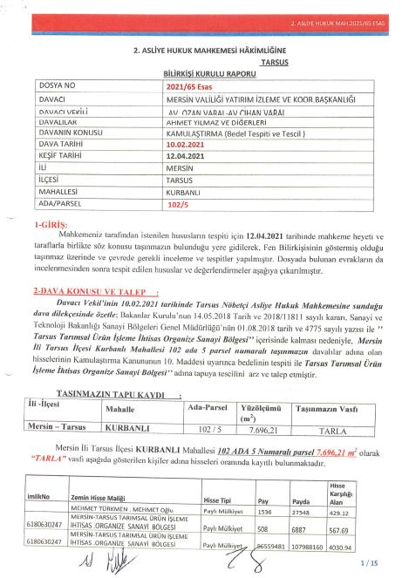

### Appendix A2. 102/5 – Public interest decision

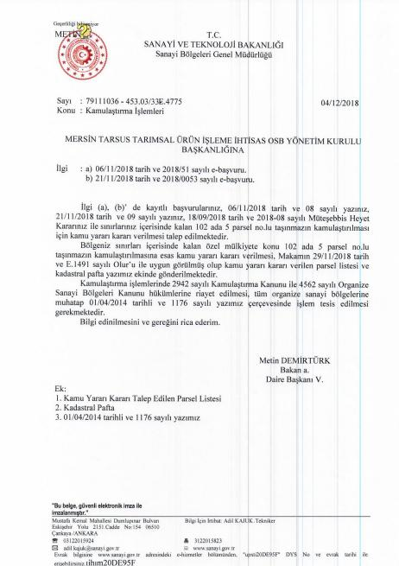

### Appendix A3. 102/5 – Decision on the need for expropriation

### Appendix A4. 102/5 – Expropriation request letter

### Appendix A5. 102/5 – Shares acquired by agreement/consent

Since it contains personal data, it will be hidden at the disclosure process.

| **NAME SURNAME** | **PARCEL** | **SHARE** | **DENOMINATOR** | **EXPROPRIATION PAYMENT** |
| --- | --- | --- | --- | --- |
| ALAETTİN ÖZTÜRK | 102 ADA 5 PARSEL | 762 | 27548 | 3.193,20 |
| FEVZİYE KARA | 102 ADA 5 PARSEL | 1143 | 220384 | 598,73 |
| MUHİTTİN ÖZTÜRK | 102 ADA 5 PARSEL | 762 | 27548 | 3.193,20 |
| FATMA ÇELİK | 102 ADA 5 PARSEL | 762 | 27548 | 3.193,20 |
| GÜLTEN SİNDAR | 102 ADA 5 PARSEL | 762 | 27548 | 3.193,20 |
| HARUN ÖZTÜRK | 102 ADA 5 PARSEL | 762 | 27548 | 3.193,20 |
| AZİME ÖZTÜRK | 102 ADA 5 PARSEL | 381 | 55096 | 798,30 |
| OSMAN ÖZTÜRK | 102 ADA 5 PARSEL | 1143 | 220384 | 598,73 |
| MEHMET SEYHAN ÖZTÜRK | 102 ADA 5 PARSEL | 1143 | 220384 | 598,73 |
| SİNAN ÖZTÜRK | 102 ADA 5 PARSEL | 1143 | 220384 | 598,73 |
| AHMET ÖZTÜRK | 102 ADA 5 PARSEL | 1016 | 27548 | 4.257,65 |
| MEHMET SEYHAN ÖZTÜRK | 102 ADA 5 PARSEL | 127 | 55096 | 266,00 |
| SİNAN ÖZTÜRK | 102 ADA 5 PARSEL | 127 | 55096 | 266,00 |
| ÖNDER YILMAZ | 102 ADA 5 PARSEL | 127 | 13774 | 1.064,40 |
| HARUN ÖZTÜRK | 102 ADA 5 PARSEL | 127 | 13774 | 1.064,40 |
| FEVZİYE KARA | 102 ADA 5 PARSEL | 127 | 55096 | 266,00 |
| BİLGE KÖKSAL | 102 ADA 5 PARSEL | 127 | 13774 | 1.064,40 |
| ALAETTİN ÖZTÜRK | 102 ADA 5 PARSEL | 127 | 13774 | 1.064,40 |
| MUHİTTİN ÖZTÜRK | 102 ADA 5 PARSEL | 127 | 13774 | 1.064,40 |
| FATMA ÇELİK | 102 ADA 5 PARSEL | 127 | 13774 | 1.064,40 |
| OSMAN ÖZTÜRK | 102 ADA 5 PARSEL | 127 | 55096 | 266,00 |
| GÜLTEN SİNDAR | 102 ADA 5 PARSEL | 127 | 13774 | 1.064,40 |
| AYLA ÖZTÜRK | 102 ADA 5 PARSEL | 508,13 | 27548 | 2.125,00 |
| AYDAN ÖZTÜRK | 102 ADA 5 PARSEL | 762,19 | 27548 | 3.190,00 |
| ŞENEL ÖZDEN | 102 ADA 5 PARSEL | 1016 | 27548 | 4.255,00 |
| AYLİN ÖZTÜRK | 102 ADA 5 PARSEL | 762,19 | 27548 | 3.190,00 |
| ÖNDER YILMAZ | 102 ADA 5 PARSEL | 60467 | 12341504 | 565,00 |
| AYDIN ÖZTÜRK | 102 ADA 5 PARSEL | 762 | 27548 | 3.193,00 |
| TESLİME SARI | 102 ADA 5 PARSEL | 60467 | 3085376 | 2.262,00 |
| BİLGE KÖKSAL | 102 ADA 5 PARSEL | 60467 | 12341504 | 565,00 |
| MÜSLÜM DOĞAN | 102 ADA 5 PARSEL | 60467 | 21597632 | 322,00 |
| NİMET ERGEZER | 102 ADA 5 PARSEL | 60467 | 3085376 | 2.260,00 |
| DUDU ERGÜL | 102 ADA 5 PARSEL | 60467 | 215976325 | 323,00 |
| ALİ DOĞAN | 102 ADA 5 PARSEL | 60467 | 21597632 | 323,00 |
| MUSTAFA DOĞAN | 102 ADA 5 PARSEL | 60467 | 21597632 | 323,00 |
| ŞENEL ÖZDEN | 102 ADA 5 PARSEL | 254 | 34435 | 850,00 |
| ŞENEL ÖZDEN | 102 ADA 5 PARSEL | 508 | 34435 | 1.700,00 |
| AYLİN ÖZTÜRK | 102 ADA 5 PARSEL | 381 | 68870 | 635,00 |
| AYLİN ÖZTÜRK | 102 ADA 5 PARSEL | 381 | 137740 | 315,00 |
| AYDAN ÖZTÜRK | 102 ADA 5 PARSEL | 381 | 137740 | 315,00 |
| AYDAN ÖZTÜRK | 102 ADA 5 PARSEL | 381 | 68870 | 635,00 |
| AYLA ÖZTÜRK | 102 ADA 5 PARSEL | 127 | 68870 | 210,00 |
| AYLA ÖZTÜRK | 102 ADA 5 PARSEL | 127 | 34435 | 425,00 |
| AYŞE YILMAZ ŞENER | 102 ADA 5 PARSEL | 46299 | 6170752 | 865,00 |
| MAFİKAR ÖZTÜRK | 102 ADA 5 PARSEL | 10793 | 1542688 | 805,00 |
| FİKRİYE YILMAZ | 102 ADA 5 PARSEL | 253 | 55096 | 530,00 |
| AHMET ÖZTÜRK | 102 ADA 5 PARSEL | 254 | 34435 | 850,00 |
| AHMET ÖZTÜRK | 102 ADA 5 PARSEL | 508 | 34435 | 1.700,00 |
| BİLGE KÖKSAL | 102 ADA 5 PARSEL | 127 | 34435 | 425,00 |
| AKİF CİNGİZ | 102 ADA 5 PARSEL | 253 | 247932 | 115,00 |
| MEHMET CAN KISA | 102 ADA 5 PARSEL | 253 | 82644 | 350,00 |
| DURDANE KISA | 102 ADA 5 PARSEL | 253 | 247932 | 115,00 |
| ELİF GÖKKOCA | 102 ADA 5 PARSEL | 253 | 247932 | 115,00 |
| CENGİZ KISA | 102 ADA 5 PARSEL | 253 | 82644 | 350,00 |
| NECATİ YILMAZ | 102 ADA 5 PARSEL | 60467 | 3085376 | 2.260,00 |
| BAHRİ YILMAZ | 102 ADA 5 PARSEL | 60467 | 3085376 | 2.260,00 |
| MEDİHA TÜRKMEN | 102 ADA 5 PARSEL | 10793 | 1542688 | 805,00 |
|  | **TOPLAM** | **1** | **1** | **71.457,67** |

### Appendix A6. 102/5 – Shares acquired by expropriation

Since it contains personal data, it will be hidden at the disclosure process.

## Appendix B. Official Expropriation documents on 105/1 and 105/2

### Appendix B1. Public interest decision

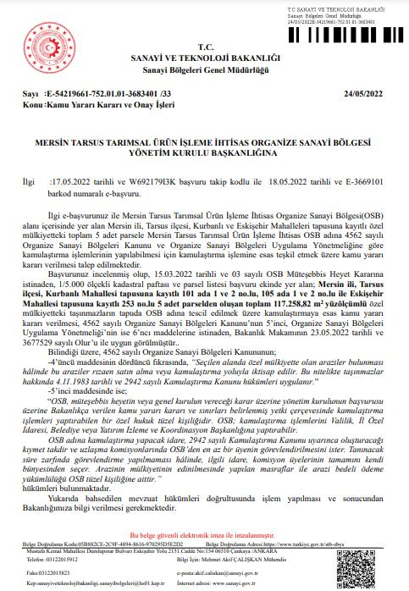

### Appendix B2. Urgent Expropriation Decision (Article 27)

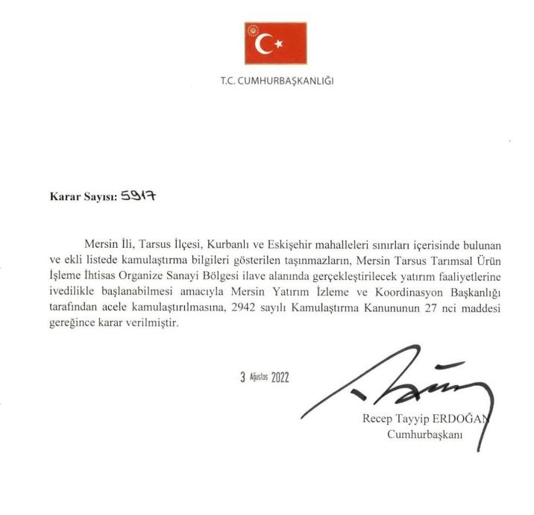

### Appendix B3. Agreement Minutes – 105/1

Since it contains personal data, it will be hidden at the disclose stage.

### Appendix B4. Agreement Minutes – 105/2

Since it contains personal data, it will be hidden at the disclose stage.

### Appendix B5. Valuation reports for 105/1 and 105/2

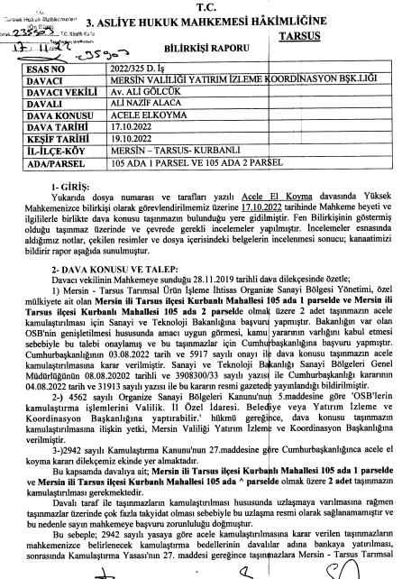

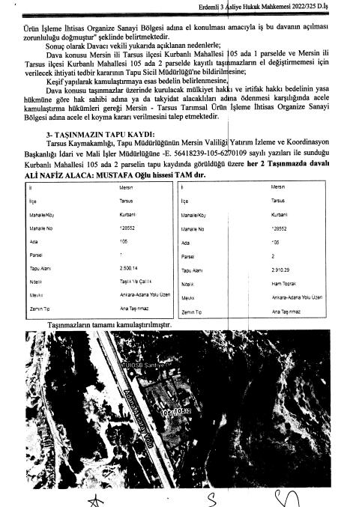

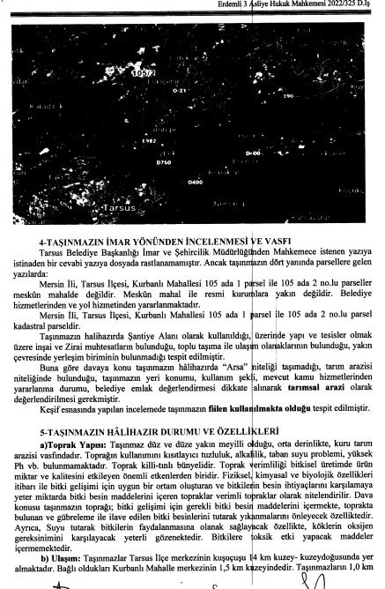

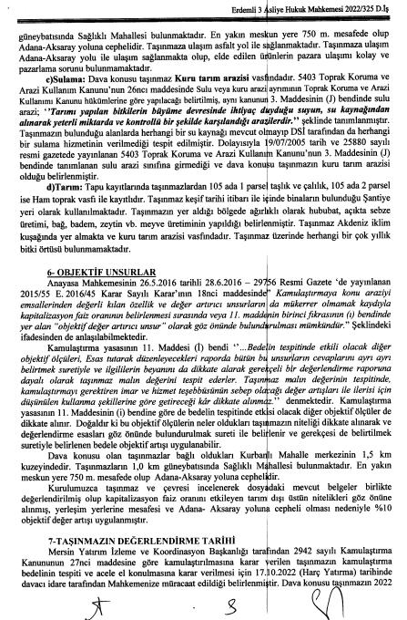

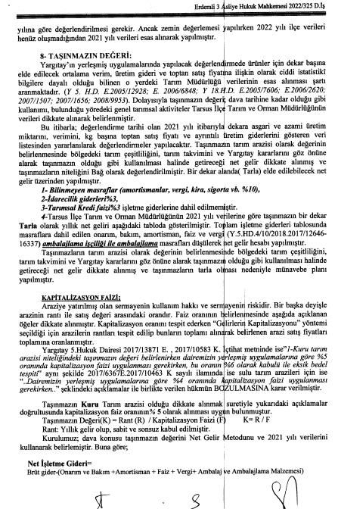

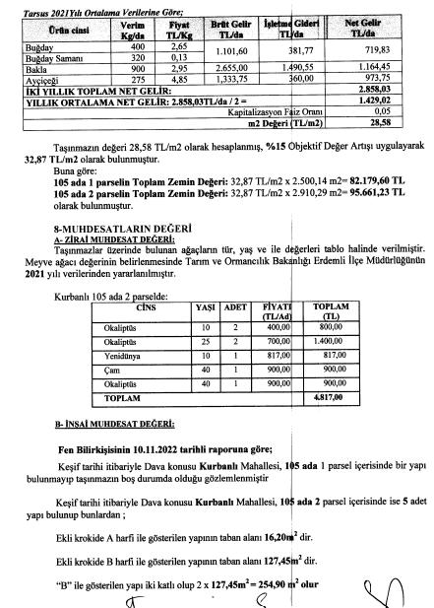

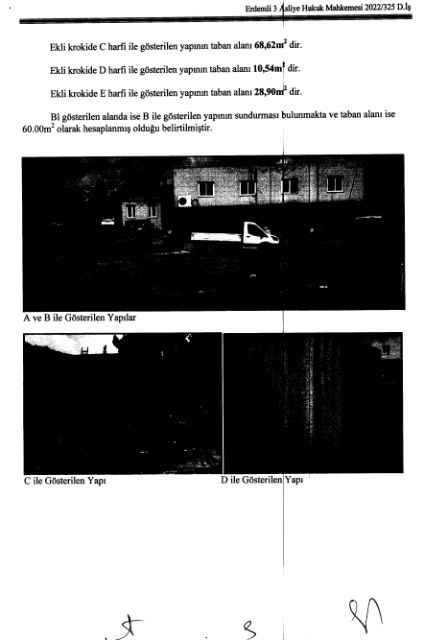

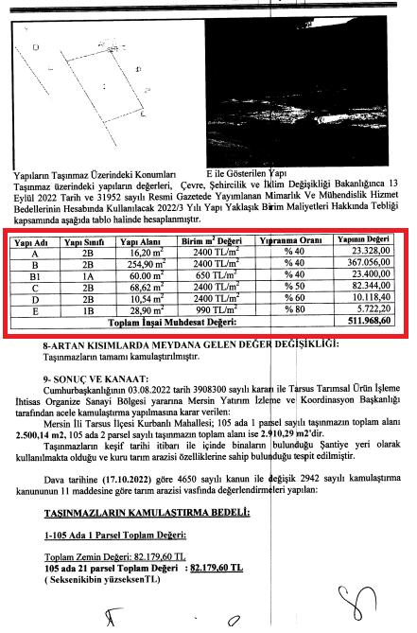

## Appendix C. Example public land title deed transferred to the OIZ

## Appendix D. Protocol/consent with İskenderun Demir, Çelik A.Ş (İSDEMİR)

## Appendix E. Adequate pay (Ecrimisil) payment documents for public parcel no. 104/1 (2014, 2008)

Since it contains personal data, it will be hidden at the disclose stage.

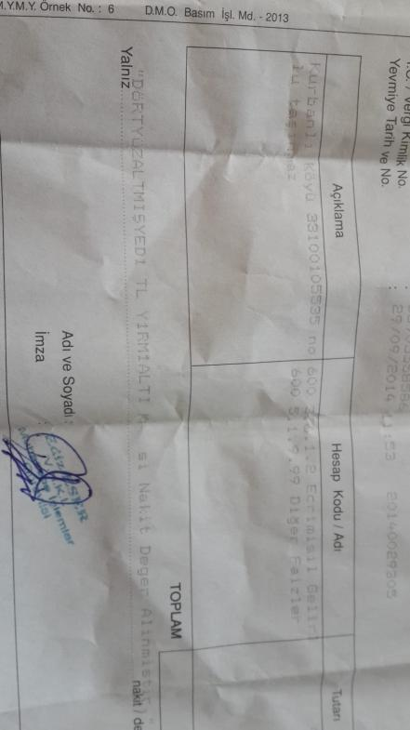

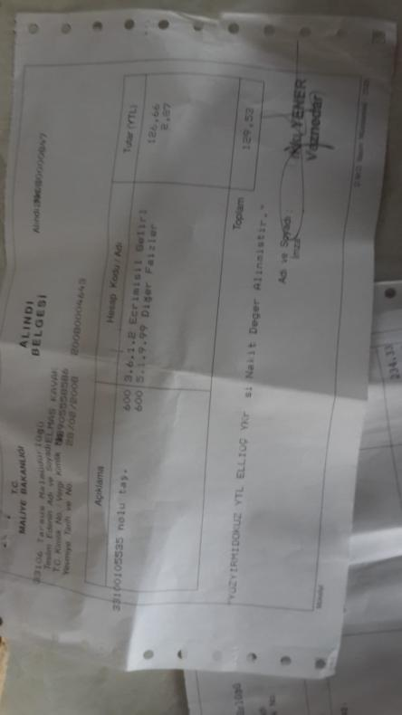

## Appendix F. Ministry of Agriculture Fertilizer and Diesel Support Amounts (Tarım Bakanlığı Gübre ve Mazot Destek Miktarları)

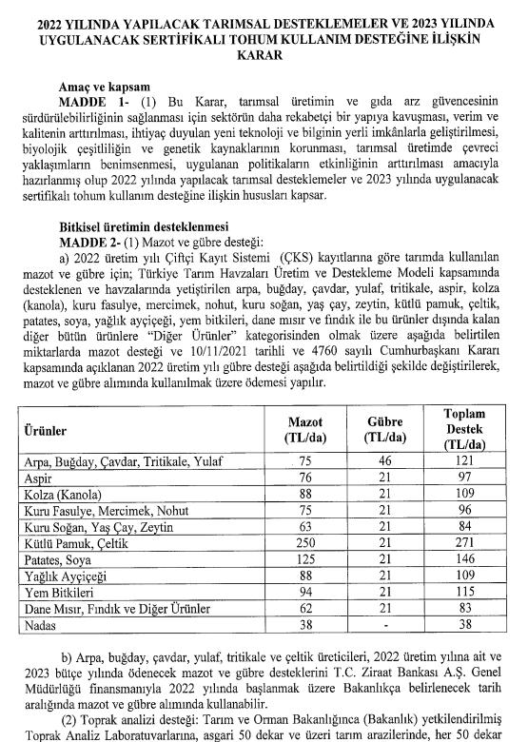

## Appendix G. Expenditure documents related to physical resettlement in parcel no. 104/1

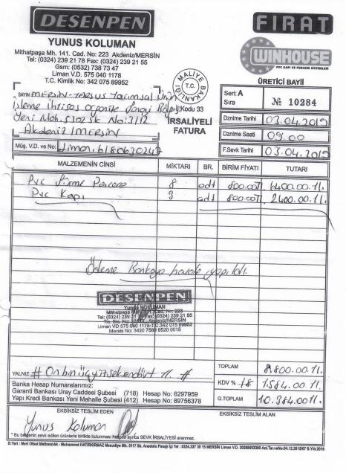

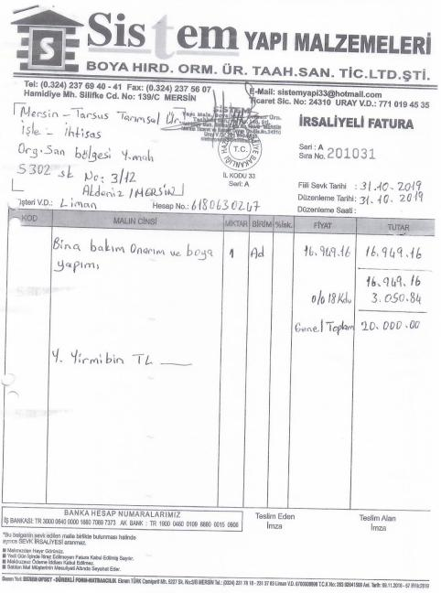

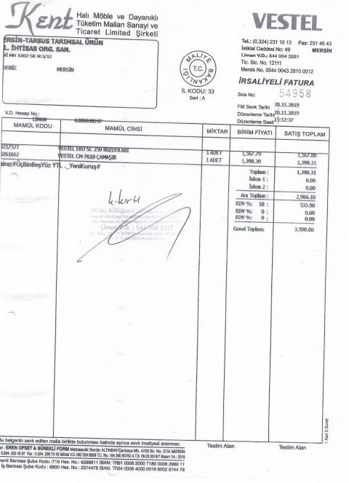

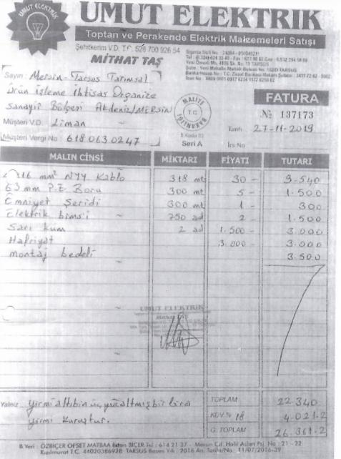

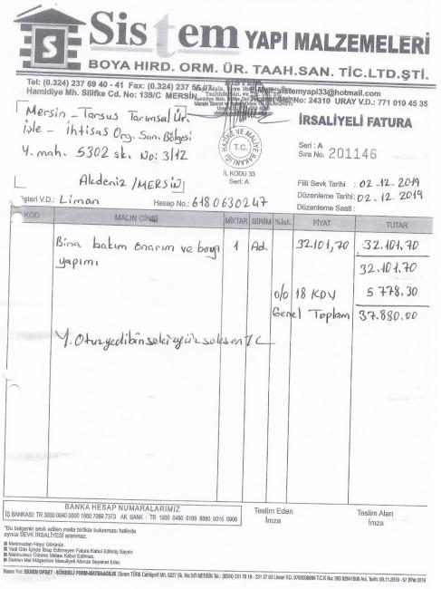

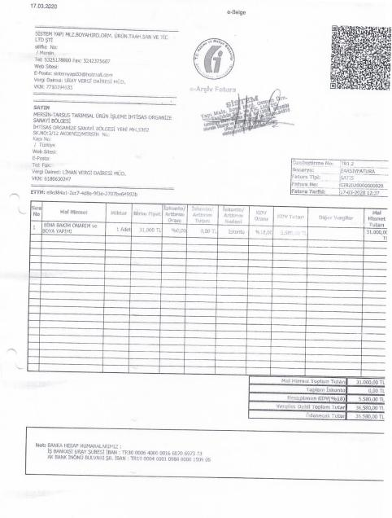

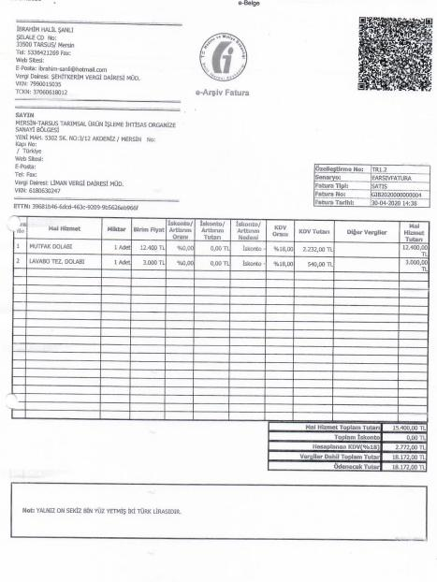

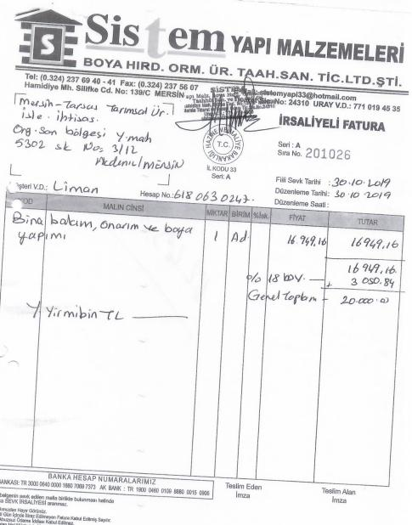

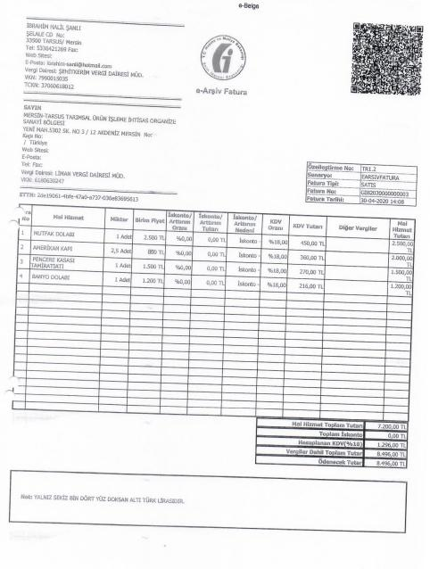

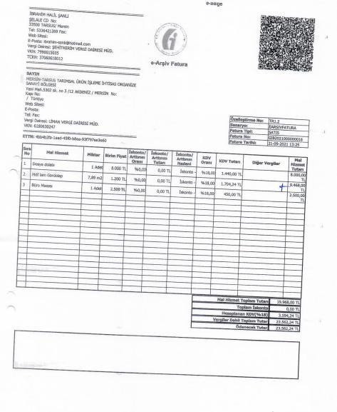

## Appendix H. Photographs of the family's renovated house after the Physical Resettlement

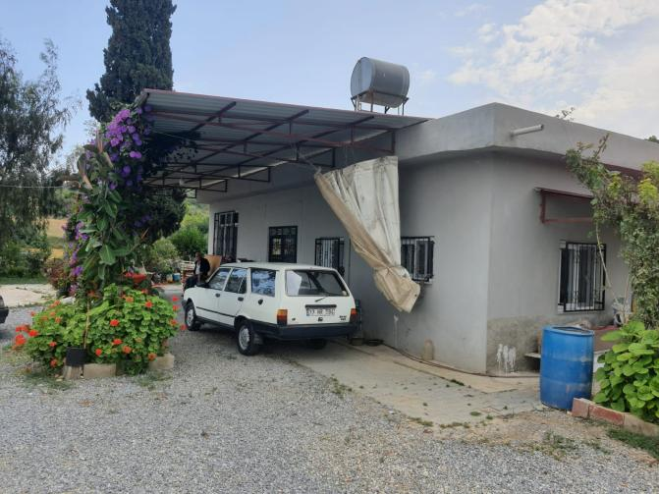

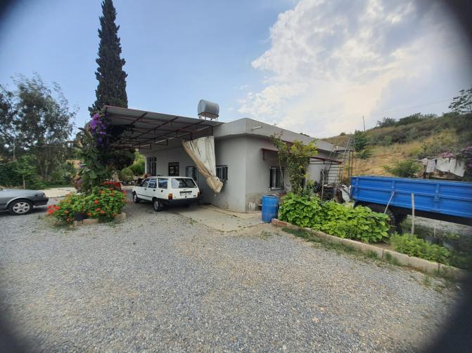

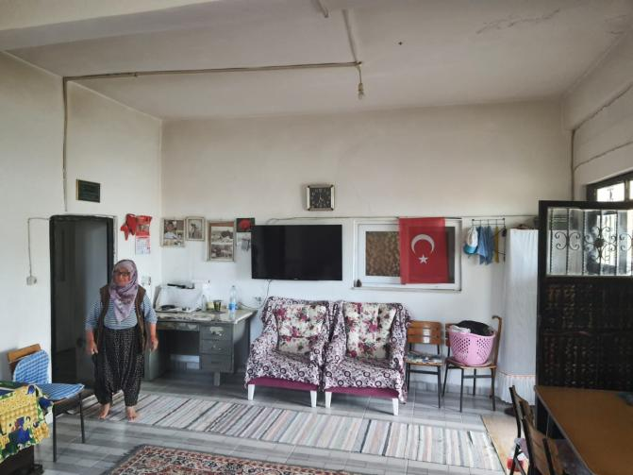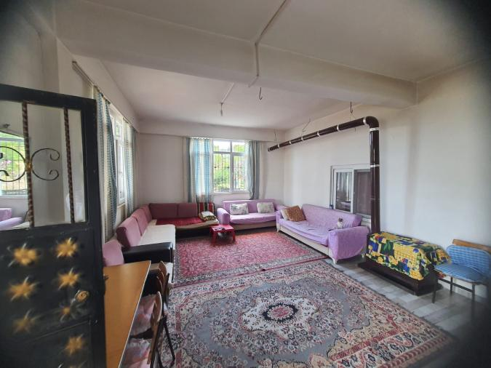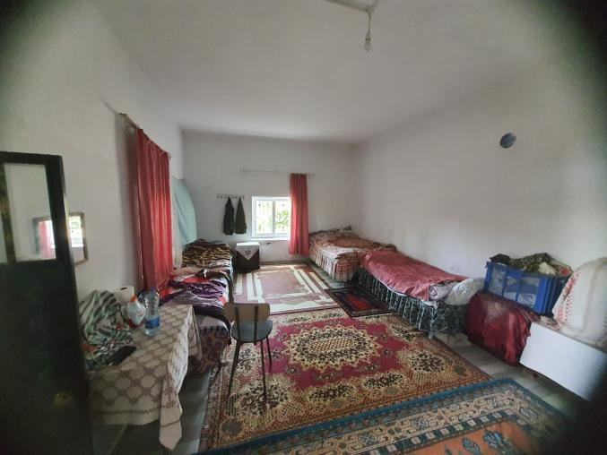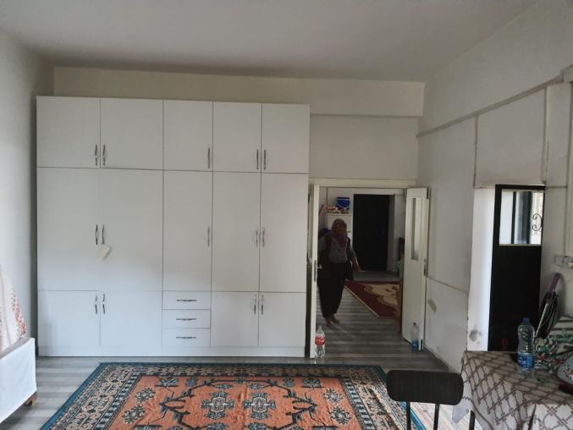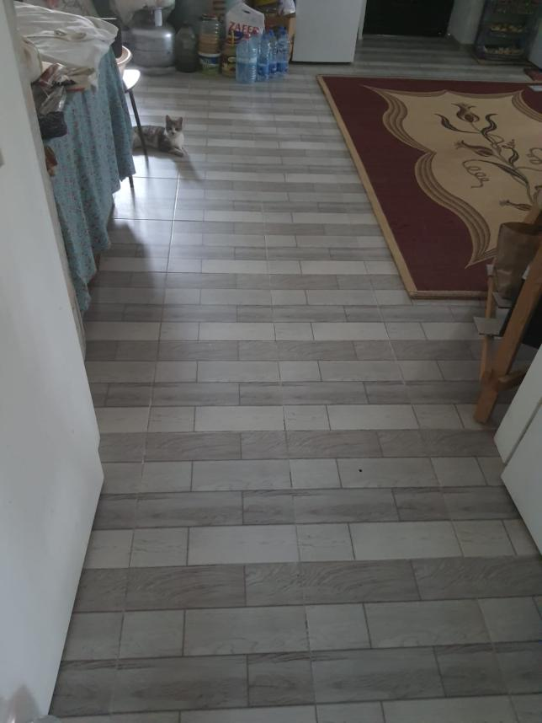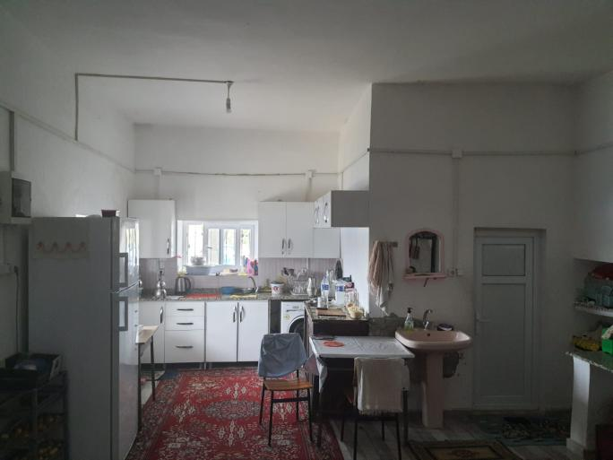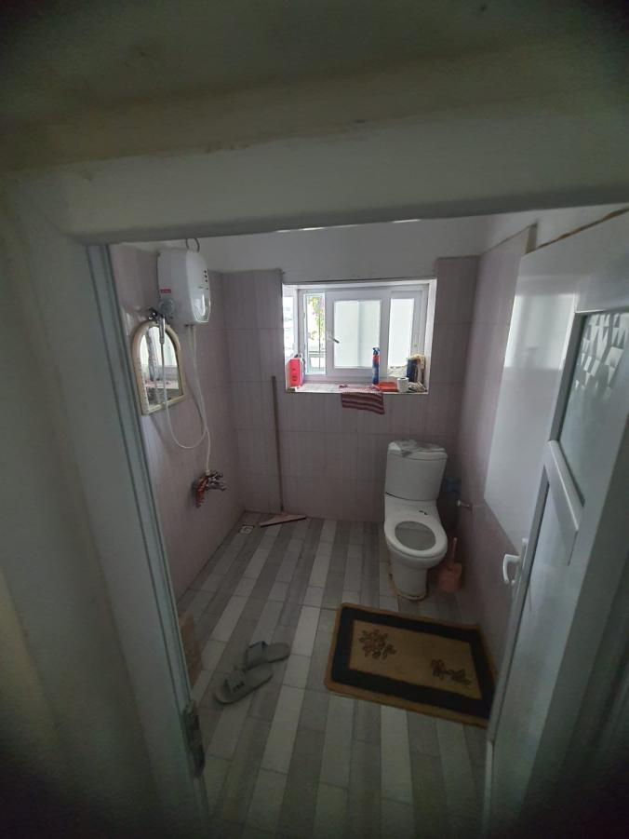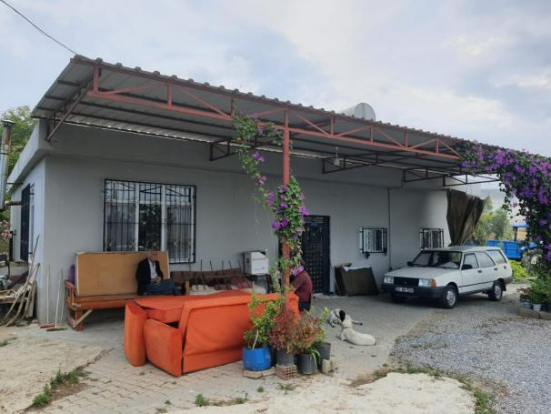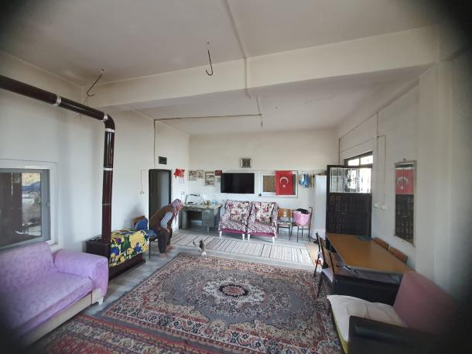

## Appendix I. Declaration of informal house owner (parcel numbered 104/1)

1. <https://www.sanayi.gov.tr/sanayi-bolgeleri/dunya-bankasi-finansmanli-osb-kredilendirme-projesi/sf1604010641>
2. <https://www.sanayi.gov.tr/sanayi-bolgeleri/dunya-bankasi-finansmanli-osb-kredilendirme-projesi/sf1604010641>
3. Since the shareholders could not be reached, it was acquired by expropriation.
4. A "urgent" expropriation decision is taken in order to obtain the shares of the unreachable owners. This decision does not eliminate the negotiation process of the expropriation process. However, the transfer of the land to OIZ is realized by depositing the compensations to the accounts opened on behalf of the unreachable owners.
5. The forest area to the east of the sub-project area was not de facto forest. For this reason, with the Presidential Decision dated 17.04.2019 and numbered 957 published in the Official Gazette dated 18.04.2019 and numbered 30749 and the Presidential Decision dated 06.10.2020 and numbered 3065 published in the Official Gazette dated 07.10.2020 and numbered 3065, the said lands were taken out of the forest. decided. As a requirement of the decree, the land in question was transferred to the Treasury by the Regional Directorate of Forestry.
6. A kind of penalty paid by informal users of public land like rent (ecrimisil).
7. such as single women headed households, households with disabled members, households under poverty line as determined by household receiving social assistance.
8. There was no land acquisition in Sağlıklı Village. However, they were included in the fieldwork considering that there may be problems with access to lands and pastures.
9. He wants to quit the activity.
10. He already wants to leave livestock because of high feed costs.
11. It is mandatory as per TS EN ISO 9001:2015 Quality Management System.
12. such as single women headed households, households with disabled members, households under poverty line as determined by household receiving social assistance.